Michael Vince

acmillan nglish

rammar

In Context

Intermediate

with key

MACMILLAN

Michael Vince

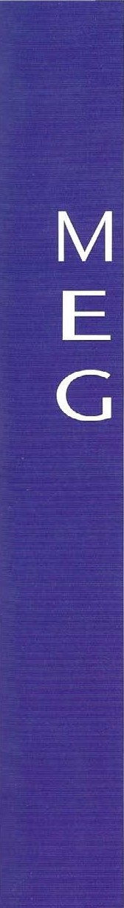acmillan nglish

rammar

In Context

Intermediate

with key

Macmillan Exlucation

Between Towns Road, Oxford OX4 31'!'

A division of Macmillan Publishers Limited

Companies and throughout the world

ISBN 978-1-4050-7140-6 (with key edition)

ISBN 978-1-40S0-7141-3 (without key edition)

Text O Michael Vince

Design and illustration Macmillan publishers Limited 2CYJ7

First published 2008

All rights reserved; no pan oi this publication may be reproduced, stored in a retrieval System, transmitted in any form, hy any mechanical. photocopying. recording, Or Otherwise, Without the pcior Written permission the publishers.

Design by Higtop

Original design by Giles Davies

Illustrated by Andy Hammond, Joanna Kerr. Darren Lingard, Sarah Nayler. Andrew Selby

Cover concept by Giles Davies

Covet design by Katie Stephens

Cover photographs by Cxjrhis. Digital Vision, Photodisc

authors and publishers would like to thank the following for permission to reproduce their material: Extractq from websites bbc. CO. ukJSChOOlS/gcsebitesize/phYSiCS copyright bbC_CO.uk reprinted by permission Of the publisher. Extract from www.equityschooltravel.co.uk copyright@EAuity• Educational by permission Of publisher, Information • Changing Cities and urban challenges' from I.elts Revise kS3 Geography by A. Arnell A. Browne' copyright O Letts

2004, reprinted by permission of the publisher, Huveaux Plc. Iniormatlon 'Energy and from Science hy G. copyright I etts

2002. reprinted by permission Of the publisher. Iluveaux Plc. Extracts from 'Weather and Climate' (Usbome Science Experiments) copyright Usbome Publishing Limited 1992, reprinted by permission Of the publisher. Extract from 'Apple Computers The Early Years' taken from http;//en.wikipedia.org/wiki/AppIeOmputer», copyright O Wikipedia, the encyclopedia.

These materials may contain links for third party websites. We have no control over. and are  for, the contents ot such third party websites. mense use care when accessing

Although we have tried to trace and contact copyright holders before publication, in some vases thi' has not been possible. If contacted We Will I.n• pleased to rectify any ot omiKSions at the earliest opportunity.

author Would like to thank Carl Robinson, Amanda Holmbrook and Sarah Curtis their support and help during this project. Special thanks arc due to my editor Clare Shaw.

 Would also like to thank the many teachers Whose classes I have visited, and who have commented on versions of this book.

The authors and publishers would like to thank the following [or trunission to reproduce their photographic material: Alamy/ Pictorial Press p60, CoverSpot pl 16, The Print Collector p124, Vocx'Pix 12St, Elmtree Images p1891; Ardea/ M Watson p77: Bananastexk/' pp 19, 1891. 191, 197. 198; Brand X/ pp 901, 97. 101, 117; Cvrbi,/ pp 12, 21, 69, 136, Smithsonian Institution pS6, Bettmann pp64, 127, 162, 187, Cat Gwynne pS4, Liu Liqun p88, Peter M Fisher p89, Ed Kashi pl 13t1, James L Amos Denis Scott plS8, Atlantide Phototravel plS6, Kristy•Anne Glubi5h/Design Pics plS9m, Andrew Brookes plS9br; Dean

Ryan/ pl Digital Vision/ p PAS; Getty Images/ Hulton Archive p76, Sean JLLStice p96, The

Bridge"lan Art Library pl 13b; John Foxx Images/ PPS. 120, 129. 199; Maty Evans Picture

Library/ p92; Ordnance Survey/ p•iS; Photodiscl pp 13. IS. 17, 27, 30. 31. 38, 95, 132. ISO; Photolibrary/ PPO), 1 2.S, Martyn Chillmaid p ISOr; Science Photo Iåbrary/ p142; Stockbyte/ pp 20, 43. 72. 80, 81. 151, 183, 189m; pp 19. 34. 46. 166, Age plS91.

Printed and bound in Thailand

2012 2011 2010 2009 2008

10 9 S 7 6 S 4 3 2 1



 Introduction

This book is designed to revise and consolidate grammar points at the level Of Council of Europe Framework (CEF) Bl and B2. It assumes that some basic points have been covered. These can be practised in Macmillan English Grammar In Context Essential.

The practice material includes a wide range of topics to reflect both everyday language use and the kinds of subjects learners might be studying in schools or colleges. Many learners are likely to use English to learn another subject during their education and the choice of text tries to reflect this fact. Some texts contain information which learners should find interesting or challenging. •Ihe intention in general is that language should have a familiar context and that learners should have something to use language for.

Within each unit, exercises range in difficulty. This allows learners to build up their confidence with the simpler, more familiar tasks before moving onto the more challenging ones later in the unit. The longer, topic-based texts include highlighted words whose definitions can be found on the accompanying CD-ROM. This is a good opportunity for learners to widen their vocabulary and see grammar used in realistic contexts.

The Review section at the back Of the book offers more activities for students who have finished the other exercises. It is also for students who feel that they haven't fully grasped the grammar point and need some further practice. In addition, it can be used as a means of testing or revising previous study, either in class or at home.

The CD-ROM

This includes two further exercises for each unit in this book, and a test section. Plus, where you see highlighted words like this, you will find the definitions in the glossary section. Just follow the link from the homepage.

To the student

Macmillan English Grammar In Context has been written to make grammar more interesting than other books on the market. We hope you find it enjoyable as well as useful. If you are studying at home, the units can be covered in any order but the exercises within each unit have been graded. If you find some exercises difficult, read the presentation page again. The extension activities and Review offer the opportunity of further practice.

To the teacher

Unlike many other grammar books, Macmillan English Grammar [n Context puts grammar into context. The aim is to encourage students to see grammar used more realistically and in more interesting ways. The topics covered in the exercises can be used as a starting point for a lesson, as a subject for discussion, and as a means of helping to build students' vocabulary in useful areas. •lhere is opportunity for individual study, group work and homework, plus testing, in the different sections Of the book.

present simple 6



Page

1. present continuous  10
2. past simple14

|  |  |
| --- | --- |
| 4 past continuous, used to do | 18 |
| 5 present perfect simple | 22 |

1. 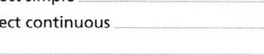present perfect continuous 26
2. past perfect28
3. tense contrasts32

### 9 will, shall, be going to36

1. future time 40
2. there, it44
3. 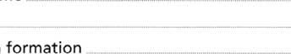question formation 48
4. tag questions52
5. infinitive after verbs and adjectives54
6. -ing form58
7. reported statements62
8. reported questions, commands, and reporting verbs66 18 conditionals: true, real and unreal70
9. conditionals: impossible past, wishes74
10. the passive and its uses78
11. causative have, verbs with two objects, passive reporting verbs82 22 modals: ability, obligation (present / future)86 23 modals: ability, obligation, criticism (past)90
12. modals: possibility, uncertainty, certainty (present / future)94
13. modals: possibility, uncertainty, certainty (past)98 26 modals: request, permission, offer, suggestion, advice, will as obligation102 27 countable and uncountable106

Unit Topic Page

28 noun + noun, 's or of110 29 articles (1)114

1. articles (2)118
2. 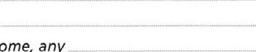quantity: some, any 122
3. quantity: much, many, few, little, enough 126
4. quantity: none, all, each, every _ 130
5. 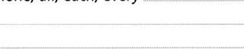pronouns134
6. adjectives138
7. adverbs140
8. making comparisons144
9. superlatives and comparatives  148
10. place prepositions, prepositions in phrases, place adverbs152
11. time (1)156
12. time (2)160
13. prepositions after verbs, adjectives, and before nouns164 43 phrasal verbs (1)  168
14. phrasal verbs (2)172
15. conjunctions, adverbs and prepositions

as connectors176

1. relative clauses180
2. defining and non-defining relative clauses184
3. purpose and result188

Review192

Wordlist 203

206

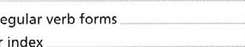

List

of

irregular

Grammar

index

207

Factual answers208

Answer key209

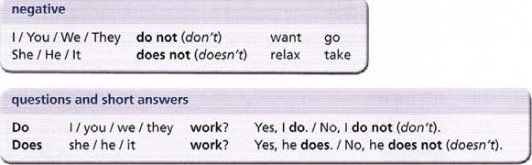

USE

tJse present simple for  facts, or things that always happen. Water boils at 1000C.

* + routines and habits.

The birds return to the island every spring.

* + timetable events.

The Drama Club meets every Thursday at 7.30.  plots of films, stories and plays.

At the party Romeo sees Juliet and falls in love with her.

yes / no questions and short answers

|  |  |
| --- | --- |
| Do male penguins keep the eggs warm?  Does water boil at 800C? | Yes, they do.  No, it does not / doesn't |

question words

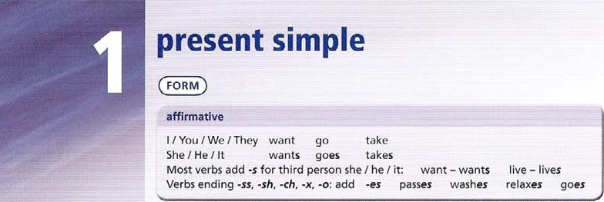We put question words in front Of present simple yes / no questions.

|  |  |
| --- | --- |
| Why | do people grow? |
| Where | does water come from? |
| When | do fish sleep? |
| What | does this word mean? |
| Who | do you sit next to? |
| How | does a camera work? |

what and who subject questions

With what and who it is possible to ask questions about the subject Of a sentence. In this case, we do not use a question form. Who knows the answer to this question ?

What makes it work?

1. Complete the sentence with the affirmative form of the verb in brackets.
   1. I (drive) drive but my sister (cycle) **cycles.**
   2. 'I-he Sun (rise) **rises** in the east and (set)**sets** in the west.
   3. The Prime Minister (travel) **travels** abroad in his own private aeroplane.
   4. It (cost) **costs** $20 million to be a space tourist for One week in the International Space Station.
   5. The European Commission (meet) **meets** in Brussels.
   6. My dad (read) **reads** two books every week.
   7. I (understand) **understand** geography more than science.

h My favourite TV programme (start) **stars** at half past ten.

G The teachers at our school (give) **gives** us lots Of homework.

H We (like) like Swimming because it's fun and good exercise.

1. Complete the sentence with the negative form Of the verb in brackets. Use contractions.
   1. You (do) -donany of the cooking!
   2. My brother (play) doesn’t play tennis because he (like) doesn’t like it.
   3. I (think) don’t think that's a good idea.
   4. Teachers (work) doesn’t work at weekends.
   5. The government (agree) doesn’t work with the new EU laws.
   6. We (want) don’t want to see that film because it looks boring.
   7. His mum (drive) doesn’t drive a fast car.

h Those new mp3 players (be) aren’t very expensive.

I These birds (stay) don’t stay in the country during winter.

J He (sing) doesn’t sing very well, does he?

1. Complete the sentence with the affirmative or negative form of the verb in brackets. use contractions.
   1. The plane (leave) leaves in half an hour but Nick (not / be) isn’t at the airport yet.
   2. My best friend (love) loves Science fiction films but they (not / interest) aren’t interest me
   3. I (not / study) don’t study chemistry because it (be) is difficult.
   4. I (not / dance) don’t dance because I (look) look stupid
   5. The Sun (not / go) doesn’t go around the Earth, the Earth (go) goes around the Sun!

F My new computer (do) does lots more things than my old one, and it (not / crash) doesn’t crash

g My dad (not / have) doesn’t has any qualifications but he (have) has a really good job.

h Fire (need) needs oxygen to burn. It (not / burn) doesn’t burn without oxygen.

I My teacher (not / own) doesn´t own a mobile phone because some people think they (be) are bad for your health.

J According to scientists, animals (live) lives longer if they (not / eat) don´t eat too much.

1. Complete the text with the affirmative form of the verbs in brackets.

|  |  |
| --- | --- |
| Emperor penguins a (live) | live in the Antarctic. |
| sea b (provide) | _ all their food, so they are good |
| swimmers. They c (dive) | . under the water and |

d (hold) their breath for up to 20 minutes. When the weather is very cold, the penguins e (stand) _ in a group. This f (keep) them warm. The Emperor is the only penguin that g (breed) in winter in

Antarctica. Each female h (lay) one egg in May or June. They then i (return) to the sea to feed. Each male then j (stand) _ with an egg On his feet. His feet k (keep) the egg warm. He J (sleep) most of the time and m (eat) no food for about 65 days. When the egg n (hatch) _ , the female o (come) back and p (find) —

|  |  |
| --- | --- |
| her mate. Now the females q (feed) | the young |
| penguins. The male r (spend) | his time eating. After |
| a few weeks, the male s (return) | _ to the family, and |
| then both parents t (look after) | the chick. |

1. Complete the text with the negative form of the verbs in brackets.

### ROMEO AND JULIET

families, the Montagues and Capulecs,live inVerona, Italy, but they a (get on) with each other. Romeo, son of Montague, thinks he is in love with Rosaline. but unfortunately she b (love) him. He goes to see her at a party at the house of his enemy Capulet, but there he sees Juliet, Capulet's daughter. She c (know) his name because he has a mask.

Tybalt. one Of the Capulet family, tries to fight with Romeo, but Capulet d (allow) this. However,Tybalt e (agree) with him. and f (forgive)

Romeo for coming to the house. Romeo manages to talk to Juliet, and he kisses her.They g (understand) that their families are enemies.\Nhen Romeo learns the truth, he h (care) that his love for Juliet could be very dangerous. Later he goes back to the house and stands in the garden. Juliet is standing on the balcony talking to herself about Romeo. but i (see) him below in the garden.After he talks to her, they soon show their love for each other, and agree to get married. However, they j (realize) that a terrible tragedy is about to happen.

|  |  |  |  |  |
| --- | --- | --- | --- | --- |
| Complete the question using the verb in brackets. | |  | Hair | Brain |
| Check the factual answers on page 208. | | (have)  (grow) | Tongue |  |
| b  d | bones $kop — growing? (stop)  How much water the brain  (contain) you hair on your tongue?  How many square metreS an adult's skin  ? (cover) hair _ faster in hot weather? |
|  | How long the heart to pump | |  | Muscle |

6

blood around the body? (take) muscles or push? (pull) Bone —.f_

|  |  |  |  |  |  |  |  |  |  |  |
| --- | --- | --- | --- | --- | --- | --- | --- | --- | --- | --- |
|  |  | 7 Complete the text with the affirmative, negative or question form of the verbs in brackets.  What a (do) vdoe$ the body to protect itself? Your body b (prevent) harmful microorganisms entering and causing harm. The skin. for example, c (allow) microorganisms to enter Hairs and mucus in your nose d (catch) invaders. and then you e (push) the mucus out when you cough, sneeze or blow your nose. Enzymes and acids in the body. and white blood cells also f (destroy) bacteria.  _ antibiotics ? Doctors h (use)   |  |  |  |  | | --- | --- | --- | --- | |  |  |  | | | common cold or  How k (work) vaccination) | | |  | (or inactive antibodies that not dangerous, n (come) antibodies o | |   antibiotic drugs to fight bacterial infections, but antibiotics i (work) _ against viruses. This is why doctors j (give) . antibiotics to patients with a flu.  immunization _ ? Immunization is another way Of protecting the body, by injecting the body with dead or microorganisms. After vaccination. the body I (start) to make destroy the microorganism. Because the microorganisms in the vaccination are the person m (get) . ill. When they  Into contact with a live (dangerous) micro organism. then the  (destroy) the infection before it makes them ill. |
|  |  |
|  |  |
|  |  |
|  |  |
|  | |
|  | |
|  |

h Which vitamin the liver Skin

(produce)

How many times a day - you in and out? (breathe)



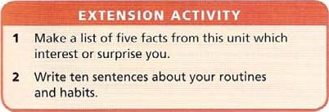

present continuous

|  |  |  |  |  |
| --- | --- | --- | --- | --- |
|  |  | |  |  | | --- | --- | | questions and short answers  Am going?  Are you / we / they waiting? Is she / he / it singing? | Yes, I am, / NO, I am not ('m not).  Yes, they are. / No, they are not (aren't / 're not) Yes, he is. / No, he is not (isn't / 's not). | |
|  |

spelling rules

* One-syllable verbs ending in one vowel + one consonant, double the consonant and add -ing: sit — sitting get — getting put — putting
* 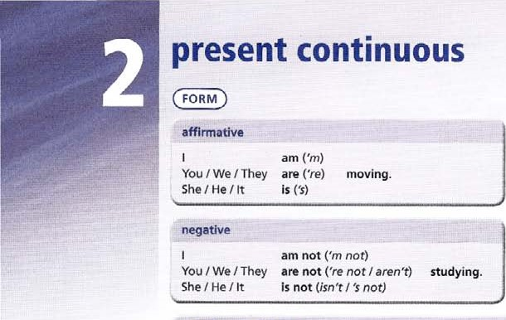Verbs ending in e, drop e before adding -ing: like — liking write - writing
* Verbs ending -ie change -ieto -y: lie— lying die — dying
* Two-syllable verbs ending in one vowel and one consonant usually double the final consonant and add -ing•. travel — travelling admit — admitting
* All other verbs add -ing: play — playing fee/ — feeling to.' — twing

USE

Use present continuous

* for actions happening at the moment of speaking, and not finished,

Sorry I'm busy at the moment. I'm doing my homework

* for continuing, unfinished actions which are not actually happening at the moment Of speaking, with verbs like work, learn, read. study etc.

What are you doing in science? We 're learning about the universe.

* for changing situations, with verbs like become. get, grow. change, increase. or with expressions such as more and more.

The earth is becoming warmer

More and more people are leaving the countryside.

* for a future arrangement, with a time reference (see Unit 10). We're leaving tomorrow.

Note: we do not repeat auxiliary be when we talk about two or more actions.

We are doing an experiment and making notes

present continuous or present simple?

The Earth moves round the Sun. (present simple = a general fact)

The floor is moving! It's an earthquake! (present continuous = at the moment) Most scientists work with computers. (present simple a general fact)

I'm working on my science project. (present continuous at the moment)

verbs not usually in present continuous

use present continuous with action verbs. For state verbs, which describe feelings, opinions etc, use present simple.

Thoughts and opinions think, understand, know, suppose, believe, Want, remember, forget. depend, agree Feelings like, love, hate, feel, prefer, need

Senses see, hear, smell: basic sense meanings with can. I can see etc

I see (z I understand) I hear (z people tell me) This meat smells (z has a smell) Possession and existence belong, contain, have, include, mean, seem, weigh

present simple and continuous with different meanings

Some verbs have a state meaning in present simple and an action meaning in present continuous.

|  |  |
| --- | --- |
| j think it's a good idea. | present simple for opinion |
| I'm thinking about it. | Present continuous for action (l haven't decided yet.) |
| It has four legs. | Present simple for description |
| I'm having a great time | Present continuous for action (happening now) |
| The surface feels hard. | Present simple for description |
| I'm feeling sick. | Present continuous for action (happening now) |

(l fee/ sick is also possible)

I'm seeing rom on Friday. Present continuous for future action (I'm meeting)

1. Complete the sentence with the affirmative form of the verb in brackets.

a 1.00k, all the people are leaving (leave)

b The Earth's temperature (rise) are raising because people (use) are using too much energy.

C She (study) ‘s studying economics and he (study) ‘s studying philosophy.

d You (stand) are standing 100 close to the road.

e We (stay) are staying in a lovely hotel by the beach.

f I (go) ‘m going to the supermarket now, do you need anything?

g The cat (chase) is chasing the dog.

h Technology (become) is becoming cheaper all the time.

i Pawel and Marek (train) are training for the football game next week.

J Manuela (listen) is listening to music in her room.

1. Underline the correct form.
2. Scientists do understand / are not understanding everything about the universe.
3. They disagree about some important facts. For example, does it get / is it getting larger or smaller?
4. Although they don't agree / are not agreeing about everything, there are some facts about the universe which they are sure about.
5. Take the planet Venus, for example. Here the temperature reaches / is reaching over 40000..
6. And another unusual fact about Venus is that a day there lasts / is lasting longer than a year.
7. Many scientists still search / are still searching for life in other parts of the universe.
8. Do they look / Are they looking for life on Venus?
9. It doesn't seem / isn't seeming to be the kind of place where life might exist.

i The atmosphere Of Venus consists / is consisting mainly of carbon dioxide (C02).

j And it has / is having an air pressure 90 times greater than that of Earth.

3 Complete the text with the present continuous form of the verbs in brackets.

Good afternoon, everybody. I a (speak) volcano,A team of scientists b (visit) anything exciting happens. I c (stand) d (look) e (climb) f (wear) special clothes and a rescue team g (stand by) just in case!

A little bit of smoke h (rise) from the volcano, but that% normal. Now the scientists i (set) up their equipment. They i (try) to collect some gas, which will help them understand what exactly k (go on) under the volcano.

Wait a minute! Something I (happen)

! The ground m (shake) ! The four scientists n (climb) out of the volcano as quickly as they can.They o (shout) something as well. I think it's time to leave!

* 1. Complete the sentence with the negative form of the verb in brackets. Use contractions.
     1. 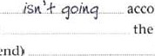As you know, the Marina space mission (go) according to plan. b As far as we can tell, the spacecraft (head for) the moon. c We can't be sure because at the moment it (send) us any useful

|  |  |  |
| --- | --- | --- |
|  | information. |  |
| d | Some of the equipment on the spacecraft (work) | properly. |
| e | As a result, We (receive) radio signals. |  |

f It seems that the solar power panels (point) at the Sun. g So as a result, they (produce) enough power.

1. And at the moment Marina's computer (respond) to our signals.

 We are trying to correct the problem but we (have)any luck.  However, we (give up) hope.

* 1. Use the prompts to make a question.
     1. the weather in your country / change e summer / get hotter _ _IS_ wca4•hcr in gour coun+rg chanqmq ?
     2. it grow / warmer or colder 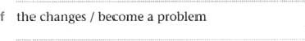

|  |  |
| --- | --- |
| c storms / happen more often | g people / worry about this |

od less snow / fall in winter h they / do anything to help

6 Complete the text with the present simple or present continuous forms Of the verbs in brackets.

Population a (mean) _ _ the number of people who live in a particular area.

The population Of the world b (not stay) the same.At the moment it c (grow) at an increasing rate. In fact, scientists d (believe) that the world population will increase until 2200, and then stop growing. However. things are not the same in all parts Of the world. At present in manyVVestern industrial countries the population e (fall)

This f (happen) because families are small, and health conditions are good.

In developing countries, on the other hand, the population g (rise) sharply. In Ghana, for example, most families h (have) several children. Many children in Ghana i (die) from illness, so it is important to have lots Of children.They earn money for the family and j (look after) their parents in old age.

7 Complete the sentence with the present simple or present continuous form of the verb in brackets.

a Everybody (know) knoasthat the world's rainforests (disappear) are. disappearing, b Although rainforests (cover)only six per cent of the Earth's land surface, they (contain)about 50% of all species of life on the planet.

1. They also (remove) —carbon dioxide (C02) from the air and (produce) oxygen (02).
2. As they are important, why (they / vanish) e Most scientists (agree) that there are two main reasons.

f First Of all, the way Of life in these forests (change) g In some forests, big companies (cut) down more and more trees (deforestation) and (cause) damage to the land. h In Other places, another kind of deforestation (happen)

Here farmers (burn) more and more of the forest and (use) the land to feed cattle.

Now that governments (understand) the problem, they (begin) to control these activities.

|  |
| --- |
| EXTENSION ACTIVITY |
| 1. Write five true sentences about your continuing activities, with learn, read, write, study and try to. 2. Write five true sentences about yourself, people you know, your school etc describing changing situations. Need more practice? GO to the Review on page 192. |



|  |
| --- |
| questions  Did I / you / we / they I she I he I it wait?  When did Leonardo da Vinci live?  What did Leonardo da Vinci paint?  short answers  Yes, I / you / we / they / she / he / it did. NO, I / you / / they / she / he/ it didn't. |
|

spelling rules

* Verbs ending in e, add -d:
* For one-syllable verbs ending one vowel + one consonant, double the consonant and add -ed:
* Other one-syllable verbs add -ed:
* Verbs ending vowel + consonant + y, change -y to -i and add -ed: Note: verbs ending vowel + y add -ed:
* Two-syllable verbs ending one vowel + one consonant, double the consonant if the stress is on the last syllable and add -ed:
* If the stress is on the first syllable, add -ed:

irregular verbs (see List of irregular verbs page 206)

decide — decided

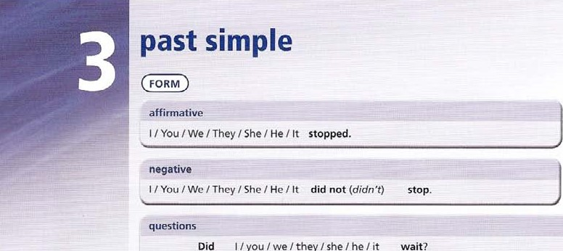stop — Stopped wait — waited study — studied play — played

p refer — preferred profit — profited

Many verbs have irregular past simple forms eg drink - drank see — Saw

USE

use past simple

* to talk about finished events in the past. when we think about a definite time. Alexanders army marched beside the river and then stopped outside the city.
* to describe the events in a Story.

Oliver heard the sound of a bell. Soon aftervvards, the door softly opened.

* to describe habits and routines in the past. We usually use a time word or phrase. Leonardo painted in his studio every day.

Subject and object questions are both possible with past simple (see unit 1).

What did Leonardo paint? object question: + auxiliary did

Who painted this portrait? subject question: no auxiliary did

Examples of time words and phrases we use with past simple:

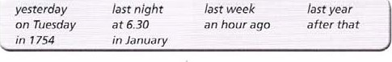

1. Complete the sentence with the past simple form of the verb in brackets.
   1. Aztec civilization (develop) .dC.Ve,lQpe-d in the Valley of Mexico, 7,500 feet above sea level.
   2. The Aztecs (leave)their own land Of Aztlan at some time during the 12th Or 13th century.
   3. They (believe)that Huitzilopochtli their war god (want) them to search for a new land.
   4. 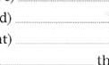They (arrive) _ _ in the Valley of Mexico during the 12th or 13th century AD, e They (build) — their capital city, Tenochtitlan, on an island in Lake Texcoco.
   5. They (plant) trees on the island to make the land better, (work) hard and

(improve) the land.

* 1. When the Spanish (arrive) in 1519, Montezuma, the Aztec ruler, (think) that Cortez was a returning god.
  2. When the Spanish (see) the Aztecs' gold, they (decide) to conquer the city.

Later they (kill) Montezuma, (defeat) _ _the Aztecs and (destroy) Aztec religion and culture.

1. Complete the sentence with the past simple form of the verb in brackets. Then decide if each sentence is True or False. Check the factual answers on page 208.
   1. Greek actors (wear) masks and special boots. Truc b Spartan children (take)baths only two or three times a year.
   2. The philosopher Socrates (drink)poison and died.
   3. Alexander the Great's army (go)_ as far as China.
   4. Heron Of Alexandria (make)a kind Of jet engine.

 The Roman Emperor Caligula's name (mean) 'Happy Soldier'.

* 1. Roman mathematics (have) _no zero.
  2. Most Roman girls (get)married at the age of 18.

Roman soldiers (pay)for their own equipment and food.

The Romans (know)how to make soap and cement.

1. Seven of the sentences (including the example) contain historical errors. Guess which ones are wrong and rewrite them with a negative past simple form. Check the factual answers on page 208.
   1. Alexander the Great married Cleopatra.

Ale-gander 4-hc grca4- didn'4• dc-opah-a, b Nelson Mandela became President of South Africa in 1994.

* 1. Leonardo da Vinci invented the Internet.



* 1. Confucius the Chinese philosopher died in 1900.



* 1. Marco Polo stayed in China for five years.

'I-he ancient Romans used steam engines in their battles.

* 1. Genghis Khan invaded Italy and captured Rome.
  2. Christopher Columbus reached America by accident.

William Shakespeare wrote Don Quixote.

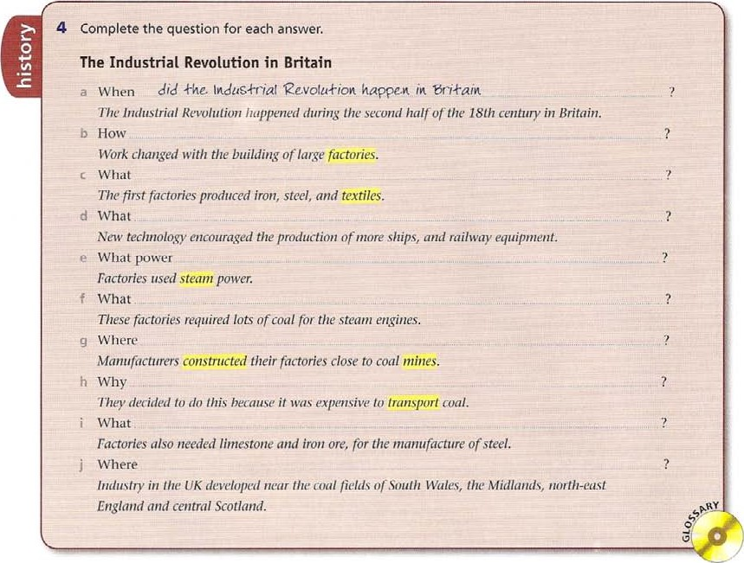

5 Rewrite each Statement about the playwright William Shakespeare as a yes / no question.

1. He came from a rich family.

Q Oid_hc conv a

* 1. No, not really. His rather was a glove maker.

1. He grew up in London.



* 1. No, in Stratford upon Avon, a small town about 160 km from London.

1. He went to school.



* 1. Yes, we think so. d He knew Latin.



A Yes, he leamt Latin at school, and some Greek as well.

e He got married.

A Yes, he was only 18 when he married Anne Hathaway, aged 26. f They had children.

A Yes, a daughter Susanna, and twins, a boy

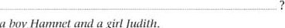

and

a

girl

Judith.

g He began writing plays in Stratford.

A We don't really know. We only know that after 1592 he was an actor and writer in London. h He wrote 37 plays all by himself.

A Well, we know he wrote two plays together with John Fletcher. Some people think that all his plays Were really written by somebody else.

 Ile made up all the characters and plots of his plays.



A Actually no. He borrowed lots olideas from other writers. This was quite usual in his time.



He

became

rich

famous.

A He certainly became quite rich, and his plays were popular. But he Only became really [amous in the 18th century and later.

6 Complete the text with the past simple affirmative, negative or question forms Of the verbs in brackets.

#### Louis Pasteur 1 822—1895

As a young man, Pasteur a at the École Normale in Paris. Then at rhe age ofjust 32, he b (become) . a professor at the University 01 Lille. In 1856, Pasteur c (receive) a visit from a man called Bigo who d (own) a factory that e (make) alcohol from sugar beet. He f (have) a question for Pasteur: why g (the alcohol / turn / to acid?) _ _ ? When this h (happen) , they i (not can) _ use it and j (throw) it away, Bigo k (ask) . Pasteur to find out the reason for this,

At first, Pasteur I (not know) , but when he m (examine) the alcohol under a microscope, he n (find) thousands Of tiny micro-organisms. He o (believe) , that they p (cause) the problem. q (milk, wine and vinegar / behave / in the same Way?)

Other scientists r (disagree) with him, and newspapers s (make) fun Of him. However, Pasteur t (continue) with his work, he u (invent) methods of testing his theory and v (prove) that he was right. Later he w (work) . together with two doctors and x (develop) , vaccines for diseases such as anthrax and rabies.

|  |  |  |  |
| --- | --- | --- | --- |
|  | EXTENSION ACTIVITY | | |
| 1  2 | Write five sentences about a famous historical figure from your country.  Write ten true things that you did, using the time words and phrases on page 14. Need more practice? Go to the Review on page 192. | | |
|  | |  | | --- | | questions and short answers  Was l / she / he l it waiting? Yes, I was, No, I wasn't.  Were you / we / they watching? you were. you weren't.  Where was he waiting?  What were they wearing? | | |
|  |

USE

Use past continuous  for a continuing unfinished action in the past.

When Sue arrived at 9.30 am, four people were waiting outside the office.

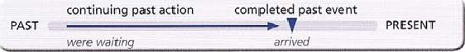

* for a continuing unfinished action interrupted by a sudden past action. While we were doing ,rnattls test, the (ire alarm went off.
* for activities as background description.

The rainforest was lull o/ sounds. Birds were calling from the trees and thousands of insects were buzzing and humming.

* for two continuing events happening at the same time.

While Cortes was talking to the emperor, his army was taking over the palace.

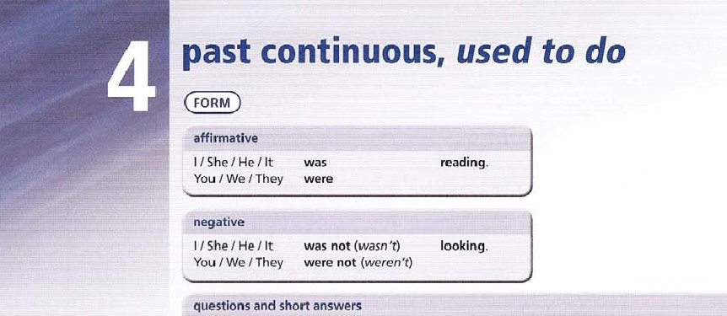while. when  use while with past continuous for the time the event was happening,

* Use when with past simple for actions.
* We can use other more descriptive time phrases instead of when.

At the moment the earthquake struck, most people were going about their normal lives habits in the past

For describing habits and states in the past, it is more natural to use used to + verb than past continuous, especially when we make contrasts with the present. We do not mention the exact date,

Used to is unchangeable, and has only a past tense form.

Negative: didn't use to Question: Did you use to?

Rainforests used to cover a third of the Earth, but now they are getting smaller.

Once people didn't use to worry about this problem.

What games did you use to play in the playground at school?

Note: we also use past simple (+ frequency adverb) to describe habitual actions in the past. 18 people thought fhäf the Sun trä•.iélléd round the Earth.

1 Under-line the correct form.

1. While he took / a bath, Archimedes discovered / was discovering the principles of density and buoyancy.
2. When Edouard Benedictus, a French scientist, worked / was working in his laboratory, he dropped / was dropping a glass bottle which had some plastic inside — and invented / was inventing safety glass.
3. Columbus arrived I was arriving in America while he tried / was trying toreach the Far East. d Alexander Fleming discovered / was discovering penicillin by accident while he looked / was looking at some Old experiments.

e While Hiram Bingham climbed / was climbingin the mountains of Peru in 1911, he discovered / was discovering the lost city Of Macchu Picchu.

f While Isaac Newton sat/ was sitting under an apple tree, an apple felt / was ralliug on his

head, and he understood / was understanding gravity. g While Dr Harry Coover tried / was trying to invent a new kind Of plastic, he made / Was making a very soft substance which stuck / was sticking things together. It was Superglue.

h While he observed / was observing the Moon through his telescope, Galileo realized / was realizing that it had mountains and craters.

2A use the prompts to make a question. The answers are in Exercise 1.

1. Where / Edouard Benedictus / work when he invented safety glass?

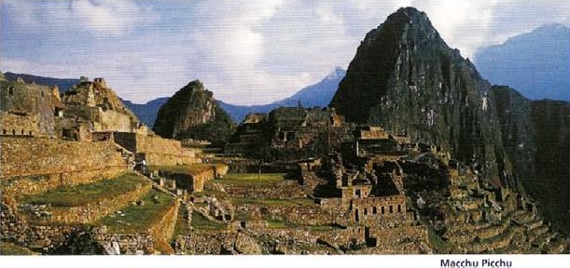.14)he-Ce. 'das Edouard he. $a$ektf qtaS$.

1. Where / Columbus / try to go when he reached

America?



1. Where / Isaac Newton/ sit according to the story about gravity?



1. What / DT Harry Coover ['hope to invent?



1. What Galileo / look at / through his telescope?



2B Complete the sentence with the past continuous form of the verb in brackets. The sentences refer to Exercise 1 .

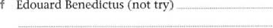

(not

to invent safety glass.

g Alexander Fleming (not hope) 0

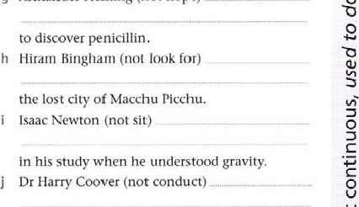

an experiment to discover a kind of glue.

O

3 Complete the Sentence With the past simple or past continuous form Of the verb in brackets.

### Alexander the Great

a While he (grow up) . the philosopher Aristotle was his teacher Alexander (become) ; interested in science, medicine, philosophy and literature, b While his father Philip (attend) his daughters wedding, a young nobleman (murder) him. Alexander was king of Macedonia at the age of 20.

While he (fight) his enemies in the north, the Greeks in the south (start) a rebellion. He (destroy) all their cities.

He (lead) his army against the Persian Empire through what is now Turkey. While he

(stay) in the ancient city of Gordium, he (undo) the Gordian knot. A legend said that only a future king of Asia could do this.

e While his army (march) through Persia, it (defeat) Darius, the king of Persia He (found) the city of Alexandria al the mouth of the Nile while he (visit) Egypt.

1. While he (travel) with his army, he (give) his name to many other towns.
2. He (kill) his friend Clitus in a quarrel, while they (have) . dinner

While he (attack) . the city of Mali in India, he (receive) a serious wound from an arrow. While he Catlend) a banquet in

Babylon in 323 BC. he (fall) ill and (die)

1. Complete the sentence with used to + a verb from the list.

spend work hold help act teach set tell do

 Charles Dickens, the novelist, 40 until early in the morning, and then go for long walks across London.

b William Shakespeare in some of his own plays.

C The German philosopher Immanuel kant exactly the same things at the same time every day, so that people their watches by his actions.

* 1. The author Agatha Christie her second husband with his archaeological excavations.
  2. The novelist James Joyce English in the Italian city Of Trieste, and some people say that he his students the wrong meanings of words as a joke.  The novelist Marcel Proust in a special soundproof room.
  3. The ancient Greek philosophers their classes outside in the open air.
  4. The Russian novelist Vladimir Nabokov his free time studying and catching moths and butterflies.

1. Complete the sentence with used to + the verb in brackets in positive, negative or question form.
   1. What things (be) _ different in the past?
   2. For a Start, all the Continents (form) — One large land mass.
   3. Obviously, there (be) Cities and buildings, and forest covered a third Of the Earth.
   4. The climate was different, and animals such as the hippopotamus and rhinoceros (exist) _ in northern Europe.
   5. Many mountains in Europe (be) active volcanoes.
   6. FMly people (live)in complex societies, but in small groups in places where they could find food.
   7. What (eat) ? They (eat)whatever they could find.
   8. Early people (stay) in the same place, but (travel) long distances, following the animals they needed for food,
2. Complete the text with the past simple or past continuous form of the verbs in brackets.

The Vikings in America

According to Viking records, around the year 1,000, while some Viking sailors a (100k for) the coast of Greenland, the,' b (reach) the eastern coast of America. While they c (live) L there. they d (try) . to trade with the local Native Americans. known by the Vikings as Skraelmgs, but in the end the Native Americans e (fight) them and (drive) them Out. After several attempts to return, the Vikings g (give up) In 1968, while Some archaeologists h (work) in Newfoundland, they i (discover) the remains Of one Of the Viking settlements, and j (prove) that this stoty was true.

#### Charles-Marie de la Condamine

In 1735 Charles-Marie de la Condamine k (sail) to South America, At that time , scientists I (argue) about the shape of the Earth. French Academy m (want) him to take measurements on the Equator, along with two other scientists. The work n (take) . them eight years and in the end, another scientific team o (find) the answer they p (look for) While de la Condamine q (travel) home along the River Amazon, he r (learn) many Interesting things about the local people and their way Of life. When he s (arrive) in Paris in 1745,

The River he t (receive) a hero& welcome.

|  |
| --- |
| EXTENSION ACTIVITY |
| Make a list of ten things you used to do, but don't do any more, and say what you do now. |

o

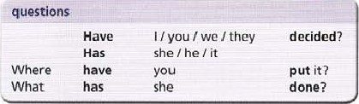

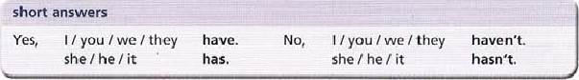

Regular verbs use -ed form as the past participle. Irregular verbs have irregular forms.

|  |  |  |
| --- | --- | --- |
| verb | past simple | past participle |
| wait (regular) | wa ited | waited |
| see (irregular) |  | seen |

See the List of irregular verbs on page 206.

USE

use present perfect simple

* 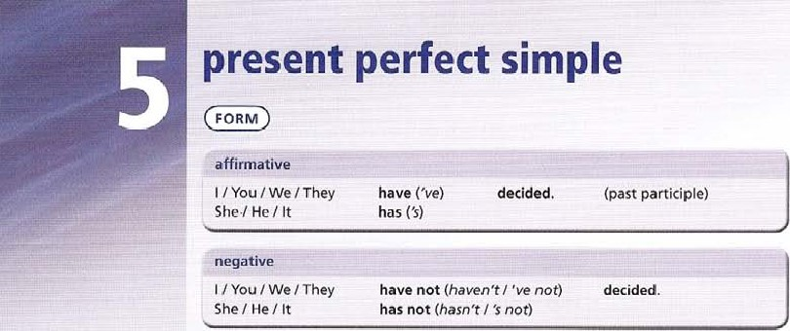to describe an event in the past without a definite time. Someone has broken a window in our classroom.
* to describe what someone has completed or achieved in a period of time. I've finished my homework, and I've cleaned my room.
* to describe how many things someone has done.

Scientists have found more than 30 unknown insects.

* to describe someone's experiences. what he or she has done in life. I've travelled by plane. but I haven't flown in helicopter.
* to describe changes, comparing past and present. Our climate has become much warmer.

|  |
| --- |
| action verb happening in a period Of time up to the present, exact time not known  PRESENT  Someone has broken a window |

We often use time words and phrases with present perfect simple to make the meaning clear. just, recently Someone has just broken a window.

Scientists have recently found more than 30 unknown insects. ever?. never Have you ever flown in a helicopter? by plane. already (sooner than expected) I've already finished my homework. It was easy! yet? (we expect something to happen soon) Have you finished yet?

not ... yet (for thi ngs which have not happened so far) Peter hasn't phoned yet. I'm still waiting.

for and since

We use for with a length of time.

She's worked here for ten years.

We use since with a point of time to describe when the period of time began. Theyve lived here since 2007.

been and gone

A number of astronauts have been to the Moon. (and have returned)

The space probe Voyager has gone past the planet Neptune. (it hasn't returned )

1. Complete the sentence using a verb from the list in present perfect simple form.



collect install organize paint plant

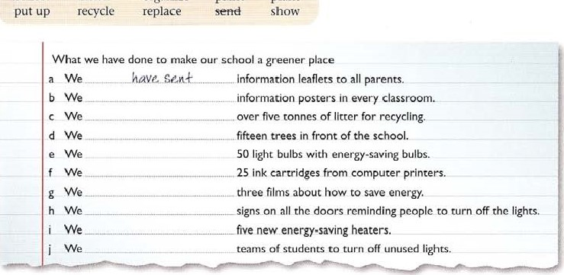

1. Read these sentences about fish. Then put the verb in brackets into present perfect simple form.

a About I Of protein eaten by humans

(always come) from fish. b Recently, however, the number Of fish (fall)

1. Several things (cause) problem.
2. Most scientists agree that governments (not do) enough to Stop

overfishing.

1. This means that fish populations (grow) smaller.

 Many fish (not reproduce) fast en ough to replace their numbers.

1. The population Of North Sea cod, for example,

(reach) a dangerous level.

1. EU laws (reduce)the numbers of fishing boats.

 As a result, many fishermen in traditional fishing ports (lose) their jobs.  In recent years, fish in the UK (become) expensive, and many eating i t.



people

(stop)

1. Use the prompts to make a question.
   1. you / ever / see a humming bird? It's the world smallest bird.
   2. you / ever / read War and Peace?

It's one of the longest 19th-century novels.

C you / ever / visit San Marino?

It'S Europe'S second smallest Country.

* 1. you / ever / swim in the Pacific Ocean? It's the largest ocean in the world.
  2. you / ever / take a trip to the Sahara Desert? It's One of the hottest places in the world.

Have,JJou Sr-eon a hunuuinq bird?







1. Complete each sentence with one of the time words in the list. You will need to use some words more than once.

since

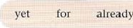

already

In the laboratory .. ..

* 1. 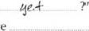'Haven't you left b 'NO. I've been here 8.00 this morning.' c 'Have you checked the results of the experiment d 'Yes, I've done that.' e 'We've worked on this project  three weeks. Unfortunately we haven't discovered anything interesting

 'NO, nothing has happenedlast •IUesday.' g 'Yes, I know. I've seen your report.' h 'so I'm going to do the experiment again. But I haven't started it

 'Don't bother. I'vestarted it. I haven't checked , but I think we're going to get the same results.'

1. Complete the sentence with have been or have gone.
   1. IWo scientists from a laboratory in Oxford a .kave qone to Antarctica, and will stay there for three months. They b there to investigate the effects of global warming on the polar ice. Colleagues in Oxford, who c to Antarctica on earlier expeditions, will keep in touch with them by radio.
   2. A team from London has arrived in China. They d there to join a project which is searching for the fossil remains Of dinosaur eggs. 'We e (not) to China before,' said team leader Mark Jones, 'though two Of us f _ _ _ „ to the USA where there is a similar project.' c A dangerous spider is missing from a private zoo in Manchester. 'Ilerbie is a Brazilian wandering spider, and we're not sure where he g said spokesperson Anne Graham. 'He only arrived in the zoo last month, so he h (not) here long. A lot of children i to the zoo in the past few days, and we are worried that someone has taken Herbie, or that he j out in somebody's pocket, and they don't know about it.'

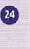

1. Use the prompts to make a present perfect simple question about scientific advances. Then answer yes or no. Check the factual answers on page 208.
   1. scientists / discover a cure for the common cold?

Have. $cie,n+i$+$ discovered b people / live for long periods in space?

* 1. human beings / land on Mars yet?
  2. Scientists / invent time travel yet?
  3. doctors / manage to transplant human hearts?
  4. archaeologists / find the lost City Of Atlantis?



* 1. scientists / ever teach an animal to talk?

|  |  |  |  |
| --- | --- | --- | --- |
| |  | | --- | | FLi-. | |  |  |

|  |
| --- |
| 7 Read the text about climate change. Choose the correct form, A or B, to complete the sentence.  At the moment, scientists agree that the world's climate a V  ',varmer over the past 50 years, but they disagree about the causes. Some believe that human activities b . climate change.They argue that for 1,000 or 2,000 years before 1850, when records c , the temperature was more or less stable. Short warm or cold periods d during that time, but the climate always to the same level. However, since the Industrial Revolution. human beings f more and more fossil fuels, such as coal and Oil. In 1800 the atmosphere g around 280 parts per million of carbon dioxide (C02). Since then there h, an increase of about 3 KThis extra carbon dioxide i _ the temperature because Of the greenhouse effect.  Other scientists disagree that human activities over the past 50 years global warming.They point out that volcanoes and other natural proccsscs C02 into the atmosphcrc, and that human activity . a rise in C02 Of only three per cent.  In 1999, 156 countries m the Kyoto protocol. part of a  United Nations agreement on climate change, which n into force in 200S.They to reduce their emissions of C02 and other greenhouse gases, although so far, some countries, such as the USA and Australia. p any action. |

a A became b A caused C A began d A occurred e A returned f A burned g A contained h A was i A raised A caused k A always released

|  |
| --- |
| EXTENSION ACTIVITY |
| Make a list of ten things you have done, or have never done in your life so far. Need more practice? Go to the Review on page 192, |

I A contributed m A signed n A came o A agreed p A did not toke

B has become B have caused

B have begun

B have occurred

B has returned 8 have burned

B has contained

B has been

B has raised B have caused B hove always released

B hos contributed

B have signed B has come

B have agreed 8 have not taken

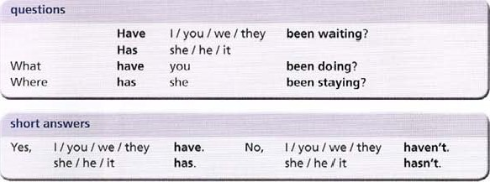

USE

use present perfect continuous

* to talk about recent continuing activities.

What have you been doing lately?

I've been revising for my exams

* to explain how recent continuing activities have caused the present situation. My eyes ache. I've been reading all day.
* to talk about recent continuing activities which will probably continue in the future.

This diagram shows how the climate has been changing.

* with how long questions.

How long have you been studying French?

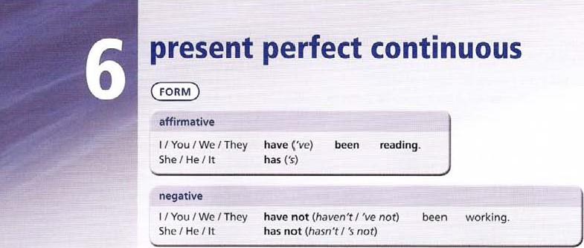(this is a continuing process, and isn't finished)  with time words lately, recently. all (day), every (morning), for. since.

|  |
| --- |
| covering a period of time up to the present  PAST  PRESENT I've been studying all morning.  (It'S Still morning now and I haven't finished my work yet) |

present perfect simple or present perfect continuous?

Present perfect simple I've written my project. (finished, but we don't know when)

Present perfect continuous I've been writing my project. (continuing up to the present, and not finished)

With verbs that describe continuing states eg work, live, there is little difference in meaning. I've worked here for three years / I've been working here for three years.

Note that we do not say

I Complete the sentence using the verb in brackets in the present perfect continuous form.

1. I'm sorry to keep you waiting. I hope you (not wait) _ have-NS* long.
2. •mere you are! We (look for) you all morning!
3. I feel really tired. I (study) hard lately.
4. Anna has got a really good suntan. She (go) to the beach a lot.

2 the correct form.

* 1. Scientists a have been identifying a new species of animal in the rainforest Of Borneo.They b have been searching I searched for this creature for several years, after reports from local villagers, and say it is a type of lemur.
  2. Archaeologists in Guatemala c have found / have been finding a Mayan wall painting which they think is more than 2,000 years old. Archaeologist William Saturno d explored I has been exploring the site since 2002.

3 use the prompts and how long to make a question.

a astronomers / look for Pluto's moons?

1. Tom needs cheering up. He (have) n a lot of problems lately.
2. I haven't seen you for ages. What (you / do)
3. I (work)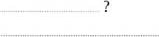here tor the past three years, and I really like it.
4. Sam and Chris (paint) their room, and their clothes are covered in paint!
5. Scientists using the Hubble Space Telescope think they e found / have found two new moons circling the planet Pluto.Ascronomers f have been looking looked closely at Pluto since 1978 when they gspotted I have spotted its first moon. The telescope h worked / hos been working for fifteen years. and i has been producing / has produced more than 700,000 images of the universe.
6. Australian scientists j have been discovering / have discovered a new coral reef over 60 km long in the Gulf of Carpentaria by using satellites to spot the reefs in deep water. Recently divers lc have managed I have been managing to reach the reefs and take photographs.

e scientists / observe Vesuvius?

1. 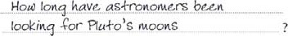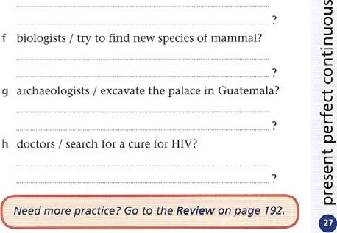archaeologists / hope to find Atlantis?
2. scientists / use satellites to discover new reefs?
3. physicists / investigate the origin Of the universe?

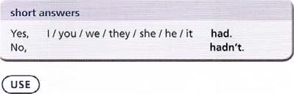

use past perfect simple to describe a past event which happens before another event in the past. Only use it when it is important to make clear that one event in the past happened before another. On 12 July 1771. Cooks ship The Endeavour arrived back in Britain. Cook had not discovered a new continent, but he had visited places ne.•er seen before. In this example, •not discovered' happened before •arrived'.

past perfect event past simple event

-PRESENT

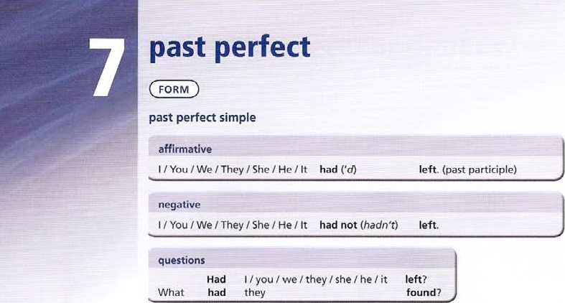(a) Cook had not discovered (b) the ship arrived back in Britain

We do not use past perfect simple simply to show that an event happened a very long time ago. We can sometimes use before or after with past simple to make the order of events clear,

By the time the ship reached the island, more then twenty sailors had died.

More than twenty sailors died before the ship reached the island forgot, remembered, realized

With forgot, remembered, realized, knew, we use past perfect simple to describe the past events that happened before the moment we forgot, remembered or realised something, When Franklin checked the ship's position, he realized he had made a mistake.



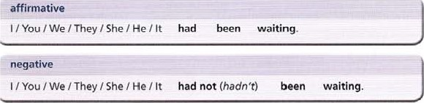

past

perfect

continuous

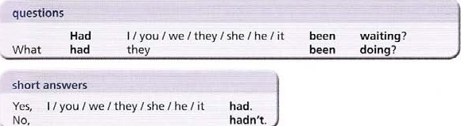

USE

use past perfect continuous  in a past tense narrative, to describe a continuing action in a period of time before something else happened.

Anna returned from France, where she had been studying French.

 to explain a past situation, by describing the events happening before.

Both boys were wet and muddy. They had been playing football in the rain.

|  |  |  |
| --- | --- | --- |
| PAST | past perfect continuous past simple event  (a) she had been studying French... (b) Anna returned from France | PRESENT |

See also Unit 16, Indirect (Reported) Statements.

1. Read the following information about famous moments in history. Then the correct form. Only one verb in each paragraph is past perfect.

|  |  |
| --- | --- |
| 1. Columbus left Spain in August 1492 with three ships, to try and find a way to India by sailing west instead Of east. When his ships a   / had finally reached land on 12 October, he thought he Was there, but the ships b actually arrived / had actually amived in America instead.   1. Captain Robert Scott wanted to reach the South pole first. He and his companions finally arrived there on 1 January 1912 after a terrible journey across the ice, but c tound / had [bund a Norwegian flag. Unfortunately for Scott, Roald Amundsen d | C Leonardo painted his famous The Last Supper between 1495 and 1498, but the painting started to deteriorate within SO years. The most common explanation for this used to be that Leonardo e used / had used the wrong kind of paint, but experts have always disagreed about this, and many believe that the damp in the wall is the cause of the damage. Between 1978 and 1999, experts f restored / had restored the painting, and the public can now see it again. |

got / had got there on 14 December, 18 days earlier.

1. Complete the sentence with the past simple or past perfect simple form of the verb in brackets.
   1. When I (try) _ &rie.d to use my laptop, I realized the battery (run) down.
   2. I (turn) the computer Off, but forgot that I (not save) my work.  I only remembered I (not pay)the bill when my Internet connection (stop) _ working.

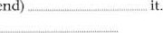d When I (receive)the e-mail, I couldn't understand who (send) „ e When I (check)the instructions, I understood what I (do)

 I knew I (receive)a virus when I (run) the anti-virus program. g As soon as I (download)the document, I knew I (make) a mistake. h I could see what (go)_ wrong as soon as I (look) inside the printer.

I knew I the wrong key when nothing (happen)

 When the screen (go) _blank, I couldn't understand how it (happen)

1. Read these sentences about Julius Caesar. Then complete the sentence with the past simple or past perfect form of the verb in brackets.
2. Choose the correct form, A, B or C, to complete the sentence.

 On 26 December 2004,Tilly Smith, a I O-year-old British schoolgirl, a C _ on the beach with her family.They

|  |  |  |
| --- | --- | --- |
| a Julius Caesar (come) _ from an |  | Between 58 BC and 49 BC he (fight) |
| aristocratic Roman family, though his family |  | a war against the people Of what are now France, |
| was not rich by Roman standards. |  | Belgium, Switzerland and parts of Germany. |
| b When he was 15 his father (die) | g | By the end of this war, according to the historian |
| , and to avoid political problems |  | Plutarch, three million men (die) |
| in Rome, Caesar (serve) | h | In SO BC the Senate (order)  Caesar |
| soldier in the east. |  | to return to Rome. By that time, Crassus was dead |
| c By the time he (return)to Rome, |  | and Pompey (become)Caesar's |
| he (win) awards for bravery. |  | enemy. |
| d He (become) a member of the |  | In the civil war that followed, Caesar (defeat) |
| Senate, and governor Of what is now Spain. |  | all his enemies. |
| e By the age of 40 he (rise) to the |  | By the time a group of Roman senators (murder) |
| top 01 [he political world, and (form) |  | him in 44 BC, he (be) |
| a political alliance with a powerful general, Pompey, and a rich man,  Crassus. |  | the most powerful man in Rome for only a year. |

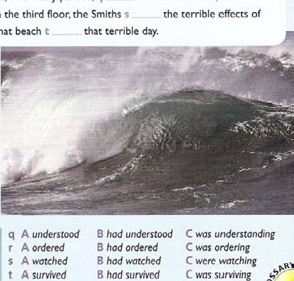Christmas in Thailand. Suddenly Tilly c that something was wrong. She could see that the water d and waves e up the beach.The beach smaller and smaller. She g that there had been an  earthquake in Sumatra that morning, but she h a geography lesson she at school just two weeks before. So she j her mother what she k about earthquakes and giant waves. Luckily for the Smith family,Tilly's teacher Andrew Kearney the class about earthquakes and m „ chem a video of a tsunami in Hawaii. Tilly screaming at her parents to get off the beach. They Tilly back to their hotel, which was not too close to the shore, and pthe alarm. One of the staff, who was Japanese, q the word tsunami. and everyone to leave the beach. From their room on the third floor, the Smiths s the tsunami on the area.Thanks to Tilly. everybody from that beach

a A walked B hod walked C was walking b A spent B hod spent C were spending

 A felt B had felt C was feeling B had risen C was rising e A come B had come C were coming f A got B had got C was getting g A did not know B had not known C was not knowing h A suddenly B had remembered C was suddenly remembered suddenly ring

1 A had B had had C was having

A told B had told C was telling k A learnt B had learnt C was learning

 A taught B had taught C was teaching m A showed B hod shown C was showing n A started B had started C was starting o A took B had taken C were taking p A raised B had raised C were raising

1. Read the story Of Archimedes and his bath. Then complete the text with the correct form of the verb in brackets.

Archimedes, the Greek mathematician, is probably most famous for the Story Of King Hieron Il of Syracuse and the gold crown. The king a (want), _ to give a gold crown as a gift to the gods, and b (give) a carefully weighed amount of gold Lo a goldsmith. The man c (produce) _ a beautiful crown, but [he king was worried that the craftsman d (not all the gold to make the crown. Dishonest craftsmen often e (mix) gold with silver. which was cheaper, but the king could not find a way Of proving thal the man f (do) _ this. He x (ask) Archimedes to solve the problem. Archimedes h (know) that gold and silver have different densities. The problem was that nobody could calculate the mass of an object like a crown. While i (think) about this problem, he decided to go to the public baths to relax. While he j (climb) into the bath, he k (notice) some water on the floor. It I (spill) over the side Of the bath, and he m (realize) „ _ that he n (solve) . the problem by accident. The total amount Of water that o (spill) out of the bath must be the same as the volume of his body. He could use a piece or pure gold and calculate its volume, and then test the crown and See if it was the same. According to the story. he p (jump) straight out of the bath and q (run) down the street calling 'Eureka — I've found it.' The goldsmith soon r (admit) — that he s (cheat) the king, and was punished. Archimedes t (discover). a pnncuple of buoyancy.

1. Read the sentences about two mountain climbers. Then complete the sentence with the past perfect simple or past perfect continuous form of the verb in brackets,

a The two climbers stopped to rest. They (climb) ._had for hours and were exhausted. Things were not looking good. b They were very cold, because it (snow) heavily since midmorning, and one Of them (hurt) his ankle.

for shelter for the past two hours, because they realized that the weather was going to get worse.



C

They

(100k)

1. They (already phone) the rescue centre for help.

|  |
| --- |
|  |
| Read the sentences from Exercise 6 again. Make sure you have checked the answers to this exercise. Translate the story into your language.  Need more practice? Go to the Review on page 192. |

1. They (also leave)— details of their planned route at the village where they Stayed the night.

 They were experienced climbers and they (prepare) carefully for their trip. They knew there was a cave halfway up the mountain.

g They spent a long time searching for the cave before they realized that they (head) in the wrong direction. Then the snow stopped, and they could see the dark entrance of the cave nearby. h Luckily they (bring) warm clothes and plenty of food with them, and they waited safely in the cave.

### tense contrasts

past simple; decided past continuous: was looking past perfect simple; had happened past perfect continuous: had been working I-Ise past simple, past continuous and past perfect for events in a narrative (story).

* Past simple to describe actions or states in the past.

That afternoon he decided to check the old experiments.

* Past continuous to describe continuing actions, or to set the scene. While he was looking at them .
* Use past perfect when we need to make clear that one past action happened before another past action.

. he noticed that something unusual had happened.

. while he had been working on the new experiments.

past simple: What did you do? past continuous: What were you doing?

We were in a maths lesson. Water started dripping from the ceiling. We changed

What were you doing? (when something happened) Wp were writinga test.

What did you do? (an action) We changed rooms,

present perfect simple and continuous; has won, has been winning past perfect simple and continuous: had won, had been playing

* Present perfect events are connected to the present in some way. Past perfect events are past event that take place before other past events.

She has just won the Grand Slam She has been playing tennis for only six years

(She plays now — she started six years ago.)

When Anna won the Grand Slam in 200 j. she had been playing tennis for only six years.

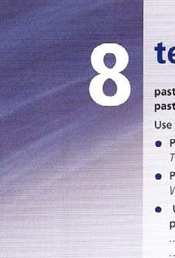(All the events are in the past she won in 2001, she started playing six years before that.) past simple: discovered present perfect: have discovered

* Use past simple for finished events in the past. We can use a definite date or time. Clyde Tombaugh discovered the planet Pluto in 1930.
* Use present perfect for recent events without a definite time.

Astronomers have discovered a new planet recently. They have named it Sedna,

* We can use since + point in time with present perfect but not with past simple, I've been here since 8.30! (I'm still here.)
* We can usefor period Of time with present perfect for unfinished time, or past simple for finished time.

I've been in the team for two years. (I'm still in the team.) was in the team for two years. (Finished — I'm not in the team now.)

present perfect simple: have taken present perfect continuous: have been taking

* Use present perfect simple when an action has recently finished. use present perfect continuous to describe a continuing action up to the present moment. Have you taken your medicine? (just now or very recently)

Have you been taking your medicine? (over a long period up to now)

* Present perfect continuous can suggest that the action might continue into the future.

I've done a lot of work lately. (but now I've finished)

I've been doing a lot of work lately. (and it is still going on)

present perfect simple and continuous: have lived, have been living present simple and continuous: live, am living

* use present perfect to describe a period of time that continues up to the present, and includes the present.

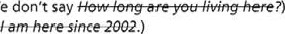How long have you been living here? (We don't say

I've been here since 2002. (We don't say

present Simple, present continuous: have, am having

* Use present simple for facts, things that always happen, habits and State meanings. Rabbits live in holes in the ground. / travel to work by bus. j enjoy Italian food. I have three sisters.
* use present continuous for events that are happening at the moment, or are changing, and for action meanings.

It's raining, Things are getting better. really enjoying this party. I'm having a great time.

|  |  |
| --- | --- |
| e We'd been watching the film for half an hour before we realized that we were making / had made a terrible mistake. We went / had gone into the wrong cinema! | After the two film stars landed / were landing at the small airport, they left quickly in a van that was waiting / had been waiting for them since the early morning. |

I Underline the correct form.

|  |  |  |
| --- | --- | --- |
| a When the police / were stopping Smith 's | g | I'm sorry I didn't answer / wasn't answering the |
| car for a routine check, they realized that he was |  | phone earlier, but I was painting / had been |
| the man who robbed / had robbed the bank. |  | painting the ceiling in my bedroom, |
| b I woke up in the middle of the night and | h | The office Marlowe was visiting was on the 15th |
| turned on / was turning on the light. Someone or |  | floor, and unfortunately the lift wasn't working |
| something climbed / was climbing in my window! |  | / hadn't been working, so by the time he arrived |
| c Unfortunately Jan arrived / was arriving at the |  | at the top Of the stairs, he was / had been out of |
| station at 3.25, and found that she missed / had |  | breath. |
| missed the train. |  | On Christmas morning when they woke up / were |
| d The doctors tried / had been trying their best, but |  | waking up, the children looked eagerly out of the |
| while they were performing the operation, the |  | window. It snowed / had been snowing, and the |
| patient died / was dying. |  | garden was covered in a thick white carpet. |

f On the morning of the accident, Mr Davis just finished / had just finished a night shift at a local factory, and didn 't have / hadn't had any sleep for

24 hours.

1. Complete the sentence with the past simple or present perfect form of the verb in brackets.

|  |  |  |  |  |  |  |  |  |  |  |  |  |  |  |  |  |  |  |  |  |  |  |  |  |  |  |  |  |  |  |  |  |  |  |  |  |  |  |  |  |  |
| --- | --- | --- | --- | --- | --- | --- | --- | --- | --- | --- | --- | --- | --- | --- | --- | --- | --- | --- | --- | --- | --- | --- | --- | --- | --- | --- | --- | --- | --- | --- | --- | --- | --- | --- | --- | --- | --- | --- | --- | --- | --- |
| |  |  |  |  | | --- | --- | --- | --- | | a I (leave) my bag on the | f | When (you go)                 to the | | | train this morning. |  | cinema last? |  | | b Helen (complete) the | g | Sam (not take) | a day off | | test half an hour before the end. |  | since last April. |  | | c The match can't begin yet because the other | h | (you see) | my wallet? I'm | | team (not arrive) |  | sure I left it here on the desk. |  | | d We (not play) _ chess for |  | When (you realize) | that you | | ages. Do you feel like a game? |  | wanted to be a musician? |  | | e I (like) their last album, |  | I (have) | an idea! Why don't | | but I'm not keen on the new one. |  | we go skating tomorrow? |  | |  |

1. Complete the text with the past simple, past continuous or past perfect simple form Of the verbs in brackets.

Mozart was born in 1756, the son of a professional musician. His father soon a (give up) composing when he recognized his son's musical talent. By the age of three. the young Mozart b (learn) to play several pieces of music. While he and his father c (travel) round Europe, Mozart met many famous musicians and composers. Before he was 1 7, he d (compose) several operas.WhiJe he e (visit) the Vatican in Rome. he f (listen) to a piece of music which, up to this point. the Vatican authorities g (keep) secret. No one h (publish) a copy of the piece before, but Mozart i (manage) to write it down from memory after he j (listen) to it once, By the age of 30 he k (become) one Of the most famous composers in Europe, and I (have) a large apartment in Vienna, which is now a tourist attraction. It was here that he m (write) his famous opera The Marriage In , While he n (work) on his Requiem, he o (fall) ill and died at the age of 35.

1. Choose the correct form, A, B, C or D, to complete the sentence.
   1. I — . this computer for more than ten years, so I'm thinking of getting a new one.
   2. You're hall an hour late! I here for ages!

these black trousers better than those blue ones. d Can I borrow a pen? I A mine.

* 1. I'd like to dance with you, but I for my friend.
  2. Kate in Poland since last October. She's really enjoying it. g Carol's great, isn't she? her long?

h Paulin all day today, so now he feels like going out. You'd better borrow this umbrella. m really hard.

|  |  |  |  |  |  |  |  |  |  |  |  |  |  |  |  |  |  |  |  |  |  |  |  |  |  |  |  |  |  |  |  |  |  |  |  |  |  |  |  |  |  |  |  |  |  |
| --- | --- | --- | --- | --- | --- | --- | --- | --- | --- | --- | --- | --- | --- | --- | --- | --- | --- | --- | --- | --- | --- | --- | --- | --- | --- | --- | --- | --- | --- | --- | --- | --- | --- | --- | --- | --- | --- | --- | --- | --- | --- | --- | --- | --- | --- |
|  | |  |  |  |  | | --- | --- | --- | --- | | on my project all morning, and I need a break. | | |  | | a A have had | B have been having | C have | D ant having | | b A have waited | B have been waiting | C wait | D am waiting | | c A have liked | B have been liking | C like | D am liking | | A have lost | B have been losing | C lose | D ant losing | | e A have waited | B have been waitiug | C wait | D am waiting | | has taught | B has been teaching | C teaches | D is teaching | | g A Have you known | B Have you been knowing | C DO you know | D Are you knowing | | h A has stayed | B has been staying | C stays | D is staying | | A It has rained | B It has been raining | C It rains | D It is raining | | A have worked | B have been working | C work | D am working | |

1. Underline the correct form.
   1. How a do you get on / are on in Paris?

Sorry b I haven't written / I'm not wNting before but c I Dain / I've been training hard for my basketball team. We d played / have played in a tournament last week — we e come 1' came third! I really f enjoy / enjoyed taking part, but g I haven't done / wasn't doing anything else for the past month.

|  |
| --- |
|  |
| Look through the unit again and find two examples for each of these tenses: present simple, present continuous, past simple, past continuous, present perfect simple, present perfect continuous, past perfect simple, past perfect continuous.  2 Look at the explanation page again. Choose an example sentence from each section. Translate it into your language.  Need more practice? Go to the Review On page 792. |

* 1. 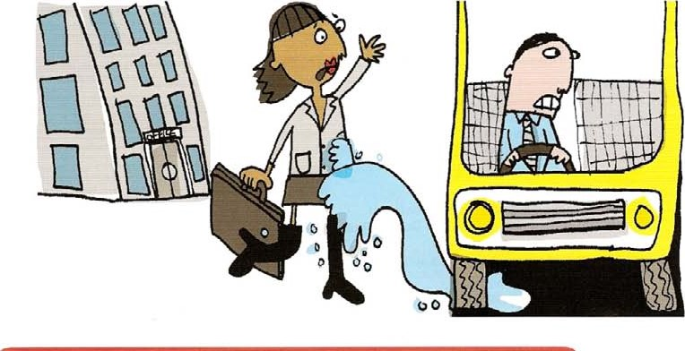Unfortunately, when Sarah's big day h arrived / was arriving, things i have gone / went disastrously wrong at first. For a start, it j was raining / has been raining and as the traffic was so heavy, she k arrived / was arriving nearly ten minutes late for her interview. Then while she I was crossing / has crossed the road, a passing bus m splashed / was splashing her with water. But inside the building her luck n changed / has changed. 'Mr Fortescue o is expecting / has expected me,' she p Was telling / told the

receptionist.

'He q hasn't arrived l' doesn't arrive yet,' she was told. 'Just take a seat.' Perhaps everything would be all right after all!

* 1. An art historian r has discovered / is discovering two missing paintings by Fra Angelico (c 1395— 1455) in the home of a pensioner from Oxford who s has died / died earlier this year. Jean Preston t bought / has bought the paintings when she u was working / has been working in America in the 1960s. Shortly before her death, a friend v recognizæd / has recognized them as part of a group of six small paintings which Angelico w painted / has painted in 1439. Miss Preston x paid / was paying about €200 for the pair, but experts y say / said they are now worth around El million.
     + to say what we expect to happen in the future.

It will take 50 years for temperatures to return to normal.

* + - with definitely. probably. possiblyto show how certain or uncertain we are.

definitely certåinl& less certain probably uncertain possibly

It will probably take 50 years for the climate to stabilize. The climate will definitely change before then.

* + - to make a social arrangement.

I'll see you tomorrow

* + - to make a promise, warning or threat.

I'll give you my homework on Monday (promise)

Careful/ You'll fall. (warning)

I'll deal with you later/ (threat)

* + - to make an offer.

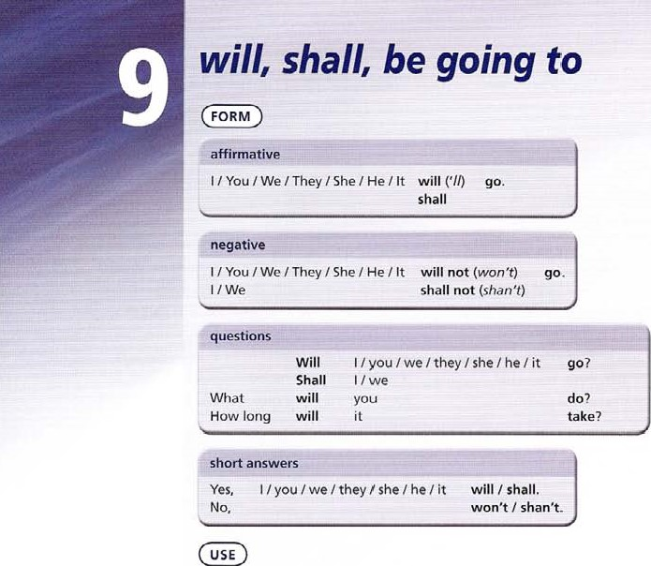

Use

will

I'll carry the projector for you. / Shall I carry it for you?

* + - in a formal rule.

Students will wear protective clothing at al/ times.

* + - to make a decision in a situation.

Which pullover do you want? I'll have this one, I think

Use won't

* + - to mean 'refuse'.

Jack won •t give me back my ruler/

See unit 24 for other uses of will.

Use shall

* + - in formal speech or writing with I we.
    - to make Offers — see unit 26. 

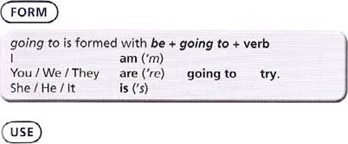

use going to

* + - to talk about a personal plan or intention.

We're going to try and recycle more of our household rubbish.

* + - to make a prediction about the future, especially when this has already started to happen. Most people can see that the Internet is going to be just as much a part of the future for us al/ as the telephone or electricity is today.

Something Strange is happening to the computer screen. The program is going to crash/

* + - to make a decision with a result in the distant future, not 'instant', as With Will.

I've decided about my future. I'm going to study law at university,

1. Read these famous failed predictions. Then complete the sentence using will + the verb in brackets.
   1. We are in September 1914: according to most newspapers in Britain and Germany, the war over by Christmas. They cannot imagine that the war (continue) until 1918, and (claim) the lives ot about 9 million in the military and a further 7 million civilians.

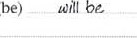

(be)

* 1. We are in 1919: according to geologist Albert Porta, the conjunction of six planets (cause) the Sun to explode. In fact, the Sun (probably destroy) the Earth onc day, when it becomes a red giant in about 4.5 billion years.
  2. We are in 1977; according to Ken Olson, head Of a computer company, people (never want) a computer in the home. Latest predictions (2005) suggest that computer ownership (reach)  1.3 billion machines worldwide by 2010.
  3. We are in 1999: according to many scientists, computers (crash)and (cause) chaos on the first day of the new millennium.
  4. And one to 100k forward to: according to the Aztec calendar, the world (come) to an end on 22 December 2012. We (have to)wait and see.

1. Complete the sentence with will a verb from the list.

carry cost take place provide sell use hokl

0 Most people know that London hotd _ the 2012 sutnrner Olympic Games.

b Most of the Games in three areas of London: in the Olympic Park in East London; along the River Thames; and in Central London.

 The Olympic Village, in the same area, accommodation for Over 17,000 athletes. d A new railway link spectators to the Olympic Park.

e The organizers - 8 million tickets for the Olympic Games, and a further 1.6 million for the Paralympics.

of the tickets less than €70.

g For some events the Games well-known places in Central London such as Hyde Park and Horse Guards Parade.

1. Match sentences a to j with their responses 1 to 10.

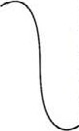a Why can't I play with the Bunsen burner? b We're really tired.

c Put away these books, please. d can't write on this blackboard. e Why is Maria annoying you?

f I don't understand this problem. g Please stop throwing things, George.

h Shall I move this desk?

I still haven't got your project!

Is that the end of the lesson?

1. Sorry, I won't do it again.
2. She won't stop taking my things
3. Yes, there's the bell, I'll see you tomorrow.
4. No, you'll hurt yourself. I'll do it.
5. I'll hand it in on Monday, I promise.
6. It's dangerous. You'll burn yourself.
7. Ok, I'll explain how to do it. 8 We'll have a short break in a few minutes.

g Shall I put them in the cupboard?

10 1'll clean it for you.

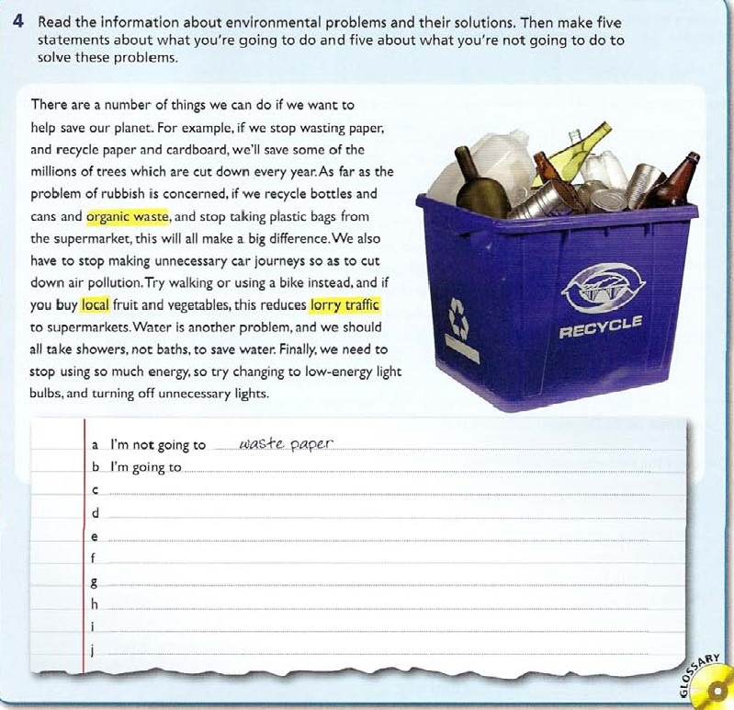

o

1. Say what you think will happen in each picture. Use a verb from the list.

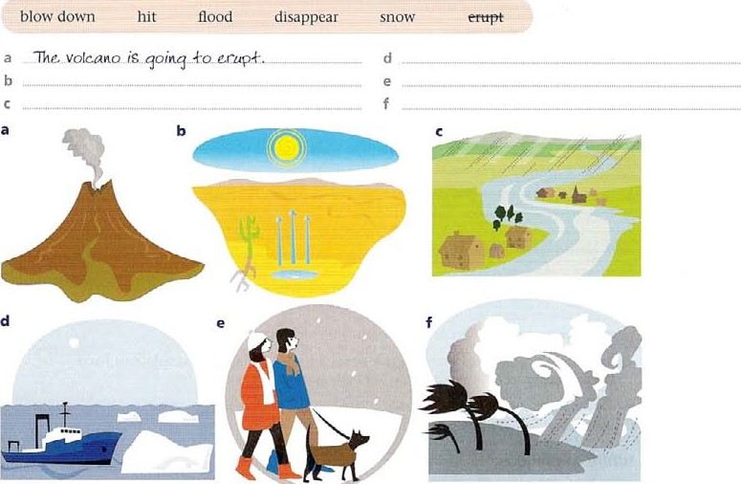

1. Use will, shall or going to + the verb in brackets
   1. Next year you have to choose between two lessons, either biology or a Second foreign language. Make your decision.

I've made up my mind. (do) qoinq ko do biotoq4.

* 1. You have to miss school to See the dentist, but you promise your teacher to be back at two o'clock. What do you say? (bey c You are doing an experiment in Science, and you can see that it isn't going well.

(work) d You are near the light switch and it's getting dark. Offer to turn the lights on. (turn)

e Your teacher asks you who you want to sit with. You decide to sit with Helen. (sit)



0

|  |  |
| --- | --- |
|  | EXTENSION ACTIVITY |
| 2 | Make ten predictions for the future about yourself, your friends, your country, the world etc.  What are your plans for the rest Of the day, and the rest Of the week? Write five sentences. |

f Your teacher asks you about your career plans, and you say you are planning to study engineering. (to)

### future time

present continuous future

• use for a fixed arrangement in the future eg an event already written in a diary.

I'm coming back next Thursday.

We're having a party next Friday. Would you like to come? Note that there is usually a time reference. What are you doing next week?

present simple use for an event that always happens at a certain time, or is part of a timetable, The conference begins on Tuesday at 10.00.

will, going to or present continuous?

When we make predictions will and going to are both possible. I th ink Helen is going to win. r' think Helen will win.

We use going to when we talk about plans.

We're going to go to France next year (a plan)

We use present conti nuous when we talk about an arrangement that is definitely fixed.

We're leaving for France on Monday. (we've bought the tickets)

When we see that an event has already started to happen, we use going to. Look at that ship! Its going to hit the rocks!

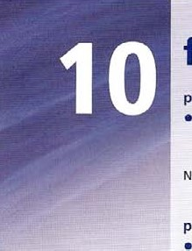future continuous will + be + -ing use future continuous

* to describe an activity in progress in the future, with a time reference.

This time next week be starting at my new school. What will you be doing in ten years' time?

future perfect

will + have + past participle

Use future perfect

* to look back from the future to an earlier event. often with by or by the time.

By the time we get home, the match will have begun

future time clauses following time words

A future time clause follows a time word or phrase.

after as assoon as before by the time until when

In sentences referring to the future, the verb following the time word or phrase is present simple, and the main verb is a will-future.

By the time we reach the station, it will be too late.

When we emphasize completion or achievement, we can use a present perfect simple verb instead Of a present simple verb.

We'll let you know when we have reached a decision.

o

1. Complete each sentence using a verb from the list in the present simple form. Then match each sentence a to j with a description 1 to 10 of where you might read or hear it.

leave open take off take place

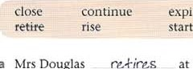

expire

* 1. Mrs Douglas at the end of this term, and we wish her all happiness for the future. 7 b There has been a change to the schedule and your flight nowat 18.40.
     + The exhibition until 31 December. Don't miss it!

d The match at three o'clock, so please be here by two. e The opening ceremony on 27 July.

* 1. Saturday 18 March. The sun at 6.08.
  2. The licence for this software one year from the agreement date. h This Offer on 30 September so buy now to avoid disappointment!  The 4.30 to York from Platform l. Cross the footbridge at the end of this platform.

Doorsat 18.00.

|  |  |  |
| --- | --- | --- |
| Cinema door | 5 Travel information desk | 8 Newspaper review |
| 2 Advertisement | 6 CD-Rom leaflet | g Notice on a sports club notice board |
| 3 Airport check-in desk | 7 | 10 Diary |

4 News announcement

1. Complete each sentence using a verb from the list in the present continuous form.

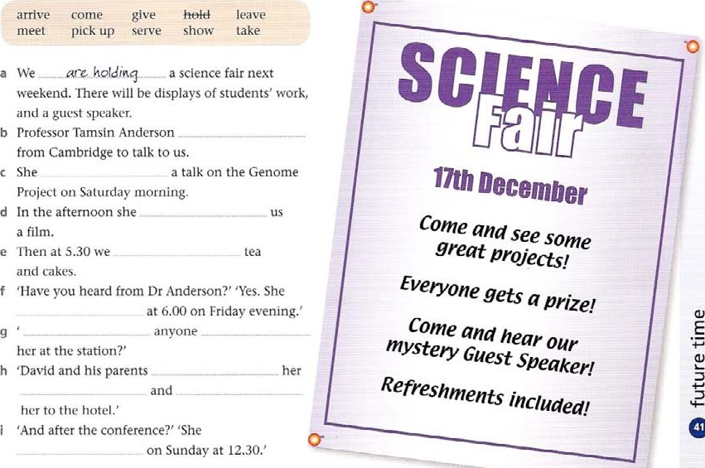

O

1. Underline the correct form.
   1. 'Be careful with that test tube. It will break / it breaks.' b 'The egg is cracking. The baby bird will come out / is going to come out / Comes out.'
      * 'Can you hurry up please. The film will start / is going to start / starts.' d 'Carry this very carefully.' 'Don't worry, I'm not dropping it / I won't drop it.' e 'We're playing / We'll play football this afternoon. DO you want to play too?' f 'This dictionary costs €50, but the red one is cheaper.'

'Ok, I'll take / ['m taking / I'm going to take the red one.' g 'Have you decided about next year yet?'

'Yes, I'm studying / I'm going to study / I'll study journalism. Well, that's the plan anyway.' h 'Ok, bye for now.'

'Bye, I'll see you / rm going to see you / I'm seeing you at the same time on Friday.'

1. Complete each sentence with a phrase from the list.

 I'll be waitingI'll be watching I'll be starting I'll be catching 

Vlhbelying I'll be living I'll be going I'll be working 

* 1. 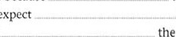Next Tuesday at this time „ .1?tt be 14inqon the beach! b outside the cinema at 7.30. See you then! c All tomorrow afternoonon my history project. d This time next weekmy holiday! e In three years' timeinto the army. f Don't phone at 9.00, because the match then. g In ten years' time, I expect in my own flat.

h This time tomorrow the plane to Brazil!

1. Complete each sentence using will have (done) or won't have (done) + the verb in brackets, according to your opinion.

|  |  |  |
| --- | --- | --- |
|  | In my opinion, by the end Of the 21st century:  av people (start)  Scientists (invent)  We (find)  Doctors (discover) Most people (move)  We (use) g The world (become) _  People (make) | living on other planets. artificial food, a solution to the problem Of poverty, a cure for cancer. Very large cities. all che fossil fuel on Earch,  . a peaceful place,  _theænvironmenccleaner. |



1. Complete the text with the present simple or will form of the verb in brackets.

#### The future of our solar system

The Sun a (continue) milt much as isuday until it b (enter) its •giant phase in 4 to 5 billionyears. Then, the core (grow) smaller ancl hotter until it finally d (finish) burning the fuel in its nuclear core. When this e (occur) the core f (become) . so dense that helium fusion will begin. When the helium atoms g (collide) , they h (form) carbon (from 3 helium atoms) and oxygen (from 4 helium atoms). When this process i (begin) the Sun j (produce) _ enormous amounts of energy. The Sun k (grow) larger as this energy I (increase) „ It m (be) over a hundred times Its present size by the time it n (stop) growing. This is why we use the term red giant, As the Sun o (expand) , it is probable that it p (absorb) the Earth. When the Sun q (use) , up all its energy, it r (become) .

a small white dwarf, and s (not make) any more energy. After a few billion years, when it IS completely cool, It t (be) Just a cold dark object.

7 Choose the correct form, A, B or C, to complete the sentence.

1. We seem to be comp letely lost. What A now?
2. 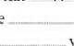Just think, this time next week wetaking a taxi to the airport.
3. As soon as we hear any news, weyou know.
4. The new film of Hamlet starring Johnny Deppnext week.
5. Some Scientists believe that theya cure for most types of cancer by 2050.

|  |
| --- |
| EXTENSION ACTIVITY |
| Look at the explanation page and read the section future time clauses following time words. Write seven sentences about yourself, using the time words in the list on the explanation page.  2 Make a diary for next week, to remind you what you are doing on each day.  Then write a sentence for each day.  Need more practice? GO to the Review on page 192. |

a press conference about Our new discovery On Tuesday.

g Look at that helicopter! It on the sports field! h In a year's time I in the music industry.

 Hold on to the camera. drop it.

We a new area in the Zoo where visitors will be able to get closer to the animals.

a A are we going to do b A are going to take c A are letting d A will have come out e A discover

 A we'll have held g A will land h A am going to work

 A You drop

 A open

B are we doing B take

B will have let

B comes out

B are discovering B We hold

B is going to land

B am working

B You're goirw to drop

1. will have opened
2. will we do

C will be taking

C will let

C Will come Oilt

C will have discovered

C We're holding

C lands

C will be working

C You'll be dropping it

C are going to openo

there, it

there use there + be

* to say that something exists or doesn't exist.

There's a diagram on page 36. There weren't any lessons yesterday.

* to say that something happens, using a time reference.

There's a disco tonight,

* to describe numbers or amounts.

There are two ways of doing this. There was a lot Of rain last night.

* in some expressions.

There's no point in waiting.

Use there

* with appear and seem.

There appears / seems to be a problem.  with modals.

There cant / could / might must should be an answer.

* to refer to place.

Who lives there

### there. they're. their

These all have the same pronunciation.

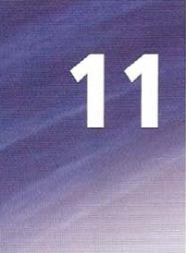they're they are their possessive form of they This is Tom, and this is Peter. They're brothers. And this is their sister, Helen.

### it

Use it + be  with adjectives.

It's important / difficult / easy / interesting / best to use a computer,

* with some nouns.

It's a pity / a shame to be indoors on a day like this.

* for dates, days and times.

It's June 4th. It's Friday. It's halfpast three.  with verbs Of weather.

It's raining / snowing use it  with seem I appear.

It seems / appears that somebody found the money in the street.  with looks as if.

It looks as if it's going to rain.  with some expressions.

It doesnt matter. Its time to go. It takes an hour to get there  to refer to something we have already mentioned. This is my new bike. It's really fast!

it's, its

it's = it is It's a lovely day today!

its = possessive of it The company gave all its employees a holiday. o

1. Underline the correct form.

|  |
| --- |
| Ordnance  Surveye  OS Landranger Map 164 |

The surface Of the Fålrth is not flat. a / They are mountains and high land and b there / they arc also low areas. c There / They are Steep slopes in some places, but in others d there / they are gentle Ones. e There / They are special symbols on maps which show the height and shape Of the land.

f There / They include colour and contour lines, and g theme / they are also height numbers for some high places.

On detailed maps, h there / they are contour lines, i There / They show how steep the slope is. j There / They usually appear every ten metres and k there / they are numbers on them to show the height.

I There / They are also numbers at the bottom and on the side of the map. m There / They are used to identify each square on the map. n There / This is called a grid reference.

o There / They is a grid reference for every place on the map.

1. Rewrite the sentence so it begins as shown. Make any necessary changes.

a A match takes place on "liaesday.

There on Tuesdad, b You can do this in three ways.

There c A lot Of snow fell yesterday.

There d We haven't got any milk.

There

1. Complete the sentence with there, they're or their.

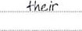a Whales have been hunted for centuries for oil and meat.

bnow in danger of disappearing completely.

are now less than 12,000 Of these beautiful creatures left.

* 1.  have been laws to protect whales since 1967.

numbers have increased slightly in recent years.

* 1. A strange man seems to be Outside.

There f A lot of people were at the rock concert.

There g Crowds of people were on the train.

There h An interesting television programme is on at 8.00.



* 1. still a source Of food and Oil in some parts of the world.

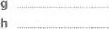meat is sold in several countries. also in danger from sonar equipment on ships.

confused by the sound signals.  As a result, they lose way and Swim into shallow water, and die.

1. Complete the sentence with it's or its. 5
   * 1. Come on, let's go home. _getting late.
     2. I'm taking my umbrella because going to rain.
     3. The horse had a white star on forehead.
     4. The school at the end of my road has given pupils a holiday on Friday.

time to go now.

* + 1. thinka pity you couldn't stay longer.
    2. My cat has broken one Ofback legs.

easy to get things wrong if you're not careful.

6 Complete the text with it or there in each space.

Complete the sentence with it or there.

_ is a problem with the computer. Can you help?

b Will be a party at the end of term?

is a pity she wasn't here to get her prize.

d 'Who's at the door?' is me.'

is a very good restaurant not far from my house.

is a long time since I went to the dentist's.

1. is easy to book a ticket on-line.
2. If you want to look up a word, is a list in the back of the book.

 Hello, Sue. is really good to see you, is no point in phoning him again. He rntiSt be out.

Tropical forests grow near the Equator where a _i+_ _ _ is warm and wet. b are only two seasons, rainy and dry. c _ is normally 20—25'C in a tropical forest and is only a drop of about SOC in the coldest months.

is a lot Of rain, on average more than 200 cm per year. is poor soil. and g is difficult for plants on the forest floor to develop. as tall trees (25—35 metres) block the light. h are many plants, birds, animals and insects.

are different kinds of tropical forests with different kinds Of trees. j depends on the temperature and the amount of rainfall.

In temperate forests, k are four seasons with a cold winter. I _ is impossible for the trees to grow all the year round in a temperate forest. and m is a growing season of only 140—200 days. n is also a greater range of temperatures, from —30 to 300C, and o rains throughout the year (75—15Öcm). As p is cooler and drier here, trees are smaller. q is more light, and the soil is richer. r are many deciduous trees in these forests, and is common to find many animals and birds.Again, t is a range of forest types depending on the annual rainfall.

o

7 Choose the correct form, A B, or C, to complete the text.

When a _ m winter, frogs stay in a dormant state at the bottom of ponds or in holes where

b. wet. In spring c . important for the flogs to reproduce, and d usually return to a place they know to lay their eggs. e may be necessary for them to travel a long distance, and f not unusual for frogs take risks. g cross from one side of a busy road to the Other. for example. When h they call to each other. Each species of frog has a particular set of sounds, because i Important that frogs of the same species find each other. •lhe frogs mate in the water and the fertilized eus live in a layer of jelly in the water. j large numbers of eggs, because

likely that predators will eat most of them. I about ten days before the tadpoles leave the eggs. m like small fish. with a large body and a tail, and live in the water until to change into frogs. o an amazing story

|  |  |  |  |  |  |  |
| --- | --- | --- | --- | --- | --- | --- |
| a A there is | B they are | C it is | |  | B they are | C there is |
| b A it is | B there is | C there are | | Altis | B They are | C There are |
| c A there is | B they are | C itis | | k A they are | B it is | C tliere is |
| d A it | B they |  | | A Il takes | B There is | C 'l •hey take |
| e A They |  | C There | | m A It looks | B Looks | C They look |
| A they are | B there is | C it iS | | n A they begin | B it begins | C begin |
| g A They might | B it might | C There might | | o A There is | B They are | C lt iS |
| h A it arrives | B they arrive | C arrive there | |  |  |  |
| |  |  | | --- | --- | |  | EXTENSION ACTIVITY | | 1  2 | Write a short description of your room or your neighbourhood using there is / there are.  Write some opinions beginning It's important / difficult / easy / interesting to... | | | | | |  |

o

### question formation

inversion

We make questions with be by putting the verb in front of the noun or pronoun. This movement of the verb is called inversion. When be is part of the verb tense we also put it in front of the noun or pronoun.

Statement (noun + verb) Question (verb + noun)

Everest is the highest mountain. Is Everest the highest mountain? The Romans were expecting an attack. Were the Romans expecting an attack?

Do the same when will, have and had are part Of the verb tense.

Will we arrive on time?

Ha ve you read War and Peace? Had Napoleon intended to fight the battle?

Present simple tenses form questions with do / does, and past simple with did, using the verb stem.

Do ants show any kind of intelligence? Does a cat know how to swim? Did Columbus discover America ?

modal auxiliaries, have to (see Units 22—25)

Modals form questions by moving the auxiliary in front Of the pronoun,

Can bats hear well? Should we stop eating white sugar?

Have to forms questions with do / does and did. Have to is generally used as a question form of must. DO have to turn on the computer first? Did Roman slaves have to work hard?

yes / no questions, short answers

Questions without a question word have the answer yes or no. When we answer this kind Of question, we often give a short answer which repeats part Of the question.

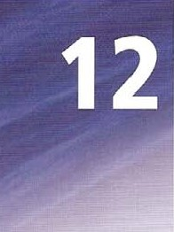 Is Everest the highest mountain? Yes, it is. / No, it isn't

Was Columbus the first European to reach America? NO, he wasn't Yes, he was_

|  |  |
| --- | --- |
| Do ants show any kind of intelligence? Had Napoleon intended to fight the battle?  Can bats hear well?  Did Roman slaves have to work hard? | Yes, theydo. / No, they dont.  NO, he hadnt. / Yes, he had.  Yes. they / NO, they can •t.  Yes, they did. / No, they didn't. |

wh- questions

We put a question word in front of question forms.

Which is the highest mountain?

HO w do ants Show intelligence?

Who was the first European to reach America?

Why is the climate changing everywhere? When will the ice at the poles melt completely? How well can bats hear?

embedded questions

Statements or questions with verbs like know and wonder, or polite requests like Can you tell me can introduce a second question. The second question is in statement form.

|  |  |
| --- | --- |
| direct question  How hot is it on Mars?  Where does the blue wire go?  Who is Romeo?  What is the answer? What was the time? | embedded question  / wonder how hot it is on Mars.  Can you tell me where the blue wire goes?  Do you know who Romeo  I know what the answer is.  I didn't know what the time was. |

question phrases

Many questions are formed from a question word and other words.

|  |  |  |
| --- | --- | --- |
|  | What is the difference between X and Y? | What kind of plant is this? |
|  | How strong / large is this? | What effect r_ioew. heat have on water? |
| o | What is the relationship between X and Y? | How does this work? |

1 Rewrite the sentence as a yes / no question.

a The Nile is the longest river.  Our climate will be different in SO years' time.



|  |  |  |
| --- | --- | --- |
| b Earthquakes have occurred in this country. | g | The capital city has continued to grow. |
| 1. The volcano had erupted before.      1. 200 million years ago there was only one | h | The Arabian Desert and the Gobi Desert are similar in size. |
| continent. |  | The ice at the Poles has started to melt. |



|  |  |  |
| --- | --- | --- |
| e People were expecting a tsunami in 2004.  2 Complete a short answer for each question. |  | Many people were injured in the earthquake, |

1. Do all birds spend winter in a different part of the world?
2. Is the peregrine falcon the fastest bird?

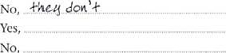  Can a racehorse run faster than a lion? No,

|  |  |  |
| --- | --- | --- |
| d | Does the giant scolpender centipede really eat mice? | Yes, |
| e | Have termites really built nests sev'en metres tall? | Yes, |
| f | DO millipedes really have a thousand legs? | No, |
| g | Are we really discovering more species of insect all the time? | Yes, |
| h | IS it true that wasps make paper to build their nests? | Yes, |
|  | Can some fish really climb trees? | Yes, |
|  | Did unicorns really exist once? | No, |

1. Match questions a to j with their answers 1 to 10. Then complete the questions.

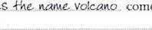Questions Answers a Where does come from? S  Scientists predict when a volcano Will erupt by b How manyon Earth? measuring movements in the Earth.

|  |  |
| --- | --- |
| C Where    come from?  d Why Of the volcano? | 1. The hot lava Comes from deep in the Earth's crust. 2. They often release sulphur dioxide gas (SO,) as a |

* 1. 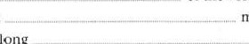What mean ? sign that they are going to erupt.
  2. How long 4 Dormant means that the volcano is not active at

|  |  |  |  |  |
| --- | --- | --- | --- | --- |
|  | remain active? |  |  | the moment — but it could erupt again. |
| g | How                  volcano will erupt? |  | that a | 5 The name volcano comes from the Roman god of fire, Vulcan. |

 h What with? 6 Most volcanoes remain active for thousands or

 What even millions of years.



volcanoes

are going to erupt? 7 People once thought that coal and sulphur (S) Whatcaused burning below ground caused volcanic eruptions.

volcanic eruptions? 8 It's hard to give an exact number, but there are more than 30 well-known ones.

* + 1. They measure the movements with an instrument called a seismometer.
    2. The lava comes out because of pressure from below. O

1. use the prompts to make a question, Then choose answer A, B or C. Check the factual answers on page 208.

 you know / what / be / the capital Of Argentina? PO b you know / how long / be / the River Nile?  you know / where / be lake 'liticaca?

* 1. you know / what colour / be I the flag of Mali?
  2. you know / how many states / there be / in Australia? f you know / how high / be / Mount Everest?
  3. you know I what I be / the capital Of the Republic Of Gambia? _ h you know how many / has got / official languages / Switzerland?  you know / what / be / the Finnish name for Finland?

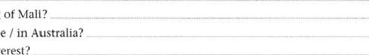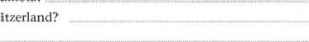 you know / what / be / the population of the Republic of San Marino?

|  |  |  |
| --- | --- | --- |
| a A Montevideo | B Buenos A ires | C Valparaiso |
| b A 6,695 km | B 8,69Skm | C 10,695 km |
| c A between Bolivia and Peru | B in central Asia | C on an island near Hawaii |
| d A red, white and blue stripes | B green, yellow and red stripes | C blue and white stripes |
| e A 12 | 9 |  |
| A 6,848 metres | B 7, 848 metres | C 8,848 metres |
| g A Conakry | B Thimphu | C Banjul |
| A Republika e Shqipérisé | B Suornen tasavalta | C Eesti Vabariik |
| A about 270,000 | B about 27,000 | C about 2.7 million |

1. Rewrite each question beginning as shown. Check the factual answers on page 208.

a 

b Is it the name of a real place?

Do you have any idea c Was it an invented name?

Can you tell me d Why did they decide 10 make up a name?

I wonder e What do the local people say?

Could you tell me

 Where does the name Taurnatawhakatangihangakoauauotamateaturipukakapikimaungahoronukupokaiwhenuakitanatahu come from?

Do you have any idea g How do you pronounce it?

DO you know h What does it mean?

DO you understand

 Which language is this word from?

Can you tell me

 What'S the longest place name in your country?

Could you tell me

6 Read the text about earthquakes. Then complete the question for each answer.

#### Earthquakes

|  |  |  |  |  |
| --- | --- | --- | --- | --- |
| tectonic plates which make up the surface press against each | | North  American |  | Eurasian |
| Other very slowly. Over thousands Of years, this movement creates great stress. In some places where rhe layers of rock | | Plate |  | Plate |
| are weak, this eventually causes a sudden movement — an earthquake.Thousands of earthquakes happen every day. but | |  | Ocean |  |
| most are very small and cause no damage.A large earthquake | |  |  |  |
| shakes buildings to the ground, or causes a tsunami wave. The | | Atlantic Ocean |  | Indian |
| effects are usually very serious.  Severe earthquakes are common in southern Europe. and | |  |  | FPlate |
| on I November 1755 a powerful earthquake hit the city | |  |  | Indo |
| of Lisbon in Portugal. Between 60.000 and 100,000 people | |  |  | Australian |
| died.After rhe earthquake a tsunami struck the city, and there was also a fire, which caused nearly total destruction. | |  |  | Plate |
| People as far away as Finland felt the shock, and the tsunami | | south American plate |  | Indian Ocean |
| reached Barbados in the West Indies. Geologists now believe that the strength of the earthquake was as high as 9 on the Richter scale.This is the same strength as the Indian Ocean earthquake of 26 December 2004. |  |
| a What moves an | e | When |  |  |
| Part of the Earth's crust moves when an |  | On 1 November 1755. | |  |
| earthquake occurs. b What |  | How many | |  |
| The movement of tectonic plates creates this stress. c How many | g  h |  | |  |

When an earthquake occurs, part of the Eartiü surface moves. In fact. the surface of the Earth moves all the time.The

Thousands happen every day. d What

Between 60,000 and 100,000. In which distant country

In Finland.

What

That the strength of the earthquake was as high as 9 on the Richter scale.

It shakes buildings or causes a tsunami wave.

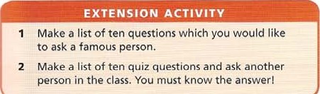 o

### tag questions

tag question forms

We can put a tag at the end of a statement to make a question. We use the verb in the statement to make the tag, using an auxiliary if necessary. The noun in the statement becomes a pronoun in the tag In the most common types of tag question, a positive verb has a negative tag. You like pizza, don't you? (I'm not sure) A negative verb has a positive tag.

Andrew won't be angry: will he? (l want you to tell me that he won't)

types of tag questions

positive verb, negative tag

When we use a positive verb and a negative tag, we generally expect a yes answer.

Russia produces a lot Of natural gas, doesn't it? Yes, it does.

A lot of diamonds come from 5011th A frica don t they? Yes they do.

* negative verb, positive tag

When we use a negative verb and a positive tag, we generally expect a no answer. There aren't ony active volcanoes in Scotland, are there? No, there aren't Switzerland doesn't belong to the EIJ. does it? No, it doesn 't.

* 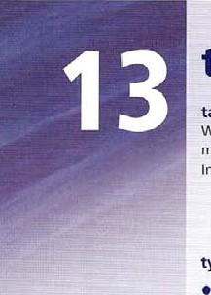positive verb, positive tag

When we use a positive verb and a positive tag, we are showing surprise.

You liked the film, did you? (l didn't expect that you would like it)

intonation and meaning

The meaning of the question depends on the intonation we use.

Budapest is the capital Of Hungary, isn't it? Yes it is.

When the intonation falls or is level, we are checking information we already know.

There are mountains in New Zealand, aren't there? thatS right. When the intonation rises, we are asking a question.

matS not the Greek flag, IS it? No, you 're righ t. The Greek flag is blue and white.

so and neither answers

In speech, we use so or neitherto add similar information without repeating the main verb. We use only an auxiliary (be, have, can etc) after so and neither. We use so to add information following a positive statement.

Stromboji is an active volcano. so is Etna.

Volcanoes cause great damage. So do hurricanes.

We use neitherto add information following a negative statement. Japan doesn't produce its own oil. Neither does Korea, A computer can't work without electricity. Neither can a car.

|  |  |
| --- | --- |
| 1 Add a positive tag to each sentence. | 2 Add a negative tag to each sentence. |

a Madagascar isn't in the Atlantic Ocean, a You were at the same school as Maria, b Astronauts haven't landed On Mars,

The climate won't get any worse, b This is the way to the station, d The Romans didn't sail to America, C You've forgotten to buy the tickets, e Chickens can't fly,d They understand this problem,

The world's population isn't growing in all e Helen is coming to the party, countries,f The bus took a long time,

1. Choose the correct sentence, A or B. for each situation.

A _ You always know the answer, in fact!

A You know the answer, don't you? B You don't know the answer, do you?

b I'm sure I left it here, but now I can't find it.

A You have seen my bag, haven't you? B You haven't seen my bag, have you? I knew that he would pass.

A Jack passed the exam, didn't he? B Jack didn't pass the exam, did he? Oh no! That means I'm going to get wet! A It's raining, isn't it? B It's not raining, is it?

You ought to get one. It's a much better way to travel in the city. A You've got a bike, haven't you? B You haven't got a bike, have you? So we can talk about the final plans then.

A You'll be here next week, Won't you? B You won't be here next week, will you? You're really good at it, so I'm sure it isn't the first time.

A You've played this game before, haven't you? B You haven't played this game before, have you? h Why didn't you tell me, I thought he'd already left.

A Mr Jones is still waiting for me, isn't he? B MT Jones isn't still waiting for me, is he?

1. Use the information to write two sentences. Begin the second sentence with the word in capitals.

|  |  |
| --- | --- |
| a Most portable radios and most CD players need batteries for power.  Mos* por•f-abtc radios ba++cr•ics power. So do -twos* CO-plagcrx b Airships and helicopters don't need a runway to land. | so  NEITHER |



|  |  |
| --- | --- |
| c Diesel engines and petrol engines produce exhaust fumes. | so |

|  |  |
| --- | --- |
| d Wind power and wave power don't cause air pollution. | NEITHER |

|  |  |
| --- | --- |
| e Computers and calculators use electronic microchips. | so |

|  |  |
| --- | --- |
| f A wireless keyboard and wireless mouse don't require a connecting cable. | NEITHER |

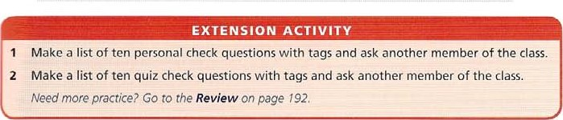g Some cookers and lighting systems can use solar power. so 

infinitive after verbs and adjectives

Many verbs and adjectives are followed by infinitive constructions, either with bare infinitive (go) or to-infinitive (to go), A good dictionary gives examples of the patterns used.

verbs followed by bare infinitive

make and let (make / let + object + bare infinitive)

Factory owners made young children work twelve hours a day, My parents don't let me hold noisy parties. would rather ('d rather)

Do you want to watch a DVD? No, I'd rather play

verbs followed by bare infinitive, or to-infinitive help, dare

(help / dare + object + bare infinitive / to-infinitive)

Computers can help us analyse / to analyse large amounts of information. Nobody dared to make / make a noise.

verbs followed by to-infinitive aim, fail. intend learn how, long, manage, need, offer, plan, prefer, refuse, try, want We aim to complete the work by next week. Please try to arrive punctually at 8 30.

verbs followed by to-infinitive, or that-clause decide. expect hoper promise, threaten, warn

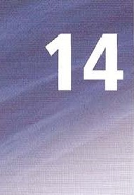We decided to lea ve early

We decided that we would leave early.

As these verbs often refer to the future, the that-clause often contains would. With the verb pretend, the that-clause often contains a past tense verb, Jack pretended to be ill. Jack pretended that he was i//.

verbs followed by an object and to-infinitive advise, allow, dare, encourage, forbid, force, instruct, order, permio persuade, remind, teach, tell

They advised me to try again later.

Tom's mother taught him to cook

verbs followed by to-infinitive. or -ing (see also Unit 15) begin, start. hate, like, love

After an hour, the spectators began to leave the stadium. After an hour, the spectators began leaving the stadium.

adjectives followed by to-infinitive

* These can describe how someone feels about something, for example: afraid, anxious, ashamed, careful, determined, free, frightened, happy, keen, quick, ready, sorry. willing. peter was determined to pass the exam.

Some adjectives can also be followed by a preposition. See Unit 42.

* We can give an opinion about something, using adjectives such as agreeable, amusing, boring, difficult, easy, hard, impossible, nice, good, important, necessary. It's easy to fall over on the ice.
* Adjectives can be used in phrases with be, for example: be supposed to, be expected to, be allowed to, be prepared to.

Sorry, but you're not allowed to wait here.

Under-line six other examples of verb or adjective followed by the to-infinitive, and one example of verb or adjective followed by the bare infinitive,

|  |  |  |
| --- | --- | --- |
|  | In India all children aresupposewwgo to school | went to school themselves, so they don't expect the: |
|  | between the ages of six and 14. In fact in the | children to go. Many parents are also so poor that |
|  | countryside it is very difficult for young children to | they don't let their children go to school, but prefer |
|  | get an education because the government has failed | to send them to work instead, because they need the |
|  | to build enough schools, and also because transport | money. Children from richer families, on the other |
|  | is difficult, and children need to take the bus to get to | hand, Often live near good schools, and their parents |
|  | school. There are few buses, so most children go on | encourage them to pass their exams so that they can |
|  | foot. On top of all these problems, many parents never | get good jobs. |
| 2 | Complete each sentence using a verb from the list. |  |
| decide to hopeto learn how to manage to prefer to | |

In deweloped countries, most students hope. +0continue into higher education. b They know that if theyget a university degree, they will stand more chance of getting a good job.

Those who _ leave school at the age Of 16 usually have opportunities to continue in education in a college of further education.

* 1. This is the kind of college where you can become a chef Or a tourist guide, and concentrates on the practical side of a job.
  2. And for those whogo straight into employment at this age, there is always the chance Of training on the job, or going back to full-time education at a later date.

aim to fail to long to need to try to

Do you ever get away from school and try something different?

* 1. 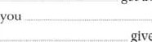Then perhaps you go for work experience.
  2. Many schools give their pupils the chance to find out what work is like, by sending them to work for a few hours a week.

Employers say that very lew pupils learn useful skills.

_ make sure that all the children who work here understand themselves a bit better when they leave,' commented one employer.

1. Complete each sentence so that it means the same as the first sentence, using either make or let in a suitable form.

a In ancient Sparta, girls had to practise running, wrestling and throwing javelins.

The ancient Spartans b A baby was not allowed to live if it was not fit and strong.

The ancient Spartans did not c They encouraged young children to fight each other to make them tough.

The ancient Spartans d People were not allowed to take a lot of baths.

The ancient Spartans didn't e The children had to sleep on rushes, a kind of grass.

The ancient Spartans

f Eating a lot Of food was not allowed.

The ancient Spartans g All the boys had to join the army. ancient Spartans h Boys were not allowed to cry when they fought.

The ancient Spartans

1. Rewrite each sentence so that it contains the word in capitals.

### The conquest of the Incas

|  |  |
| --- | --- |
| 1. Francisco Pizarro decided that he would return to South America in 1532.   Francisco Pizarro de-cidcd •+0 rz4•unt +0 Souå•h America in 1632.   1. He hoped that he would conquer the Incas. 2. He also expected that he would become rich. 3. When he reached the Inca city of Cajamarca, he pretended that he was a friend. 4. He threatened that he would kill his prisoner, the Emperor Atahualpa, unless the people brought him their gold and silver. 5. But he had no intention of letting the Emperor go free. 6. HIS aim was 10 make sure that the Incas had no leader. 7. He made a promise that he would set the Emperor free, but killed him.   Pizarro also killed his friend Almagro, who wouldni obey his orders.  Almagrc* friends succeeded in killing Pizarro three years later. | TO  TO  TO  INTEND  AIMED  PROMISED  REFUSED  MANAGED |

5 Complete each sentence so that it means the same as the first sentence.

a Learning how to live in space is difficult.

It's -di$$icul+ +0 te„ant how to live in space. b Fating in weightless conditions isn't easy.

It isn'tin weightless conditions. c Taking enough exercise is difficult.

It's enough exercise. d Being in good health is very important for astronauts.

It's very important for astronauts in good health.

1. Imagining what astronauts have to do is difficult.

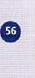 It'S what astronauts have to do.

1. Living a completely normal life in space is impossible.

It's a completely normal life in space. g Going into space is never boring.

It's never  into space.

h Returning to Earth makes most astronauts feel happy.

Most astronauts feel to Earth.

6 Complete the text with one word from the list in each space.

|  |  |  |  |  |
| --- | --- | --- | --- | --- |
| allow | careful | decided | encouraged | failed |
| forced | learned |  | managed | prepared |
| refused |  | supposed | threatened | trying |

I'm to say that we have b to close the science laboratory until further notice. Although wc have always c pupils to conduct safe experiments, and have always believed it was important to d students discover science for themselves, recent events have made it difficult for us to e such work to continue.

I am referring of course to the robot that Class 5 to construct recently while they were to be constructing a simple computer. Although at first the builders Of this machine were h to hide their machine from members of staff. unfortunately they i to control the robot. It not only j how to leave the laboratory, but walked into the town centre and broke into the National Bank in Green Street. It is impossible to imagine what it was k to do. The pupils who built it have I to say whether they were controlling its actions. In any case. the police were not to permit this situation to continue, especially when the robot n to attack members Of the bank staff, and 0 them to fill a large bag with money. Please remember, this is not what science is for!

|  |  |
| --- | --- |
|  | EXTENSION ACTIVITY |
| 2 | Choose eight verbs from page 54 and write true sentences about yourself.  Choose eight adjectives from page 54 and write true sentences about yourself. |

-ing form

This is the name for the form of the verb ending -ing. When we use it as a noun, we can also call it a gerund, and when we use it as an adjective or verb, we also call it the present participle, though it is often difficult to decide which is which.

verbs of feeling and opinion etc followed by -ing admit, avoid. consider, deny dislike, enjoy, fancy, feel like. finish, can't help, involve, keep, mean, mind, miss, practise. risk, can't stand, suggest

Having a healthy lifestyle involves following a balanced diet, which means eating a variety of fruit and vegetables and avoiding too many sweet or fatty foods and also taking regular exercise.

* expressions with it's it's no good, it's no use, it's not worth

It's not worth taking an umbrella. It's not going to rain.

* expressions with spend spend (one's) time, spend (quality) time

/ spent my time swimming and sunbathing. Anna spent a lot of time researching her project.

* expressions with like

We can use -ing and to-infinitive after like.

don't like getting up early like to watch JV late at night

* 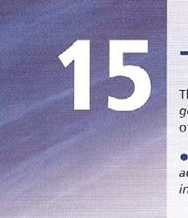verbs followed by •ing or to-infi nitive with different meanings

Stop It's a good idea to Stop eating Sweets between meals. (stop an activity)

They stopped to buy food, and then continued theirjourney. (stop in order to) try Try going for a swim — it's a good way to get fit. (see if it works)

They tried to reach the island, but it was too faraway (make an effort) remember Remember to warm up before you start exercising. (don't forget)

I remember going to school for the first time. (past memory)

* prepositions followed by -ing (See unit 42)

We use the •ing form after a preposition, A preposition can follow a verb or an adjective.

be interested in, apologize for, be used to, accuse (someone) of, specialize in, succeed in, insist on Are you interested in joining a tennis dub?

I must apologize for arriving late.

I am not used to staying up so late.

They accused Rick of stealing the money.

* Come and go followed by -ing

There are many expressions Of this kind, mainly connected with sport, but not team games. We use shopping in this way.

Do you want to come swimming / sailing / running with us?



They've gone shopping.

 •ing form as subject

We can use -ing form as a noun subject.

Adding and subtracting decimals is simi/er to adding und subtracting whole numbers.

I Under-line the correct word or phrase.

1. New research shows Some young people / consider / risk eating food which contains large amounts of sugar, salt, and animal fat.
2. Many young people also avoid / enjoy / keep taking any exercise.

 They don't even avoid / enioy / suggest walking to school or playing active games with their friends.

1. For too many young people, enjoyment feels like involves I keeps sitting in front of the television. or in front of a computer playing games.
2. Of course if they involve / keep / suggest doing this, they are very likely to have health problems at an early age.
3. Health experts consider / mean / suggest taking hard exercise at least three times a week.
4. This can't help / keeps / means running, cycling Or swimming.
5. so even if you don't avoid / [eel like / risk taking exercise, it's important to organize regular exercise activities.

 You could go f involve I practise swimming or logging, for example.

You may also consider / involve / keep changing your diet, and eating more fruit and fresh vegetables.

1. Complete each sentence a to h with an ending from 1 to 8.

|  |  |
| --- | --- |
| a For a Roman soldier, joining the Roman army meant _u   b He received wages, but had to spend money too, since being in the army involved c In the early days of Rome, everyone became a soldier and young men couldn't avoid             d However, as time went on, fewer Romans served as soldiers. The army stopped | being completely destroyed by the ancient world's best fighting force.   1. buying his own food, uniform and weapons. 2. ... attacking it faced very serious problems. 3. taking all the young Roman men, and service became voluntary. 4. fighting, until the end if necessary, and rarely surrendered. |

e When the army was at the height Of its power, an enemy who considered7 training to use their weapons, and fighting in

|  |  |
| --- | --- |
| f Unless the enemy had very large numbers Of | organized groups. |
| soldiers or attacked by surprise, they risked | 8 serving in the army if there was a war, as it was |
| g Foreign armies were Often disorganized and ran away, but the Romans always kept             h The Romans were more successful because their soldiers Spent more time | compulsory. |

1. Complete the text with the -ing or to-infinitive form of the verbs in brackets.

People who remember a (do) — +0 da_ everything they have planned are usually people who organize their tasks in some way, and avoid b (get) into a muddle. A shopping list is a good example of this technique, provided you remember c (take) the list with you when you go d (shop)

It's sometimes possible to remember a fact, for example, if first of all you Stop e (think) for a few moments. When you try f (remember). something, this will be easier if you have learnt it in an organized way. If you are not sure how to do this, try g (write) brief notes about the text you are reading. Many people find this an effective way of learning. After all, it's easy to read something and not understand or remember it, usually because you have stopped h (pay) attention.

1. Complete the text with a word from the list. You will have to use some words more than once.

|  |  |  |
| --- | --- | --- |
|  | at between by for in on of  Galileo  As well as being a scientist, Galileo was interested a painting and music. He started his studies b attending medical school in Padua. Unlike most scientists at that time. who usually relied c discussing the facts, not trying to prove them, he recognized the importance d doing experiments to prove the facts. He is famous e dropping different weights from the Tower of Pisa to prove that all bodies fall at the same rate. though [Ills IS probably not a true story. Through practice, he also became good f   observing the stars, and identified craters on the Moon. sunspots, and rhe moons of Jupiter. As a result g studying the planet Venus. he succeeded h proving that Copernicus was correct. and that the Earth moved around the Sun. Unfortunately, the Church authorities accused him i publishing unacceptable ideas. In the end he was forced to choose j being punished by the Church, or denying his own ideas. He spent most 01 the last nine years Of his life imprisoned in his own house. |  |
|  |
|  |
|  |
|  |

1. Rewrite each sentence so that it contains the word in capitals.

|  |
| --- |
| Fossils are the remains of animals, plants, and other organisms preserved in rocks,  The word fossil comes from the Latin word fossus, meaning 'having been dug up'. |

|  |  |  |
| --- | --- | --- |
| a | Does fossil-collecting interest you?  Arc gou -Cossd-collzck-inq?e | INTERESTED |
| b | Do you have to walk long distances? | INVOLVE |



|  |  |  |
| --- | --- | --- |
| c | I often find rocks that aren't really fossils. | KEEP |

|  |  |  |
| --- | --- | --- |
| d | When you look for fossils on a cliff, you could fall. | RISK |

* 1. I really think this is the wrong place to look for fossils.
  2. You have to get up early to go on the Club trip.

|  |  |  |
| --- | --- | --- |
| g | I left my hammer at home. | REMEMBER |

h I want to sit down and have a rest!

|  |  |  |
| --- | --- | --- |
|  | I know how to find fossils. | GOOD |

oDon't take up a hobby unless you're serious about it. WORTH

1. Rewrite each sentence so that it begins with an —ing form as subject.

a It can be very relaxing to collect fossils. can be, b It can be very difficult to give up Smoking.

* 1. It isn't a good idea to do an exam without revising.
  2. It is fun to learna new sport,



* 1. It takes lots of hard work to learn a foreign language,
  2. It was very exciting to see my favourite band play live.
  3. It will never be possible to live on Mars,



* 1. It took a long time to write the report.
  2. It is so tiring walking up this mountain!



* 1. It is illegal tn drive without a licence.

1. Complete the te;qt with the -ing form or to-infinitive of the verbs in brackets,

The first explorers to cross Australia Darwin

John Stuart decided a (cross) _ Australia from south to north in 1859. He wanted b (win) _ a prize offered by the NOR RN

### TERRI

South Austrahan government. This meant c (travel) OUEENSLAND

|  |  |
| --- | --- |
| acros> mounlains and de_serl Ior 3,000 kilometres, He and his three companions WZST*N  AUSTRALIA SO kept d (ride) _ for eight months belore reaching the centre AUSTRAU Of the continent, What had they expected e (find) _ ? $0 far they had only succeeded ill f (dlscover) a huge desert. On this Adela ideexpedition Stuart (ailed (reach) _ the coast. and turned hack ill and short of food. He tried h (complete) the journey the next year. but failed again.  Finally in 1861 he managed i (arrive) . at the northern coast, near the modern city of  Darwin. Ever since he has been ramous for j (cross,) the continent though sadly he died soon alter his return to Adelaide_ | NEW  SOUTH |

|  |  |
| --- | --- |
|  | EXTENSION ACTIVITY |
| I  2 | Choose eight verbs from page 58 and write true sentences about yourself.  Make a list of ten things you are interested in.  Need more practice? GO to the Review on page 7 92. |

o

61

reported statements

Direct speech is the actual words people say. We use speech marks.

Napoleon said: 'l have fought sixty battles and / have learned nothing. '

Reported or indirect speech tells us what people have said. We do not use speech marks. Napoleon said that he had fought sixty battles and had learned nothing.

tense changes

In reported speech we usually begin with a past tense reporting verb (eg said) so we change all the verbs that follow. and put them back further in the past.

|  |  |
| --- | --- |
| 'l know the answer', she said 'I've done it, ' she said.  'I'll see you later', he said. | She Elid (that) she knew the answer  She %üid (that) she had done it. He said he would see us later. |

people: personal pronouns

We also change the word we use to refer to the person who spoke.

Jack said: 'l have finished. ' Jack said that he had finished.

words referring to time and place

In direct speech time words like now, today. tomorrow, change because there is no longer a 'here and now' reference. The point of view has changed.

'I'll see you tomorrow. He said he would see me the following day. Reference words like here and this also change.

'l like this painting. ' She said that she liked the painting.

'l don •t understand this, He said that he didn't understand it.

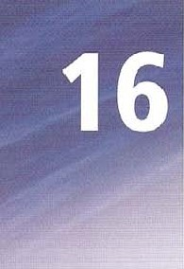tomorrow —+ the following day, the next day yesterday the day before here —s there this (pronoun) it this (determiner) -+ the

### say and tell

We always put an object after tell.

He said that he felt ill. He told them that he felt ill.

We use tell in the phrases tell a lie and tell the truth.

She told her teacher a lie. He told me the truth, I'm Sure. We don't say He said the-truth or Hesaid a lie.

no changes

* When we report immediately what someone says, or talk as if it was very recent, we use a present tense reporting verb and we do not make tense changes.

Helen says she'll be back later;

* When we report a state meaning (eg like, live, believe etc) it is possible to make no changes if we want to show that the State continues.

'l still don't believe you. ' He said that he still doesn't believe me.

We can also make the tense change, but it can suggest that the state belongs to the past. He said that he didn't believe me at that time.

* When we report a narrative we need not change past simple to past perfect.

'f' was standing at the bus-stop, and / saw everything that happened, ' he said He said he was standing at the bus stop and saw everything that happened  We do not make tense changes when we report quotations.

Napoleon said that you must n eve•r interruptyour enemy when he is making a mistake.

|  |  |  |
| --- | --- | --- |
| a 'I getup every day at 6.30,' she said. |  | 'Scientists don't understand everything,' she said. |
| She Said 6.30. |  | She |
| b 'l forgot to phone the doctor,' he said. | g | 'I've decided to look for a new job,' he said.  He |
| c 'Everybody likes comedy films,' he said. | h | 'I can swim 5,000 metres,' he said. |
| He |  | He said |
| d 'I'm thinking about it,' he said. |  | 'I'm going to have a baby,' she said.  She |
| e 'I was reading the paper,' she said. |  | 'I'll phone on Friday,' he said. |
| She |  | He |

1. Rewrite each sentence as reported speech with tense changes.
2. Read the information about the Trojan War. Then put one pronoun or reference word

in each space-

A 'I love you, Helen, and I want you to come with me to Troy,' Paris told Helen.

Paris told Helen that he loved a. and he wanted b to go to Troy with



 'I'm going to attack Troy and get my wife back because she loves me best!' Menelaus told his brother.

Menelaus told his brother that he was going to attad Troy and get d wife back because e

best.

1. 'We'll come with you to Troy and get your wife back,' the Greek heroes told Menelaus,

The Greek heroes told Menelaus that gwould go with h to attack Troy and get i wife back.

1. 'We've been fighting here for nine years and we want to gel back 10 Our lamilies,' the Greeks said.

The Greeks said that they had been fighting for nine years and they wanted to get back 10 k families.

1. 'I'm going to take some soldiers with me inside this wooden horse,' Odysseus told them.

Odysseus told them that he was going to take

some soldiers with I inside wooden horse.

1. 'My plan has worked, and the city is ours,'

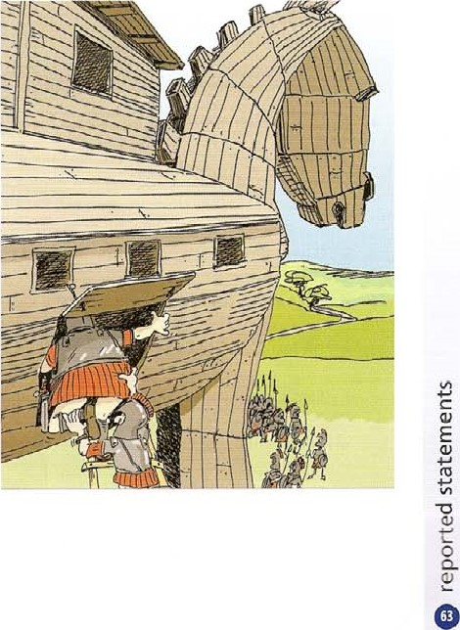Odysseus told the Greeks. Odysseus told the Greeks that n plan had worked and the city was

3 Read the information about Heinrich Schliemann.

Then complete the text by writing said or told in each space.

### Heinrich Schliemann — an interview in the 1860s

Heinrich Schliemann Was a German archaeologist who excavated a city in Turkey in 1871 and decided that it was ancient Troy. He Ibnnd evidence of destruction by war, and also discovered some gold objects. Nowadays archaeologists believe that his methods or excavation were unscientific, and they also believe that some Of his discoveries were false,

Recently many experts have a. Said that Schliemann had a habit Of not telling the truth. and this has raised doubts about his work. For example, he b everyone he was a US citizen, but in fact this wasni true. He also c had a degree (he Liniversity Roswck, in the university rejected his thesis He d . he had IOund gold jewellery at Hissarlik, but some people believe these were modern pieces. In fact, his servant later e „ people that no jewellery had been found in the places that Schliemann claimed to have found it. He also f authorities in Turkey thal he was an archaeologist, but he didnt have any qualifications. When he talked about his work, he always g people thal he had dreamed 01 finding Toy when he was a small boy, but many people feel that he invented this story later, Ilowever, although many archaeologists at the time that his work was inaccurate, we have to remember that archaeology was not a science in Schliemanns Lime. He may not have always i the truth, hut he brought a lot of energy to the discovery of the ancient world, and devoted his lite and his wealth to his excavations.

1. Rewrite each sentence about Schliemann as reported speech.

a "l have always been interested in the story of Troy,' he told journalists.

OH' &Qtd b 'My father read the stories to me when I was a child,' he said.

c 

* 1. 'At an early age I decided to discover the site Of the city,' he said.
  2. 'For many years I worked as a merchant in the USA and Russia,' he said.
  3. 'I am a wealthy man and I have retired from business,' he said.

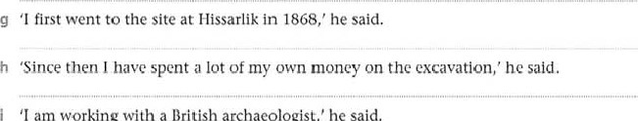

'I

am

working

with

a

British

archaeologist,'

he

said.

 'We are hoping to prove that Hissarlik is the site Of ancient Troy,' he said.

1. Read the statement from a news conference held at an archaeological site. Then answer the questions.

'Good morning everyone, my name is Julia Richmond, and I'm the director of this dig.Thank you for coming to this news conference. First I want to explain how wc found this site, and what we've been doing here. I'm sure you have read the publicity handout, so you know something about this. ltS important to give you the latest information. Then I'm going to give a description of some of the interesting discoveries we have made here. I'll give you a general account of the project. and I'll show some slides of the site.Then there will be a chance for ali of you to look at some fascinating objects.We•ve brought some of rhe more spectacu lar finds.

They are waiting for you in the room next door, and you will be able to take photographs. YouVe been very patient. So now let's begin .

What did the archaeologist say about her job?

She told the journalists. b finding the site?



aaS

dig,

She said c the publicity handout?

She told d the latest information? She said interesting discoveries?

She told a general account of the project?

She said g . slides?

She told h fascinating objects?

She said i spectacular finds?

She told j the room next door?

She said k ... photographs?

She told

|  |
| --- |
| EXTENSION ACTIVITY  Choose five sentences and their answers from Exercise 1 and translate them into your language. Are the tense changes and punctuation rules the same?  2 Read Exercise 3 again. Write four things that  Schliemann told people, using direct speech. |

 I being patient?

She said

reported questions, commands,

and reporting verbs

reported questions yes / no questions

We report these questions using if or whether. We follow the tense-change rules (see unit 16). We change the question form of the verb to the statement form. We do not use a question mark.

'Do you understand the question?' she asked us.

She asked us if / whether we understood the ques tion.

• reported questions with a question word

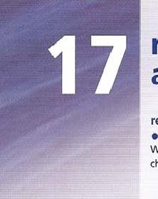We report these questions using the question word and the following tense-change rules. We change the question form of the verb to the statement form.

'What temperature is the water?' she asked.

She asked what temperature the water was.

reported requests and commands

Use ask to report requests: ask + Object + to-infinitive.

'Please turn on your computers ' He asked us to turn on our computers.

Use tell to report commands: tell + object + to-infinitive.

'Turn on your computers! ' He told us to turn on Our computers, 'Don't turn it on!' He told us not to turn it on.

report verbs

Some verbs explain what people say, or summarize their words. using a report verb often means you can summarize the actual words people say, without repeating them.

•r/l bring my homework tomorrow. honestly I will, really!' He promised to bring his homework the next day.

|  |  |
| --- | --- |
| * verb + that-clause   'Why don't you use a calculator?' promise '/'ll do it'.   * verb + -ing sugqæ.t 'Why don't you use a calculator?' deny didn't break the jar. * verb + to-infinitive offer 'I'll help you.' promise '/'ll bring it tomorrow ' refuse 'l won't sit down! • agree to 'Ok. pay (you) €300.' * verb + object + to-infinitive advise 'l would (wouldn't) stop, if I were you. ' remind 'Don't forget to lock the door' 'Don't touch that wire!' * verb + Object invite 'Would you like to come to dinner?' affer 'Would you like some ire cream?' * other patterns explain This is how you do it, ' agree with 'Yes, I think the same. ' congratulate 'Well dong you 've "von. ' | He suggested (that) I used a calculator.  He promised (him) (that) he would do it  He suggested using a calculator He denied breaking thejar  He offered to help her.  She promised to bring it the next day  He refused to sit down  He agreed to pay (him) €300,  She advised me (not) to stop.  She reminded him to lock the door.  She warned me not to touch the wire.  He invited me to dinner.  He offered her some ice cream.  She explained how to do it.  She agreed with ,hfm,  He congratulated her on winning, |

IA Complete the reported yes/ no questions.

a 'Have you done your homework?'

Rewrite the Sentence as direct speech. Include necessary punctuation.

tense shift.

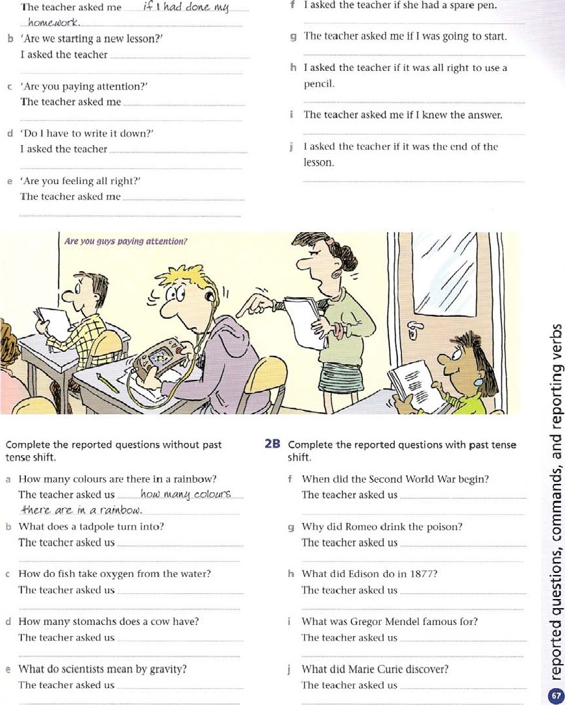

ZA

a How many colours are there in a rainbow?

The teacher asked us C,QtQUr$

-+kcrz are a b What does a tadpole turn into?

The teacher asked us

1. How do fish take oxygen from the water?

The teacher asked us

1. How many stomachs does a cow have?

The teacher asked us

1. What do scientists mean by gravity?

The teacher asked us

3A Complete the reported questions.

a 'DO you live here?' I asked.

I asked him b •What's your name?'



hcAivc,d

He asked me c 'What time is it?'

I asked her d •Are you sitting here?'

She asked me e 'DO you want some coffee?'

I asked her

3B Rewrite the sentence as direct speech. Include necessary punctuation.

1. He asked me when the next train left.
2. I asked him where the bus station was.
3. She asked me whether I had any change.
4. I asked her what she was staring at.
5. They asked me if I was waiting for them.

4 Complete the reported requests or commands.

a 'Fill the jar with water, John.'

The teacher •hold dohn +0 -Cdt jar ai4-h aa4•zr• b 'Please help him, Angela.'

The teacher c 'Michael, don't spill the water!'

The teacher d 'Please pour a little watex into here, Alison.'

The teacher e 'Light the gas, Steve.'

The teacher f 'Don't touch it with your finger, Alan.'

The teacher g 'Sarah, heat the water gently until it boils.'

The teacher h 'All Of you, please watch the water carefully.'

The teacher 5 Match the sentences a to h with the same words reported in 1 to 8.

|  |  |
| --- | --- |
| 1. This is how you turn on the computer. 2. I wouldn't turn on the computer if I were you. 3. I'll turn on the computer. 4. It's not true — I didn't turn on the computer. 5. Careful — don't turn on the computer. 6. Why don't you turn on the computer? g Would you like to turn on the computer?   h No, I won't turn on the computer! | 1. He explained how to turn on the computer. 2. He warned me not to turn on the computer. 3 He invited me to turn on the computec 4 Ile suggested I turned on the computer. 3. He refused 10 turn on the computer. 4. He denied turning on the computer. 5. He offered to turn on the computer. 6. Lle advised me not to turn on the computer. |

6 Reed the advice from sports expert. Then complete each sentence using one word from the box and any other necessary information.

'Hello. my name's Vernon Marchewski and I'm going to tell you about the best ways to improve your fitness.

If you're interested in being an athlete, or just doing sport for fun, this advicc is for you.

I think the most important thing is to choose a workout that you enjoy. Don't cycle if you don't like cycling.

You need to do something that will motivate you, so avoid activities that are too hard for you, or boring.

To make your workout more fun and challenging. do it a bit differently each time.Try a new activity, or vary how long you spend doing something. and how difficult you make it.

Another great way to motivate yourself is to make sure you have goals. For example, if you run 5 km a day. try to increase it to 6. But be careful. dorft overtrain.This Can lead to injury, and your body needs to rest as well as work hard. Look after yourself, remember to eat good food and drink lots Of water.

A healthy diet is the best way w a heal'hy body.

Finally, only use proper equipment. If you cycle, have your bicycle checked and repaired regularly. Only wear good running shoes. and invest in comfortable clothing.'

esplained warned reminded told

1. Vernon said advice. aaS

athletes.

1. He _ the audience c He d To make your workout fun, Vernon e He yourself.

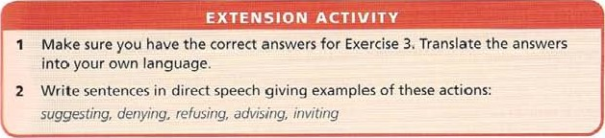He g He h He advised shouldn't suggested

for people interested in being

they enjoyed. too hard, Or boring,

, goals is a good way to motivate

lead to injury. good food.

bad equipment.

real conditions if X happens, Y will happen

These sentences describe what the speaker thinks will possibly happen as a consequence Of a real situatior

present si mple will future If we do not deal with the gtobal warming problem, temperatures will rise.

/twe leave now, we'll catch the bus. If we don't leave now, we won't eateh it.

In informal speech, we often use going to instead of will.

If you don't take an umbrella, you're going to get wet.

We also use might or can / could in place of wilt. See Unit 25

We can also use imperatives in real conditions.

Ifyou don't know a word, 100k it up in the dictionary.

Sentences beginning Ifyou will... are only used when will means insist, or is used as a polite form. ff you will stay up so late, then of course you'll feel tired (insist)

Ifyou'll wait here, I'll see if the manager is ready (polite)

### unless

Unless means only if not. We use it when we say that if something does not happen, something else will happen.

Unless we deal with the global warming problem, average temperatures will rise.

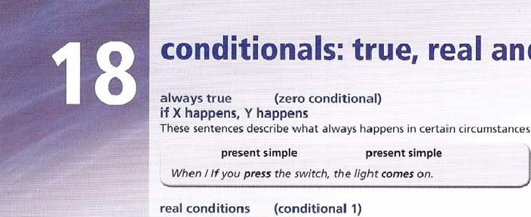

and

unreal

circumstances

eg

scientific

facts.

provided, as long as + present simple Provided and as long as mean only if.

Provided / as long as wp reduce pnprgy consumption, can slow down global warming.

in case + present simple

This describes a possi ble situation we want to be prepared for. rake an umbrella in case it rains.

unreal conditions (conditional 2) if X happened, Y would happen

These sentences describe what the speaker thinks would happen in an imaginary situation.

past simple would + verb

If you were on Venus, you would see the Sun rise in the west.

What would happen if the Earth stopped turning?

If the Earth didn't have a Moon, there wouldn't be any tides.

The past simple tense We use in if-sentence does not describe past time, but unreal time. We also use might or could in place Of would, See Unit 25.

if I were you

We give advice with If I were you.

o I Wouldn't do that, if I were you. or If I were you, I wouldn't do that.

teal or unreal?

¯nis depends on the situation of the speaker, or what the speaker is thinking.

For example, we're in the classroom, There are some heavy tables, think a friend is going to lift them. I give a warning.

'tfyou try to lift those tables on your own, you'll hurt yourself.

Same situation. Nobody is thinking of lifting the tables. I make a comment. Those tables Nook heavy/ Ifyou tried to Nift them. you'd hurt yourself. '

Complete the answers using the word or words in capitals.

|  |  |
| --- | --- |
| a What happens when you heat water to 1000C?  If you 00' c, | BOIL |
| b What does water turn into when you boil it?  If you | SIAM |
| c What happens when you cool the steam?  If you | TURNS BACK |
| d What happens when you heat a piece Of metal?  If you | EXPANDS |
| e What happens when you freeze a piece of metal?  If you | CONTRACrs |
| What happens when you freeze water? | EXPANDS |

If you

1. Use the words to complete an if-sentence about solutions to environmental problems.

Solution A — recycle paper, metal and glass a everyone l' recycle paper / companies / not cut down so many trees gvzrgonz rccgctcs papør, coupanizs cue donn so numg *rms. b everyone / recycle metal and glass / we not waste valuable resources

c everyone / recycle paper, metal and glass / we not produce so much rubbish

Solution B — turn Off lights, don't drive so much, insulate your house d everyone / turn Off unwanted lights / save a lot Of electricity

* 1. everyone / walk or cycle / not waste so much oil and petrol
  2. everyone / insulate their houses / not waste so much energy for heating

Solution C — use renewable energy g countries use more wind and Water power, not depend so much on power stations

h countries use power stations less, cause less air pollution

1. Use the prompts to complete the question.

Then choose the most likely answer.

Check the factual answers on page 208.

* 1. what / happen if you / travel through the Earth to the other side?

aould happen gou *cave-Ilea

A-hroaqh {he, Ear-WI +0 {he, OR-her

* 1. what / happen if the Earth suddenly stop / going round?
  2. what / happen if we not / have a Moon?
  3. what / happen if all the ice at the poles / melt?
  4. what / happen if there be / no more electricity?
  5. what / happen if aliens receive / messages from Earth and decide / to visit us?

|  |  |  |  |
| --- | --- | --- | --- |
| a A You would fly out the | B | This would be impossible | C You would fall to the centre |
| other side into space. |  | because the F.a,'th's core is hot. | and then stop. |
| b A We would enjoy longer | B | It would start moving in the | C Even ifthe Earth stopped, we |
| and warmer days |  | opposite direction | would keep moving! |
| c A There would not be any | B | The Earth would spin more | C The Sun would grow stronger. |
| ocean tides. |  | slowly |  |
| d A Sea levels would fall. | B | Sea levels would slay the same. | C Seu levels would rise. |
| e A The universe would no | B | People would use candles ror | C The world would be u safer |
| longer exist. |  | light and fires heat. | place. |
| f A They wouldntknow | B | They wouldn't amive for | C They wouldn't understand |
| exactly where we were. |  | millions oryears, as they would be so far away. | Our messqges anyway. |

4A Rewrite each sentence so that it contains unless or as long as and begins as shown.

a If you don't train hard, you won't succeed in sport.

You Succeed in spork unte.SS goa krain hard. b If you train regularly, you can improve your performance.

You can improve c If you enjoy your sport, it doesn't really matter whether you succeed or not.

It doesn't really matter d If you don't eat and sleep properly you won't develop as an athlete.

You won't

4B Rewrite each sentence so that it contains in case.

* 1. Take a spare pair Of running shoes, because it's possible that you will need them.

Take a spare pair of running shoes f Take a waterproof coat with you because it's possible that it will rain.

Take a waterproof coat with you g take a warm jumper because it's possible that you will get cold when you stop.

"It'ke a warm jumper h Take a first-aid kit because it's possible that someone will get injured.

Take a first-aid kit

5 Use the Words to complete the Conditional if-sentence. use an always true, real Or unreal conditional to suit the meaning.

1. Scientists are planning a way Of writing extremely small letters, using xenon (Xe) atoms. If you (use) _ _uscd _ this system, you (be able) to write ten copies of the Bible on the area Of a postage stamp.
2. Humans are among the few animals to have colour vision. If you (be)a horse, for example, you (see)everything in black and white.

 The brain works in two parts, the left side and the right side. Scientists can put one side of the brain to sleep, and see what happens. For example, if they (turn off) the right side of the patient's brain, the patient (not be able) to sing, because musical ability comes from the right side of the brain.

1. Beetles are one of the most numerous species on the planet. In fact, if other insects and animals (not eat) beetles, ill about a year and a half the beetle population (weigh) as much as the whole Earth!
2. Parts of the body send messages to other parts of the body when they have to do things.

For example, if you (not have)  enough water in your body the brain (let) you know that you need more, by making you feel thirsty.

1. If you (100k) inside your own eye at the images there, they (be) upside down, and they (be) moving.

|  |
| --- |
| EXTENSION ACTIVITY |
| 1. Write five sentences about your life which begin Unless . 2. Write a list of eight interesting scientific facts you found in this unit, which begin If   Need more practice? Go to the Review on page i 92. |

1. If you (smoke) chemical changes (take place)in your cells, which do not receive enough oxygen and die.
2. The world's oceans contain huge amounts of salt. In fact, if you (remove) all the salt from the oceans, you (be able) to use it to build a wall about 300km wide and a kilometre tall all around the Earth!

I'm sorry I didn't talk to you yesterday but I simply didn't see you! ff I'd seen vou, I would have hello.

We also use might have or could have in place of would have. See unit 25.

past condition with a result in the present if X had happened, Y would be different

We often think about past events, and their effects on the present. If Chris hadn't gone to the hospital, he wouldn't be alive today.

wishes

 about the present

When we use wish to make a wish about the present, we use the unreal past simple, as in an unreal conditional sentence. We can also use could / was able to.

I wish I knew more about European history.

(2 If I knew more about it now, I would be happier.) wish I could swim really fast  wishes about the past

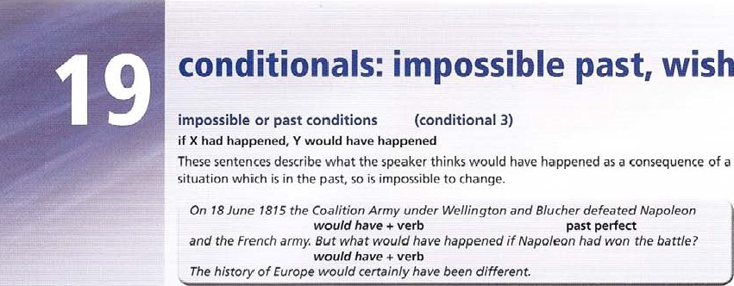

wishes

When we use wish to make a wish about the past, we use the past perfect, as in an impossible past conditional sentence.

I wish I had been prsent at the battle of Waterloo.

 If I had been present at the battle Of Waterloo, I would have been happy!)  wishes with would

We also use wish with would when we want someone to do something or not to do something. This is often because we think it is a bad habit.

wish you wouldn't keep staring at rne/

I wish Pete would phone

• if only

We can use if only to make a stronger kind of wish about the present or the past. If only I knew more about European history! ff only I had studied harder!

1. Compiete the sentence using the verbs in brackets.
   1. If Alexander the Great (march) _had west instead of east, he (conquer) the whole of Europe. b If more Vikings (go) to

North America, the Viking settlements (succved)

c If the ancient Egyptians (build) bigger boats, [hey the Atlantic in America,

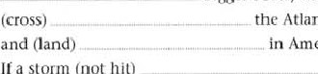

d

If

a

storm

(not

hit)

Bartolotneu Dias's ship off the coast Of Africa in 1487, they (not arrived) in the Indian Ocean by accident, e Il Cheng Ho and other Chinese explorers (continue) further on their voyages, they (sail) up the west coast of Africa and reached Europe in the early 15th century.

* 1. If Columbus (not read) about Marco Polo's trip to China, he (not try)

to sail there by crossing the Atlantic.

* 1. If Columbus (sail)east jn 1492, he (reach)

China or Japan, h If the Aztecs (not think) that Cortes and his men were gods, the Spaniards

(not conquer) Mexico so easily.

 If Lewis and Clark (not find)

a way across America from St Louis to the Pacific in 1806, thousands of settlers (not make). the

journey in later years to settle in the central and western parts of North America.

If Charles Darwin (not take) a voyage to South America between 1831 and

1836, he (not write) famous book 'Ibe Origin o[Species, which argued that living creatures evolved over millions of years,

1. Use the information to make an impossible past conditional sentence which has a result in the present.
   1. Columbus 1492: 'Don't worry men, I've d Mrs Abraham Lincoln, April 1865: •We went brought a map With me, so I know exactly to the theatre last night, and now my poor where we are, If I -  , husband the President is dead, shot by lost!' a political opponent. If We
   2. 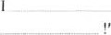Galileo 1640: 'I've explained my new ideashe — (h to the Church, but now I'm in trouble! Ifalive today!' e Leonardo da Vinci, 1518: Tve done a lot of things in my life, but perhaps I haven't spent c Marco Polo 1300: 'It's true, I exaggerated enough time on my paintings. I didn't always and made up some of the descriptions in the manage to finish them, I'm afraid. If 1 book about my travels. I suppose that'S why, more of them people don't believe the true things. 'If f Napoleon, 1820, in exile on the island of St

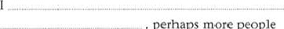

_

,

perhaps

more

people

Helena: 'Looking back, I can see that invading

Russia was a mistake. Without that, perhaps I wouldn't have lost the war. ff I

Russia, perhaps I

Emperor Of France!'

1. Use the information to make an impossible past conditional sentence, beginning as shown. It is not necessary to use all the information.

|  |  |  |  |
| --- | --- | --- | --- |
| The Trojans Saw the wooden horse, and | d | In 1469, Isabella |  |
| decided to take it into Troy. Once it was |  | of Castile married |  |
| inside the Walls, the Greeks hidden inside the |  | Ferdinand of Aragon. |  |
| horse came out, opened the gates, and the |  | Their marriage |  |
| Greek army captured Troy. |  | combined the two |  |
| If the Trojans aood&n |  | kingdoms and |  |
| , Greeks |  | created the kingdom |  |
| have. c-ap+ure.d c.i+g. |  | of Spain, which soon |  |
| b In September 490 BC, an army from Athens |  | became One of the | Of CastjtC |
| Plataea met the Persian army Darius I |  | most powerful , countries in |  |
| on the Greek coast at Marathon, about 35 km |  | If Isabella |  |
| from Athens. It Seemed that nothing could |  | Spain |  |
| Stop Darius conquering Greece. However, |  | In September 1066, Duke William Of |  |
| the Greek army won a total victory, and the |  | Normandy sailed with an army to England. | |
| Persian army went home, |  | He believed that he, and not Harold, was the | |
| If the Greeks |  | rightful king. Ilarold marched to meet William | |
| T)ariu.s and his army |  | bul his army was tilQd after fighting a battle | |
| C On 10 January 49 BC, Julius Caesur Crossed the |  | in the north against the Vikings. William Won | |
| River Rubiwn on the border of Italy with his |  | the battle that followed, and became king of | |
| army. This led to civil war which Caesar won, |  | England. | |
| anci so became leader of tile Roman state. |  | Il Harold's army | |
| If Julius Caesar |  | William | |

he

1. Complete the wish-sentence with the verb in brackets.
   1. 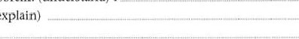What on earth is the answer to this problem! (know) Iaish I kite-a b Unfortunately, I haven't got a calculator. (have) I c The trouble is, I don't really understand the problem. (understand) I

d And my teacher never explains things to me. (explain) e I think I'd prefer to be in a different class. (be) f Ln fact, I'd rather do French instead. (do) g love France — it would be great to live there! (live) h Bul at the moment I have to my homework! (have to do)

1. Complete the wish-sentence with the information provided.
   1. Juliet: 'Considering what happened later, c meeting Romeo was a mistake.' m him!
   2. Christopher Columbus: 'Sailing to America was a mistake, perhaps, and it would have been d

better to stay at home!' at home!

Harry Potter: 'Learning to be a wizard has turned out to be rather dangerous. Deciding to go to a wizard school was a mistake!' school ! Marco Polo: 'It was great being in China.

Perhaps it would have been better to stay there, and not come home to Italy.'

I WishChina.

|  |  |  |
| --- | --- | --- |
| e Newton: 'Actually the Story Of the apple falling g Dt Frankenstein: •This monster is causing a lot Of | | |
| my head is true, and I can tell you it really hurt! trouble. Making him was a mistake.' | | |
| Sitting under the apple tree was a big mistake!'            him ! | | |
| tree : h Archimedes: Clumping out of my bath and | | |
| f Helen of Troy; 'I didn't really like Paris very much. running down the street shouting 'I've found it!' | | |
| Running away with him was a mistake.' was a great idea. But it was mistake not to put | | |
| 1 with him  some clothes on first!'  6 Rewrite the sentence as a complaint, using wish with would or wouldn't. Use contractions. | | clothes on |
| a Vou never hand your work in on time! [ aish goa 'd' b You always make so many mistakes! c You always drop litter on the floor! d You never pay attention!  e You always talk during the test!  You never listen to what I'm saying! g You always interrupt people!  h You always throw things across the room!  You never behave!  You always make so much noise!  7 Complete the text with the verbs in brackets.  Sloths live in trees and eat mainly leaves, twigs and fruit, In fact, if you a (be) a sloth, you b (spend) most of your life hanging upsidedown from a tree. This is the safest place for sloths.  sloth c (stay) completely stille predators d (nol realize) it is there, because it has green algae living on its skin, and il is difficult to see. Sluixs move very slowly on the ground, but if they |  |
| in Water, they f (swim) | extremely well. | they |
| have a IOW body temperature, and if g (remain) | _ too long in hot sunlight, they | |
| h (die) Sloths are not large animals. growing to about a metre in length. On the other | | |
| hand, if you I (be) in North America 20,000 years ago, you J (see) a giant | | |
| ground sloth. as large as an elephant! These giant sloths died out thousands of years ago, Modem sloths live in | | |
| the rainforest of South America, and they are in danger, like many rainforest animals. Il human beinvs | | |
| k (continue) to destroy the rain forest, sloths I (become) | | |

c o

|  |
| --- |
|  |
| What would your life have been like, if you had lived a hundred years ago? Write five sentences.  2 Write a list of wishes about things you want to change about yourself. |

c o

Use the passive

* to move important information (the object of the active sentence) to the beginning. Two men are being questioned by the police.
* when we want to be impersonal and not mention the name of the person who performs the action.

We often use the passive in scientific or technical processes. Oil and gas are found beneath the ground or sea.

* when it is obvious who performed the action, eg teachers, or we do not want to use a general subject eg people, they.

Aztec boys were trained to fight.

Two missing children have been found safe and

* more often in formal speech and writing than in everyday speech.

transitive and intransitive

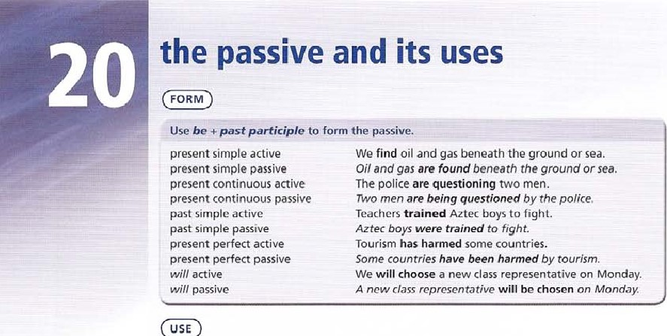Verbs wh ich have an object are calied transitive verbs; verbs without an object are intransitive. Only transitive verbs can be made passive.

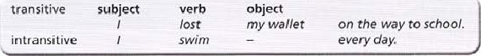

use by

* when it is important to know the 'agent' or person who performed the action Some countries have been harmed by tourism.  only when it is really necessary.

The two men were arrested. (by the police — this is obvious)

Use with  for objects which perform actions.

The wos played With a ball Of solid rubber

 Complete the sentence with the past simple passive form Of the verb in brackets.

* 1. In ancient times, fires (light) _ _ to use smoke as a signal over long distances.
  2. Morse code (invent)by an American called Samuel Morse.
* 'l'he world's first television images (show)  scientists in Scotland in 1926.

d Radios (use)to broadcast coded messages during the Second World War.

 The World Wide Web (design)originally to make it easier for nuclear physics researchers to communicate.

1. Buying books and CDs over the Internet (make)popular by the company Amazon.
2. The first mobile phones with cameras (sell)in Japanh Vinyl albums and tapes (replace)by CDs, which are now being replaced by mp3.

 The first English dictionary (wrote)by Robert Cawdrey in 1604.  The first mass-produced cars (introduce)by the Ford company in the USA.

1. Read the text and underline all the subject, verb and object structures. Then rewrite the text using present Simple passive verbs. Leave out any unnecessary words_

How a toy car is made

In the factory, they to plan the exact shape of the car. They then feed this computer program into a machine, and produce a plastic prototype. Then they produce the actual toy cars in a factory abroad. As far as construction is concerned, they make the bodies Of the cars from plastic. They add small electric motors to the cars, and then they paint them. They also attach licence plates. Quality control inspects the cars and then they wrap them and pack them into cardboard boxes. They ship the cars to Britain.



a

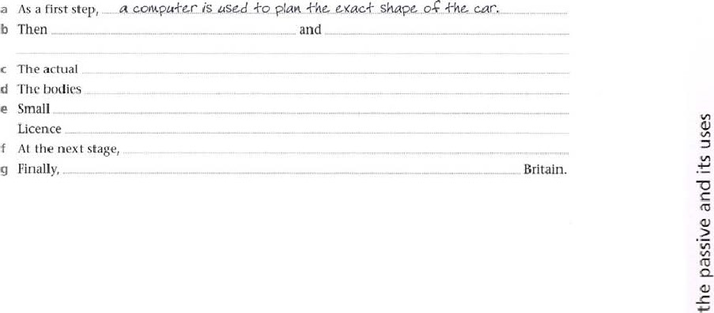

1. Complete the text with either the will passive or present perfect passive forms of the verbs in brackets.

In recent years many plans a (make) for large floating cities with living accommodation for as many as 50.000 people. One such project which b (advertise) is the Freedom Ship-According to the plans for this project, this huge ship c (construct) from smaller units. which d (take) out to sea for final assembly.The ship e (power) by diesel engines. and the residents on board f (carry) around the world continuously.

The large number of people on the ship g with all kinds of entertainment and sports facilities, and modern recycling methods h (use) to save energy on board.At the time of writing, this project i (not build) - .and j (criticize) by some people

11 who say it is too expensive.We shall have to wait and see whether this ambitious plan ever becomes

reality.

1. Rewrite the sentence using a present perfect passive with by. Leave out any unnecessary words.

a Cheaper air travel has made possible the global expansion in tourism.

 qtobat LKpanSion in *our-ism has  possible. cheaper b Countries all over the world have experienced a growth in tourism.

* 1. Millions of tourists have visited the popular Mediterranean resorts since the 1970s.
  2. Recently tourists have chosen more distant locations in Africa, Asia and South America.
  3. Mass tourism has badly affected some coun tries.
  4. international companies have built large hotels on unspoilt coastline.

g 

h Tourists have damaged coral reefs and other habitats.

 Such developments have also displaced local people.



 Some governments have developed the idea Of ecotourism to counteract some Of these problems.

1. Read the information about urban development. Then complete the text with the present perfect passive or past perfect passive form Of the verbs in brackets.

In many countries in recenc years. areas of urban 'and which w•ere once used for industrial purposes a (redevelop) have _bccn redevetopd for other purposes. In London, for example, the Docklands b (transform) since rhe 1980s. The docks c (built) _ in the 1 9th century when London was a busy port, but by the 1980s. most business d (lose) and many docks e (close) This left large areas of derelict land, and many people without jobs. Since the 1980s, 10 billion (€ 14.7 billion) f (spend)

On the projeet. 600 heetares Of derelict land g (improve) 90 km of new roads h (build) , 80.000 new jobs i (create) and 24,000 new homes j (construct) _ In addition to this, 1 00,000 new trees k (plant) and 130 hectares of parks I (create)

Cultural venues such as the Docklands Arena m (open) Some local people do not agree with all the things that n (do) , as houses here are expensive, and most jobs are in media. IT or business. On the other hand, a declining area of the city o (give) a new lease of life.

|  |  |
| --- | --- |
| Rewrite each sentence so that it does not contain the words someone or people.  a Someone built ships with sails more than 5,000 years ago. | Rewrite each sentence so that it includes the agent by.  f The Chinese probably printed the first books more than a thousand years ago. |

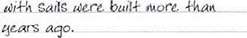Ships g,ocog The Remington company sold the first modern

|  |  |
| --- | --- |
| b Someone constructed a hot-air balloon in 1783. | typewriters in the 1870s. |



|  |  |  |
| --- | --- | --- |
| c People developed the steam ship in the | h | Edison recorded the first words on a |
| 19th century. |  | gramophone record in 1877. |

|  |
| --- |
| EXTENSION ACTIVITY |
| How much do you know about history? Write five sentences about famous events in the past, using these verbs: discover, invent, paint, write, build.  2 Write a list of five recent news events in your country. Describe what was done at a particular time.  Need more practice? Go to the Review on page 192. |

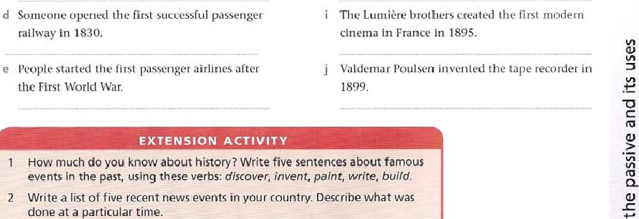o

use causative have

* to describe a service eg painting, decorating, haircut, operation, etc that somebody does for us.

We do not usually say who performed the action unless this is important.

I'm going to have my photograph taken. (by a photographer = not necessary)

I'm going to have my photograph taken by a top fashion photographer. (important information)

* for unfortunate events eg accident. fire, theft etc.

Sa/ly has had her ear stolen

We can use get instead of have in everyday speech eg I get my hair cut once a month. Note: Get something done can also mean manage to do something. Did you get your project done?

We also use get done for unfortunate events when there is no agent. Did anyone get hurt?

We can also use get instead of be in the passive in everyday speech with Verbs such invite, Offer, choose, take, send etc.

We got invited to Jim's house. She got sent to France on a course.

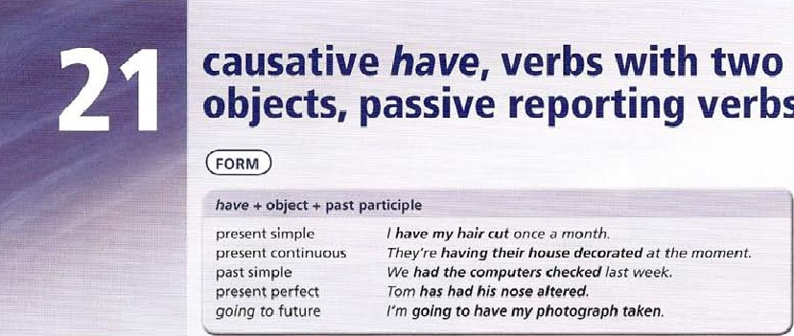

verbs

FORM

* Verbs with two possible objects

buy, give, lend, make something for someone, offer, prepare something for someone, promise, sell, send, take something to someone give Jim gave Alan some help. Jim gave some help to Alan.

take David took Susan a present. David took a present to Susan.

Verbs with two possible objects have two passive forms, but one is more commonly used. Alan was given some help by Jim. (more common) Some help was given to Alan by Jim.

Susan was taken a present by David. (more common) A present was taken to Susan by David.

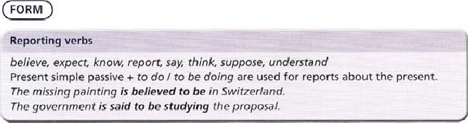

use reporting verbs and to do/ to be doing

* when there is uncertainty about the report. This is common in news reports.

The missing painting is in Switzerland ( = a definite fact)

The missing painting is believed to be in Switzerland. ( = that's what people believe)

Includes exercises from Units 20 and 21.

1 Complete each sentence using present continuous causative have.

Leave out the words

o a What are you doing on Monday?

In the afternoon a photographer is taking my photograph.

In the afternoon I n_atw having ?hv4vqraph b What is Anna doing on Tuesday?

In the morning a is cutting her hair.

In the morning She c And what is Alan doing on Wednesday?

In t he afternoon a dentist is taking out a tooth. In the afternoon he d What is happening at your house on Thursday? Some decorators are painting our kitchen.

we e Are you using your car 011 Friday?

No, the_.rage is servicing it. o

f And what are Sue and David doing on Saturday?

Some plumbers are fitting their new central heating.

They

2 Rewrite each sentence so that it contains a past simple causative have, Leave out any unnecessary words.

1. Sonwone broke 'Mm's nose while he was playing football-

Tim had broke-it

1. Someone stole Maria's bike last week. o

Maria c Someone damaged Mr Grover's Car last week.

Mr Grover d Someone took Anna's mobile.

-B

Anna e Someone sprayed paint on Our garden wall.

Our f Someone broke into our house. we g Someone knocked Off one policeman's helmet.

One policeman h Someone smashed our windows with a brick we

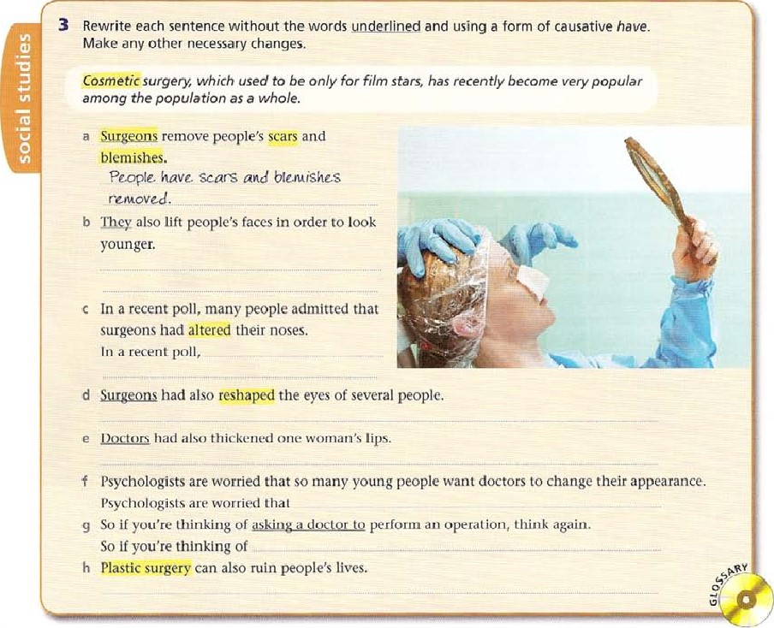

1. Rewrite each question so that it contains a form of get. Make any necessary changes.
   1. Did you finish your project in the end?

Oid gou gour prvc,/- $inishgd in cmd? b Was David sent to the head teacher's office?

 Have you done all your homework?

* 1. Did they choose Susan as class representative?



* 1. When are you sorting out the school sports programme?
  2. Have you organized your revision?
  3. Was Tony injured playing basketball?
  4. Were you invited to Maria's party?

1. Rewrite each sentence beginning and ending as shown.
   1. At the end of her term at college, a multi-national company offered Emma a job in Dubai. At the end of her term at college, Emma OMS in Oabai by a multi-national company.
   2. It wasn't very well-paid, but they promised her a good position in the future,

It wasn't very well-paid, but shein the future.

C They sent her a letter explaining all the details.

She the details. d The company explained that they would give her free accommodation,

The company explained that she free accommodation. e Her parents lent her some money to buy some new clothes and a laptop.

Sheby her parents to buy some new clothes and a laptop.

f Her fellow students gave her some CDs as a present.

Sheas a present by her fellow students.

1. Rewrite each item beginning as shown,
   1. People believe that the Prime Minister is seriously ill.

The Prime Minister _i$ b people think that she is in hospital.

She

 People suppose that She is flying to Washington tomorrow.

She d People understand that she is remaining in London.

She

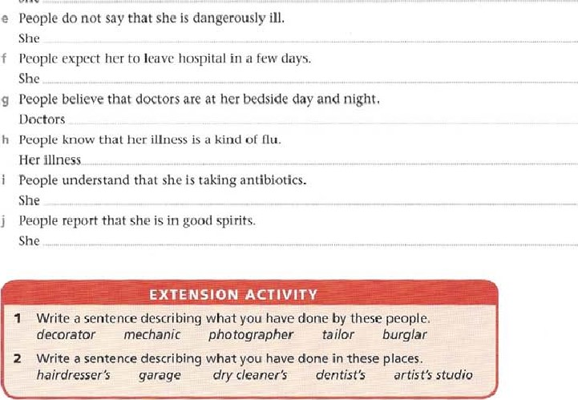f

modals: ability, obligation (present I future)

ability. can, cant. cannot

Cant is the negative. with cannot as a formal and written form. There is no third person -s form.

Question forms are Can l, Can you etc.

Use can } can't

* to describe ability or lack of it.

Many animals can See dearly in the dark Human beings cant do this. to describe what is allowed or not allowed.

Yau can look at the animals in the Zoo but you can't touch them. with a future meaning.

Sorry, but / can •t come to the party next week.

with verbs of perception: hear, see. taste, feel, smell. What can you see? / can smell gas!

ability: be able to

This has the same meaning as can.

Use be able to

* instead of can.

Many animals are able to see in the dark.

* whencan is unsuitable. Because can has only present and past forms. we use be able to for other tenses, and infinitive form.

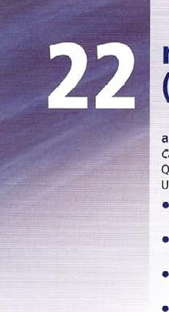 I haven 't been able to finish my project. We hope to be able to visit you next month.

obligation; have to / has to

The forms follow have: / have tow he / she has to etc; do / have to. does she have to; / don't have to etc. Use have to / has to

* to describe what is necessary. a rule, or something we do because other people tell us to.

Baby birds have to learn how to fly or they won't survive.

Do we have to buy another ticket to see this part of the castle?

The negative form. don't/ doesn't have to, is used to describe something unnecessary. I don't have to go to work tomorrow There's a holiday.

obligation: must / mustn't

The negative is mustn't with must not as a formal and written form. There is no third person -s form. Question form is must must you etc.

use must to describe something we personally think is necessary and important to do,

* There is sometimes little difference between first person I must and I have to. Sorry, I really ha ve to go now. Sorry. I really must go now'
* In Other contexts, there isa difference.

You must bp more careful! (2 personal Opinion of the speaker) We have to wear safety goggles. (z an 'outside' opinion or rule)

* We usually use the question form Of have to for must. Do I have to sit here?
* We use mustn't when we think an action is against the rules. Y'öü mustn't throw things the science It'S dangerous!
* Compare mustn't and don't have to.

You mustn't use a pencil. (itX not allowed)

You don't have to use a pen. (it's not necessary — use a pen or a pencil)

use should, ought to

* to say what we think is right or correct, or is a good idea in your opinion. This is not as strong as must. You should pay more attention. shouldn't talk so much.
* to give advice.

/ think you should study biology noxt year.

* in the same Way_ Ought to/ ought not to has the same meaning as should / should not.

use had better

* to say what we think someone should do. There is only one formhad better rd better. The negative is had better not.

You'd better wear your raincoat. It's going to rain. You'd better not wait too tong. You•/l be late.

use need to  with the same meaning as have to. Need to is not a modal verb.

You need to work harder. You don't need to come tomorrow. Do I need to bring my dictionary?

Need is a modal verb and has no third person form. It is mainly used in questions and negatives, and is more formal in use.

Need say more? He need not take the exam.

1. Complete each sentence With tan or can't + the verb in brackets. Use a form Of be able to if can / can't is not possible.

|  |  |  |
| --- | --- | --- |
| a That shelf is too high. I (reach) | e | Sorry, I (come) |
| it. |  | tomorrow. I'll try and see you next week. |
| b What'S that noise? I (hear) |  | I really want (use) |
| something. |  | a computer properly. |
| c There's something wrong with this door. I (open)  . it. | g | Don't push Harry in the water. Ile (swim) |

* 1. 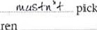I'm really hungry! I (take)h my lunch break yel-

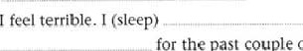

for

the

past

couple

of

nights.

1. Complete the sentence with must or mustn't. They are all strange but true laws.

a In New Hampshire, USA, you pick up seaweed from the beach. b In Inuisiana, USA, schoolchildren call their teachers Sir or Ma'am. C In Canada youlet a llama eat grass in a national park. d In Italy, a manWear a Skirt iri public.

e In Illinois, USA, you. use the steering wheel when you drive a car. f [n Michigan, USA, peopleswear in front Of women and children.

* 1. In Baltimore, Maryland, USA, you take a lion into a cinema.
  2. In Kentucky, VSA, everyone takc at least one bath every year,

1. Complete the sentence with mustn't, or don't / doesn't have to.
   1. You _ _ stand on the desk. You'll break it.
   2. we take an umbrella. I'm Sure it isn't going to rain. letter.
   3. weforget to take the presents with us when we go. e In our country childrengo to school on Saturday. f You touch the ball. It's against the rules.

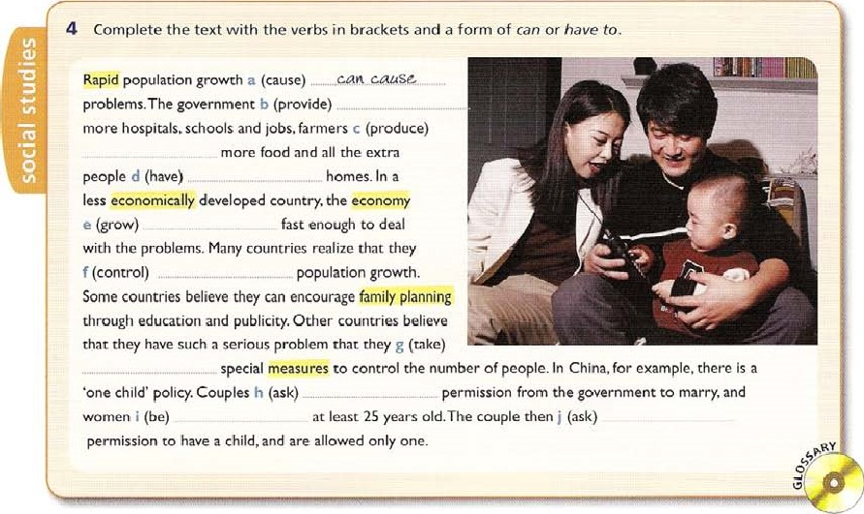

1. Complete the text to give advice on how to deal with a snake bite using should or shouldn't. Check the factual answers on page 208.

You Should stop the victim moving too much. You give the victim a painkiller.

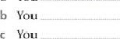

a

_ check the person's temperature, breathing and blood pressure. d If the snake is dead, you keep it for later examination. e Youcut into the bite.

 Youkeep the person calm.

g Youtry to suck out the poison with your mouth. h You ..„— „ give them food and drink.

1. Add a comment to each situation, using the pronoun in brackets and an idea from the list with had better.

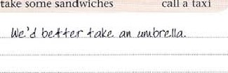don't play in the match check it in the dictionary leave now wear a hat don't wake him up take some sandwiches call a taxi

* 1. I think it's going to rain. (we) _ b It's a long way to the station. (you) c You don't look very well. (you) „ d We might get hungry later, (we) e It's going to be hot today, (you)

 The last train leaves in fifteen minutes. (we) g He's still asleep. (we) 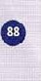 h That word doesn't look ri;ht.

* 1. Don't worry about spelling, but you should try to be as accurate as you can. NEEDN'T

You c It's necessary for you to identify all the necessary steps to solve a problem. NEED TO

You d You have to understand technical words, e; equation. NEED TO

You e It's vital for you to be able to use methods of multiplication and division. NEED TO

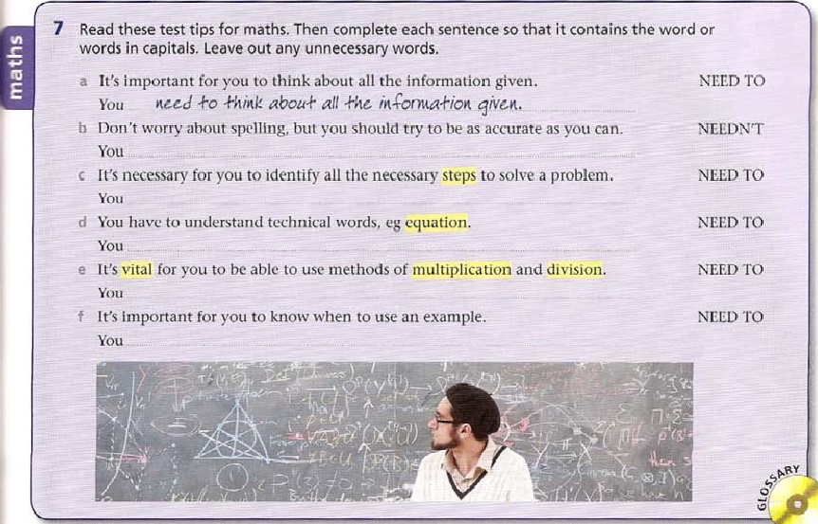You f It's important for you to know when to use an example. NEED TO

8 Choose the correct option, A, B, C or D, to complete the sentence.

1. Are you any good at athletics? How fast you run?
2. You take some money with you in case you need it,

|  |  |  |  |
| --- | --- | --- | --- |
| b A have to | B shouldn 't | C can | D should |
| A Wc needn | B We'd better | C We're able to | D V•Ve don •t have to |
| d A can 't | B don't have to | C had better | D shouldn 't |
| e A had better not | B needn't | C don't have to | D mustn 't |
| A mustn 't | B needn | C ought to | D |
| g A have to | B shouldn't | C mustn't | D can |
| h A can't | B don't have to | C shouldn 't | D needn |

|  |
| --- |
| EXTENSION ACTIVITY  Make a list of ten things you have to do at school or at work,  2 Give some advice about what you should do if you want to learn a foreign language well. |

 C I think that was the last bus. look for a taxi.

d I'm really tired, but luckily I get up early in the morning.  You look at other students' work. It's against the rules.  'My tooth really hurts!' 'l think you go to the dentist's.' g Sorry, but my train is at 6.00. I leave now.

h You eat so many sweets. They aren't good for you.

 A should B must C need D can

modals: ability, obligation,

criticism (past)

past ability: could, couldn't, was / were able to

Cou,'d I couldn't are past forms of can I can't. Could not is used in formal speech and writing. use could / to describe past ability.

We don 't know how fast Ancient Greek athletes could rum to describe What was allowed or not allowed.

Women couldn't compete or watch the ancient Olympic Games.

See also Units 22 and 24 for Other meanings Of could.

We can use was / were able to in the place of could / couldn't to describe past ability in general. He tried hard hut wasn't able to win the race.

We use Was I were able to, not could I coutdn't; when we mean that we could do something and we actually did it.

One runner fell badly, but fortunately was able to finish the race,

past obligation: had to, didn't have to

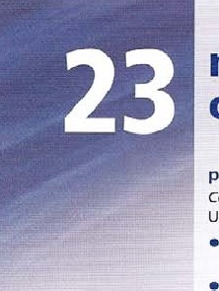Had to / didn't have to 1' did you have to etc are past forms of have to and must. use had to

• to describe past obligation, for both must and have to.

A thletes who cheated in the Olympic Games had to pay for a statue Of the god Zeus.

Ot course, in ancient times ath/etes didn't have to take drugs tests_

past necessity: needed to, didn't need to, needn't have Use needed to (regular verb) to describe what was necessary. He needed to stop tor a drink, but he kept running.

use didn't need to to describe what was not necessary.

In ancient Greece, winning athletes didn't need to work again. The question form is did you need to etc.

use needn't have + past participle (a form Of modal Verb need) to explain that someone did something, but what they did was unnecessary.

I was worried because / thought that my tickets for the Games wouldn 't arrive in time. But I needn't have worried They arrived this morning!

past criticism: should have / shouldn't have, ought to have, ought not to have use should have I shouldn't have + past participle to criticize a past action.

'You started before the gun/ You shouldn't have done that, '

'But ir was an accident/' 'Well, you should have been more careful/' use Ought to have / Ought not to have + past participle in the same Way. 1 Complete the sentence with could or couldn't.

1. The suitcase was so heavy I _ lift it.
2. I learned to play the piano when I was ten but I only play one song. c I have to go home soon, my parents said I stay out late.

d We don't know how, but the ancient Egyptians move huge pieces of stone to build the pyramids.

 Frank Sinatra sing really well but he— write his own songs.

1. He do the homework because he lost his book.
2. The Britons make soap before the Romansh I OO years ago, most people travel abroad because it was too expensive.

 The class worked hard so they leave early.

 When you were younger, you play any musical instruments?

2 Complete the comment on the situation with either didn't need to or needn't have (done) and the verb in brackets.

a I worked fast and finished my project on time, but now our teacher has given the class three more weeks.

(work) Ivme,eUn'khavzso hard! b At least I managed to do it without working at the weekend.

(work)the weekend.

C And although I thought I would have to borrow some books, in the end this wasn't necessary.

(borrow)any books. d But I gave up a lot Of my Spare time when I didn't have to!

(give) _ so much Of my spare time.

1. I spent a lot of time reading and writing every evening,

(spend) reading and Writing every evening.

1. But I managed to do it on my own, and I didn't ask for any help. (ask) any help. g And I didn't give up playing tennis.

(play)_ tennis. h I spent a lot of time using the Internet unnecessarily.

(use)so much.  But it was quite easy in the end, and I did it without thinking too hard! (think) too hard.  In the end, I worried about it a lot, but this wasn't necessary!

(worry) it so much

Complete the text with had to, didn't have to, could or couldn't the verbs in brackets.

låfe for children in Victorian Britain was very different from the life children lead today. Firstly, Victorian children a (go) have to school, and in any case poor families b (pay) lessons because they didnt have enough money so children c (find) . _ jobs at an early age, starting in the coal mines, for example, at the age of live. The more fortunate chi_ldren became apprentices, learning a trade and working at the same time. Such children d (work) for fifty or sixty a week, usually for very low wages, and e (Sign) an agreement which kept them with the same master for a number 01 years. The worst jobs were in factories. many children under the age of nine were employed. Children were also employed to clean chimneys, and known as 'chimney sweeps'

These children f (Climb) up A sweep chimneys and clean them. They g (be) small. or else they would get stuck in the chimney Using children to do this job was banned in 1840, but employers then h (use)Special brushes. which were expensive. and so [hey continued to use children. The employers i (pay) a small fine if they were caught. After the Factory Act of 1 833, employers in textile factories j (employ) children under the age of nine. though children aged ninc to Il k (work) — eight hours day, Howe,'cr, nothing changed in coal mines and in Other factories. where employers I (put) children to work in dangerous and dilly conditions. It wasnt until 18+7 that employers m (limit) the working day to ten hours, for both children and adults.

4 Comment on the situation saying what the person should have done or shouldn't have done. Use the verb in brackets.

a The ancient Greek philosopher Aristotle said that a heavy Object always falls faster than a light object, but he didn't conduct an experiment to prove it, and in fact he was wrong.

(conduct) _ He Should cegpcrbuen+, b The English scientist Francis Bacon wanted to find Out whether snow would preserve a dead chicken. He spent a long time in the cold doing this, and then died of a chill.

(wear) c Scientists often test things on themselves or their students. In the case of von I.iebig, a German chemist, he dropped acid onto the arms of his students to see what would happen. Unfortunately the acid burned their skin very badly.

(test) d Other scientists injure themselves by accident. Pierre Curie carried radioactive substances in his trouser pockets. This burned holes in his pockets and injured his legs. (carry)

e Another problem is that of lame. In some cases, scientists have their work done for them by others. The astronomer William Herschel made many important discoveries, but he was helped a lot by his Sister Caroline. Unfortunately, he didn't mention this to Other scientists.

(told people) f Other scientists get into political trouble, The French  Lavoisier discovered how oxygen is used in burning, and in rusting, Ilowever, the French revolutionary authorities arrested him because he was also a tax collector, and in 1794 he was executed, (execute)

5 Complete the text with could, couldn't, had to, didn't have to, didn't need to, needn't have, should have or shouldn't have and the verbs in brackets. Not all are used in the text.

lot of storie about people who a (be) Should a little bit more careful.

In 1576 the explorer Sir Martin Frobisher sailed '0 north Canada trying to lind a way 10

Unfortunately, he b (find) . it. but during the voyage. his men landed on Baffin Island as they c (look for) food and shelter- Here he discovered some rocks which he thought contained gold. When he returned to England he showed the piece of roek to people who agreed that it was gold, and Frobisher returned to the island with a larger ship. It was a difficult journey. as the ship d (avoid) huge icebergs. On the island there were polar bears which e (kill) a man quite easily And Frobisher was worried that someone else would get to the gold first. Perhaps he

|  |  |  |  |  |  |  |  |  |  |
| --- | --- | --- | --- | --- | --- | --- | --- | --- | --- |
| |  |  | | --- | --- | | (tell) so many people about his |  | | discovery, he thought. But he g (worry) | that's why | | about his secret- He found the place again, and his men | they call it | | h (work) in the freezing weather to dig for the gold. They returned to England again, and this time he i (stop) his discovery from becoming generally known. More and more people wanted go to Baffin Island, and the next year the ships came back with hundreds of tonnes of gold. Unfortunately.  this is where things went wrong, When Froblsher tned sell the gold, he discovered thal perhaps he j '(show)  - it to more people in the first place. The people he had showed it to had been wrong. They k (tell) the difference between gold and iron pyrite, a compound '_lf iron ancl sulphur. Everyone laughed at Sir Martin and his men. and he  I (admit) that he had made a mistake. | Fool's gold | |  |
|  |
|  |
| |  | | --- | | EXTENSION  ACTIVITY | | 1 Think about your first school. Make a list of thing you had to do, or didn't have to do. 2 Make a list of things that famous people in the past should or shouldn't have done.  Need more practice? GO to the Review on page {92. | |

### modals: possibility, uncertainty, certainty (present I future)

possibility and uncertainty Use may, might, could + bare infinitive

• to describe things that will possibly happen.

The next earthquake may might / could happen 

Use may not and might not + bare infinitive to describe things that will possibly not happen in the future.

The next earthquake may not / might not happen for another fifty years, Its impossible to predict exactly.

#### possibility

Use can + bare infinitive  to describe a possibility in general, but not with a future time reference.

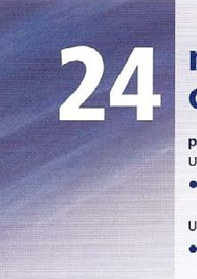During an earthquake people can suffer injuries when parts of bui/dings fall into the street

certainty

Use will + bare infinitive  when We are certain something Will happen in the fi-jtüre.

Dunng a strong earthquake, some Older buildings will collapse

Use must + bare infinitive  when we are certain something is true (usually with be), or when we suppose what a situation is like.

I've never been in an earthquake. rt must be really frightening.

(z I'm certain Of that.)

You've done a lot of work. You must feel really tired!

(z I'm sure you do.)

negative certainty

Use can't + bare infinitive  when we are certain something is not true (usually with be) or impossible.

That can't be an earthquake! We don't have earthquakes here' can't know the answer already/ That's impossible!

1 Complete the sentence with may or may not.

1. They sky looks a bit grey. It — nug _ ram later.
2. I don't think the new secretary likes her job. She stay very long. you leave right now, be on time.
3. In the future when technology has improved, it be possible to build a spaceship that can travel to distant planets.
4. I'm not sure if Sue's at home today. She have come back from her holiday yet. f The Prime Ministerfly to India later this week for talks on reducing global warming.

go to the party because I'm not feeling very well.

h According to astronomers, there be i_ntelligent life On other planets. We don't know because we haven't travelled very far into space yet.

 Jarekhave an mp3 player. Ask him if you can borrow it. Juan pass his exams if he revises every day,

2the correct form.

if you don't live in a Mediterranean can / Uzis!!! already know about earthquakes.

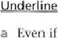

a

1. They can / might be frequent in some countries, though most are too small to be noticed by humans and you may not / cannot even notice when one occurs.
2. 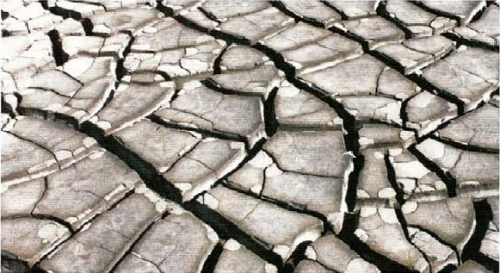Earthquakes are the result of movements Of the Earth'S tectonic plates, though human activity may / will be responsible.
3. Most earthquakes happen at depths of 20 or 30 km, though they will / can be as deep as 600 km. e What is it like to experience an earthquake? If the tremor is very small you might / couldn't feel nothing at all.
4. In a stronger tremor, there is more movement, and so the furniture in the room can / will move.
5. Tall buildings will / may definitely move a little, and, depending on how well the building is constructed, cracks will / might appear in the walls, h In a major earthquake, the building could / can collapse completely, though with modern earthquake-proof buildings, this is unlikely.

3 Rewrite the sentence so that it contains the word in capitals.

a I'm sure you know the difference between a solid and a gas! MUST You: know •Wtc diÆ$crznce bc&accn a solid and a, gas,' b If a substance does not contain hydrogen, then we are SUfé that it isn't an acid. CAN'T

* 1. If we put some litmus paper in a solution and it turns red, then We are sure that the solution is an acid. MUST
  2. If we add a to a red-cabbage solution and it stays red, then we arc sure the substance isn't an alkali- CAN'T

If we add a substance to a red-cabbage solution and it turns green, then the substance is sure to be an alkali. MUST

* 1. If we put some litmus paper in a solution and it turns red, then we are sure that the solution isn't an alkali. CAN'T
  2. If it's not an acid, or an alkali, then it's sure to be neutral. MUST
  3. If we use a universal indicator to check a substance, and it turns purple, then we are sure that the substance isn't an acid_ CAN T

|  |  |  |  |
| --- | --- | --- | --- |
| 4 | Rewrite each sentence so that it begins as shown and contains the word in capitals, | |  |
| a | If the world becomes warmer, as some scientists predict, it is possible that Europe will |
|  |  | change dramatically over the next century.  If the world becomes warmer .AS. pre-dig*, | COULD |
|  | b | It is possible that there will be no snow-covered mountains in Europe by then. There | MIGHT |
|  | c | And it's possible that areas in the south of Europe will become deserts. And areas | COULD |
|  | d | It's also possible that heavy rain will become normal in northern Europe. | MIGHT |

1. While it's possible that southern Europe will be always short Of water. COULD

While southern Europe

1. It's possible that there Will be some benefits for some people. MIGHT

There g It's possible that summers will become longer, and hotter, and winters will become warmer. COULD

Summers h On the other hand, it's possible that some species of plants and animals will become extinct. MIGHT On the other hand, some species Of plants and animals

5 Choose the possible answers. A. 8 or C, for each gap.

Most Of us enjoy a night"s sleep, _ not realize just how important sleep is. Everyone knows that without sleep for a night or two, a person b find it hard to think well. After three nights without sleep. you c Start to see things, and you d begin to lose your sense Of reality. In experiments, rats which are not allowed to sleep e actually die, which seems to prove that sleep f be very important-We know that children who do noc sleep enough can fail co grow properly, as growth hormones g be active while the body is asleep. Lack of sleep h also damage the immune system. so you i fall ill more often. Scientists don't know exactly what sleep is for and why humans need so much of it, but they believe that it j give the body a chance to repair muscles and replace cells. It k.

also give the brain the opportunity to organize memory. and some experts believe that dreams I help in this proeess.The brain also needs to rest. so sleep m give the brain a chance to •recharge' its batteries. Obviously, sleep n also be related to the fact that there are hours of darkness when our activities are limited.Another possible reason for sleeping is that if we didn't sleep and save some energy, We have to eat a lot more food.

a A may B might C must A might B must C could b A can B will C must A might B can't C will c A can B could C might k A might B could C may d A can't B must C could A could 3 can't C may

A might B can C will A might B can C cant A will B must C can't A must B can C can't g A can B can t C may o A can't B will C might h A can B may C could

|  |  |
| --- | --- |
|  | EXTENSION ACTIVITY |
| 1  2 | Make some predictions about how your life could change in the next 20 years.  What do you think it must be like to be an astronaut? use these ideas; food, feelings, sleep, washing, how you spend the time, training. Need more practice? GO to the Review on page 192. |

modals: possibility, uncertainty, certainty (past)

Use could, may, might + have + past participle to describe things that possibly happened in the past.

/ don't know where my bag is. I suppose someone else might have taken / could have taken it by mistake. Scientists now believe that ice may have shaped the surface Of the planet Mars.

use could, might + have + past participle

* to make a contrast between what was possible in the past and what actually happened.

That was a stupid thing to do! You might have hurt someone, It was lucky you didn't light the gas. It could have exploded

* to criticize someone's actions.

You might have told me the bus left at 3.00! I missed it/

Use can't have + past partici ple

* when we are certain something was not true.

I Still haven't heard from Peter. He can't have got my message.

use must have + past participle

* when we are certain something was true.

Congratulations on your exam results. You must have been really pleased when you heard the news. After the volcanic eruption on the Greek island of Santorini in about 1650 BC, there must have been a huge tsunami.

Use could, may and might and could have, may have, might have  in conditional sentences, when the results are not certain.

Ifyou heat the solution too quickly it may / might / could explode. If we found water on Mars, we could use it to make rocket fuel.

ff the dinosaurs had survived, they might have stopped mammals developing. // you hadn't reminded me about the party / might have forgotten all about it.

98

|  |  |
| --- | --- |
| a You almost dropped the computer and you nearly damaged it.  You | COULD |
| b You weren't careful when you were carrying it.  You | MIGHT |
| c It would have been a good idea to ask for help!  You | MIGIIT |
| d You pulled out the sheet of paper and you nearly broke the printer.  You | COULD |

1 Complete the comment using the word in capitals.

|  |  |  |  |
| --- | --- | --- | --- |
|  | e You opened an e-mail and the computer nearly got a virus.  The computer | | COULD |
|  | f Why didn't you check the name Of the sender!  You | | MIGHT |
|  | g The computer almost crashed and you would have lost all your work.  You | | COULD |
|  | h That was nearly a very serious problem.  That | | COULD |
|  | i You didn't tell me you hadn't used a computer before!  You | | MIGHT |
|  | j You didn't turn the comp uter off when you finished!  You | | MIGHT |
| 2 | Complete the sentence using the word in capitals. | |  |
|  | a | Don't go near the edge. You'll fall!  Il you qo near *he. e.dqe. gou could Calt _ | COULD |
|  | b | You rescued me and I didn't drown. If you | MIGHT |
|  | c | Nobody saw Tom come in late, and he didn't get into trouble. If somebody | COULD |
|  | d | Run a bit faster! Maybe you'll win the race! If you | MIGHT |
|  | e | Maria'S explanation wasn't detailed. We didn't believe her. If Maria'S | MICswv |
|  |  | Don't lift such heavy weights. You'll hurt yourself! If you | COULD |
|  | g | Put your wallet in your pocket! Perhaps someone will steal it! If you | COULD |
|  | h | Lucky you didn't drop the plates and break them! If you | COULD |
|  |  | Phone him and perhaps he'll still be at home. If you | MIGHT |
|  |  | United didn't score an early goal, and they didn't win. | MIGHT |

If 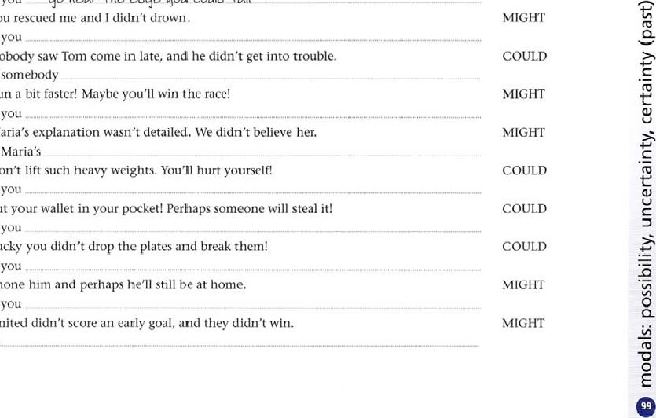3 Rewrite the sentence using the word in capitals.

a Some people think it is possible that the ancient Egyptians crossed the Atlantic. MIGHT



|  |  |
| --- | --- |
| b They think it is possible that the Egyptians traded with America more than 3,000 |  |
| years ago. | COULD |



|  |  |
| --- | --- |
| c Traces of tobacco have been found in Egyptian mummies and it's possible that this came from Central America. | MAY |

|  |  |
| --- | --- |
| d The discovery of silk in mummies also suggests that it's possible the Egyptians traded |  |
| with China. | COULD |



|  |  |
| --- | --- |
| e And because there are pyramids in Central America, it's possible that the Mayas got the idea for building pyramids from Egypt, | MIGHT |

|  |  |
| --- | --- |
| f On the other hand, as Egyptian pyramids and Maya pyramids are so different, it's Poysible that the two civilizations had similar ideas. | MAY |

|  |  |
| --- | --- |
| g lhere has even been a claim that it was possibly aliens from another planet who built the Mayan pyramids. | MIGHT |

|  |  |
| --- | --- |
| h According to this theory, it's possible that the aliens used the pyramids as landing places for their flying saucers. | COULD |



|  |  |  |
| --- | --- | --- |
| 4 | Rewrite the sentences about the conquests of the Spanish in South America using the word in capitals. Leave out 'l imagine...' |  |
|  | a I imagine the local people were shocked when they saw the Spanish armies.                         people have shocked | Mt;sr |
|  | b I imagine they didn't know where the Spanish came from. | CAN'T |



|  |  |  |
| --- | --- | --- |
| c | I imagine they soon realized that they were enemies. | MUST |

|  |  |  |
| --- | --- | --- |
| d | I imagine they weren't aware of the invaders' intentions. | CAN'T |



|  |  |  |
| --- | --- | --- |
| e | I imagine they wondered whether they were gods. | MUST |

|  |  |  |
| --- | --- | --- |
|  | I imagine the Spanish didn't expect to beat the local people so easily. | CAN'T |

|  |  |  |
| --- | --- | --- |
| g | I imagine they thought they would be killed. | MUST |

|  |  |  |
| --- | --- | --- |
| h | I imagine they didn't realize what the Incas were like. | CAN'T |

|  |  |  |  |  |  |  |  |
| --- | --- | --- | --- | --- | --- | --- | --- |
|  | |  |  |  | | --- | --- | --- | |  | I imagine the local people gave up when faced by horses and guns. | MUST | |  | I imagine the Spanish didn't expect to find so much gold. | CAN'T | |
|  |

1. Rewrite the two sentences as one if-sentence, containing could have (done) or might have (done). Leave out any unnecessary words.

|  |  |
| --- | --- |
| a The Trojans took the wooden horse into Troy. If they hadn't, perhaps they would have won the war. | d The medieval Europeans didn't know that America existed. If they had, perhaps they would have |

 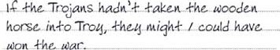 gone there sooner.

|  |  |
| --- | --- |
| b Alexander the Great died at an early age. If he hadn't, perhaps he would have conquered the whole world. | e The Aztecs thought the Spanish used magic powers. If they hadn't, perhaps they would have beaten them. |



|  |  |
| --- | --- |
| c The Romans spent a lot of time fighting among themselves. If they hadn't, perhaps their empire would have lasted longer. | f The Spanish didn't succeed in invading Britain in 1588. If they had, perhaps they would have then conquered all Of Europe. |

1. Read the text, Then write eight sentences explaining what people think might have happenedtothe Mayas.

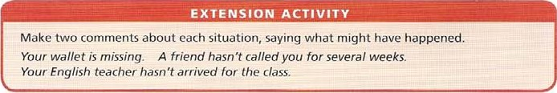Nobody is quite sure what exactly happened to the Mayan civilization.\Ne know that in 900 AD their cities were still prosperous, but a hundred years later they had been abandoned.A number of theories have been put forward to explain this. One theory is that the Mayan ruling class died out because rulers did not work and so became unhealthy, and there was nobody to tell the farmers what to do.Another idea is that farmers were unable to grow enough food to support large populations in cities. Other people believe that a natural disaster, such as an earthquake, occurred, the cities were destroyed, and the people never moved back. Or perhaps another Mexican people conquered the Mayas. and destroyed their cities. Another theory is that there was a revolution, in which the farmers killed their rulers. Some experts believe that an epidemic of some kind caused the disappearance of the Mayas. Others think that the Mayan cities suffered from an environmental disaster, caused by drought or overproduction. Finally, some people belicvc that the people abandoned their cities because their priests told them to do it.

a Magan "Aiqh+ have died e ou+ bccausc rotors did aoru, b

d

### modals: request, permission, offer, suggestion, advice, will as obligation

requests

A request is a way of politely asking someone to do something. The kind of request we use depends on where we are, who we are talking to, and what we want the person to do. Some forms are considered to be more polite than others.

polite Can you help me with the computer?

More polite Could you help me with the computer?

Would you help me with the computer?

Do you think you could help me with the computer?

Could you possibly help me with the computer?

00 you mind helping me with the computer?

Would you mind helping me with the computer? Responses Sure. / Of course. / No problem.

asking permission

We ask permission when we want to be allowed to do something. Some forms are considered to be more polite than others.

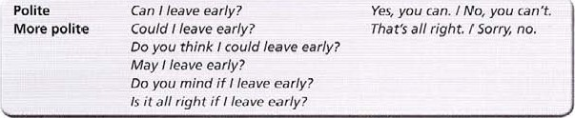

making offers

We make an Offer when we ask if someone wants us to do something, or say that we will do it.

Shall I tum on the light? Yes, please.

I'll turn on the light. Thanks,

Making an Offer can also mean asking someone if they want something. Would you like a glass of water? Yes please. / No thanks.

making a promise

I'll be back in five minutes. / won't do it again, I promise.

making suggestions and giving advice

A suggestion is an idea about what we or other people could do.

Let's go to the library and look it up. Good idea.

How about going to the library and looking it up?

Shall we go to the library and look it up?

Why don't we go to the library and look it up? (Why don't you, doesn't she, etc) We could go to the library and look it up-

Giving advice involves telling another person what they should do.

|  |  |  |
| --- | --- | --- |
|  | |  | | --- | | I think / I don't think you should make a decision now.  You shouldn't make a decision now.  If / were you, / wouldn't make a decision now. I'd make a decision now, if I were you. | |

will as obligation

In formal language and writing we can use will to describe a rule.

All students will wait outside the examination room until told to enter.

I Underline the correct form.

1. I have an appointment at the dentist's at 4.00. Would I / Maya leave half an hour early?
2. John, you're nearest the window. Could you / Could I Open it please?
3. Would you mind taking / Do you mind I take this note to the teachers' room for me?
4. Those books must be heavy. Shall you / Shall I carry some of them?
5. If I were you, I wouldn't leave / you shouldn't leave your bag by the door.

 I don't think you should spend / Why don't you spend so much time playing computer games.

1. DO you think I could explain / DO you think you could explain what this means?
2. I haven't got time to explain now. Let's ask / Why don't you ask me again tomorrow?

 Would you like / DO you mind more paper?  Can you / May you let me have your project tomorrow?

1. Choose the correct form, A, B or C, to complete the sentence.

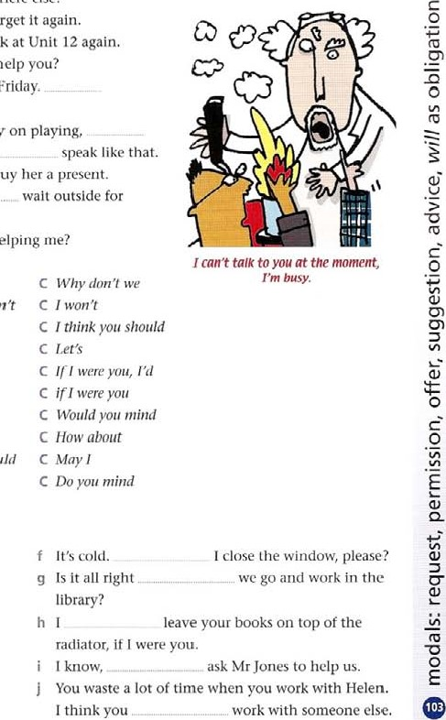Sit here, Or do you want me to Sit somewhere else? b I'm sorry I haven't got my homework.forget it again.

* 1. I don't think you've understood this._ 100k at Unit 12 again.
  2. Good morning, welcome to our school.help you?
  3. We need to talk about our group presentation for Friday, meet after school tomorrow?

 Your leg is certainly badly bruised. I wouldn't carry on playing, g That's not a very nice way to talk to Other people.

h Mrs Allan is leaving at the end Of term.buy her a present.  I can't talk to you at the moment, I'm busy.wait outside for a few minutes?

 I don't think I can do this on my own.helping me?

* 1. A Could you B Shall 1 C b A DO you mind ifI B IfI were you I wouldn 't C I won't

 Ifl were you B Do you think I could C

d A May B VVould you mind C Let's e A How about B Why don't we C

 you shotlldn't B shall 1 C

 A I don't think you should B IS it all right ill C h A Lets 8 Do you mind ill C

 A I were you I'd B Do you think you could C May 1

 A Would you like B I think you should C Do you mind

1. Complete each sentence with one suitable word.
   1. I've got an idea. Shall we record the f It's cold.

conversation on tape? g Is it all right b DO you think you— go next door library?

and borrow a piece of chalk? h you, I'd pay more attention. d Would youcarrying this? I know, e Perhaps playing football isn't such a good idea.

HOWgoing to the gym instead? I think you

1. Match sentences 1 to 10 with sentences a to j.

|  |  |  |  |
| --- | --- | --- | --- |
|  | Would you mind staying behind for a few | g If I were you, I'd talk to your parents | |
|  | minutes? | about it. | |
|  | g I've got a really bad headache. | 10 Why don't we meet before school | |
|  | h We've kicked the ball into one of the gardens over there.  1 1'm sorry I behaved so badly.  You should be able to see the cells if you use the microscope properly, | tomorrow? |  |
| 5 | Rewrite the sentence so that it contains the word in capitals. |  |  |
|  | a DO you mind if I keep my coat on?  IS ik alt riqhk coa4- ont_ |  | RIGIIT |
|  | b Do you want me to give out the books? |  | SHALL |
|  | c If I were you, I'd buy a dictionary. |  | SHOULD |

* 1. 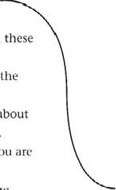Giving up maths is quite an important1 1 don't think you should worry about it, decision.2 I think you should have another 100k. b Could you possibly give me a hand with these 3 I won't do it again.

books?4 I'd like to have a word with you about

 Well done, you've worked very hard for the something.

past hour.5 Yes of course. Where do you want me to d I think we should get together and talk about put them?

Our presentation before we do it in class.6 Shall I climb over the wall and get it? e You've done a lot Of work, and I think you are 7 Would you like a break now?

ready for the exam.8 May I go Out for a few minutes?

|  |  |  |
| --- | --- | --- |
| d | Can you share with Mary? | MIND |
| e | Why don't we play volleyball for a change? | HOW |

|  |  |  |
| --- | --- | --- |
|  | I promise not to forget my homework. | WONT |

|  |  |  |
| --- | --- | --- |
| g | Could you explain What this means? | DO |



h I think you should read it again.

|  |  |  |
| --- | --- | --- |
|  | Do I have your permission to leave the room? | MAY |



 I wouldn't touch that if I were you. DON'T

6 Rewrite each sentence so that it begins as shown and has the same meaning.

a Do you want to go to lunch now?

Would _ t/kc*o +0 lunch .noa? b Could you collect in the homework please?

Do you think



1. Let's have another 100k at the table on page 218.

Why

1. I think you should revise all Of Unit 6.

|  |
| --- |
| EXTENSION ACTIVITY |
| Write examples of: a request, asking permission, making an offer, making promise and giving advice. |

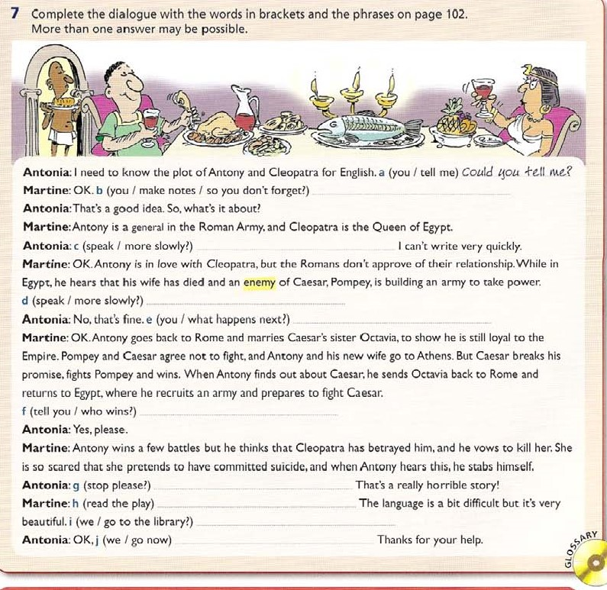If

1. Would you like me to explain it again?

Shall f Would you mind staying behind for a moment?

1. May I sit near the front, please?

Is

1. We could look for the information on the Internet.

HOW



### countable and uncountable

most nouns add —s to form the plural there are irregular nouns like man / men, knife / knives, life / lives, loaf/ loaves, person / people, child / children, mouse / mice some nouns like sheep, fish, aircraft do not normally add plural -s some nouns are always plural and have no singular form: clothes (cloth is a material), belongings, congratulations, goods, stairs. surroundings, thanks many nouns are uncountable. and do not have plural -s, or have a different meaning when countable or uncountable. Uncountable nouns normally use a singular verb. countable trees uncountable electricity countable woods (small forests) uncountable wood (material)  many nouns have an uncountable general meaning, and a countable particular meaning which can have plural -s general Few people are in favour of war.

particular There have been several wars between the tm countries.

* most uncountable nouns are things which we clearly cannot count. We use zero article, or some.

|  |  |  |  |  |  |  |
| --- | --- | --- | --- | --- | --- | --- |
|  | |  |  |  |  |  | | --- | --- | --- | --- | --- | | Gas, liquid, material  Grains etc  Abstract ideas  Feelings  Activities | rice health anger travel | Water sugar time pity work | Iron flour fun courage research | paper co ffee peace boredom behaviour | |

Other common nouns which do not normally have plural -s. and use a singular verb:

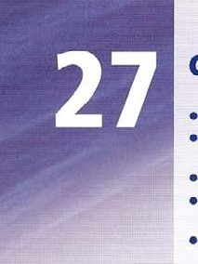advice, cash, Clothing, equipment, furniture. hair, information. knowledge, luggage, money, rubbish, scenery, traffic weather, work

* note changes Of meaning when uncountable nouns are used as countables with a/ an (see unit 31), and can have plurals

The doctor had many years of experience (knowledge of life)

Helen had a bad experience at her last school. (something that happens to you)

Many people here are looking for work (jobs)

This is a work of J 926. (a work of art: a painting etc)

Can you buy a paper? (a newspaper)

We had a good time last night. (when you do something) There is a hair in my soup' (a single one) Other countables with specific meaning:

an Iron an object used to make clothes smooth a coffee, a beer etc a cup or glass etc of a liquid  some uncountable nouns have a different countable word

bread — a loaf luggage — a bag, a case money — a note, a coin work — a job travel — a journey, a trip accommodation — a room, a flat etc

• many uncountable nouns have a scientific or technical use in countable form. Always use your dictionary to check which meaning is being used.

Sugars are a/so classified by the number of carbons they contain.

#### singular nouns ending in -s plural

Some nouns end in a plural -s but have no singular. and have a singular verb. the news mains electricity mathematics / physics / economics

Underline the correct farm.

|  |  |  |
| --- | --- | --- |
| a There are more than a thousand / sheeps on | f | Kate decided to change her style and bought new |
| this farm. |  | cloth / clothes. |
| b Please accept my thank / thanks for your beautiful | g | Paul found his belonging / belongings outside in |
| present. |  | the street. |
| c Helen is the only person / people I know with | h | Would you like to try a chocolate mouse / mice? |
| three cars. |  | World Airways has bought 20 new aircraft / |
| d There are two Kni[e / knives in the lop drawer, |  | aircrafts. |
| e Alan hurt his leg when he fell down the  Stair / stairs. |  | We have already sent the good / goods you Ordered. |

1. Complete the sentence with a word from the list in either singular or plural form as necessary.

You can use a word more than once. One word is not used.

 advice hair information Iron  knowledge travel

* 1. Some doctors say that it is dangerous to put too much _On Our food.
  2. If you want to be an explorer, you have to enjoy

. That's obvious.

* 1. Until the 19th century, ships were built using different kinds of d The body of an armadillo is completely covered in e There are rnany organi7A1tions that give school leavers about careers.

1. Rewrite each sentence so it contains a word from the list.

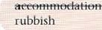clothing equipment scenery weather

* 1. The students' rooms were Of a very high standard. accojwuodakion verg ,hiqR s+andard.
  2. The rain and snow and high winds have been very bad this year.



* 1. The chairs and tables and cupboards are arriving tomorrow.



* 1. There are a lot Of bottles and bits Of paper at the edge of the sports field.

journey wood

1. The first electric , in the late 19th century, had no temperature control.
2. In chemistry, solutions ofin water are called electrolytes. h TheOf France are famous throughout the world,

 Discoveries made in physics in the 20th century

have given us newof the universe.

 The Internet is a good source Of though not all of it is accurate.

furniture work 

e The new things we use cost a lot of money, so look after them.

f

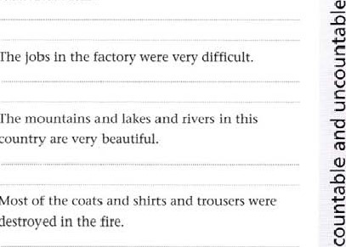

The

The

country

Most

destroyed

g

h

1. Choose the correct form, A or B, to complete the sentence.
   1. Martin had some very strange when he stayed in the Old castle.

A experience B experiences b I've always enjoyed , which is why I have worked abroad a lot.

A travel B journey c The teacher was upset at the children's

A behaviour B behaviours d Some people thin_k that if they don't eat, they will lose weight.

A bread e The computer printer has run out of

A paper B papers

In this part of the country, it isn't easy to find a

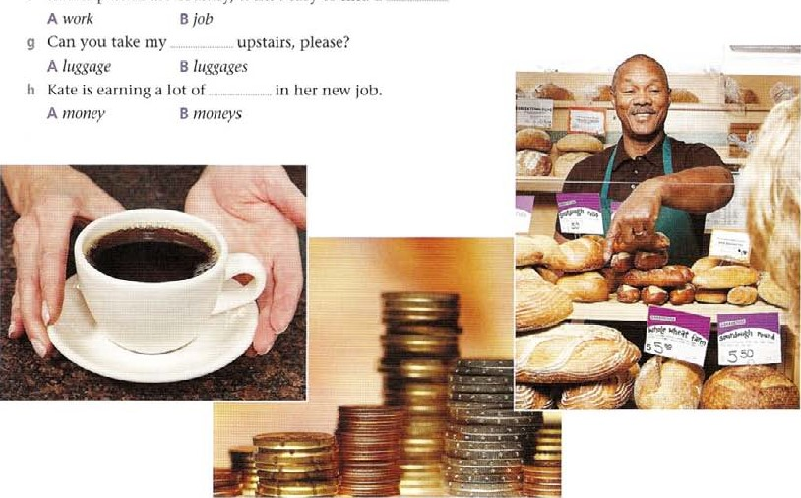

1. Complete the sentence with a singular or a plural form of be.
   1. The news _is on Channel Five at nine o'clock. b These loaves really fresh.

c I think that maths the most difficult subject. d The Coffees you ordered on the table over there. e The works Of Shakespeare still popular.

f Everyone says that money hard to come by these days. g The people I know all on holiday at the moment. h The traffic really terrible this evening.

1. Answer the questions about the text below. Letters in the questions refer to the nouns lettered in the text.

#### Energy is never created or destroyed

If you turn 011 a a light at the switch, b the room goes dark immediately. c Light doesn't stay as light [or very long after leaving d the lamp, so the light in the room has to be continually replaced. What happens to e the energy that leaves the lamp?

The hot lump loses energy 10 the surrounding fair — this is carried away by a g convection current_ The light and infra-red h radiation are absorbed by the walls and other surfaces, causing them to warm upD All the energy from the lamp spreads out into the room, causing a very srnåll i temperature rise.

Almost all the energy that we take from sources such as j electricity, gas, coal and petrol ends up as k heat in our surroundings — in the buildings that we live in, the air and the outdoors. We cannot get this energy back very easily; it is much easier to obtain more energy from a fuel or electricity than to extract the energy from the air and the I ground outside.

Circle the correct answer.

a a light (a) means A light in general B a lamp, something that makes light b light (c) means A light in general B a lamp, something that makes light c Which of these nouns can we make plural?

A the room (b) B light (C) C the lamp (d) D the energy (e)

Complete these sentences with a singular or plural form Of one Of the nouns in the text.

d all over the country will fall rapidly tomorrow, and there is a danger that the demand for may cause power cuts in some places.

is made up Of nitrogen, oxygen, carbon dioxide and a number Of other f People in London reported seeing numbers of unusual in [he sky, and many believed they were UFOs.

|  |  |
| --- | --- |
|  | EXTENSION ACTIVITY |
| I  2 | Make a list Of nouns from this unit that are uncountable in English, but plural in your language.  Correct the errors in these sentences.  Jane had her hairs cut last week. She looks fantastic.  I'm looking for an accommodation near the college.  I'll give you an advice. If I were you, I wouldn't take thatjob. Need more practice? Go to the Review on page 192. |

3

#### noun + noun, 's or of

##### noun + noun

Nouns are often used before other nouns as adjectives. The noun that comes first does not have plural -s. This is called a compound noun.

power station (a building that contains machines that produce power) export earnings (earnings from exports)

A noun as adjective often explains

• what a thing is part of a computer screen where the thing is found the bathroom window

|  |  |
| --- | --- |
| • what a thing is for | a bottle opener |
| • what type of thing it is | a seat belt |
| • what a thing contains | a teapot |

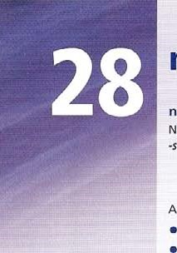Words which are always plural eg clothes, news, keep the plural form in compounds. a clothes brush a news broadcast

Two short nouns usually join together as one word, eg teapot. Other compounds are written as two words, eg a bottle opener, or may have a hyphen, eg a bus-stop. Check in a dictionary as the use of hyphens varies greatly.

A noun can have two nouns as adjectives.

shop window displays Christmas tree lights

possessive apostrophe, of

Use the apostrophe and -s at the end Of a singular noun or name to show that something belongs to Someone, eg Helen's bike.

use only an apostrophe after a plural —s, eg the junior girls' team.

With names ending in -s, use either an apostrophe, or an apostrophe with -s.

St James' Park St James's park

We generally use of when we describe one thing belonging to another. the bottom of the sea the rotation of the Earth

Note that usage varies, and other forms are possible, depending on the context. When you are uncertain, use of.

the sea bottom the Earth's rotation

Note: the apostrophe is also used in contractions, eg it isn't. This is not a possessive apostrophe.

IA Explain what each thing is for.

a a bottle opener 1k opt-RS bokklc-s. b a pencil sharpener c a coffee maker d a lawn mower e a dishwasher

1B Make a noun + noun compound.

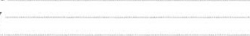f a strap you find on a watch g a hole where you put a key h a racket for playing tennis i a light you find in the street j a book you get from the library 

2 Rewrite each phrase underlined as a noun + noun compound. You may have to change plural and singular forms.

a The Eastern Highlands are a range of mountains running along Australia's cast coast.

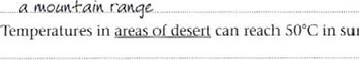

b

summer.

C Aboriginal peoples are thought to have come to Australia from Southeast Asia around 50,000 years ago when J.gyg.Is-QL.ths.sea were much lower.

(leave out thé) d Over a third Of Australia's income from exports comes from agricultural products.

|  |
| --- |
| exporter of |

e Australia is still the largest in the world.

is the northern state of Queensland.

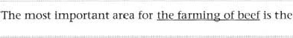

f

(leave out the) g Crops are watered with systems of irrigation.

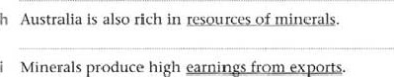

from

 Sydney is the largest city and has an important district for business. 3 Rewrite the underlined words as a phrase with of. You may have to change plural and singular forms.

The a air temperaWre in a cloud determines b and temperatum is mainly above OOC, rain is formed by a process called coalescence. The clouds arc made up of millions Of d droplets, and as these droplets collide. they form larger droplets. Cradually the e drop'#_ increases until they are too heavy to be kept in the air by f areas, clouds may stretch up into air which is below freezing. These clouds are a mixture of water droplets lower down, and h and special supercooled water droplets higher up.The supercooled droplets exist as water even though the temperature is below freezing-As well as coalescence at the bottom. a process called accretion happens higher up in these clouds.The ice crystals attract the supercooled droplets, which freeze onto them.As the crystals grow and stick to others, i snowflakes form.When they become too heavy to be held up, they fall.

o o

o

1. the -f-hc. air.
2. the c the the

4 Make a noun + noun compound using two of the words. You may have to change a word from plural to singular.

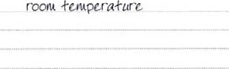a the same temperature as there is in the room b fumes which come from exhausts  salts which come from minerals d chemicals present in food e generations which will exist in the future f disease suffered by the heart g a solution Of salt h pollution carried in the air  change in the climate  a bill you receive for your use Of electricity 5 use some of the words to make a two- or three-word compound. You may have to change a word from plural to singular.

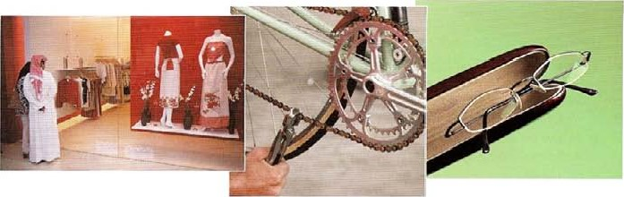

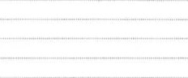a a window in which things are displayed in a shop b a ticket you buy so that you can travel on a bus c a key you use to open the front door d a chain you use as part of a bicycle e a directory which contains a list of telephone numbers  a case in which you can put your glasses g an engineer who knows how computers work h a shelf on which you put books a bell which rings when there is an alarm a bus which takes children to and from school



Shop

6 Put in eight more missing possessive apostrophes, not counting the example.

David Copperfield, the novel by Charles Dickens, is a Story Of one

Struggle after losing his parents. Davids father dies when he is young. and his mother remarries. His stepfather, Mr Murdstone. treats David unkindly, and he can only find happiness With the Peggoty family, his nurses relatives. At school, at first he is unhappy but Chen wins his friends respect. However, when his mother dies, his stepfather sends him to work in a factory in London, where the Other boys make fun Of him. David runs away and walks to his aunts house in Dover. Here he grows up happily, goes to school and becomes a clerk in a lawyers office in London. He falls in love with Dora, his employers daughter. and when his aunts money is lost in a bad investment. he works writing reports of parliament for the newspapers. Many parts of the Story follow the events of Dickens life.



|  |
| --- |
| EXTENSION ACTIVITY |
| Make a compound noun from each description. 2 Explain what these words mean. a lamp you have on your desk Check in a dictionary. a bus stop a dog trainer a handle on a door a football shirt kitchen paper a jug that contains water a news report a coffee maker a book you use for writing exercises the door at the front of the house a room where computers are used |

O

articles (1)

use indefinite article a / an

* when first describing something, or making a general statement about something not known or without any details. Use an when the word following begins with a vowel.

Suddenly a man appeared outside the window. That is an interesting point.

* to give an example.

A thermometer is used for measuring temperature.

* to describe one of a class of things or people. Paula is an Italian. She's a teacher, It's a racing bike.
* for rates and speeds etc,

Some people can cycle 50 km an hew,

Phi/ earns €500 a month

use definite article the

* 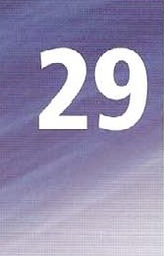with things or people already mentioned.

First, I take a test tube. rhen into the test tube I pour 50 cc of water  when a noun is made definite by details following it.

That man outside was the man that the police were looking for.

* when we definitely know what is being talked about. Are you going to the post office? Can you get me some stamps? Pass me the salt please.

Use zero article

* to describe something general or uncountable.

Love makes the world go round. Water boils at T OTC.

Some pc-aple believe that men and women think differently.

* with proper names, though these can begin with the if they have details following them.

Kate lives in Manchester in a little street Green Street.

This is Mary Smith. She is the Mary Smith I told you about.

* with general examples, countable or uncountable.

Doctors often have to work more than a hundred hours a week. Water is a scarce resource in many parts of the world.

Note that article use depends on context. Unit 30 contains more examples of how to use a / an, the and zero article.

I Underline the correct word.

1. I don't like that coat. / A colour is horrible.
2. He doesn't like going to see the / a dentist.
3. She asked for the / a cup of colfee, but she got tea instead. d "I-he / A laboratory is a place where scientific experiments are done.

e I don't believe he's the / a policeman, he looks too young! f She is a / an intelligent woman, g I went to the / a bank today and they said I didn't have any money!

h Who left the / a door open?

 A / An hotel is more expensive than a / an youth hostel.  The / A film starts at half past seven.

1. Choose the correct form, A, B or C, to complete the sentence.

|  |  |
| --- | --- |
| a If you want to be healthier, think carefully about | you eat. |
| A food B the rood b If you don't enjoy     , do something else. | C a rood |
| A the exercise 8 an exercise c Try learning | C exercise |
| A a new sport B new sport d Sometimes the food you eat is less important than | C the new sport |
| A rood you don't eat B a food you don't eat e Do you eat enough | C the you don't eat |
| A fruit and vegetables B the fruit and vegetables | C [ruit and the vegetables? |

f There is a saying, 'a day keeps the doctor away.'

A The apple B A apple C apple g chocolate cake should Only be eaten occasionally.

A The piece or B Piece or C A piece or h Stress also makesunhealthy.

A the people B people C a people  If you've had, try and do something nice for yourself.

|  |  |  |
| --- | --- | --- |
|  | A the bad day B bad day  You could visit a friend or go to | C a bad day |
|  | A cinema 8 the cinema | C a cinema |



1. Complete the text with a / an or the.

### Memo checklist

word memo is short for memorandum and it means b note to help as reminder. within d business and

It is only used for e full external

so there is no need address Of person you are sending it

to. However, you might need to show g „ internal office address, eg room number and building.

There are usually just spaces for h

names of the person sending and the person memo. However, copies might receiving i be sent to other people in i A company

for reference.

The subject is clear from heading and I text is brief.

There is no formal signature. Sometimes originator will sign their name freehand at n bottom.

Business letter checklist

language used in p business letter tends to be formal eg 'We regret to inform you

q letterhead includes full address and telephone number Of business.

address of u

recipient is also included in full on v _ left-hand side above

Everything is left justified (starts at x left-hand edge) except letterhead.

Letters Starting 'Dear Sir' end in 'Yours faithfully'.

If you Start With name of the person you are writing to, for example 'Dear Mr Brown', you end I letter with •Yours sincerely'.

|  |  |  |
| --- | --- | --- |
| 4 Complete the text with a / an, the or leave blank for zero article.  Energy  waves are vibrations that transfer energy• fmm place to place without b matter (solid, liquid or gas) being transferred. For example, think of   |  |  | | --- | --- | | Mexican wave in d  f_ wave moves around g seat, only moving up then down when  Some waves must travel through h | crowd at e _ football match_  m. stadium, while each spectator Stays in their their turn.  substance. •lhis substance is known as |   medium, and it can be solid, liquid or gas. j _ sound waves and seismic waves are like this. As the waves travel through it, k medium vibrates. |

2 date and any reference number are shown at 3 top of 4 letter.

Other waves do not need to travel through I substance.

|  |  |  |  |  |  |  |  |  |
| --- | --- | --- | --- | --- | --- | --- | --- | --- |
| 5 Complete the text with a I an. the or leave blank for zero article.  Glaciers  Most Of a glaciers are found near   |  |  | | --- | --- | | b | Poles. but c glaciers exist on all | | of d _ | world's continents. glaciers | | need | special kind Of climate. Most are found | | in g | areas of high snowfall in winter and cool |   temperatures in summer. These weather conditions ensure that snow that falls in the winter isn't Iosc by melting. or j evaporation in summer.  Such conditions typically occur in polar and high alpine regions.There are two main types of k glaciers: I valley glaciers and m continental glaciers or ice sheets.  glaciers depend on o , snow or p freezing rain to survive. In Antarctica.  for example. although q temperature is low. there is little snow or rain. and this causes |

travel through m medium, but they do not have to. n infrared rays. and microwaves are like rhis. They can travel through o may be able to visible light. empty space. there to grow Very Slowly.

A glacier forms when snow builds up over time, turns to outwards and downwards because of pressure of its own weight.

slowly grow together to form a thickened mass of w ice. x n glacial ice usually makes it seem a little blue in colour

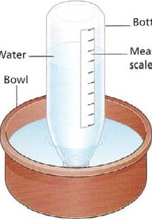

Bottle

Water

6 Complete each sentence with the, a / an or zero article.

Inst week at school we learned how to make a barometer.

b This iscardboard which we used to make our barometer.

C And this isbottle we used. We attached the cardboard to it. d We mademeasuring scale and attached it to the side of the bottle.

1. This isbowl we also used as part of our barometer.

We filled the bowl with water, and filled the bottle three quarters full, and then turned the bottle upside down in the bowl.

1. The pressure of air has an interesting effect on water you put in the bowl.
2. The pressure makeswater in the bottle rise.
3. We used measuring scale on the side of the bottle to measure the air pressure.



|  |
| --- |
| EXTENSION ACTIVITY |
| 1. Does your language have definite. indefinite and zero articles that work in the same way as English articles? Look at all the examples on page 114 and translate th em. What are the differences? 2. Check that you have the correct answers to Exercise 1, and then translate the sentences. |

ice. and begins to flow buried layers thickness of

Measuring

articles (2)

use indefinite article a / an

* to mean one.

What would you like to eat? Can / have a banana?

to refer to large whole numbers, fractions, weights and distances. a hundred a million a third a fifth two and a half a kilo a metre and a halt

* with a headache, a cold etc.

I've got a headache / a toothache / an earache Have you got a cold? Note that most illness words use zero article.

I've got flu. She's suffering from appendicitis.

* in the expressions what such

We use what a when we are surprised or impressed by something. What a fantastic idea/ What a great bike you have got/ We use such a for emphasis with singular nouns.

This is such a difficult problem/ Thanks, you 've been such a good friend

* to describe one example of a set of things. That's a Picasso (a work of art) This is a Robbie Williams song.

Use definite article the

* with nationality adjectives that refer to all the people of that nationality, eg Chinese, Japanese, French, Spanish, British, Swiss.

The French drink a lot of wine.

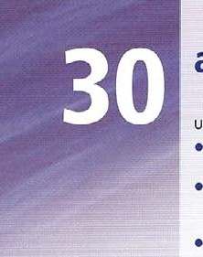The Swiss ere tamous for their bunks.

* with plural nationality nouns in same way, eg Russians, Americans, Poles, Greeks, Turks. The Russians and the Poles are used to cold weather
* with a singular noun to describe a class of things. The car has taken over our cities.
* with the names of shops and places with a general reference.

Annat at the cinema / the supermarket / in the qdrden / in the mountdins / at the beach etc.

* with some familiar objects when we think of them as the only one.

One moment the Sun was shining in the sky. Then the Moon seemed to rise out of the sea.

 with the names of oceans.

They crossed the Pacific in a small boat.

use zero article

* to talk about school subjects, such as geography, history etc. ffyou want to study physics, you have to be good at maths.
* to refer to days. months or parts Of the day,

I'll see you on Monday at midday. School begins in September.

* with continents, countries, lakes, mountains etc. When plural, we use the.

Lake Geneva borders France and Switzerland. From here you can see the Alps  with at home, at school, in hospital, in prison, in bed when we speak in general,

David isn't at school today. He's in bed at home

But when referring to something other people know about, eg a specific place, building etc we use the. The bus Stops outside the school Leave the towels on the bed.

* with such for emphasis with plural or uncountable nouns.

You are such noisy children! [hrs is such wonderful ice cream!

1. Underline the correct option. This may include a space for zero article.
   1. Tue / Republic Of Slovenia lies at a / the heart Of the / Europe.
   2. It is where the / Alps face the / Pannonian plains and the / Mediterranean meets the / Karst region.
   3. To the north is the / Austria and the I Hungary is to the / east.
   4. To the south is the / — Croatia and to the west is the / Italy.
   5. A / The / weather here is ideal for the / holidays.

 There are approximately 2,000 hours of a / the / sunshine per year, and there is plenty of the / snow in winter.

* 1. There are many woods and forests covering more than half of a / the / country.
  2. In the / Kocevje area in one of a / the / oldest forests in the / Europe, it is possible to walk among the trees for days.

1. Complete the text with a / an, the or leave blank for zero article.

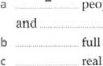people often Say they have flu when all they have iscold slight temperature.

full name Of flu isinfluenza.

real flu is caused byvirus. d There are many different kinds offlu virus.

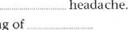e They give you high temperature, aching muscles and f They also give youcold shivers and feel ing of tiredness.

* 1. You may also getcough.
  2. There is no treatment as _ antibiotics cannot kill viruses.

 You should go to bed and rest.

 If you go to school and mix with others, you will spread virus to them, so it is better to stay athome until you feel better.

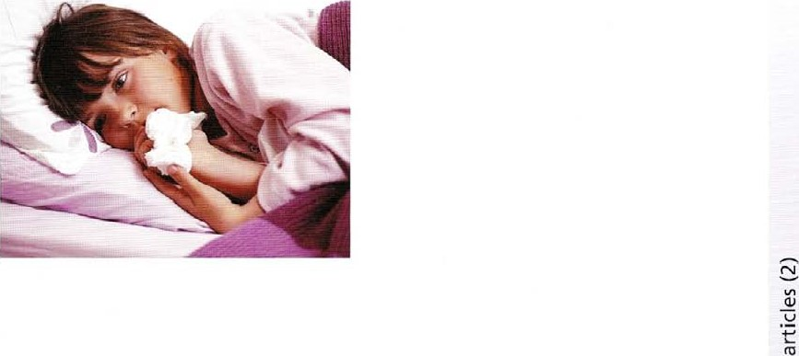

1. Complete the text with a / an, the or leave blank for zero article.

|  |  |  |  |
| --- | --- | --- | --- |
| Equity Travel School Tour Specialists | We organize tours to j wide range of | | |
| Equity has been arranging a | countries in k Europe, and also offer | | |
| educational tours since 1991 and our Directors and | tours in I USA, m | | |
| Managers have many years' experience in  . school travel, making us true | South Africa, and other parts of the world. | | |
| Specialists in c field. | Study Tours | | |
| Youth and School Group Travel | History tours, geography tours, n | | |
| We know and understand d special | language courses and cookery courses are all | | |
| requirements Of schools and youth organizations | available in our study tours programme, specially | | |
| and can meet your needs. You will receive        high-quality educational tour, with | designed for o .school groups. | | |
| unrivalled personal service and excellent value for | World Wide— USA, South Africa, China | | |
| money. | and India  There is p special brochure of tours | | |
| Educational Tours | New York and Washington, | | |
| All our tours have g educational value | West Coast Of America, South Africa | | |
| and many have been specifically designed to | (visiting big game parks) China, visiting | | |
| comply with h _ requirements Of | Great Wall and t Golden | | |
| UK National Curriculum. | Triangle in India (visiting Delhi, Agra and Jaipur). | | |
| 4 Look carefully at each line. If the line has an article (a / an or the) which should not be there, write the article and the word following in the space. Put a tick in the space if the | | |  |
|

line has no errors.

A hurricane is a fast-moving storm moving in a circlc measuring between

60 and 1,000 miles in diameter. It forms over a warm water far out at sea. b (zaanu)

It begins as a group of strong thunderstorms moving across the ocean.

usually known as a tropical wave. The weather conditions must be just right to turn a tropical wave into a hurricane, and the less than five per cent of them ever become the real hurricanes.A tropical wave that begins to spin around a centre Of low pressure is called a tropical depression. The tropical depressions have a maximum wind speeds Of less than 65 km per hour at the ocean's surface. h

When the winds reach 65 km per hour Or greater, the storm changes into a tropical storm, and the meteorologists give it a name.Vy'hen these winds reach 120 km per hour or greater, a hurricane is formed. Each hurricane has an area in the middle called an eye. In the eye there is the low pressure and the winds are calm.The eye is surrounded by severe thunderstorms with high winds and a heavy rain. Hurricanes are called typhoons when they occur in the western Pacific Ocean, and cyclones in the Indian and southern

Pacific Oceans.The name hurricane is used for storms in the North Atlantic p and in other parts of the Pacific. Most hurricanes occur between the June 1st and 30th November.

1. Complete the text with a / an, the or leave blank for zero article.

Do exams make pupils lose interest?

children could be turned Off their favourite subjects for b life if they are pushed too hard to take exams,d psychologists are warning.

study of I I-year-olds found that those who had taken exams to win f school places rapidly lost g interest in their school work after h exams were over. Other children, who did not take i same kind of tests, did not have same experience. In this study. k group of researchers measured I motivation Of children in m science, English and o maths. Before p exams q . children all appeared very motivated, but as soon as exams were over. that changed, and their motivation went down. Motivation stayed same among another group who took normal school tests. Researchers think it is possible that some children ence can be put off t — subject permanently by an exam.

1. Complete the text with a an, the or leave blank for zero article.

Apple Computer was founded in Los Gatos, California on 1 April, 1976 by Steve Jobs, Steve Wozniak and Ronald Wayne, to sell a _ _ khc._ Apple I personal computer kit at $666.66.

They were hand-built in Jobs' parents' garage, and bApple I was first shown to public at d Homebrew Computer Club. Jobs and Wozniak, two Steves, had been f friends since 1971 _ Jobs managed to interest Wozniak in assembling g personal computers and selling them. Jobs approached computer store, which ordered SO units and paid for each unit. Jobs then ordered components from Cramer Electronics, i company making electronic parts.

Using j number Of methods, including borrowing space from k friends and family and selling Ithings including m Volkswagen Type 2 bus, Jobs managed to secure n _parts needed while Wozniak and another friend, Ronald Wayne, assembled oApple I. The computers were delivered in June, and paid for On delivery. Eventually 200 Apple I computers were built.

Apple Il was first sold in q 1977 . It was popular with home users and was occasionally sold to s business users, particularly after t release Of u first computer spreadsheet, called VisiCalc.



|  |
| --- |
| EXTENSION  ACTIVITY |
| 1. Look at all the examples on page 118 and translate them. Does your language use these articles in the same way? What are the differences? 2. Check that you have the correct answers to Exercise 1, and then translate the sentences. Need more practice? Go to the Review on page 192. |

Could you give me some advice?

* in questions when we expect the answer yes. Have you got some homework to give me?
* to mean 'not all'.

Some of the people / Some people were drowned, but others survived

Use any

* with plural countable nouns, in questions and negatives.

Are there any books in that cupboard? There 't any books in this one.

* with uncountable nouns in questions and negatives with a singular verb.

Is there any information about this subject? There isn't any water left.

* to mean 'whichever one you like'.

You can borrow any books you need from the library.

uncountable (mass) nouns (See also Unit 27) Use a singular verb with:

Things we eat bread, chocolate, food, fruit, meat, spaghetti

Other words accommodation, advice, behaviour, damage, education, furniture. grass, hair, help, information, jewellery, knowledge, luggage, money, news, rubbish, shopping, traffic, weather, work

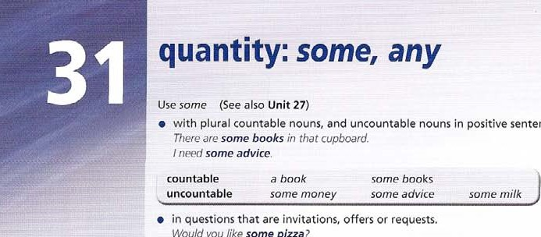

sentences.

Would

you

like

some

pizza?

People uses a plural verb.

There are some people waiting for you.

It also has a different countable meaning with plural -s. The peoples of the world want peace.

countable versions Of uncountable nouns

Many uncountable nouns have a countable version. Always use a dictionary to check the meaning.

a chicken (an animal) some chicken (food) a coin, a note (money) some money a glass (container) some glass (substance) an iron (for ironing) some iron (material) a paper (a newspaper) some paper (material) a tea, two teas etc (a cup or glass) some tea etc (a liquid)

partitives

A partitive is a noun + of which makes a countable version of an uncountable.

a slice of bread a sheet of paper a bar of chocolate / soap a packet of rice a can of cola a tube of toothpaste a cup of tea a bottle of water a loaf (of bread)

1. Use the prompts to make a question with there any, using a singular or a plural verb. Check the factual answers on page 208.
   1. be / oxygen On Mars?

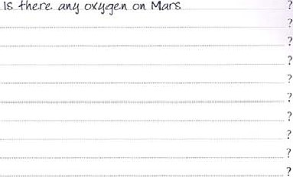

_IS

* 1. be / cheese on the Moon?
  2. be / mammals with beaks and webbed feet?
  3. be / weather on other planets?
  4. be / fish that can walk on land?

be / birds that can't fly?

* 1. be / water on the Moon?
  2. be / apes that can be taught to speak?

be / Oil or coal on the Moon?

be / living dinosaurs left on Earth?

1. Rewrite the sentence to make a statement With not any beginning as shown. Then decide if each Statement is True or False. Check the factual answers on page 203, a Cars don't use water as fuel.
   1. 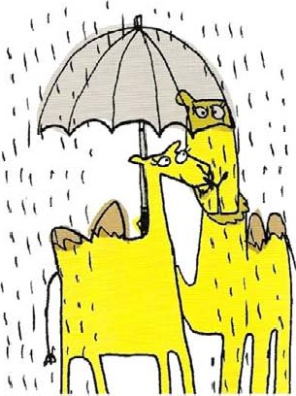Mammals don't lay eggs.

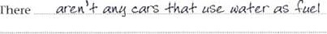

There



ere

There

* 1. polar bears don't Jive in the Antarctic, There
  2. Alien beings don't exist in our galaxy.

There

* 1. Britain is a country without volcanoes.
  2. It never rains in the Sahara desert.

'There

1. Complete each sentence with a / an, some or any.
   1. My shirt is dry now; but I need _ ML_ iron to press it with, b Would you likechicken? And how about potatoes?

c I can't print off my project because I haven't got d Have you got money for the machine? I didn't bring e Sorry I didn't come to the party. I had to finish work. I'd like to drink some water, but I can't find glass.



paper.

* 1. Could you buy me paper on your way home? I want to read the sports news.
  2. J needadvice about which subjects to do next year.

I'm really hungry. Can you make me meat sandwich?

Excuse me, could you give me information about the trains to Rome?

1. Complete each sentence about endangered species with a / an, some, or any.
   1. When the last member Of Within a hundred years, the dodo became species dies, we say that the species has extinct, and although we still have become extinct. paintings of dodos, there aren't b There aren't dinosaurs left alive preserved examples.

because they died out millions Of years ago. Scientists have recently found plants, birds and animals are bones on the island, but nothing else is left still in danger from human beings. of the dodo. d This is often because human beings destroy the habitats of animals, so that they don't have food to eat.

* 1. When animal Or a plant becomes extinct, this can affect the plants and animals which depend On it for food.
  2. For example, there aren't dodos left alive.
  3. This bird once lived on the island of Mauritius where there weren't animals to eat it.
  4. It couldn't fly, and was easy meal for dogs and rats brought to the island by Europeans in the 16th century.

1. Complete each sentence with a word from the list.

bar  carton cloud Crowd  packet piece sheet slice tube

* 1. Suddenly at the end Of the street, a croad  Of people appeared, shouting and waving flags.
  2. When I opened theof cola, it sprayed out onto my shirt. C We both felt hungry, and luckily I had a Of biscuits in my bag.
  3. If you go to the supermarket, could you buy a of toothpaste?
  4. There was a sudden explosion, and then all they saw was a _ of dust.
  5. Anna always eats a_ of chocolate on her way to school.
  6. Shall I cut anotherof bread for you?
  7. Can I give you a of advice? Spend more time on your work.  David took a of paper from his bag, and started writing.

 When I try to open a Of milk, I wish it still came in bottles!



1. Complete the sentence to make a summary statement with some (meaning not all), and others,
   1. Mountain ranges vary in age. The Alps are only 15 million years old, but the Urals and the Appalachians are over 250 million, and the Highlands Of Scotland are 400 million years old.

Summary: Some ranqc,$ art only 15 million years Old, while arc 400 million years old.

* 1. Pine trees depend on birds to spread their seeds. The monterey and pond pine, however, depend on forest fires, which release the seeds from the cone.

Summary: to spread their seeds, while to release the seeds from the cone. Frogs jump from place to place using their powerful back legs. Asian gliding tree frogs (Rhacophorus reinwardtii), however, 'fly' from tree to tree for as much as 12 metres using their webbed feet as parachutes.

Summary:

using webbed feet as parachutes, while

d Rivers generally flow into a larger river Or a lake, or flow to the sea, but in some desert regions, they simply evaporate in the desert and disappear.

evaporate in the desert and disappear, while into rivers, lakes or into the sea, e The difference in sea level between high tide and low tide varies from place to place. It can be almost nothing, while in Alaska and eastern Canada the difference can be as great as 10 to 15 metres.

Summary: the difference in sea level between high tide and low tide can be almost nothing, while as great as 10 to 15 metreS.



|  |  |  |  |  |  |
| --- | --- | --- | --- | --- | --- |
| |  |  | | --- | --- | |  | EXTENSION ACTIVITY | | 1  2 | Look at all the examples on page 122 and translate them into your own language, underline any problem examples.  Check that you have the correct answers to Exercise 5, and then translate the sentences. | |  |

### quantity: much, many, few, little, enough

Use how many to ask questions about quantity with countable nouns. How many tigers are there in the world today? use how much to ask questions about mass with uncountable nouns. How much water is there on Earth?

Use not many to make a negative statement about quantity Of countables. There aren 't many tigers left in the nor/d today.

Use not much  to make a negative statement about mass of uncountables. If we want to save the tiger. there isn't much time left.

Use many and much

* in positive statements in formal or written language.

Many people hunt wild animals for sport. Much damage has been caused by this kind Of hunting. use a few

* to talk about a small number of countable nouns in a positive way. We managed to see a few tigers in the distance.

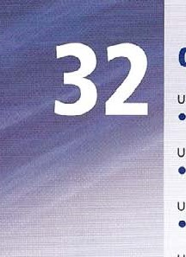Use a little  to talk about a small amount Of an uncountable noun in a positive way. There is a little water left in this bottle. use a lot (of), lots (of)  to talk about a large number of countables or a large amount of an uncountable. We saw a lot of / lots of animals close up and took a lot of / lots of photos There was a lot of / lots of rain last month. use few, very few, only a few

* to talk about countables in a negative way.

Unfortunately few conservationists believe that tigers in the wild have a future Experts believe that within fifty years there will be Very few remaining. Unfortunately: there are only a few biscuits left.

use little, very little, only a little

* to talk about uncountables in a negative way.

There is little hope that tigers will survive, as they have very little space for their natural habitat I'm afraid there is only a little water lett

Use too many

* with countables to talk about more things than are necessary or possible.

There are too many stars for scientists to count

Use too much

* with uncountables to talk about a greater quantity than is necessary or possible. Some plants are damaged by too much sunlight.

Use enough (of)  for countables and uncountables when we say that the quantity or number is sufficient.

Have we got enough food Have we got enough?

There are enough plates for evewone. We 've got enough (of them). use not enough  for countables and uncountables when we say that the quantity or number is not sufficient.

Thom is not enough information about this problem, and there are not enough scientists working to try and find a solution.

Use plenty of

* for countables and uncountables when we say that the quantity or number is more than enough. Don't worry we have plenty of time. I've got plenty of pens ifyou need one.

|  |  |  |  |  |  |  |  |  |  |  |  |  |  |  |  |  |  |  |
| --- | --- | --- | --- | --- | --- | --- | --- | --- | --- | --- | --- | --- | --- | --- | --- | --- | --- | --- |
| |  |  |  |  | | --- | --- | --- | --- | | I | Complete the question with how many or how | 2 | Complete the sentence with aren't many or isn't much. | |  | much. Check the factual answers on page 208, |  | a There _ much w rain in the Sahara Desert. | |  | a goa active volcanoes are there |  | b There     giant pandas left in the | |  | throughout the world? |  | world. | |  |  |

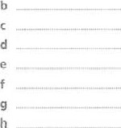oxygen is in the air?  There, snow in countries near fish are there in the sea? the Equator.

water is there on Earth? d Thereunexplored places left on kinds Of clouds are there?

teeth does an adult human have? e Therepeople living in the does the Earth weigh? Antarctic.

oil is used in the world  There light in the ocean below



every day? 200 metres.

* 1. There iron in the human body.
  2. Theremountains on Earth higher than 7,000 metres.

1. Complete each sentence so that it Contains the word Or words in capitals. Make any necessary changes.

|  |  |
| --- | --- |
| 1. Not many people have travelled deeper than 10,000 metres under the sea.   Onlg a people have travelled deeper than 10,000 metres under the sea.   1. In fact there are only one or two ways of doing this.   In fact there are Of doing this.   1. Divers could not survive at such depths.   could survive at such depths.   1. Some people have descended this far in underwater vessels called bathyscaphes.   have descended this far in underwater vessels called bathyscaphes.   1. They cannot remain under water for many hours.   They can remain under water for              f There are many problems involved with descending into deep water.  problems involved with descending into deep water.  9 There is some light up to 200 metres, but at 10,000 it is completely dark,  There is some light up to 200 metres, but at 10,000    h There are not many creatures that live at such a depth. | A FEW  NO  A FEW  A FEW  NONE  FEW |

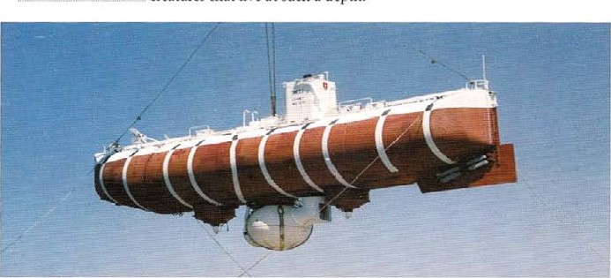_ creatures that live at such a depth.

A bathyscaphe is used to descend deep into the sea.

1. Complete the sentence with few or little.

_ people think that there are other planets in our solar system with human life just like Our Own.

* 1. In fact, there isreason to believe that life of any kind exists on other planets.
  2. There are aindications that microbes may exist, or may have existed On Mars.
  3. However, there isreal proof of this.
  4. There are atraces Of methane in the Martian atmosphere, and some scientists believe that this could have a biological origin.
  5. Unfortunately, there is agreement among scientists about this.
  6. Analysis of the Martian soil suggests that water exists on Mars, and there are a a areas where scientists believe ice forms and melts.
  7. Other scientists argue that there is chance 01 finding any life at all On Mars.

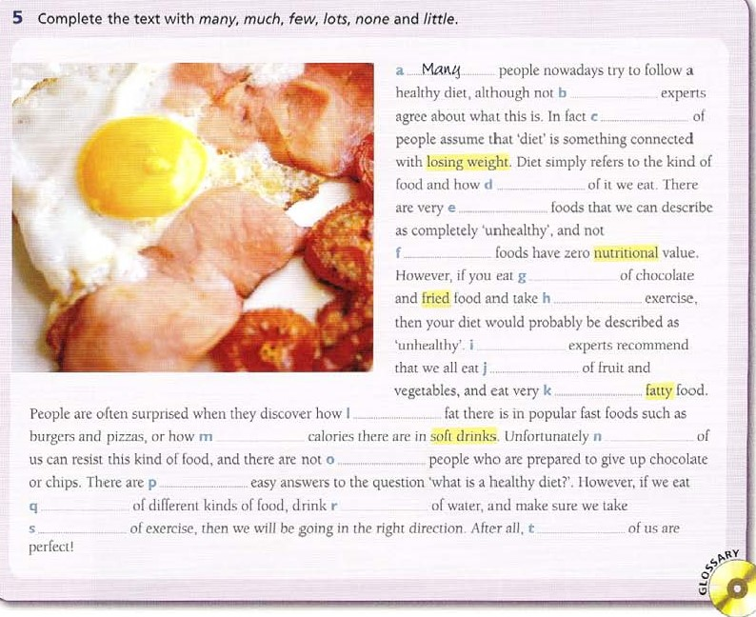

|  |  |  |
| --- | --- | --- |
| a What is the total amount of salt contained in the |  | It's impossible to swim in the Dead Sea because |
| world's oceans and seas? |  | of the large amount of salt in it. |
| How salt is there in the world's |  | You can't swim in the Dead Sea because it |
| oceans and seas? |  | contains toosalt. |
| b We don't know very much about the deep oceans. | g | There is a Shortage of fish in some parts of the |
| We know very about the deep |  | world. |
| oceans. |  | There aren't                    fish in some parts of |
| c Water covers a large part of the Earth's surface. |  | the world. |
| „ of the Earth's surface is covered | h | The Sargasso Sea contains large amounts of |
| by water. |  | seaweed. |
| d There seems to be more than enough food for |  | There isof seaweed in the |
| everyone in the world in the oceans. |  | Sargasso Sea. |
| There seems to be of food for |  | There are areas near the Equator where the wind |
| everyone in the world in the oceans. |  | does not blow very much. |
| e In fact, large amounts Of the food we eat come |  | There are areas near the Equator where there is |
| from the oceans. |  | not wind. |
| In fact, a Of the food we eat comes |  | Pollution affects nearly every one Of the world's |
| from the oceans. |  | ocean areas. |

1. Complete the sentence with one word so that it means the same as the first sentence. 

There are . areas Of the world's oceans not affected by pollution.

1. Underline the correct option.

In geography. a desert is an area which receives a few / rain and which loses a b few I lot of its moisture through evaporation. c Many / Much polar regions can be called deserts. but most Of us think Of a desert as being a sandy. rocky area with d not enough / few water. e Lots Lot Of deserts consist Of sand dunes or bare rock. and f many I much are near mountain ranges, which take away the moisture from clouds. Others are far away from the sea or other water, so receive g few / little moisture. Although we might assume that very h few / lots kinds Of life live in deserts, in fact there are i lots / many of plants, animals and insects in these regions. j Lots I Many desert plants store water in their leaves or roots, and some desert plants can live for k lots I many years. Some desert animals live underground.They spend I little / a few time in the sun and only come out at night-There are m enough / lots of insects, scorpions and spiders as well as reptiles, such as snakes, lizards and tortoises, in deserts.They need to spend n much / many hours in the Sun to generate body heat.

so they have o rew / little difficulty living in high temperatures. However, p few / lime of them can bear extreme sunlight, so they tend to move from one area Of shade to another.

#### EXTENSION ACTIVITY

Write a list of how much and how many questions, and ask someone else in the class.

2 Write eight true sentences about your country, city or town using not many and a lot of/ lots of.

quantity: none, all, each,

Use no

* with a noun to describe zero quantity or mass.

No animal can live for long without water use none of

* to mean •not one' of a group.

None of the students had done the work.

use none  to mean 'not any', or •not one' with countables or uncountables Countable We looked for some chairs, but there was / were none free.

Uncountable I thought we had some milk, but there is none left. (singular verb)

Use al/ (of)

* with a plural noun and verb, often in contrast with some.

All animals need water to live.

Not all the cabbages were eaten. Some were left.

* after be or an auxiliary verb.

You are all wrong. You have all made a mistake.

You must all be more careful.

Note: all ofhas the same meaning.

Wild rabbits have eaten all of our / the cabbages.

* as a pronoun at the beginning Of a sentence.

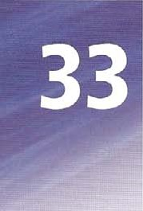All I could see was hundreds of bats

Note: everything is more usual as an Object. / want to know everything that happened.

use most (of)

* to mean 'nearly all'

Most mammals have hair.

Wild rabbits have eaten most of our / the cabbages.

Use each (of)

* to mean the separate members of a group.

We put 50 cc of water in each test tube.

Note: each of is also possible.

We put 50 cc of water in each of the test tubes / each of them.  with one.

There were five test tubes, and we put 50 cc of water in each one.  after a subject or at the end of a sentence.

The members of the team each received a medal use every  with a singular noun, to mean all the members Of a group together.

Every person in the class took part in the play use whole

* to mean 'all of something'.

You'd better tell me the whole story from the begjnning. rhe whole class clapped and cheered.

use both (of)

* to refer to two things, with a plural noun and verb, as in these sentences: Both bööks Were Wtrttén in 1986_ (plural itöUii + verb)

You are both wrong. (after be)

You have both made a mistake. (between auxiliary and participle)

You must both be more careful. (between modal and verb)

Both of the pencils were broken. / Both of my pencils were broken (both of + the + plural noun / possessive)

Both of you are wrong. (both of + pronoun) use either (of)

* to mean 'this or the other', with a singular noun and verb. There are two methods. Either method wiJ/ give results.
* with the + plural noun. Either of is a pronoun form.

Either Of the methods will give results.

You can use either of them (either of + pronoun) use neither (of)

* to mean *not this or the other'.

These are incorrect answers. Neither is correct.

with the + plural noun. Neither of is a pronoun form.

Neither of the answers is correct.

Neither of them is correct (neither Of + pronoun)

1. put most, all, or no in each space, according to your opinion. Check the factual answers on page 208.

a Att birds have feathers, and they are the Only animals that do.

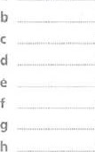_ animals (roughly 85%) eat plants or their products, Such as seeds.

mammals have hair that is naturally blue or green in colourreptiles are 'cold-blooded' and need heat from the Sun to live.

mammals give birth [o live young, but a few, Such as the duck-billed platypus, lay eggs.

mammals, other than bats, can really fly.

animals, but not apes and monkeys, are colour•blind.

birds lay eggs with hard shells made mostly of calcium carbonate.

i 'There are reptiles in the Arctic or Antarctic.

birds, except penguins, ostriches and some others, are able to fly.

1. Decide where to put whole in each sentence. and write whole and the following noun at the end.
2. After fire destroyed their house, the family was put up in a hotel by the local authorities.



1. The forecast for the end of the week is for high winds and Snow over the country.
2. I certainly thought that the first two episodes were weak, but I could change my mind when I've seen the series.
3. There is now a generation of teenagers who cannot live without texting and phoning.
4. Late in the evening there was heavy rain, and now the area is under water.
5. Mother Teresa. who died yesterday aged 87, spent her life caring for the poor.
6. Complete the text with most of, all of and none Of.

However hard they try to solve the problem.a _ the world's large cities suffer from traffic problems. b them were not planned to cope with so many vehicles, so the streets are narrow, and there is not enough space for parkingA number Of different solutions to this problem have been suggested, but c them has been completely successful. For example, many cities try to discourage the use Of private cars in the centre, but even so it is impossible to keep d the traffic away.

the larger Shops, Offices, hotels. railway Stations etc are in the Centre Of the City. there Will always be a need for buses and taxis and some private cars.An obvious ansv.rer is to move f the hotels, offices and large stations out of the city centre. It would be impossible to move g chem. but ic would still make the situation better.The new areas would have plenty of parking and public transport, so they would have h the problems Of the old city centre.

1. Underline the correct option.
   1. It's difficult to describe a typical school system, as / each / every countries are different.
   2. In some countries, all / each / every school chooses its own curriculum, Or programme Of study.  In Others, the government decides all / each / every detail of the educational programme. d Class sizes vary as well, and in some places there are more than 40 pupils in all I each /

every class.

 In other places, classes are small, and the teacher has more time to spend with all / each / every individual pupil.

* 1. In some countries the government provides all / each / every textbooks completely free Of Charge.
  2. In other countrie•s, however, ail j each / every schoolbook for the different subjects has to be bought from the school, or from a bookshop.
  3. In some school systems all each / every pupils eat their midday meal at school.  In other places, however, all / each / every pupil makes his or her own arrangements, some going home and returning, and others bringing a packed lunch.

All / Each / Every wc can be certain about is that no two countries are exactly the same where education is concerned.

1. 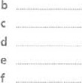Complete With both and or neither nor. Check the factual answers on page 208_
   1.  Alexander andNapoleon were leaders who conquered a number of

Other countries.

AlexanderNapoleon died in his own country.

AlexanderNapoleon successfully handed on power to a son.

Alexander  Napoleon managed to completely defeat all their enemies.

AlexanderNapoleon successfully invaded Egypt.

AlexanderNapoleon were excellent generals who won a large number of battles.

AlexanderNapoleon led their armies to far distant countries.



g

AlexanderNapoleon married more than once, and had a number of children.

|  |  |
| --- | --- |
| Alexander | Napoleon lived to an old age. |
| Alexander | , Napoleon were poisoned, according to some historians. |

1. Choose the correct option, A, B or C, to complete the text.

Nowadays a us spend a lot of time watching DVDs or going to the cinema. but so far there is b sign that we have stopped reading books. It sometimes seems that c child in the world has read a Harry Potter book, and d people on the beach, and not only older people, seem to be reading something. Obviously it is possible to enjoy books and films, but books do seem to have a number of advantages.With new DVDs costing anund €30 f is clearly cheaper read. g you need to enjoy a book is a comfortable chair, after all. Films show you all the action in colour, but for many people h of the special effects in a film is as good as the pictures in their own imagination-And the i experience Of reading a good book can be a lot more rewarding. Of course. films can be great too. but in the end. j Of us has to decide how we would rather spend Our time.

a A every B most of C all b B none C neither c A whole B every C all

A most or B all C most e A both B neither C even' f A every B all C each g A Either B All C None h A all B none C every A whole B most C both

A none B all C each

Mine is a possessive pronoun, This bike is mine means This is my bike. We cannot put a noun after a possessive pronoun.

Whose bike is this? It's mine.

Possessive pronoun mine purs hers his ours theirs

a (noun) Of (possessive pronoun) use a possessive pronoun with a noun in this expression.

This is an interest Of his, This great country Of ours.

It is very common with friend. We can also use friend of + a name with a possessive apostrophe.

15 she a friend of yours_? No, she's a friend ot Martin's use myself etc

* for emphasis, and with some verbs.

Can you make me some tea? Why don 't you make it yourself!

* as an object with verbs that describe doing something to ourselves.

Look at yourself in the mirror, and ask yourself this question.

Sally is too young to wash herseff and put herseffto bed.

Other verbs often used like this: cut, enjoy, hurt, behave.

Did he hurt himself? Please behave yourselves/ Enjoy yourselves I've cut myself.

Cut, enjoy, hurt can also have an object, but not behave. Enjoyyour meal/ Please behave!

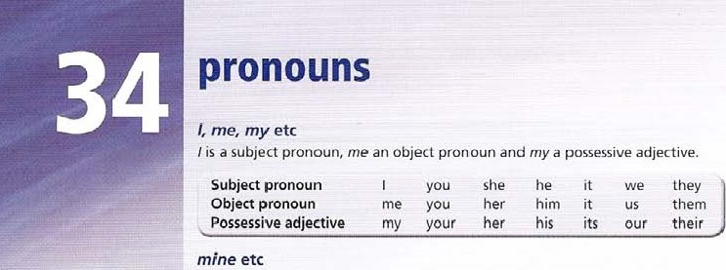some-, any-, no-, every- pronouns use someone, anyone, no-one, everyone (See also unit 31)

* following the same rules as some, any and no.

use somebody, anybody nobody, everybody with the same meaning. There's someone outside. (l don't know who it is).

js anyone there? There isn't anyone. There S no-one. Everyone means 'all the people', with a singular verb. Everyone knows that Paris is the capital of France. use something, anything, nothing, everything

* in the same way as someone etc.

Have you got anything for me? There's something wrong. Theres nothing here. Everything is 0/1 right!

### somewhere, anywhere, nowhere, everywhere

These are adverbials, and are used in the same way as someone etc, They couldn't find the cat anywhere l,'lfiects can be taund everywhere on Earth

Ihere is nowhere for children to play in this area.

use else

 after some-. any-, nö-, every- pronouns to mean 'other' or 'more'. didn't realize it was you. / thought it was someone else. Nothing else really matters.

1. Complete about the pharaoh Tutankhamun with personal pronouns (l, you, he etc) and possessive adjectives (my, your, his etc). a has been famous ever sinceg Tutankhamun's death took place when

|  |  |  |
| --- | --- | --- |
| tomb was discovered in 1922. |  | was still a teenager. |
| b However, little is known about for | h | The ancient Egyptians buriedyoung |
| certain. |  | pharaoh in a tomb full of beautiful objects. |
| began reign with the |  | In modern times these objects have been seen |
| name of •liltankhaten at the age Of nine. |  | by thousands Of tourists and have |
| d Because of his youth, it was probably |  | made IUtankhamun famous, |
| chief minister Ay who ruled instead |  | If you want to see death mask and |
| of |  | other amazing objects, you Will have to Visit |
| e While still a boy,    married Ankhesenpaaten. |  | the Egyptian Museum in Cairo. |

f As a result Of political changes, both names were later changed.

1. Complete the sentence with a possessive or an object pronoun.

|  |  |  |
| --- | --- | --- |
| a This CD belongs to me. This CD is |  | We own this house. This house is |
| b This is his calculator. This calculator is | g | Those boots are theirs. Those boots belong to |



|  |  |  |
| --- | --- | --- |
| 1. That bike belongs to her. That bike's 2. This ball is ours. This ball belongs to | h | That's mine. It belongs to  Those are their books. These books are |

Is this yours? Does this belong to

* 1. That is your desk. That desk is

1. Rewrite each sentence so that it contains the word in capitals.

a Harry is one of my friends.

 is a -Grie.nd euiu..

|  |  |
| --- | --- |
| b That idea was theirs. | THEIR |

|  |  |
| --- | --- |
| c This one belongs to us. | OURS |

|  |  |
| --- | --- |
| d This is my pencil, but where's the One that belongs to you? | YOURS |

|  |  |
| --- | --- |
| e Sue is talking to one Of her friends. | HERS |



|  |  |
| --- | --- |
| f This is his bike. | HIM |

|  |  |
| --- | --- |
| g Do they own that house? | THEIRS |



h That cup is yours. YOUR

1. Complete giving advice to climbers with a reflexive pronoun (myself etc).

|  |  |  |  |  |  |
| --- | --- | --- | --- | --- | --- |
| a If you are climbing alone, and have an | | | e | It's important to think carefully: 'Can 1 100k after | |
| accident, you have to try and keep calm. You | | |  | in this situation? | |
| have to ask _ a number | | |  | In some cases you may have to make a difficult | |
| Of questions. | | |  | decision to save | |
| b Have you hurt     in any | | | g | In a famous case, climber Aron Ralston trapped his | |
| way?  c Sometimes when we have injured | | |  | arm, and was forced to cut it off in order to free | |
| , we don't even realize | | | h | Very few people think that they | |
| that this has happened. | | |  | could do thal kind Of thing. | |
| d Some people may not realize they have | | |  | But most of us would have to consider doing it | |
| cutuntil they see the | | |  | if we foundin a similar | |
| blood.  5 Complete the sentence so that it contains a word beginning some-, any-, no-, every-.   1. We have all heard Of the Pyramid Of Giza, One of the seven wonders of the ancient world.   has heard of the Pyramid Of Giza, one of the seven wonders of the ancient world.   1. It is not known exactly how such a huge | | |  | situation. | |
| pyramid was built. | | | g | people all suppose that the Egyptian pyramids | |
| exactly how such a | | |  | are the oldest, but this may not be true. | |
| huge pyranud was built. | | |  | that the Egyptian | |
| c This huge project probably involved all the | | |  | pyramids are the oldest, but this may not be | |
| people who could work. | | |  | true. | |
| This huge project probably involved | | | h | People don't visit the Greek pyramid Of | |
| who could work. | | |  | Hellenikon, but in fact it may be older than | |
| d We can also assume that it must have been | | |  | any Of the pyramids. | |
| designed and planned, | | |  | the Greek pyramid Of | |
| We can also assume that | | |  | Hellenikon, but in fact it may be older than | |
| musl have designed and planned it. | | |  | any Of the Egyptian pyramids. | |
| e Most pyramids were tombs, but now they are | | |  | People don't know exactly why it was built, | |
| empty inside, | | |  | but it is believed to be a monument over a | |
| Most pyramids were tombs, but now | | |  | tomb. | |
| inside. | | |  | exactly why it was | |
| If you ask people whether there were | | |  | built, bul il is believed to be a monument | |
| pyramids in Greece, they would probably | | |  | over a tomb. | |
| answer 'No'. | | |  | It's not one of the seven wonders of the | |
| If you ask whether | | |  | world, but it is an interesting thing. | |
| there are pyramids in Greece, they would | | |  | It's not one of the seven wonders of the | |
| probably answer 'No'. | | |  | world, but it is | |
| 6 | Replace | | underlined part of the | with a word beginning some-, any-, no-, every-, and else. | | |

* 1. There's another thing I want to ask.  waiting outside?

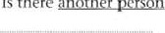

there

another

Is

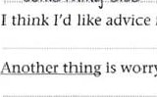

from

another

Sojuc-f•hinq CISC

* 1. person. g Does another person want to use the computer?
  2. is worrying me. h There isn't another-thing in the box. It's empty.

|  |  |  |
| --- | --- | --- |
| d We're alone. All the Other people have left. |  | Mary has just told me that She loves |



* 1. Jim is mad about football. He thinks about  Please be quick. Another person wants the

 computer.

|  |
| --- |
| EXTENSION ACTIVITY |
| Write ten sentences using someone, no-one, everyone, somewhere and nowhere. |

1. Complete the sentence with somewhere, anywhere, nowhere, or everywhere.

|  |  |  |
| --- | --- | --- |
| a Eighty per cent Of the flora and fauna on the | f | All animals need                           to feed |
| Galapagos Islands exists ncuÖhe.rc. else. |  | and sleep in safety. |
| b A mosquito will lay its eggs | g | Tsunamis are most often caused by earthquakes |
| there is water. |  | in the Pacific. |
| c Every second, someone | h | in the universe  Is  there |
| in Africa is infected With tuberculosis. |  | without heat energy of some kind? |
| d Forests in general and rainforests in particular |  | Bacteria are micro-organisms that grow |
| are in danger |  | on Earth. |
| e Is there on Earth where |  | on Earth are glaciers easier |
| Life is impossible? |  | to study than in Iceland. |

1. Complete the text with one suitable word in each space.

One Of the adventures Of Odysseus is the Story Of Polyphemus the Cyclops, a one-eyed giant. Odysseus arrived at an island with his men, and took some of them to the cave where Polyphemus lived-There wasn't b else in the cave, only some sheep and goats.When the Cyclops arrived, he shut c , in his cave by rolling a huge rock over the entrance and then killed some Of the men. d else could move the rock. so Odysseus knew that it would be foolish to kill the Cyclops. He had to think of e else to do. He waited until the evening and made the Cyclops drunk. He told the Cyclops that his name was . When the giant was asleep, Odysseus and his men pushed a huge piece Of wood into his eye. so that he became blind.The Cyclops shouted with pain, and some other giants heard and asked him who had injured . He told them OdysseusS name, and so they laughed, and supposed that he had just hurt h . Odysseus and his men escaped by hiding under the sheep as they left the cave in the morning. Polyphemus couldrft see or feel .The giant threw huge rocks at the Greeks' ship, but they managed to escape from the island.

O

# adjectives

Adjectives describe things. They generally come in front of nouns. They have one form and do not change for singular and plural or before masculine and feminine nouns.

This subject can be interesting. Hilary Clinton is famous.

They can appear on their own without a noun after some verbs: be, 100k, seem. appear, become, get, This seems interesting. You're becoming difficult. It's getting ho t

Some adjectives eg alive. alike. ashamed, alone, asleep, awake. afraid can only be used after be. seem. appear to. look.

He's not awake He 's asleep

He looks afraid. He appears to be asleep

order Of adjectives

When we use more than one adjective, we use this general order. Note that a noun can do the work of an adjective.

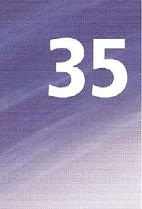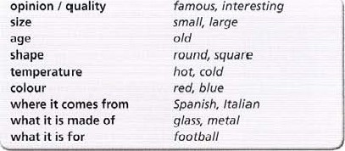opinion / quality

a famous old football stadium a small round metal object

Avoid using more than three adjectives together.

gradable adjectives and intensifiers

Some adjectives, eg those that describe age, size, beauty, can be measured or graded. and are caned gradable. We can use intensifiers eg very, extremely with them.

This tree is extremely old. It's a very beautiful painting.

This problem is extremely difficult. / feel Veo• unhappy.

Other adjectives cannot be graded because the qualities they describe are either present or absent.

This painting is superb This problem IS impossible. We can not say +hisp&inting-is-yery-sttperb.

We cannot make comparative forms of non -gradable adjectives. For example, we cannot say This -moreimpossib/e-than-that-one.

We can use the intensifiers really, absolutely with non-gradable adjectives.

This painting is really superb This problem 15 absolutely impossible

Typical non-gradable adjectives include: microscopic, enormous, freezing, boiling, wonderful, terrible, excellent, perfect,

adjectives ending in -ed and -ing

Some adjectives have two forms, one ending in -ed and one in -ing.

Are you interested in painting?

Yes. I think Paula Regot paintings are interesting.

|  |  |  |  |
| --- | --- | --- | --- |
|  | |  |  | | --- | --- | | Something is:  Someone feels: | interesting, boring, frightening, surprising, confusing etc interested, bored, frightened, surprised, contused etc | |

You can see from the painting that the girl is really frightened

I Complete each sentence about paintings in a gallery so that it contains a word from the list.

|  |  |  |
| --- | --- | --- |
| afraid alike alive alone ashamed | asleep awake dead | |
| a The boy in the painting doesn't seem to have | d | Ile isn't asleep, but looks as if he is in a dream. |
| woken up. |  | He but looks as if he is |
| The boy in the painting Seen'S |  | in a dream. |
| b Both girls in this painting look the same, | e | Does this painting frighten you? |
| The girls in this painting |  | of this painting? |
| c I'm not sure that the person in this painting is alive. |  | It's a painting of a battle and most of the soldiers |
| I think the person in this painting |  | are dead.  It's a painting Of a battle and very few soldiers |



|  |  |  |
| --- | --- | --- |
| Cairo Istanbul London Tokyo Moscow |  | Paris Sydney Venice |
| a The best way to get around in the city is to get on | e | At the heart of the city is this |
| _ bus. (red, big) London |  | fortress which is still home to the president. |
| b The city is full ofpalaces along |  | (medieval, well-known) |
| the sides of the canals. (old, wonderful) |  | This is a city, not a centre for |
| c Just outside the city you soon see the |  | historic buildings, but still a great place to visit. |
| shapes Of the Pyramids. |  | (busy, commercial) |
| (stone, vast) | g | This spectacular city where Europe and Asia |
| d From the top of the, tower you |  | meet hasbuildings, as well as |
| can 100k across the French capital. (graceful, iron) |  | ancient palaces. (modern, tall) |

1. Put the adjectives in brackets in the correct order to complete the sentence. Then decide which city in the box the speaker is talking about.
2. Write each possible intensifier at the end of the sentence. One, both or neither may be possible.
   1. This fish is (really, absolutely) fresh.
   2. 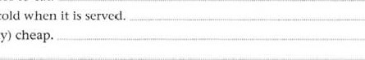Unfortunately the food in the hotel was (very, extremely) terrible. c The mushroom soup was (very, absolutely) tasty. d I find raw fish (absolutely, very) impossible to eat. e This drink should be (very, completely) cold when it is served.  The cheese was good and (extremely, very) cheap.

g I'm afraid the meat is (very, really) salty.

 4 the correct form.

There are some students who feel a / depressing by studying, especially subjects which they find b confused / confusing.They Often leave their work until the last minute, and then find the amount they have to do is simply c exhausted / exhausting, or they are d embarrassed / embarrassing to admit that they need help.They simply become more and more e worried / worrying, and then work even less than before. Or they blame the school system. because the subjects they are studying are just not f interested / interesting. However, you may be g surprised / surprising to know that very few students feel this way, according to recent research. In fact, most students dorft find school work h annoying / annoyed at all.They are usually i excited / exciting by the subjects they are studying, and they feel j satisfied I satisfying when they do something well,



Some adverbs have an irregular form, eg good —y well.

#### adverbs with the same form as adjectives

early fast hard high late low right wrong

Hard and hardly are often confused. Hardly means 'almost not'. Hard is an adverb form meaning 'using a lot Of energy'.

can hardly hear you/ Are you working hard?

#### adjectives that look like adverbs

Some adjectives ending -ly look like adverbs but are not, eg friendly, jovejy, lonely, likely, lively, silly.

# frequency adverbs

These describe how often something happens.

People often think that bats are birds, hut they are mammals.



Put the frequency adverb between the subject and verb, but after be.

A painting often tells a story What sort of films do you usually go and see? Cartoon films are usually entertaining.

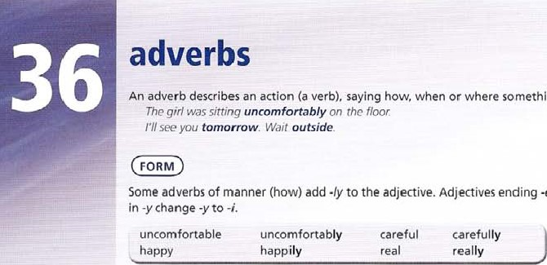

something

happens.

•e

drop

•e.

Adjectives

endi

ng

irregular

adverbs

intensifiers (see unit 35 on gradable adjectives)

Adverbs like very, really, extremely are used to make adjectives or adverbs stronger. / think this film is really terrible. Everyone has worked extremely carefully.

#### too, very

TOO means more than is necessary, very means a lot. Compare the meanings:

I'm too tired, / can't work any more.

This is a very interesting painting.

Too is often used with to-infinitive to explain why something is not possible. I'm too tired to work.

#### well, ill. bad. badly

Well and badly are adverbs and describe how an action is performed. She writes well. He plays tennis badly Well and ill are adjectives describing health.

I don't feel well. You look ill.

With verbs like look. seem. feel we do not use an adverb.

This fish smells bad That looks good

c

1. Decide whether the words underlined are acting as adjectives or adverbs,
   1. Some people think modern paintings are '_di_fficult-'. adJe.c4-TVeE b find them confusing because they not 'pictures' c They say that a good photograph would be better.
   2. At least, they say, a photo does show the real world.
   3. It's also hard to persuade them that the artist worked

 Some modern painting could easily have been painted by a child.

* 1. Artists sometimes make the situation more difficult.
  2. They write explanations of their work which can seem unnecessary.  They may not seem to have yg1E' much connection with the art.  Still, if the work seems interesting then it is worth looking at. 

1. Complete the sentence with an adverb formed from the adjective in brackets.

|  |  |
| --- | --- |
| 1. The play begins rather (Slow)  with a scene at a bus stop. 2. Just as you think the main characters are going to live (happy)ever after, the film takes an unexpected twist. 3. This book is (beautiful) written, but in the end the story is disappointing. 4. Mark's guitar playing is pretty good, but he sings so (bad) that I just wanted him | e The whole show was (real) entertaining and the singers and dancers showed a lot of enthusiasm, f This is a (true)                     great book. Go out and buy it today.   1. This is an (incredible)           good album, with a lot Of fantastic tracks. 2. Jim Carrey in the main role is (unbelievable) funny. |

to stop,

1. Put the frequency adverb in brackets into the most appropriate space in the sentence. Decide whether the statement describes a good listener, or a bad listener.
   1. I _O•G+T_ finish sentences for other people. (often)

Good or bad listener? b Other people seem to be comfortable „ when they talk to me. (usually)

Good or bad listener?

|  |  |
| --- | --- |
| c Whenpeople talk to me, I  Good or bad listener? | look at the floor. (sometimes) |
| d If I don't like a person's voice, I  Good or bad listener? | , pay attention to them, (never) |
| try to be sympathetic when  Good or bad listener? | people talk about their problems. (usually) |

try to give people my complete attention when they speak to me. (always)

Good or bad listener? interrupt people before they have finished what they are saying. (rarely)

Good Or bad listener? laugh at whatpeople say to me, and upset them. (sometimes)

Good or bad listener?

1. Make an adverb ending in -ly from the word in brackets, and use it to complete the sentence.
   1. Cholera is a disease spread by dirty water, either when people drink the water, or eat food which has been washed in the water, and not _ cooked- (proper) n , until the mid 19th century, people believed that the disease travelled through the air. (unfortunate) c In the crowded cities of 19th-century Britain, cholera spread (easy) d Most doctors believed that fresh air and a better diet would prevent the disease. (wrong) e Huge fires were lit in the streets to drive away the infection, and the clothes of victims were also burned. (usual) f The streets were also cleaned with powerful chemicals. (thorough) Dr Snow g However, people continued to suffer

(dreadful) J He managed to prove that in an area where h In 1854, a doctor in London, John Snow, deaths from cholera were highest, the proved that cholera spread water was responsible for through infected drinking water. (definite) cholera infection. (entire) i He did this by collecting Improvements made to sewers and supplies statistics about the infection in One part Of of drinking water later led to a decrease London. (careful) in deaths from cholera.

1. Use the prompts to make a question with the frequency adverb in brackets.
2. you / take the lead in group discussions?

(usually)

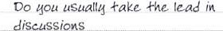

1. you / feel / unable to say anything interesting? (sometimes)



1. you / change / your opinion after you hear what others say? (often)



1. you / listen carefully to what all the others are saying? (always)



 you / feel that nobody is interested in what you say? (sometimes)

 you / find ways of keeping other people's attention? (usually)



1. you / avoid saying what you really think?

(often)



1. you / encourage other members of the group to speak? (always)



1. Underline the correct word.
   1. I recommend this book. I think it's too / interesting.
   2. This is a too / very unusual film, and probably won't appeal to everyone.

C This book has more than 700 pages, so it's too / very long to read in an afternoon! d I liked this film because it is too / very funny, and it made me laugh a lot.

 What I like most about this book is that the characters are too / very true-to-life. f This film is too / very romantic, and it really made me cry!

* 1. I couldn't understand this book at all! The language is just too / very difficult.
  2. There are some too / vet)' good scenes in this film, but on the whole I didn't like it.

1. 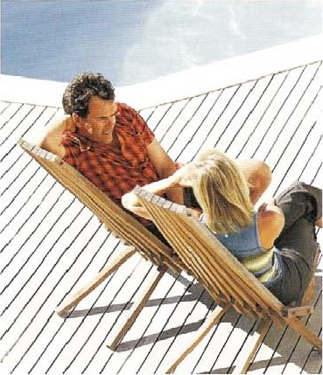Decide whether the word underlined is used as an adjective or adverb.
   1. We had a

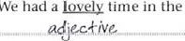

time

in

the

hotel.

* 1. All the staff greeted us yearmly.
  2. And they spoke to us very pQLi.!e1y.
  3. Most people we met in the town were very friendly.
  4. You certainly never feel in a place like this!
  5. The night life is also very liy_e/-y.
  6. We are very likely to go back next year.
  7. we would certainly thoroughly recommend it.

1. Complete the sentence with well, ill, bad, badly, hard, or hardly.
   1. Last Thursday I woke up feeling b When I got up I realized J could walk. c I had exercised in the gym the night before. d My left ankle seemed to be swollen.

e I didn't feel at all but 1 had to go to the doctor's. f I found it to walk there, but I managed it in the end.

* 1. The news was that I needed an x-ray and had to go to the hospital.
  2. The doctor there told me there Was nothing Seriously wrong. I could believe it!

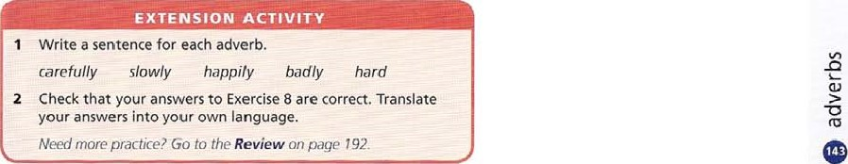

### making comparisons

Use comparative forms of adjectives

* to compare two things with than.

People are bigger than snakes

* to compare two things without than.

Which are bigger, people or snakes? People are bigger

* to compare two things with than. repeating be, or the auxiliary from the verb. ['m teller than you are. You look shorter than I do, with a than-clause.

This book is more interesting than I expected

spelling rules  one-syllable words add -er long — longer  one-syllable words ending vowel consonant, double the consonant hot — hotter  words ending in -y change -y to -i and add -er  two-syllable words ending -y change -y to -i and add -er angry — angrier happy — happier lucky — luckier

— some two-syllable adjectives use -er or more. use more if you are in doubt. more common / commoner more narrow / narrower more pleasant / pleasanter more polite / politer more simple / simpler  most two- and three- syllable words put more in front more modern more expenswe more comfortable

— irregular adjectives good — better bad — worse far — farther or further

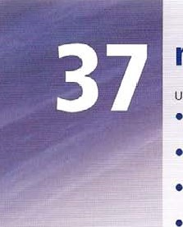Make comparisons with

* a comparative form + than.

The bite of an Egyptian Cobra is more poisonous than the bite of an Indian Cobra.

* less + adjective + than, not as adjective + as

The bite of an Indian Cobra is less poisonous than the bite of an Egyptian Cobra The bite of an Indian Cobra is not as poisonous as the bite Of an Egyptian Cobra. e (just) as + adjective + as when two things compare equally.

I don't care which one is more poisonous. I'm (just) as scared Of them both.

comparative adjective + comparative adjective use two comparative adjectives joined by and for a changing situation. Learning gets harder and harder as people grow older.

use the + comparative, the + comparative for the same meaning. The older people get the harder learning is.

intensifiers

Use intensifiers much. a lot etc  to say how great the comparison is,

It'S a lot hotter than yesterday This chair is much more' comfortable.

o

1. Write a comparative sentence using the information and an adjective from the list. Make any necessary changes, leaving out any unnecessary detail.

deep dry high large long low old small

 The River Mackenzie, Canada; 4,240 km

The River Niger, Africa: 4, 170 km

Pive.r• Mackenzie. ig giver

* 1. Lake Victoria, Africa: 69,484 km2

Lake Michigan, North America: 57, 757 km'

* 1. The Marianas Trench, pacific Ocean: 10,900 m

The Japan Trench, Northern Pacific: 9,000 m

* 1. Mont Blanc, France: 4,807 m

Mount Elbrus, Russia: 5,642 m

* 1. Arica, Chile: average rainfall 0.76 mm per year

The Libyan Sahara Desert: average rainfall, less than 15 mm per year

* 1. The oldest rocks in Scotland: 3 billion years old

The oldest rocks in Canada: billion years old

* 1. The lowest recorded temperature in Finland: —57'C

The lowest recorded temperature in Sweden: —525C

* 1. The island state of Nauru, South Pacific: 21 kmz

Monaco: 1.6 km?

|  |  |
| --- | --- |
| a The first question in the test Was easier than the second one.  The second question in the test was . -Cirsk_oneæ_ | DIFFICUIX |
| b think my sweets taste better than yours.  I think my sweets | TASTY |
| c Staying at home for a holiday is cheaper than travelling abroad.  "Itavelling abroad for a holiday | EXPENSIVE |
| d The Royal Hotel is more old-fashioned than the Holton Hotel.  The Holton Hotel | MODERN |
| e This chair isn't as comfortable as the sofa.  The sofa | COMFORTABLE |

|  |  |
| --- | --- |
| f I think Water refreshes     than milk does.  J think water is | REFRESHING |
| g Romantic films interest me more than war films.  I find | INTERESTING |
| h Jim's suitcase was lighter than Jack's suitcase.  Jim's suitcase | HEAVY |

1. Complete the second sentence so that it means the same as the first sentence, using the adjective in capitals. 3 Complete the sentence with one word.

|  |  |  |  |
| --- | --- | --- | --- |
|  | a I expected my exam results to be better. |  | I thought the station was nearer. |
|  | My exam results were  than I |  | The station was than I thought. |
|  | expected. | g | Moths lessons don't seem as short as English |
|  | b Harry doesn't look so clever. |  | lessons, |
|  | Harry isthan he looks. |  | Maths lessons seem      than |
|  | c •Ille black coat is smaller than the brown one. |  | English lessons. |
|  | The brown coat is _ than the | h | I'm sure this year is colder than last year. |
|  | black one. |  | I'm Sure last year was |
|  | d Helen's brother is older than her. |  | than this year. |
|  | Helen is than her brother. |  | I'm not as happy as I used to be. |
|  | e Jim Carrey's previous film wasn't as funny as |  | I used to be—than I am now. |
|  | his latest one. |  | The weather yesterday was worse. |
|  | Jim Carrey's latest film is |  | 'Ille weather today is than it |
|  | the previous one. |  | was yesterday. |
| 4 | Rewrite the first sentence so that it contains the word or words in capitals.  a This book isn't as interesting as that one. | | |



|  |  |
| --- | --- |
| b A bike is less expensive thun u scooter. | MORE |

|  |  |
| --- | --- |
| c You're taller than I am. | AS |



|  |  |
| --- | --- |
| d The first explanation is unlikely, and so is the second. | JUST |

* 1. Carol thought the accident was less serious than it was. MORE
  2. My arm isn't as painful as it was.

1. Complete the text with an adjective from the list, using a comparative form where necessary.

cheap clever difficult fast important up-to-dale

Nowadays using computers is more and more a have to be an expert to use one, as using a computer is b all the time. You don't need to be rich either, as computers are also becoming c as time goes on. Also, if you are studying, the Internet is becoming more and more d — as a place to find information. This used to take a long time, but the latest machines are a great improvement. -lhe the computer, the it works. However, protecting computers from viruses is becoming more and more f as the people who invent viruses are becoming g — and . The Internet has become a dangerous place, so it is more and more h to be very careful when we use computers.

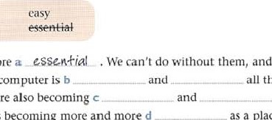

and

you

don't

1. Choose the correct form, A. 8 or C, to complete the text.

When you look into the night sky, you may not be able to tell the difference between stars and planets, but planets area A to Earth. However, they are still very (ar away, and a journey to Mars would be about nine months, b than a journey to the Moon (about three days) _ Even if your future space ship was

_ the simple space probes we have now. it would still take you a couple of years to get to Jupiter, which is d Earth — more [han I ,300 times, in fact, and it' more than 300 limes e . Jupiter is a giant ball of gas and the atmospheric pressure is f it is on Earth. If you could land there. you would be g more than twice as much. The whole planet is h Earth as well, and scientists think that the centre of the planet may be as hot as 10,0006C. Intelesnngly, the day on Jupiter is i , and only lasts about ten hours, but a year onJupiter lasts for I I Earth years. So when you came back, you would be when you ser out!

#### rth

Sun • Ma iter

Satur

Me

Oon

I uto

Neptune

The Solar System

a A a lot nearer B nearer than C less near than b A more longer B as long as C much longer

A more last B a lot [aster than C not as rast as d A very much bigger than B as big as C less hig than

A as dense as B more dense C less dense than a lot greater than B just as great C less great g A more than heavy B less heavy C much heavier h A as hot as B a lot hotter than C hotter

A a lot shorter B shorter than C less short

A more old B older C much older than

#### EXTENSION ACTIVITY

1. Write six sentences com paring yourself now with yourself aged eight.
2. Write six sentences comparing cars and bikes.

use the superlative forms of adjectives

* to compare one thing with a lot of other things of the same kind. Put the superlative adjective between the and (noun).

Most experts say that the Anaconda is the biggest snake in the world. The largest one ever captured was about 9 metres in length.  with ever and present perfect to talk about experiences.

This is the easiest language I've ever learned

We use present perfect because we are talking about the speaker's lifetime experience, which is unfinished.

We can also use comparative adjectives when we talk about experiences.

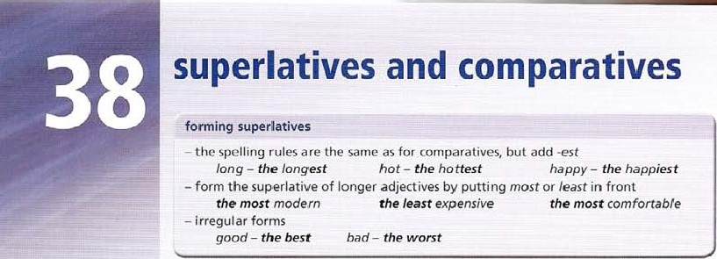I

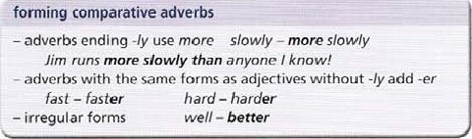

Have

you

ever

seen

a

bigger

snake

(than

this

one)?

use

comparative

adverbs

* to compare two actions.

Anna runs faster than the rest of the team,  without than.

Who runs faster, Anna or Helen? Anna runs faster.

* with than, repeating the auxiliary from the verb. I run faster than you do.

forming superlative adverbs

— adverbs ending •ly use the most / least slowly— the most slowly

Jim runs the most slowly of anyone I know/

— adverbs without -ly add -est fast — the fastest

— irregular forms well — the best

use superlative adverbs  to compare one action with a lot of other actions ofthe same kind, using of.

Everyone worked hard, but Kate worked (the) hardest. Kate worked the hardest of all the girls in her class.

1. Complete sentence with the superlative form of adjective in capitals.

|  |  |
| --- | --- |
| a The , —heavies— whale ever caught weighed more than 171,000 kg. b The  whale recorded was over 33 m in length.   1. A specimen Of king's holly, a plant found in the rainforest of 'lastnanja, is one of the plants on Earth — over 43,000 years old. 2. The cheetah is the creature on Earth, and is capable of running at over 110 kph. 3. Thepart of the ocean where a fish has been found was 8,372 m down in the Puerto Rican Trench.   fish in the Sea is the Sailfish, which Can travel 100 kph. g No prizes for guessing the world's _fish. It is the deadly piranha fish.  h The sea wasp, which lives Off the north coast Of Australia, is the    creature in the Sea. If it stings you, you have   30 seconds and four minutes to live.  spider in the world is the goliath spider from  The  South America, which can be 28 cm across. | HEAVY LONG  OLD  FAST  DEEP  SPEEDY  FEROCIOUS  POISONOUS  LARGE |

 And the mammal is probably Savi's pygmy shrew, a mouse-like creature, which weighs between 1 and 3 grams.

1. Complete the sentence so that it means the same as the first sentence, and includes a superlative adjective.

a I've never sat in a more comfortable classroom than this.

ms is the . -.M0S+ com$or+ablz classrootM .l?vcu ever. sat in. b I've never eaten a tastier school lunch than this.

l'his is theeaten. c I've never read a worse book than this.

This is theread. d We've never had a more useful English lesson than this. This is thehad. e I've never solved an easier problem than this.

This is thesolved. f I've never taken a longer test than this.

This is thetaken. g I've never written a more difficult test than this.

This is thewritten. h I've never seen a more entertaining school play than this.

This is the

 We've never used a more interesting textbook than this. This is the

 I've never had a better friend than you,

You are thehad.

3 Rewrite underlined part of sentence, using a comparative form of an adverb in the list

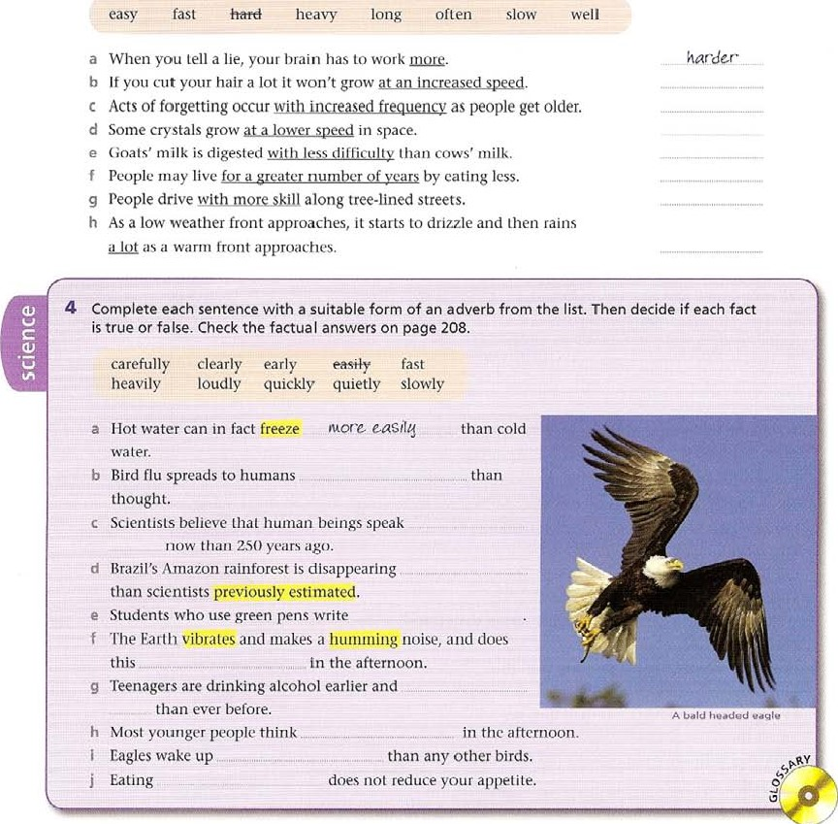

5 Choose correct form, A, B, C or D, to complete sentence.

1. You left school _ A than I did.
2. Mirror, mirror on the wall, who is_ of them all? c What'sbook you've ever read?
3. Helen's teacher congratulated her for working so_ before the exams.
4. Our company can help you to manage your money f You can typeI can.
5. I find Frenchto speak than Italian.
6. Which moves, a snail or a worm?

 Have you ever eatenmeal than this?

|  |
| --- |
| EXTENSION  ACTIVITY |
| 1. Make a list of facts about your country, using superlative adjectives. 2. Write a sentence for each adjective or adverb. the most uncomfortable the hardest the least expensive more quickly more carefully more quietly |

 Picasso's paintings are among

|  |  |
| --- | --- |
| a A later B more lately C most lately  A the more beautiful B as beautiful C the most beautiful  A more interesting B the most interestiug C the rnore interesting d A hardly B hardest C hard e A success fill B just as successful C more successful than  A much raster than B more fast as C just as rast than g A difficult B more difficult C as difficult h A quicker than B as quick as C more quickly  A as good B the best C the good  A the most expensive B more expensive C as expensive  6 Complete the text with the most suitable form of the adjective in brackets.  London is one of a (large) •He cities in the world. Its population is b (IOW than Tokyo or Shanghai, but it is one of c (popular) tourist destinations of all. London is probably d (famous) for its museums, galleries, palaces and other sights, but it also includes a e (wide) | D more late  D more beautiful  D "lore interesting than  D harder  D more successfully  D fastest than  D most difficult  D as quickest  D a better  D not as expensive |

range of peoples, cultures and religions than many other places. People used to say that it was f (dirty) city too. but it is now much g (clean) than it was.To che surprise of many people, it now has some of h (good) restaurants in Europe too. For some people, this makes London i (exciting) city in Europe. Unfortunately, London is definitely not j (expensive) city in Europe, though a holiday in London is good value for money, considering what there is to see and do there.

### place prepositions, prepositions in phrases, place adverbs

in, at, on use in for things enclosed in something else. We use in with towns and countries. Sugar dissolves in water. The cell is found in the upper part of the leaf. in Ghana in Pisa in the north of ftaly use at with a place.

Ask at the cinema for details At the point where the two lines meet . use On for things on the surface or side of something. and with islands.

Some lichens grow on bare rock There were no trees on the island. We generally use on for trains. buses. sh ips and planes, and in for cars/ met an O/d friend on the train.

#### into, out of

Into describes movement in and out of is the opposite. In everyday speech, out is used instead of out of.

Two men came into the bank. Everyone ran out of the burning building. Out of is also the opposite of in.

Mr Smith is out of the building at the moment.

inside, outside

Inside is used to describe something in a room etc, especially when the speaker is outside.

The police were watching what was happening inside the bank. Can you stand outside the door, please.

to, from use to with verbs Of movement. change etc, though not with home.

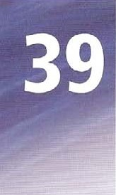Not many children go to school in Burkina Faso. I went home at 6.00 Use to and from to describe the two points Of a movement.

It changes from a liquid to a solid

below, under, beneath

Below means 'at a lower level* and occurs in phrases such as below zero; below average; see below for more information.

Under can mean 'covered by', as in under the bed and under a pile of books.

We also use it in these phrases:

Look it up under 'Mammals Children under five are admitted free.

Beneath means 'exactly under' and can be used in place of under.

We Sat beneath / under a tree Beneath / under a pile of books

#### above, over

Above means at a higher level than something. and not touching it.

Put your hands above your head There is a forest above the vil/aqe_ Over is the opposite of under, and can mean •touching or covering'. They put a blanket over him to keep him warm.

Above and over can be used to mean the same thing, especially when something is at a higher level exactly vertically.

They lived in a f/at above / over the bank.

##### preposition + noun + of

at the end of at the front of in front of

at the side of at the back of in the middle of at the beginning Of at the bottom of

at the end Of at the top of

The cinema is at the end of the Street.

Two tall people were sitting in front Of m

prepositions as adverbs

Many prepositions are used as adverbs.

Is Susan in? (at home) No, Shet out, (not at home) From the mountain, we could see a village far below.

Other examples: away (on holiday); indoors; inside; outside; underneath.

Peter is away at the moment. He's on a trip abroad. 'n France, actually. Let's go indoors / inside It's getting cold outside Ifyou can't find it on top, look underneath.

1 the correct option.

|  |  |
| --- | --- |
| 1. More than a thousand people came at / t" the match. 2. I'm sorry, but no children beneath / under twelve g are allowed. h c The noise was loud, so I put my hands above / over my ears. 3. Are you going al / to the cinema this evening? 4. There was a bird singing in the tree just outside / Out orthe window.   2 Rewrite each sentence so that it contains the word in capitals.   1. Can you tell me whether Jim is at home?      can goa .01! mhc+hcrJinc.i$ 2. Mary has gone to live in a foreign country.   C Shall we go into the house now? | David didn't feel well while he was in / on the ship.  Get out 01/ from my house, or I'll call the police.  Her left leg had to be cut off above I over the knee.  David Bowie was born at / in London in 1947. Maria was walking in / into the garden picking flowers.  ABROAD  INDOORS |

|  |  |
| --- | --- |
| d This snake is red on the top but green on the bottom. | UNDERNEATH |



|  |  |
| --- | --- |
| e Don't come in, please. | OUTSIDE |

|  |  |
| --- | --- |
| f David has gone on a trip. | AWAY |
| g Alan lives on the other side of the road. | OPPOSITE |

h Sorry, but Sue isn't here at the moment. OUT

3 Complete the text with in, at and on.

Many arclraeologists had searched for the tombs of Pharaohs a _ _ the Valley of Lhe Kings

Egypt. Only Howard Carter believed he knew where the tomb might be. He had a map Of the valley, and c . it he had marked all the excavations until he discovered a space. d the ground there was a pile of stones and earth from earlier excavations. Some steps were uncovered, and e the bottom the steps was a door f door was symbol Of Tutankhamun. Carter had to wait for Lord Carnauon, who was g home h England, to arrive. Carnarvon was paying for the work. When he arrived i _ the excavation. after digging some more, Carter and his workers bmke thlough a door and found themselves j the tomb. k this point they thought they had failed, because the tomb was empty Then [hey round another door, which led [0 an undisturbed room. There were many beautiful things I this room, and wonderful paintings the walls. Most Of the Objects from the tomb are now displayed n _ _ a local museum.

a Complete the sentence with in, at, on or to.

a Columbus and his three ships started on the voyage „ America in August 1492. b They stopped first , one Of the Canary Islands, c On 12 October they came the coast of the Bahamas.

1. 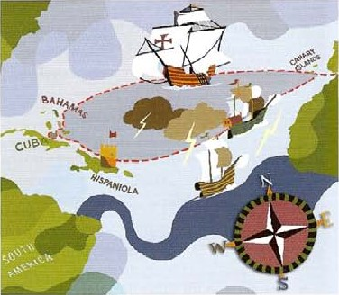From there they went Cuba, where one Of the ships, the Pinto, left in search of gold an island called 'Babeque'.
2. Columbus continued with the Other two ships and they came Hispaniola on 5 December.
3. Unfortunately, the flagship Santa Maria ran aground a reef on Christmas Eve, and sank the next day.
4. Columbus built a fortthe shore and left some Of his men there, because there was not room for all the men the tiny Nina, the other ship. h While he was on his way back Spain, Columbus found the Pinto again.

 The two ships left together, but were parted by a storm the North Atlantic.

 Both ships arrivedLisbon on 15 March within a few hours Of each other.

1. Complete the sentence with a suitable preposition.

a uvula is a small piece of flesh that hangs down the back of your throat. b The island of Alcatraz is the middle Of San Francisco Bay. c Write your address the top of the letter on the right-hand side.

d It was hard to watch the match because there were several tall people Standingfront Of me. the end Of the play, the whole audience burst into applause. f The man was completely bald the top of his head.

g Anna felt tired, so she stopped the Car the side Of the road and got out. h Divers cannot work w the bottom of the sea for very long.

1. Choose the correct option, A B, C or D, to complete the text.

We know that the inside of the Earth has a metallic core (or central part), a rocky mantle (or outer part), and a thin crust or surface.

As a result Of high pressure a _ the core. it is hotter the centre of the Earth than it is c the Sun. The

Crust Mantle

mantle is a layer Of dense rock chat lies d „ the surface and above the liquid core.

The crust is the thinnest layer, being only about 35 km deep continonts„and f , tho oceans it is even thinner

— only S km. Because Of the low density the material floats the denser mantle.The crust is divided into sections called tectonic plates.The Earth as we now know it was formed in four different stages. First of all. the most dense material (eg iron) sank h _ the centre of the planet. Lighter materials and gases stayed i the surface and the atmosphere.

The dense material formed the core Of the Earth, and the lighter solids formed the crust. In the second stage. impacts from objects eg asteroids. comets. left the kind of Crater marks we can still see the Moon.

During the third stage, lava came up I the Earths crust and rain began to fall m the sky.The first heavy rains

Inner core Outer core

formed oceans and lakes.

The fourth stage is still going on now as the surface changes. Mountains arc rising nsome areas. Large areas of solid material. tectonic plates. are moving just o the surface.

a A to B at C from D outside B to C at b A under A at g On C under

A on B under C to D from k A in B on C to d A into B outside C below D on B prom C at e A to B at C under D in from B to C u nder f A under C on D outside B to C in g A on B trom C under D Out 01 B trom C below

h A at C on D to

|  |
| --- |
|  |
| 1 Check that you have the correct answers to Exercise 3. Translate the sentences into your own language.  2 Write a sentence with each phrase.  at the back of at the end of at the bottom of in the middle of in front of into the room |

### time (1)

at, in, within. on

Use at with clock time and midday, midnight and night. Note: we cannot say at-last-night at 512 am at midday at midnight at night Use at with Christmas, Easter and New Year. What are you doing at Christmas?

use at with expressions showing definite times.

What are you doing at the moment? I'll see you at the end Of the week.

Ms Graham is busy at present. mat were you doing at the time of the robbery? use in with months, years, seasons, and morning. afternoon, evening, in April in 1906 in spring summer / autumn / winter in the morning in the afternoon in the evening use in with units of time (week, hour, moment etc) to refer to future points. I'll be back in a week I'll see you in a moment.

If use time, we add apostrophe, I'll see you in six months' time

Within means inside or during a period of time.

The work must be completed within a month. Four other cases have been reported within the past week Use on with dates, days Of the week and expressions with day. Note: we don't say 'on-next-Friday'. on April 18th on Tuesday on the last day 0f August We're going Out on my birthday.

next, last use next for the future, and last for the past with week, month, year, summer etc.

I'll sep you next week Last summer was the driest for twenty years

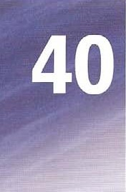since, for, ago, ages

Use since with a point in time and for with a period of time.

I've been waiting since six o•clock I've been waiting for two hours. use ago to measure time in the past.

The earthquake took place more than 100 years ago

For ages means for a long time. It follows present perfect simple as it describes a period Of time up to the present eg I haven't seen you for ages.

It's ages since is followed by a past simple verb, as since describes a point in time. It's ages since I last went to the theatre.

from, to, till, until / till

Use from and to for the start and finish of a period of time eg IW be there from 5.00 to 6.30. until means up to a point in time, and then stopping. Till is an informal form of until. waited until seven o' clock, and then left.

Some people were trapped under buildings until the following day. Use not + until to show when something finally happens.

Helen didn't arrive at the party until 1.30. It wasn't until much later that the truth finally came out.

by, by the time

Use by to mean at some point in the period of time before.

The city was rebuilt by the end of the following year.

Use by the time to describe events wh ich will be, or were, too late.

By the time we get to the party, it will be over! (We'll be too late)

By the time (that) we got to the station, the train had left. (We were too late)

during use during to mean 'in a period of time'. either at one point, or for the whole period. During the night, people felt a sudden shock. (one point)

During winter, some animals in cold countries sleep for long periods. (whole period)

1. Complete each question with at. in or on. Check the factual answers on page 208. What happened
   1. __„ivv 1918 S am?

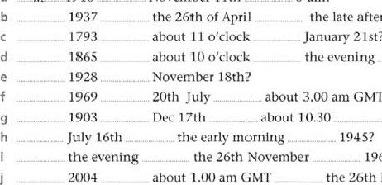

November

1

Ith

21st?

GMT?

the late afternoon?

the 14th Of April

the morning?

1962?

the 26th December?

1. Complete the sentence with at, in, on, next or last.
   1. Thetime you visit us, you must stay for dinner.
   2. Wait here, and I'll be backa few minutes.
   3. I haven't seen Helen sincemonth. d Are you having a partyyour birthday?

 Your salary will be paidthe end of the month.

 We didn't take a trip abroadsummer, but we're going to Crete this summer.

g Peter managed to break his legthe first day of his skiing holiday. h Are you going to universityyear?

 Take some warm clothes, because the temperature dropsnight.

two weeks' time, the school year will be over!

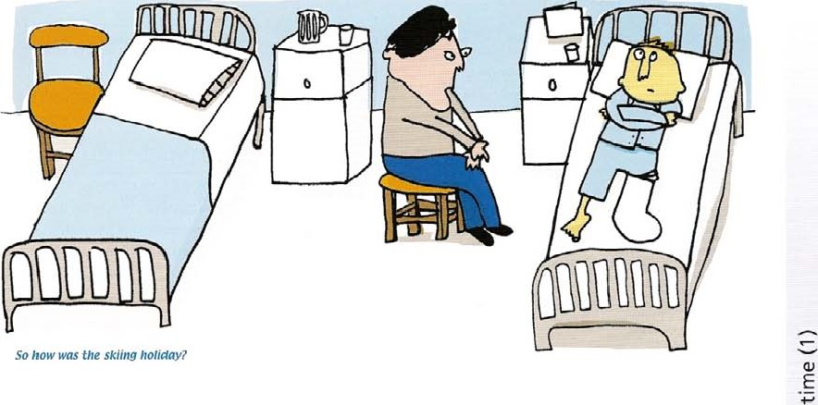

1. Complete the text with next, last, since, for, and ago.

#### Visitors from space The Transit of Venus

Scientists believe that the a _ task A Transit of Venus is an astronomical event, when time a large object from outer space hit the Earth the planet Venus is exactly between the Farth and was in 1908. Luckily it landed in a sparsely- the Sun, so it is seen crossing the face of the Sun populated area of Sibena, but people 60 km away as a small black disc. The f. Venus from the crash site were thrown to the ground. Transit took place in 2004 and the g

When it happened, just over a hundred years one will occur in 2012. Nearly 400 years

_ . Scientists thought the explosion . the astronomer Kepler predicted might have been caused by part of a Comet. the event would take place in 1631, but did not then. research has shown that realize it could not be seen in Europe.

it was a stone meteorite which exploded in the then, there have been transits atmosphere. Objects of this kind have been in 1639, 1761, 1769, 1974, 1882 and 2004.

striking the Earth d Obviously such events been taking place millions of years, but serious millions of years, hut the event explosions are rare. was not seen by astronomers until 1769, when two

Astronomers are astronomers in England both observed it. If you trying to predict missed it in 2004, and miss it in 2012, there will be when the another Venus Transit in 2117 , but that is a long time senous to wait! impact might be.

1. Complete the sentence with from, to, until, by, or during.

a Some animals cannot survive _  _ autumnspring because of the cold weather, b They hibernate (which means they sleep through the winter) as a way of keeping themselves alivethe spring.

C Another reason for hibernation is that it is hard to find food the winter.

the time winter comes, they need to have enough body fat 10 keep them alive while they hibernate.

autumn, hibernating animals collect food for storage, and eat more food than usual.

f If there is a shortage of food at that time, the animal might not livespring when it can find its food again.

the end of hibernation, the animals live off their body fat.

hibernation, they lower their metabolic rate — the rate at which they use energy.

 Animals may hibernate for several months, but they do not remain completely inactive this time.

 Some hibernate in a series Of short periods lastinga few days a few weeks.

1. Rewrite the second sentence so that it means the same as the first sentence, and contains the word in capitals,

|  |  |  |
| --- | --- | --- |
|  | Paula only arrived at school at 12.30.  Paula school | DIDN'T |
| b | My library card runs out at the end of July. | ON |

|  |  |  |
| --- | --- | --- |
| c | We arrived at the cinema, but the film had finished. | BY |

d What were you doing when the accident happened?



|  |  |  |
| --- | --- | --- |
| e | It's three o'clock now, and I've been waiting since two. | FOR |

|  |  |  |
| --- | --- | --- |
| f | At some time in the night there was an earthquake. | DURING |

|  |  |  |
| --- | --- | --- |
| g | I waited but I left at 4.30. | UNTIL |

h I'll have finished in a week's time.

I haven't seen George for ages. SINCE

 It's Monday today, so I'll see you next Monday,

1. Complete the text with words from page 156.

Lenses have been used a _ hundreds ofyears to light fires.As long b as 424 BC, a burning-glass is mentioned in Aristophanes' play The Clouds. c that Chere are references co lenses in Roman writing. but mainly to glass spheres filled with water.The Arabian mathematician Ibn Sahl who lived about 940 1000 AD wrote about lenses. Another Arabian scholar,Alhazen (965-1038), who lived slightly f than I Sn Sahl, wrote the first description of how the lens in the human eye forms an image on the retina. Recent excavations in Sweden have also shown that the Vikings used lenses the Ith and 12th centuries.True glass lenses were not invented the 13th century, probably in Italy. i then, lenses have been used in reading glasses and other optical instruments, such as telescopes and microscopes.The telescope seems to have been invented by Dutch lens makers j

the 1 7th century.The microscope seems to have been invented k . . about the same time.



|  |  |
| --- | --- |
|  | EXTENSION ACTIVITY |
| 2 | Write a true statement about yourself with each of these time words.  on last since ago till during  Check that you have the correct answers to Exercise  5. Translate the sentences into your own language. |

### time (2)

#### now

Now means 'at the present time'. Helen is now the new student representative.

By now means 'at some time before now'. We should have heard some news by now.

From now on means 'from the present moment'. From now on, this class will meet in Room 2.

##### then

Then means 'at a particular time in the past'.

Einstein was then working in a government office in Zurich.

We could also say at the time / 0t that time. We can also use then with future reference,

'Let's meet outside the cinema at 8.00. ' 'Ok, I'll see you then until then. by then. before then are also possible.

I'm leaving on Saturday morning. Until then, I'm staying in a hotel.

Phone Maria at 6.00. She should have finished work by then. You con come on Thursday? Can't you come before then?

Then also introduces the next thing that happens.

First open the back of the radio. Then remove the batteries.

##### soon

Soon means 'in a short time from now'.

If it doesn't stop raining soon, we'll go home.

Soon after the match began, a fight started behind us.

Please cal/ me back as soon as you can / as soon as possible.

once, at once, immediately

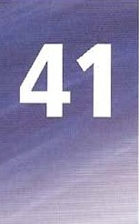Once refers to a point in the past when something happened. We once spent Christmas in Thailand.

Once also describes a situation in the past, usually before a change that has taken place. Helen was once national judo champion. (She isn't now) At once and immediately mean 'without delay".

Stop doing that at once!

When Jim saw the men go into the bank, he immediately called the police.

##### on time, in time

On time refers to a timetabied event which happened as planned.

The train arrived on time, Dina handed in her project on time.

In time refers to an event which happens early enough. We can also say just in time, and in plenty of time.

We got home just in time to watch the TV news.

Our bus was delayed, and we didn't reach the airport in time.

##### at the end, in the end

At the end describes the final point Of a period of time.

At the end of the film, everyone clapped. I'll see you at the end of the week.

In the end means the Same as finally, or 'after a period Of time'.

I was thinking Of buying a new bike, but in the end I decided I couldn't afford it.

##### later, after, afterwards, before

Later is an adverb and means 'at a later time', We can also say later on,

I'll see you later. Can you phone me later on?

After can be used as a preposition with an object, or as an adverb without. Afterwards is an adverb and can stand alone.

I'll see you after the lesson. It's long film. What are you doing afterwards? use before as an adverb or as a preposition.

I saw herbefore the lesson. (preposition) I've seen this film before. (adverb)

just, yet, already. still use just for very recent events. I've just had an idea!

use yet in negative sentences and questions for possible future actions. Have you finished yet? Not yet! / haven 't started yet!

use alreadyto describe actions before now. In questions, already expresses surprise that something has been done so quickly.

I've already seen this fi/m_ (before now)

Have you done your homework already? (this surprises me) use still when we describe actions that are continuing.

I'm still reading your book. / haven't finished it.

1. Choose the correct option, A, B. C or D. to complete the sentence.
   1. It seems that the Olympic Stadium will not be finished for the Games.
   2. I haven't eaten  , so I feel really hungry.

 I won't be long, I'll be back d Could you let me have my book back e I've had an idea. Why don't we go and see Kate?

I wanted to be an engineer, but now I want to study computers.

* 1. I thought I had caught a cold, butit was nothing.
  2. Maria promised to return my books. she could.

|  |  |  |  |
| --- | --- | --- | --- |
| A immediately | B in time | C yet | D soon |
| A now | B soon | C at once | D yet |
| already | B just | C once | D soon |
| d A in the end | B after | C yet | D as soon as you eun |
| e A already | B soon | C just | D now |
| f A by then | B later on | C once | D just |
| g A in the end | B at once | C in time | D still |
| h A as soon as | B before | C in time | D just |

1. the correct option.
   1. You should have finished your project soon / now.
   2. I nearly dropped the eggs, but managed to catch them just in time / on time.

C Let's meet after I later school and talk about it, d From now on / later on, things are going to be different!

 The results come out next week, so berore / until then, you'll have 10 wail.

f The meeting starts at 7.30.' 'Right, I'll see you at once / then.' g Our teacher once / at once sang in a rock band.

h At / In the end Of the match, the spectators ran onto the pitch.

 Mix the butler and sugar and then / citter add the eggs.

Immediately / As soon as she came into the room. I knew we were going to be friends.



o

1. Choose the correct option, A, B or C, to complete the sentence.

|  |  |  |  |
| --- | --- | --- | --- |
| a | Alexander Fleming is usually described as the |  | A few years , in 1942, Bumstead and |
|  | scientist who discovered penicillin in 1928, |  | Hess became the first doctors in the world to |
|  | but in fact at least two other scientists had |  | save a patient using penicillin. |
|  | noticed its antibiotic effect he did. | g | At this point, Dorothy Hodgkin had |
| b | The antibiotic effects of penicillin had |  | described the chemical structure of penicillin, |
|  | been recorded in France by a Costa Rican |  | so it was now possible for penicillin to be |
|  | scientist. |  | produced in large quantities. |
|  | Fleming conducted experiments with | h | Penicillin is used to treat many |
|  | penicillin, but decided that it would |  | infections. |
|  | not work as an antibiotic in humans. |  | However, in the 1940s, the first cases |
| d | Luckily, other scientists continued with the |  | of resistance to the drug had been reported. |
|  | research and were making progress |  | Because bacteria can change, they grow |
|  | when the Second World War began in 1939. |  | resistant to antibiotics, and scientists have not |
| e | However, at that point they had not |  | found a solution to this problem. |

treated any patients.

|  |  |  |  |  |  |  |
| --- | --- | --- | --- | --- | --- | --- |
|  | a | A alter |  | C already |  |  |
|  | b | A already | B later | C still |  |  |
|  | c | A after | B later | C just |  |  |
|  | d | A a/ter | B afterwards | C still |  |  |
|  | e | A yet  A after | B just  B later | C still C yet |  |  |
|  | g | A just | B still | C yet |  |  |
|  | h | A still  A yet  A later | yet  B still  B yet | C already  C already  C already | Dorothy Hodgkin |  |
| 4 | Rewrite each sentence so that it contains the word or words in capitals. | | | | |  |
|  | a They'll be back after twelve. | | | | | IN |



|  |  |
| --- | --- |
| b Can you do it now, please? | AT |



|  |  |
| --- | --- |
| c When the lesson finished, Helen asked the teacher a question. | AT |



d My head hasn't stopped aching.

|  |  |
| --- | --- |
| e Jan wasn't late for his music lesson. | TIME |

|  |  |
| --- | --- |
| f It's eight o'clock and I've been waiting for two hours. | SINCE |

* 1. 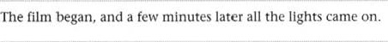 SOON ALTER
  2. Lunch isn't ready yet, so before that we'll sit in the garden

|  |  |
| --- | --- |
| I'm still doing my homework. | YET |
| When I've finished watching TV I'll start my work. | AFFERWARDS |

5 Complete the text with suitable time words.

a they were deciphered nearly two hundred years b , Egyptian hieroglyphics could not be understood by European scholars. c hieroglyphics were deciphered. people had to guess what this form of writing could mean. It was originally used by the ancient Fgyplian priests, d about

3000 BC e the time of the Roman Empire. One of the men who deciphered hieroglyphics was Jean-Francois Champollion

(1790—1832) a self-laugh! linguis[ who had learned Latin and Greek the age of nine. When he entered the

School of Orietual Languages in Paris

The Rosetta stone _ 1807. he had already suggested, the age of sixteen, that the ancient Egyptian language was Coptic. i . the age of nineteen Champollion became assistant professor Of history in Grenoble. Here he continued his studies and this period he started 10 examine texts brought from Egypt. The French had sent an army there I 1 798, and a year m a group of soldiers had accidentally discovered rhe

Rosetta Stone, on which was written the same text in three languages — in hieroglyphics. in demotic Egyptian, the everyday language. and in Ancient Greek. n however, the French army in Egypt was defeated by the British, and soon o , the Rosetta stone was taken to London. •lhere, by comparing the different kinds of writing on the Stone. Thomas Young showed that some of the hieroglyphs on the stone wrote the name Ptolemy. Luckily Champollion was able to study a copy of the text on the stone, and 1824 he pubhshed an explanation of the hieroglyphic system. q then, archaeologists have been able to read thousands Of inscriptions left behind by the ancient Fgyptiarl>. The Rosetta Stone is r in the British Museum in London.

|  |  |  |  |  |  |
| --- | --- | --- | --- | --- | --- |
| |  |  | | --- | --- | |  | EXTENSION ACTIVITY | | 1  2 | Write a true statement with each time word. soon on time once yet still  Check that you have the correct answers to Exercise 2. Translate the sentences into your own language. | |  |

prepositions after verbs, adjectives,

and before nouns

verb + preposition (See also Units 43 and 44)

Many verbs are followed by a particular preposition, or by different prepositions for different meanings eg laugh at / laugh with. Always check in a dictionary for meaning and usage.

verb + preposition + noun

|  |  |
| --- | --- |
| Everyone laughed at the cartoon. I can't deal with this problem. suffer from panic attacks.  You can depend on us.  They were protesting against the war.  We laughed about the problem the next day.  verb + preposition + noun / -ing We apologize for the delay.  He can't concentrate on his work.  I'm not used to studying late at night.  They succeeded in making matters worse.  verb + noun preposition + noun / always confuse "lie' with •lay'.  I'll have to discuss this with your parents. | I'll pay for your ticket.  / find it hard to cope with stress.  How do they differ from one another?  You can't rely on Tom to arrive on time They're talking I arguing about history. What does the word 'input' refer to?  Dr Sims specializes in back problems.  me congratulate you on your success, / insist on seeing the manager.  They blamed everything on me  / prefer tea to coffee |

verb + person + preposition + noun / -ing

They accused her of cheating. Can you provide us with a copy? You remind me of someone I once knew.

adjective + preposition

An adjective can be followed by different prepositions for different meanings eg be angry with

someone / be angry about something.

You're right / wrong about that.

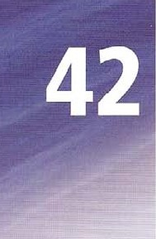I'm not sure about the answer.

I'm sorry for being late.

Are you afraid Ofspiders?

Are you angry with me?

I'm bored with the same o/d mutine Kate isn't keen on animals.

We were shocked / annoyed by the news.

preposition + noun phrases Is this boat for sale?

We found the answer in the end.

In practice it doesn't work.

Are we in danger (of + ing)?

It happens on averageonce a year. They received the letter by mistake The bus was out of control. Sorry I'm out of practice

Everything is under control.

I'm sorry / upset / angry about that.

Our town is famous for its cakes.

Who IS responsible for this mess?

Speech is different from writing.

I'm annoyed with you!

I wish / was good at maths.

Is your sister married to him? Are you interested in jazz?

Are you on holiday here?

That sounds good in theory.

My little brother is in trouble.

In fact, this is true.

I think he did it on purpose After running I was out of breath.

Don't worry: he is out of danger.

I was under the impression you knew ThereS no school tomorrow after all.

1 sentence with a suitable preposition.

1. Most people would expect a work environment to differ an educational environment.
2. When you Start your first job, you may find that you are not used the way that your colleagues behave.
3. You may not understand what people are talking
4. You may have to ask a lot Of questions, and worry that Other people can't rely you. e Or you may find it difficult at first to cope the demands your job places on you.
5. But there is no reason to Suffer feelings of anxiety.
6. You have to concentrate_ learning the job, and understanding the people around you.
7. Don't worry that people are laughing you, Or making fun of you because you are new to the job.

You'll soon learn to dealeveryday problems, and gain in confidence.  Don't be afraid to ask for advice, and you'll soon be congratulating yourself your Success.

2 Rewrite each sentence so that it begins as shown and contains an adjective and preposition.

a You really annoy me sometimes.

Sometimes I'm _ b The things we saw on the news shocked us all.

We were all

 I'm sorry but I lost your magazine.

I'm sorry for d Who caused the accident?

Who was e I don't really like horror films.



not

 Football and rugby are not the same.

Football is g Are Madonna and Guy Ritchie married?

Is Madonna h Does playing computer games interest you?

Are you _

 I find doing the Same things every clay boring.



 Going to the top of high buildings makes some people afraid. Some people are

3 text with the words from the list. Use each word once only.

average control end fact impression practice purpose theory trouble

11 1

10 2

In a •WtZcC4 people are either morning people, who get up very early, or

3

afternoon people, who don't, but things may not be quite as simple as this. people

4

who sleep until late may not do this on b .They may just be under the c — that they are afternoon people, so they simply couldn't get up early even if they tried. Or they think that they could get up early, but they are out of d It's just a question of getting used to itThen one day they realize that morning people are more successful.They decide they have to change, but then their problems Start. For example. you may really want to get up at 5.00 am, but when the alarm clock goes off, you decide that perhaps you are an afternoon person after e .And so you fall asleep again.What can you do?

Some research suggests that people who want to get up early Often go to bed too early, and this is What lands them in f when the alarm clock rings. Their sleep patterns are out of g and either they can't get to sleep or they wake up too early, or they carft wake up until late. In h , we may not need the same number Of hours sleep every night-As long as we sleep roughly the same amount on i over a period Of time. we probably get enough sleep. so in the j we may be better off going to sleep only when We really feel tired, provided we always get up at a fixed time each day.

1. Rewrite each sentence so it contains the word in capitals.

|  |  |
| --- | --- |
| a In the end I managed to find the answer.  A-he I succe.gdgd in $indinq A-he anSÆé.r. | SUCCEEDED |
| b Martin's teacher said that he had cheated. | ACCUSED |



|  |  |  |
| --- | --- | --- |
|  | We get a free lunch at school. | PROVIDES |

|  |  |  |
| --- | --- | --- |
| d | I must have my money back! | INSIST |

|  |  |  |
| --- | --- | --- |
| e | They said the fire was Anna's fault. | BLAMED |



|  |  |  |
| --- | --- | --- |
| f | When I see you, I think of my sister. | REMIND |
| g | Getting up early in the morning is new to me. | USED |

|  |  |  |
| --- | --- | --- |
| h | Don't worry, you can trust Chris. | DEPEND |

|  |  |  |
| --- | --- | --- |
|  | What were you two discussing? | TALKING |

 I like jazz better than rap. PREFER

1. sentence with one suitable preposition.

On average, a yawn lasts about six seconds. b If you yawn . purpose in front of other people, they will start yawning.

* 1. You might be the impression that a yawn is a bad thing.
  2. People usually apologizeyawning when they are in meetings or lessons.
  3. We often assume that we yawn because we are boredsomething.
  4. People often yawn, for example, when they can't concentrate their work. g wever, we aredanger of simplifying the complex process of yawning.

h For example, athletes often yawn before races, and we can suppose that they are quite interested  what they do.

fact, scientists are not exactly sure why we yawn.

 Some believe that people yawn because they are sufferinga shortage of oxygen.

k Others th_ink that it is part of Our animal past. and we are showing our teeth to other people to make them afraid

 Apparently. even if people read about the subject

01 yawning they start yawning the end. m So if this article has succeeded

|  |  |  |
| --- | --- | --- |
|  | you yawn, don't worry about it. |  |
|  | n You are just being normal, | all. |
| 6 | Complete the sentence so that it contains the words in capitals. |  |
|  | a Are you selling your bike?  Is | SALE |
|  | b I haven't done this for a long time.  Eventually we stopped and turned back. In | PRACTICE |
|  | d Are you spending your holiday here? | ON |
|  | e I thought it was Andy, but actually it was David.  I thought it was Andy, but | FACT |
|  | f I think you broke the window deliberately.  I think you broke the window | PURPOSE |

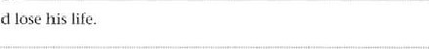g They told him that he could DANGER

They told him that he was

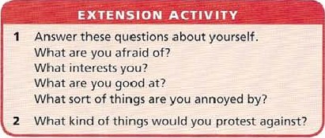

We

turned

left

|  |  |  |
| --- | --- | --- |
| h | The driver had no control over the train. The train was | OUT |
|  | I thought it was a holiday today. I was | IMPRESSION |
|  | We accidentally turned left instead of right. | MISTAKE |

### phrasal verbs (1)

* We use phrasal verbs in everyday language rather than formal language.
* We cannot usually guess the meaning from the combination Of words.

Some of them have more than one meaning. Only a selection appears on this page.

two part verbs: unsplittable verb + preposition

We cannot put the object between the verb and preposition. We can sometimes guess the meaning.

/ came across this word in a magazine. (find by chance) What are you getting at exactly? (suggest) j won 't stand for this behaviovr any longer! (tolerate)

|  |  |
| --- | --- |
| It took me a long time to get over my illness. | (recover from) |
| The police are looking into the robbery. | (investigate) |
| Wi/j you look after the baby? | (take care of) |
| Anna takes after her mother | (look or behave like) |
| / ran into Tom the other day. | (meet by accident) |
| Tom is heading for trouble. | (go in the direction Of) |
| When I laughed, everyone joined in. | (do the same activity) |
| l,et'5 run through the details | (explain) |

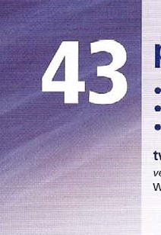two part verbs: splittable verb + adverb particle

We can put the object between the verb and particle, or after the particle. If the object is a large number of words we put it after the particle. If the object is a pronoun eg me, it, him, we put it between the verb and the particle. We can sometimes guess the meaning.

|  |  |
| --- | --- |
| Try to carry out a 'task ana/ysjst Con you give in your homework now. Can you fill in this form?  You can leave out / miss out the next exercise.  We're trying to sort out the problem.  You can work Out the answer for homework, Don't forget to turn off the lights.  We have put off the match until next week.  Thé bus dropped Off the students Outside the schööl.  Out teacher told us off because we vvere noisy.  Don't let down the team, will you/  We 'f/ come and pick up the others at 6.00. Sw»an brought up three orphan children.  people say its hard to give up smoking. You have to look up these words. | (do a piece of work)  (give it to the teacher) (write information on it)  (don't do it)  (deal with)  (find the solution)  (stop using)  (postponed)  (take to a place)  (criticize angrily)  (disappoint by not doing what was promised)  (collect in a car)  (look after a child until it becomes an adult)  (stop doing something)  (find in a dictionary) |

Note: always check in a dictionary for meaning and usage.

1. Use a phrasal verb from the list to replace the words underlined.



came across getting at getting over heading for joined in looked after looked-into running into running through took after

* 1. A special committee b Everyone said that Richard c If things go on like this, the company is disaster! d Our neigh bour ILQk-SAig_9f e When a man at the front started shouting, everyone else the same this article while I was doing my project.

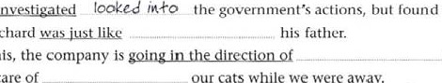

found

nothing

wrong.

our

cats

while

we

were

away.

* 1. Listen carefully, the teacher is explainingthe details again.
  2. Maria is slowly rece.yg.Ling-LL-om her illness.
     + I don't understand what she is trying-to—say

 1 keep Harry in the library.

1. Complete the sentence with a word from the list. Two words are used twice.

come get head join 100k run stand take

* 1. 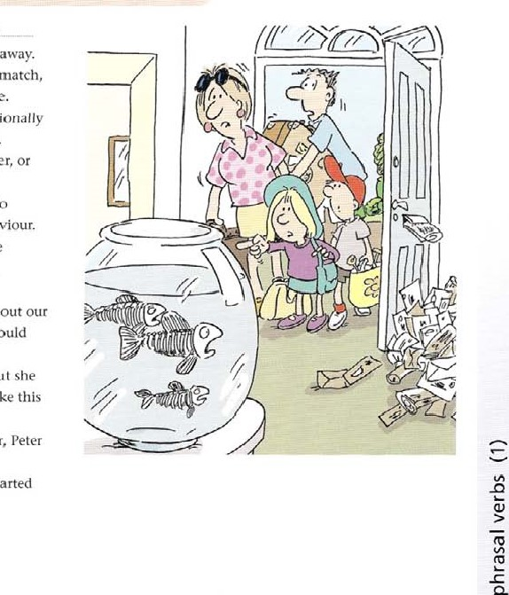We couldn't find anyone to _ took after our three pet fish while wc were away.
  2. Tony is disappointed to have lost the match, but he'll over it in time.
  3. I don't see much Of David, but I occasionally

into him in the library.

after your father, Or your mother?



d

Do

you

e Our teacher told us she wasn't going to for any more bad behaviour.

 Could youthrough the programme again? I'm sure there's an error somewhere.

* 1. We made a complaint to the airline about our missing luggage, and they said they would into the matter.
  2. Anna knew a lot about tropical fish, but she had never across one like this one before.

When the other children play together, Peter seems too shy to

 When the alarm bell rang, everyone started tofor the exit.

1. Rewrite the sentence so the word underlings/ is in a different place.
   1. Don't forget to give your homework at the end of the lesson.

Don 4-0 give. in {our 0-C teS60w. b The maths teacher has put the test until Friday.

* 1. I'll come round and pick up the letter tomorrow.
  2. Make sure you 100k every new word up.
  3. Remember tö turn Oft the 'IV when you go to bed, f Don't worry, we'll sort the travel arrangements next week.
  4. please fill jn Lhe form as carefully as you can.
  5. The bus drops Off passengers right Outside the hotel.
     + You have let the whole class, und I'm very disappointed.  An elderly couple brought the children up after their parents died.

1. Complete the text with the appropriate phrasal verbs from page 168.

#### A Japanese ToCktaCe

Once upon a time, a man had to a some work in another village.The work was difficult and there were many problems to

b . He was tired and was a cold. so he decided to d finishing the work until the next day. It was late by the time he left and he had to walk home over the mountains. Soon it started

. 11, 

to get dark but luckily he e a tree Where he could sleep. He was woken up in the middle Of the night by strange noises. He could'ft f what was going on, so he decided to get up and g the situation. He was surprised and scared when he saw a group of elves singing and dancing around his tree, but they were having so much fun that he wanted to h

The elves liked him and asked him to return, and as a guarantee they took the wart on his forehead.The man left feeling very happy because he didn't want his wart On his way home. he i one of his neighbours, who also had a big wart on his forehead. He told the neighbour his story. and the neighbour decided he would go that night, and hopefully the elves would take his wart too.The next night the neighbour went to the tree and found the elves. They thought he was the man from the night before and gave him back his wart! Now he had two warts instead Of One, and went home feeling very j

1. Rewrite the sentence using the word in capitals.
   1. The trip to the National Gallery has been postponed until next Friday. PUT



|  |  |
| --- | --- |
| b Make sure you check the meaning Of these words in a dictionary. | LOOK |

|  |  |
| --- | --- |
| c You don't have to do Exercise 9. | MISS |

|  |  |
| --- | --- |
| d A special team is trying to find Out the cause of the accident. | LOOK |

|  |  |
| --- | --- |
| e I will not tolerate such bad language in the classroom! | STAND |

|  |  |
| --- | --- |
| f Don't leave the computer on when you leave. | TURN |

|  |  |
| --- | --- |
| g A taxi will come and collect you at 7.30. | PICK |

|  |  |
| --- | --- |
| h I wish I could stop eating chocolates. | GIVE |

i Please complete the application form. FILL

i Tina hasn't recovered from her illness yet.

1. Rewrite the sentence using a phrasal verb instead of the words underlined-
   1. Have you ever found this word before?

Mave-gou .e-vzr across*his aord be-Gord b I'm takjng_carg of the children until their mother comes home.

|  |
| --- |
| EXTENSION ACTIVITY |
| 1. Write a true sentence about yourself with each phrasal verb.   get over (00k after take after give up look up   1. Check that you have the correct answers to Exercise 6. Translate the sentences into your Own language.   Need more practice? Go to the Review on page 192. |

* 1. 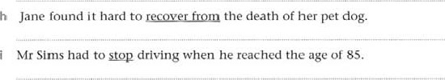Make sure you dontleayethe lights on.

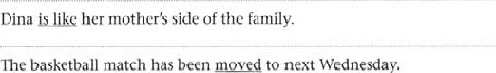

c

d

* 1. The police are a fight Outside the cinema.
  2. Let me explain the details of the plan just once more.

j Peter promised to come and sing in the concert, but he disappointed us. 

phrasal verbs (2)

two-part verbs: no object verb + adverb particle

These verbs do not have an object (intransitive). rhe traffic builds up here every day.

My car has broken down again. It's important to speak out, What exactly is going on?

The feeling of shock gradually wore off Stop showing Off!

Jim always turns up late.

Everything turned out all right in the end.

three-part verbs: unsplittable verb + adverb particle + preposition

The object always comes after the preposition.

Have you come up with any ideas yet?

Whpn are you going to get round to your MO,rk?

We've come up against a problem.

She didn't get away with cheating in the exam.

Maria has gone down with a bad cold.

I can't put up with Alan/ He annoys me!

We want to do away with school uniform.

I'm really looking forward to seeing you.

(increase)

(Stop working)

(be frank, give an opinion)

(happen)

(go away)

(behave to attract attention)

(arrive, often unexpectedly)

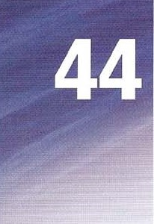(have a particular result)

(think of)

(finally do something)

(met a difficulty)

(escape capture or detection)

(become ill with a disease etc)

(accept something / someone unpleasant)

(abolish)

(think with pleasure about the future)

verb + adverb particle + preposition + object or verb + particle (no object)

|  |  |
| --- | --- |
| We've run out of milk again. rhe milk has run out | (have none left) |
| 1•/1 catch up With you later.  Anna can't catch up | (go faster to reach someone) |
| DO you get on with / along with David? Do you two get along? | (have a good relationship with) |
| / can •t keep up with the class. | (go at the same speed as) |

I'm finding it hard to keep up

Note: always check in a dictionary for meaning and usage.

172

Includes material from Units 43 and 44.

1. Underline the correct option, A, B, C or D, to complete each sentence.

 Misunderstandings are common in relationships, simply because communication _ b Even when two people extremely well, they still have to talk to one another.  It's not unusual for people to because Of some annoying habit. d For example, if someone often late, this can be very annoying. e It can also be very annoying if your partnerin front of others. f Many people just accept these problems, and ignore what is g However, a sense of resentment often _ between two people if issues are left unresolved, h Good communication usually to be the only way to deal with the situation.

|  |  |  |  |
| --- | --- | --- | --- |
| a A breaks down | B goes on | C turns up | D shows om |
| b A tum up | B go on | C buildup | D get along |
| A show | B rall out | C get along | D turn up |
| d A builds up | B [alls Out | C breaks down | D |
| e A rurns up | B gets along | c shows | D goes on |
| f A going on | B turning out | C getting along | D turning up |
| g A breaks down | B shows om | C turns out | D builds up |
| h A turns out | B sets along | C shows off | D goes on |

1. Rewrite the sentence so that it contains a phrasal verb from the list instead of the words underlined. Change the tense etc if necessary.

come up against come up with do away with get away with get along with ;et-tttttttt-b-tt-' go clown with keep up with put up with run out of

I'm finding it difficult to my geography project.

Girding ik di#iült+ +0 +0 .qr,ogr-aphg proje,c+ b I'm afraid we've a rather serious problem.

Tim thought he had escaped unpunished after cheating in the exam.

* 1. Ilave you th0Agght_of any good ideas yet?
  2. I

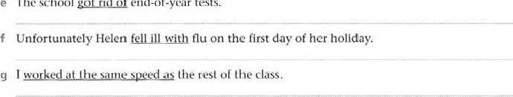

The

School

got

rid

of

end-of-year

tests.

* 1. 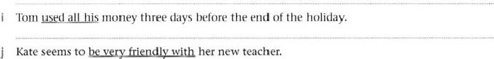I'm sorry, but I really can't tolerate this terrible noise. 3 Complete each sentence with a word from the list. You can use a word more than once.

|  |  |
| --- | --- |
| down Off on Out up   1. I was really tired, and I couldn't keep            with the others. 2. Steve is one Of those people who shows   all the time. | 1. I can't write any more. I've simply run    Of ideas. 2. Dina has come with a good idea for using less electricity. 3. Halfway up the mountain, the bus broke   and all had to |

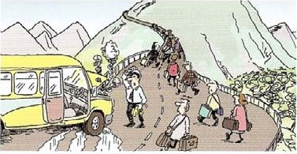 the passengers c I've worked with Paula for two years, but we don't get out. really get d By the time we left, [he traffic had begun fo build and we had to keep stopping.

* 1. After a few days, the pain in my wrist began to

 Maria won't be coming with us, as she has gone with flu.

g Jack turned halfway through the lesson, and looked very embarrassed.

1. Complete the sentence with a phrasal verb from the list, Change the tense if necessary

come up with drop (someone) off fill in get away with get over give up  look into put Off work out

* 1. Basic tomato and basil sauce—you can — the basil ifyou don't have any available, or use half a teaspoon Of dried basil instead.
  2. Learn how to your feelings Of shyness quickly and permanently!  Scientists ways of treating cancer by strengthening the immune system.
  3. the details at parts 3 and of this form, and return il to us al the address shown above.
  4. Wallace and Gromit's Children's Foundation is challenging pupils in schools throughout the UK to ideas for new inventions in 'Wallace's Inventing Competition'.

 We'll give you some ideas of how you might build it. You canthe details and Change the plan as you See fit.

* 1. When Alan's mother at school the next morning, he felt confident and happy again.
  2. The wedding of Prince Charles and Camilla Parker Bowles until Saturday to allow the prince to attend the funeral Of Pope John Paul Il.
     + I have decided 10 eating meat. Whal are Some 01 the difficulties of becoming a vegetarian?
     + She might well havethe Crime had she not been arrested for robbery while Carrying documents relating 10 two 01 her false identities.



1. Rewrite each sentence so that it contains the words in capitals as part of a phrasal verb.
   1. Most students searching for information try to find the details on the Internet. LOOK



* 1. Doctors say that the unpleasant effects of the new malaria pill Soon go away.

|  |  |
| --- | --- |
| c The battery loses power completely after about three months. | RUN |



|  |  |
| --- | --- |
| d The three astronauts said they were feeling happy about coming back down to Earth. | LOOK |

|  |  |
| --- | --- |
| e Continue to learn about the latest science news with Science Magazine. | KEEP |



|  |  |
| --- | --- |
| f There is a great deal of confusion and the authorities are still trying to deal with the situation. | SORT |

|  |  |
| --- | --- |
| g The launch of the next Mars mission has been postponed until next April. | PUT |

1. Complete the text with the appropriate phrasal verbs from page 172.

### The world of work

IÜ official: people arc more stressed now than they were in the past. Although our quality of life is better, we seem to have more to worry about than previous generations. Here are some stressful situations you may a CONIC up at work. and ways to solve them.

Your boss is scary, and you don't want to b .

You are asked for your opinion. but don't want to say what you really think co because you don't want to annoy your boss. c your boss is very important, so try to give your opinion politely.

You d a great idea, and someone else steals it.

You work hard, but a colleague gets all the credit_The best thing to do is make a note Of all your ideas, and send them to your boss.Then if someone 00.

else says they thought of it first, your boss will know really

Your colleague always late, and you have to do their work

Some people never do their share Of their work, and when they finally g doing something, it' usually not very good.Try not to let your anger with them h and tell them calmly that you refuse to do any more of their work.

Your computer I telephone I photocopier i

conjunctions, adverbs and

## prepositions as connectors

because, so, as, since use because, so, as and since to link an action with its purpose.

We went home early, because / as/ since we felt tired.

We telt tired, so we went home early

#### for example, such as

Use for example and such as to give examples. We usually put a comma after for example.

Eat lots Of green vegetables, such as cabbage and spinach.

Try taking more For example, you could walk to v.'0rk.

instead (of) use instead when we say that one thing replaces another. We can put it at the end or beginning Of a clause or sentence.

He was too tired to go out so (instead) he watched television (instead). We could watch television instead of going out.

according to use according to when we say where an idea or statement has come from.

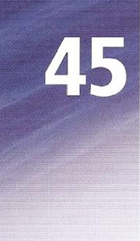According to Freud, '.•ve learn through fairy tales, myths, jokes, and folklore,

however, yet, although / though, even though, while Make contrasts with however, although, even though, and while.

However comments on what has come before. use it to begin and end sentences, or put it inside a sentence to separate parts of the sentence. Note that however always has punctuation before and atter it.

Crude Oil itself is not useful. However, its compounds have many uses.

Its compounds (, however,) have many uses (, however.)

Yet has a similar meaning to although, or but. It cannot come at the beginning of a sentence. Crude oil itself is not very useful, yet its compounds have many uses.

Although is followed by two contrasting ideas. The although-clause starts or finishes the sentence. Though is another form of although.

Although crude Oil itself is not very useful, its compounds have many uses.

The compounds of crude oil have many uses. although crude oil itself is not very useful. use while in the same way. It does not have a time meaning in this use.

While crude oil is not very useful, its compounds have many uses.

Use even though to make a surprising contrast. It has the same positions as although. We continue using oil-based products, even though many pollute the environment.

#### as well, too, also

As well and too go at the end of a clause or sentence. Also goes in the middle Of a clause, before a verb, or after an auxiliary or modal.

The roots of acacia trees grow deep in the soil, but spread ouwards too.

The roots of acacia trees grow deep in the soil, but spread outwards as well.

The roots of acacia trees grow deep in the soil, but also spread / can also spread outwards

I Rewrite each sentence so that it contains according to.

a Experts say that school science textbooks are not good at teaching science.

 science, b Their reports say that most books cover too many topics.



1. These experts believe that the classroom activities in the books don't help students learn basic scientific ideas.



1. One scientist said the books are 'full Of unconnected facts'.



1. Some educational experts say that students learn science more effectively when they try to answer an everyday question.



1. These experts say that a question such as 'Why is the sky blue?' is the kind of science question students like answering.



1. This theory Suggests that Students learn better if they carry Out project work based on this kind Of question.
2. However, many science teachers believe that the school syllabus does not allow enough time for this kind Of exploration.
3. Rewrite each set of sentences as one sentence so that it contains instead. Add or, and, but and so where necessary.

a You don't have to use butter. You can use olive oil.

 You doni+ have._+o.usc use otivc ins+cad b Cooking spoils the flavour Of carrots. Fat them raw.

* 1. This is usually made with apples. Or you could try pears.
  2. Fresh fish is best for this recipe. You can use frozen fish,
  3. Try leaving out salt. Use Other spices.
  4. Sweets are fattening. Eat fresh fruit.
  5. You don't have to use cream. You can use yoghurt.
  6. In some versions of this dish beef is not used. lamb is used.

1. 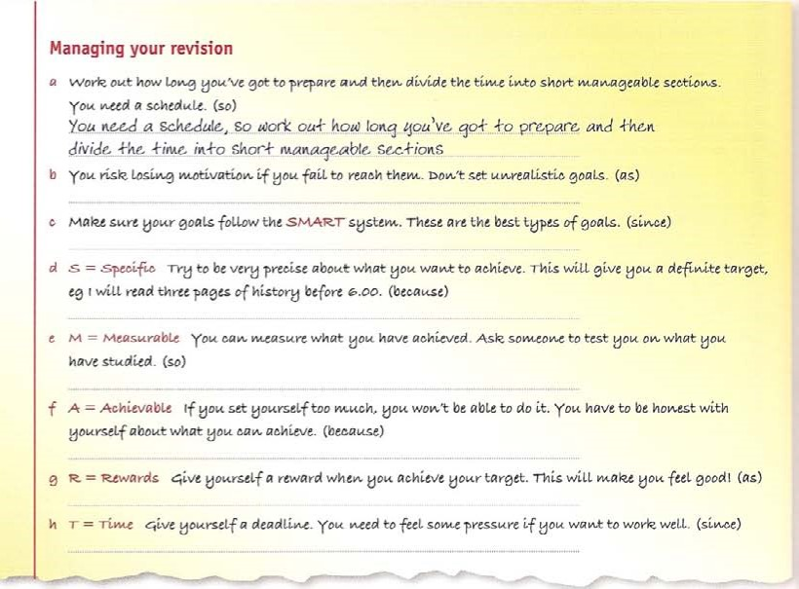use the words to make one sentence containing the words in brackets. You may have to change the order.
2. Complete the sentence with however, even though, or while. More than one answer may

be possible.

1. Oil is an important part of the global economy. _040zdc.Ve-r-„_ it is becoming more expensive all the time.
2. Some large industrial countries, Such as the

USA and Russia, produce their own Oil,

_ most European countries have to import their oil.

1. And in 2001 the USA, for example, produced 181 million barrels of oil, it still imported 273 million barrels from other countries.
2. many countries produce large amounts of oil, exploration must continue to find new Oil fields.
3. New fields have been found under the sea, it is harder to extract the Oil in these places.

_ , new technology may solve this problem.

the demand for Oil is rising all over the world, oil is a non-renewable resource, so supplies will eventually run out. h this is an obvious fact, there is still disagreement as to how long oil supplies will last.

1. 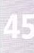Rewrite each set Of sentences as ONE sentence containing the word in capitals. Make any other necessary changes.
   1. Every living organism needs energy to maintain its body. It needs energy to grow. ALSO



* 1. Omnivores are animals that cat plants. They eat other animals.

|  |  |
| --- | --- |
| c Decomposers are organisms that eat dead animals and dead plants, They enable other plants to feed off the dead material. | AS WELL |

|  |  |
| --- | --- |
| d Producers are plants that use photosynthesis to turn the energy of the Sun into food. They are the lowest layer Of the food web. | AISO |

|  |  |
| --- | --- |
| e Primary consumers are the animals that eat the producer layer. They are called |  |
| herbivores too. | A [SO |

|  |  |
| --- | --- |
| f Secondary consumers eat the primary consumers and are carnivores. Some of |  |
| them eat plants. | AS WELL |

1. Complete the text with one suitable word or phrase from page 176 in each space.

|  |  |
| --- | --- |
|  | EXTENSION ACTIVITY |
| 1  2 | Write one or two sentences with each word or phrase as they are used on page 176. so for example according to although too  Copy out five Of the exam ples from page 176, and translate each One into your own language.  Need more practice? Go to the Review on page 192. |

Wind power is another way Of producing electricity. a At+houqh wind power produces just 0.4% Of the electricity. many countries are building Wind farms, b this has many advantages over other methods. Compared to a power station using oil or coal, , a wind farm produces no air pollution and wind itself will never run Out _ _ a Wind farm only works well when it is built in the right place.Wind plants generate electricity only when the wind blows, if there is no wind, there is no electricity. On the Other hand, f there are many advantages, there are 8 some problems, h noise and the way the turbines spoil the look of the countryside. i wind farms are Often built on mountains or near the sea. the people who visit these places often feel that they have been spoilt by the wind turbines. One solution to this problem may be to avoid building the farms on land, and where possible to build them on man-made islands out at sea this is a solution for countries with long coastlines, it is obviously not the answer everywhere. visitors to areas with wind farms usually complain about the noise and the spoilt view, pcoplc who live nearby often get used to wind farms.There may be problems with wildlife, Birds. n _ are Often killed by the turbines. 0 there are problems with wind farms, they are clearly better for the environment than most other forms Of power station.

relative clauses

These come after relative pronouns who / whom for people, which / that for things, whose for possession. Relative clauses can refer to the subject of the sentence or the object. They behave in different ways. In object clauses, it is possible to leave out the relative pronoun which / that. Glaciers are rivers of ice which form in cold climates on mountains. rhe amount of fresh water (that) glaciers contain is greater than al/ other lakes and rivers on Earth.

Subject: which form in cold climates This refers to glaciers, the subject Of form. Object• that glaciers contain This refers to water, the Object Of contain. Note that in a subject clause there is never a subject pronoun after the relative pronoun.

Glaciers are rivers of ice. They form in cold climates on mountains.

Glaciers are rivers Of ice which form in cold climates on mountains.

subject: who Or that use who I that to refer to people in subject relative clauses. When we refer to a named person we ge nerally use who, and that in informal speech and writing.

Charles Dickens was the novelist who wrote David Copperfield.

Louis Agassi? was the first scientist who argued that there had been an Ice Age in (he past.

### subject: which or that

Use which / that to refer to things in subject relative clauses.

East week I bought a now computer which is much faster than the o/d ane. In 1840 Agassiz published Etudes sur les glaciers which was the first book to describe the movements Of glaciers and the way they changed the landscape.

subject: whose

use whose to refer to things belonging to people.

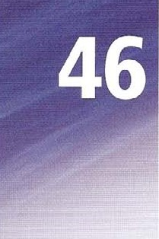That was the man whose car was stolen.

Louis Agassiz had a son, Alexander, whose main interest was mining.

### omitting the relative pronoun

When you omit the relative pronoun in an object clause, you might also need to omit the verb after it.

The photos (which were) used On the web site are fascinating.

"he glaciers (which were) described in the book are in danger of melting.

### object: who, that, whom or zero

Use who / whom / that in an object relative clause when we refer to people. Whom is used in formal language. or after a preposition.

He is one of the scientists who I whom I that admire most.

It is possible to leave out the relative pronoun in this kind Of sentence. He is one ot the scientists / admire most.

object: which, that or zero use which / that in an Object relative clause when we refer to people.

This is Pickwick Papers, one of the first hooks which / that Dickens wrote It is possible to leave out the relative pronoun in this kind of sentence. This is Picknck Papers. one of the first books Dickens wrote.

object; of which

Use of which in an object relative clause when We refer to one thing belonging to another. It is used in formal language.

This is his third book, the publication of which made such an impression.

It is possible to use whose in informal language. It is also possible to avoid this kind of construction.

This is his third book, whose publication made such an impressionv

This is his third book, the one that made such an impression when it was published.

1 Tick the sentence if the words underJjned can be left out. or write 'no' if it cannot.

a Charles Dickens was one of the first authors books reached a wide public. "o b This was partly because, with the first book he wrote, he introduced a range of mainly London characters which people found interesting and amusing. 

1. He invented people names often suggested what they were like.
2. For example, David Copperfield has an unfeeling stepfather who_is called Mr Murdstone. e It was also a result of changes in publishing introduced at around the time he began writing.

f Books became cheaper because Of new methods of printing which used steam-powered machinery. g Ilis novels were published as serials, and people waited impatiently to read the next part he produced.

h He was one of the first novelists who also worked as a magazine editor, journalist and social campaigner.

The magazine that he edited, Household Words, was mainly his own writing. Dickens was also famous for the dramatic readings he gave from his own novels.

1. Match the famous people a to h with information 1 to 8. Then complete sentences about them. including the relative pronoun who.
   1. 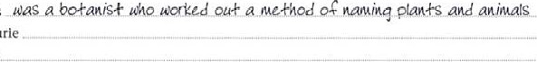Linnaeus b Marie Curie c Aristotle d Mary Shelley e André-Maric Ampere f Sonja Henie g Maria Montessori h Marco polo

 He was a physicist and made an instrument for measuring current and voltage.

2 She was a physicist and the first woman to receive a Nobel Prize. 3 She was a writer and wrote the novel Frankenstein.



* 1. She was an ice-skater and took part in the Olympic Games at the age of ll.
  2. He was a merchant and visited China in the 13th century.
  3. He was a philosopher and taught Alexander the Great.
  4. She was a doctor and invented a new method Of teaching young children.

1. Rewrite each pair of sentences as one sentence, using whose. Make any necessary changes.
   1. J S Bach had two sons. Their music was better known than his for many years.



* 1. John F Kennedy had a brother Robert. His death was also a political assassination.
  2. Lord Byron the poet had a daughter, Ada Lovelace. Her work in mathematics led to the development of the first computer.
  3. Pablo Picasso had a daughter, Paloma. Her fashion designs have become famous worldwide.
  4. John Lennon had a son, Julian. [lis music career has not been as successful as his father's.



o

* 1. The astronomer William Herschel had a sister, Caroline. Her research contributed to his discoveries.
  2. Paul McCartney has a daughter, Stella. Her career in fashion design has been very successful.

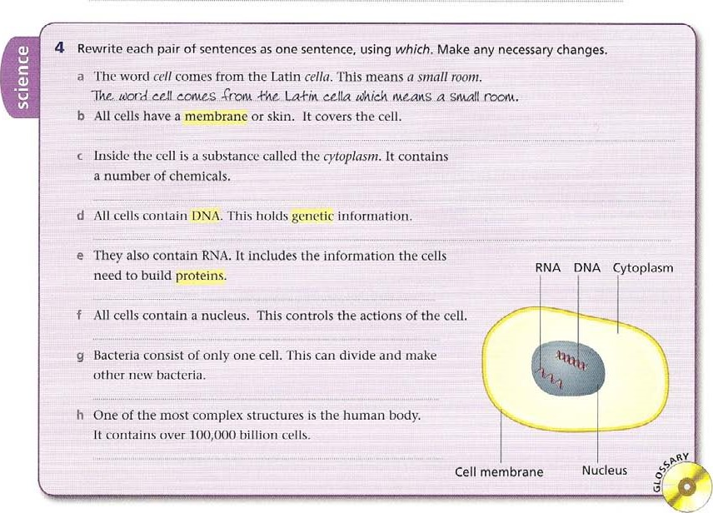

5 Rewrite each pair of sentences as one sentence, containing the relative pronoun in capitals, or zero pronoun.

|  |  |
| --- | --- |
| a Einstein is a scientist. I admire him.  Pinskt.in. is.,au seizn+is+ aho lu adnürz. | WHO |
| b Shakespeare is a writer. I don't understand him. | ZERO |

|  |  |
| --- | --- |
| c Marie Curie is a scientist. We are studying her. | WHOM |



|  |  |
| --- | --- |
| d Newton is a physicist. We often discuss him. | ZERO |

|  |  |
| --- | --- |
| e Homer is an ancient Greek writer. We study him in translation. | WHO |

|  |  |
| --- | --- |
| f Leonardo is an artist. Everybody knows him. | THAT |

g Jane Austen is an author. Most people enjoy her. ZERO



 h Beethoven is a composer. I like Flim.

6 Rewrite the sentence, beginning as shown. DO not use a relative pronoun.

1. I made this in a craft lesson.

This is — 4-h&lajuplouade .ip, a-cra$k„te.sscne.

1. We lost this ball in the park last week.

This is c I wrote this poem in my first year.

This is d She painted this portrait as part of her project.

This is _ _ e We used this computer to get the results.

This is f We found this dog in the playground.

This is g I borrowed this book from the library.

This is h Mr Smith took this photo of the basketball team.

This is

7 Complete the text with a suitable relative pronoun in each space (including of which). Leave the space blank if this is possible.

Antarctica is mainly known for the penguins and seals a _ live there, but recently scientists have discovered the remains Of two dinosaurs b , lived there millions Of years ago.These are not the first dinosaur fossils c have been discovered in Antarctica, and bring the total to eight. The first new discovery was a plant-eating dinosaur d was found by a mountain climber. Scientists examined the fossils say it is a plant-eating dinosaur f _ is nearly 200 million years old.The parts Of the animal g they examined suggest chat was nine mecres long and two metres tall. Dinosaurs h have been found in Other parts Of the world are as long as 30 metres. however. So this specimen. the discovery i has excited researchers, is rather small. On the other side ofAntarctica, dinosaur bones were discovered by accident have also proved interesting. This second dinosaur was a meat-eater k stood about two metres tall. Scientists I were sheltering from bad weather found the bones near the sea-The dinosaur they discovered, bones were next to fossils of sea life, probably died and was washed out co sea after its death. Dinosaurs are creatures could not in cold conditions, but in their time, Antarctica was different. It didrft have the cold climate o it has today, but was warm and wet.

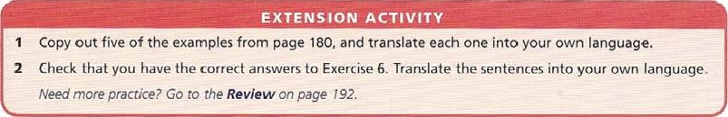

### defining and non-defining

relative clauses

In written language, defining clauses give important information about the subject or object, and are not separated by commas.

Friction is the force that resists the movement of one object against another.

In written language non-defining clauses give extra information. which we could leave out, and are separated by commas. We cannot use that as a relative pronoun.

Wrapping an object in a/urninium foil, which reduces energy loss. keeps food hot.

object clauses with prepositions: whom, who

In object clauses when we refer to people and use a preposition, we use whom in formal language. gnter the address of the person to whom you want to forujard the message

It is more usual informa lly to use who and put the preposition at the end.

Enter the address of the person (who) you want to forward the message to,

object clauses with prepositions: preposition + which. whose Formal [his is the spacecraft in which the astronauts visited the Moon.

The tree from which this drug is obtained only grows in the rainforest.

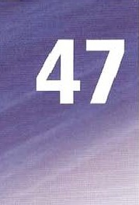The instrument with which we measure air pressure is called a barometer. Dr Gibson, the scientist on whose research the article is based, agreed.

|  |  |
| --- | --- |
| Informal  (more usual) | This is the spacecraft (which) the astronauts visited the Moon in.  The tree (which) this drug is obtained from only in the rain-forest. |

The instrument (which) we measure air pressure with is called a barometer. Dr Gibson, the scientist whose research the is based on. agreed.

reason: why

Clauses of reason use why or the reason why.

I've just passed my driving test, and that% why I'm so happy

When wa ter finds a natural opening in the ground that is lower than the water table, a spring comes into existence, rhis is the reason why most springs are found in {ow places or valleys.

time: when

Clauses of time use when or the time / year etc when. We can also use the + time word + in Which in more formal language.

1969 was when the first men went to the Moon.

It was also the year in which the Venera 5 space probe landed on Venus.

place: where

Clauses of place use where or the place where.

A habitat is the place where an animal or plant species lives

sentence relative: which

Use which to refer to the sentence or clause that comes before iti not just the word before it. There must be a comma before which.

Tina got very good marks In the exam, which pleased all her teachers.

I Make a non-defining relative clause from the two sentences. Make any necessary changes.

1. The polar bear is a large bear that lives in the Arctic. It is also known as the white bear.

TAZ polar be-at, ahicR is-also knoan as khe- L'hi4-g bear', is a Vlar•qt-_ bearkhak lives in *he, Arc-kic.

1. The polar bear is found all across the Arctic. It has a population of about 20,000.
2. About 6CYYo of the bears are found in Canada. They hunt well on land and in water.
3. The polar bear may become extinct by the end of the century. It is threatened by global warming.



1. The sea ice in the Arctic is beginning to melt. Bears use this as a platform when they hunt seals.
2. The polar bear is the largest land predator. It is twice the weight Of a lion Or tiger.
3. The males weigh between 400 kg and 600 kg. They are twice the size of the females.
4. The bear cubs remain with their mothers for ten months. They are born helpless and blind.

 Adult bears live for as long as 30 years. They do not hibernate.



 Polar bears can often be seen in open water kilometres from land. They are excellent swimmers.

1. Rewrite the formal sentence as an informal sentence ending with a preposition- Leave out the relative pronoun.
   1. Alan Graham is the teacher from whom I've learnt most.

Alan is khe- •f-e-ache-r b He is someone for whom I have the greatest respect.

* 1. We all admire people to whom we owe a lot.
  2. Especially if it is a person with whom we enjoy working.
  3. There are some people with whom you can easily form a relationship.
  4. But you don't always work with people for whom you feel admiration.
  5. And now here is the person for whom we have all been waiting.
  6. He is the man to whom I am pleased to present the Teacher of the Year Award.

1. Rewrite each pair of sentences as one new sentence, using the preposition und erlined followed by which.
   1. There are a number of trees and plants. Rubber is taken from them.

•Ike-re. arc. a number 4-re.e.s and planks -Croru uhic.h rubber is kake.n. b The Paru rubber tree is the major commercial source. Rubber is extracted f.r.Q!.n 

* 1. Brazil is the country. Rubber originates 110m there•
  2. Ancient Central American cultures collected rubber. They made balls from it.
  3. The Mayas made temporary shoes by using a rubber mixture. They dipped their feet it.
  4. The people in Brazil used a mixture of rubber, They made waterproof clothes from it,
  5. In England people noticed it was a substance. You could rub out marks with it.
  6. This was the origin of the name. English people called it by this name.

1. Underline the correct option.

Easter Island, a which it is in the Pacific Ocean more than 3,000 km from the coast Of South America, has a ierrible lesson 10 teach the modern world. When the first Europeans visited it in 1722, they found an island short of food on b which / which are about 3.000 people were living in a state of constant war. The Europeans were surprised 10 find a large number of huge statues. c which / which they had been moved over great distances, and d to

/ which clearly belonged to a great civilization. The people e whose / — they [ouncl on the island. however. were poor and backward, The Europeans supposed that these people could not have built such large statues, f which / which it meant that some olher mysterious people must have done so. Howexer, modern research has shown that the inhabitants of Easter Island were responsible for the ternble condition g in which / — the Furopeans had found them in. The inhabitants divided into many family groups. h which / which they competed with each other Their religion involved building huge Statues, i which / whose consumed lime and resources.

Their home was volcanic island on j where / which few trees grew, and k which / which it produced little (ood. To make matters worse, to build statues they cut down trees, I which / which it caused soil erosionBy the middle Of the 16th century, the population had reached about 7,000, m which / which 'vas too great for the. island Lo support. By this Lime there were no more trees, n which / which they the islanders needed to build boats, There was not enough food o which / with which to feed such a large population, and they were unable to leave, so the population fell. By the end of the 19thccntury. there were only a hundred or so inhabitants remaining.

1. Complete the sentence using why, when or where.

|  |  |  |
| --- | --- | --- |
| a Most of us at some time have wanted to |  | Other colours in the leaf are hidden by the |
| know  leaves change colour |  | chlorophyll, and this iswe only |
| and fall in autumn. |  | see these colours when the tree stops making |
| b It is difficult to predict exactly |  | chlorophyll. |
| this will happen, as it depends on the autumn | g | Red colours in the leaves are made by food |
| weather. |  | trapped in the leaves the tree stops |
| c It also depends onexactly the |  | making food. |
| tree is growing, since some trees may receive | h | Deciduous trees have adapted to survive the |
| more light than others. |  | winter without leaves, which is one reason |
| d The leaves start to change colour |  | their leaves fall Off in autumn. |
| the tree stops making |  | They are less likely to be damaged |
| chlorophyll, the substance which gives them |  | strong winds blow, |
| a green colour- |  | Many deciduous trees also produce flowers |
| e The trees stop making chlorophyll |  | they have no leaves, as this makes |
| there is not enough light for the process of photosynthesis to work. |  | it easier for them to pollinate. |
| 6 Complete the text with a relative pronoun in each space, or leave it blank if this is possible. | | |
| John Lennon, a _ was born in 1940, was a member Of the Beatles, | | |
| the British rock group. He yew up in Liverpool. b he performed | | |
| in a number of groups, and met the other members of the Beatles.After | | |
| studying at art college, he disliked as much as he had disliked | | |
| school. Lennon spent his time learning to be a musician. In 1962. the Beatles had | | |
| their first hit record, d was soon followed by success in the USA | | |

Lennon and Paul McCartney, another young musician e he had met in 1957, wrote most Of the group's songs.The success Of the Beatles, was worldwide, created problems for Lennon, g often said exactly what he thought to the press and TV. and got into trouble. By the time the Beatles stopped working together, h came about during the late 1 9605, Lennon's songs had become both political and highly personal. His personal life. i was made more difficult by his problems with drugs and alcohol, was also often in the news. He and his wife Cynthia were divorced, and he married Yoko Ono, with j he carried out political protests.They also made records together, and went to live in the USA. k Lennon continued his solo career. In the mid 70s he took a break from music I lasted for five years. In 1980 he started to record a new album, m still unfinished he was shot dead by Mark Chapman, a fan o wanted to become famous, on 8 December 1980.

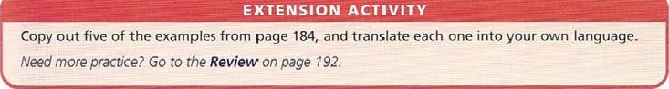 o

purpose and result

### purpose infinitive

Use the to-infinitive for describing the purpose of an action. when the subject of the action and the purpose are the same.

We used the information in the table to complete the graph.

(we use / we completed = same subject)

### need and purpose infinitive

We often use the purpose infinitive with need, often with an object after need. Wait a minute, we need to discuss this. You need a special key to open it.

### explaining purpose

Use so (that) + can could to explain the purpose Of an action, especially when there is a lot Of detail. We measured the amount of water in the jar every day, so we could work out the average dddy rainfall. use so (that) + can J could when we describe the purpose Of an action, but the subject Of the action and the purpose are different.

We displayed the information in the classroom so the rest of the class could read it.

(we displayed / they read different subjects)

Use so that + didn't / wouldn't to describe an action the purpose of which is to stop something happening.

We used an umbrella so we didn't / wouldn't get wet.

use forto describe the purpose of a thing using for* noun ing.

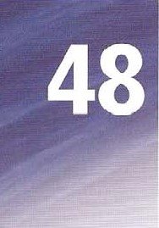Soap is good for washing things because ot the shape of its molecules.

too + adjective + to-infinitive

Use too + adjective + to-infinitive when we describe a situation and its result. The result involves something negative, eg you can't do it, something bad might happen etc. These molecules are too small (for us) to see with the naked eye.

### adjective + enough + to-infinitive

Use adjective + enough + to-infinitive in the same way, when the result has a positive meaning.

This cornet is bright enough to see with binoculars

It is possible to add a negative, eg not large enough means the same as too small. These molecules are not large enough to see with the naked eye.

### explaining a result

Use so + adjective + (that) to explain a result.

Some cornets are so bright that people think they are planets or stars.

We often use so + adjective + (that) with can / could.

Thor molecules are so small (that) we can't see them with the naked eye use such a in front of an adjective used with a singular noun. It is such a bright comet that you can see it with binoculars. Use such in front of an adjective used with plural nouns.

Molecules are such small parts of matter that can't see them with the naked eye. Use so with an adverb (that) to explain a result.

They searched the 50 so carefully that they found three new comets.

because of, as a result of use the preposition phrase because of+ noun or as a result Of + noun to describe a result. Put the because of I as a result of clause at the beginning or end of the sentence.

Because of the great distances involved, it is hard to see any details.

Pollution has been increasing as a result of air traffic

|  |  |
| --- | --- |
| a Rich Romans wanted a comfortable life. Roman slaves worked hard.  Roman slaves 'Corue„d hard So rich Rovuans could have. a eotu-$or•+able-               b When enemies shot arrows at Roman soldiers, they put their shields over their heads. They did this as a way Of protecting themselves.  When enemies shot arrows at Roman soldiers, they | SO THAr  TO |

|  |  |
| --- | --- |
| c •rhe Romans built a road system all over Europe. This helped their armies move quickly from one place to another.  The Romans built a road SYSteni an over Europe | SO THAT |

|  |  |
| --- | --- |
| d When the Romans wanted to catch mice, they used other animals so they could catch them.  When the Romans wanted to catch mice, they | TO |

I Use the information to complete a new sentence so that it contains the word or words in capitals. Make any necessary changes.

|  |  |
| --- | --- |
| e The Romans used a pointed metal stylus when they wrote on pieces of wood covered in wax.  The Roman> used a pointed metal stylus | TO |

|  |  |
| --- | --- |
| f The Romans buried their dead beside the road Outside their town. They didn't want the ghosts to return to their old homes. | SO THAT |

The Romans buried their dead beside the road outside their town



2 Complete the Sentences a to h With information from 1 to 8, and for.

I do maths problems 2 heat things in a lab 3 look at things that are too small to see

4 make someone's voice louder 5•neasure-air-pressttre 6 measure humidity

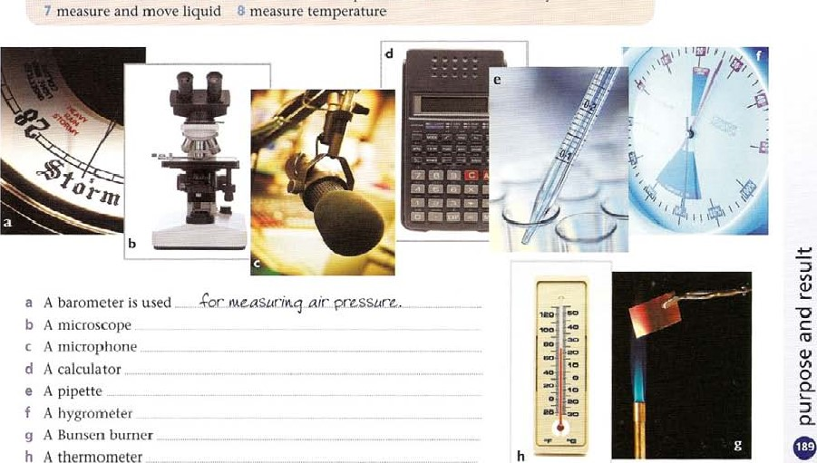

A

thermometer

1. Rewrite the sentence SO that it contains too + adjective + to-infinitive. DO not include for us.
   1. Some parts of the universe are very distant so we can't visit them. parks 04 universe. are +00 disk-ae- +0 visi&.
   2. atmosphere of Mars is very thin and we can't breathe it.

C Venus is very hot and We couldn't land on it.



* 1. For most people, a journey into space is very expensive and they can't take it.
  2. Trips to most Other planets are very dangerous so we don't consider them.
  3. The universe is very large, and we can't explore it completely.
  4. Perhaps its meaning is difficult and so we can't grasp it.



1. Rewrite the sentence so it contains the word enough.
   1. If all the blood vessels in the body formed one line, it would be very long and would reach more than twice round the Earth.

all khe blood vcsscts in +hc bodil Gonucd onc tine, would bc log enough +0 reach khan r'0Lotd ear-WI.

* 1. Some metals, eg sodium, are light and they float.



C A Week after it is born, a baby gazelle is Strong and can run with adults.

* 1. The planet Pluto is very small and can't have a proper atmosphere.
  2. The dinosaurs were not adaptable and didn't survive climate change.

If a spider's web had threads as thick as a pencil, it would be so Strong that it could catch a Boeing 707 jet!

1. Rewrite the sentence so it contains so or such.
   1. Tropical rain is sometimes heavy enough to damage the leaves Of trees.

Tropical raiü$ SovvCkinwS So kc,avg khak can_døuaqe b The bee hummingbird is small (6.2 cm long) and people often think it is an insect.



04

* 1. Jupiter's moon Europa is cold and the ice on the surlace is probably as hard as rock.
  2. A Camel Spider is a greedy eater and will eat until it cannot move.



* 1. The Sun is hot and the chemical elements found on Earth exist on the Sun as gases.
  2. The African Elephant is heavy and it's only able to move at the speed of a fast walk.

1. Rewrite the sentence so that it begins as shown, making any necessary changes.
   1. More than half a million people visit the famous caves in Han-sur-l.eses every year.

Because Of _i+s .cave.s, raor•c hal$ a. pc-opte visi+. Han-sur-Le.sescvcrvg gcar. b Most of the caves are too dallgerous for visitors to enter as there are falling rocks.

As a result c The river's disappearance beneath a hill led ancient people to throw Objects into the water.

Because of d The beauty Of its unexplored cave system made it a challenge to cavers for many years.

Because of e Its disappearance under the rocks made the course Of the river through the cave unknown.

As a result of f The ice-cold water meant that many explorers of the cave System lost their lives.

As a result g The importance of the caves, however, means that they are open to scientific researchers.

Howev'er, because ot h And the course of the river has now been traced thanks to recent explorations.

And as a result of

|  |  |  |
| --- | --- | --- |
| 7 Complete the text with one suitable word in each space. |  |  |

Most people now have a home computer, a so they can shop online or download music or send and receive e-mails. Many others, who find commuting to work so stressful b they can't stand it, use a computer to work from home_ A computer is also useful c playing music. or storing photos, and a hundred and one other things. d of its usefulness, the computer has changed our lives. In fact, it's e useful that many Of us wonder how on earth we managed before it was invented. It is f an essential part of everyday life, that we run the risk of forgetting the disadvantages of the electronic lifestyle. It's g easy for us to send an e-mail instead of a letter. Shopping online is h convenient i we can forget the thousands Of delivery Vans which have to bring the things we buy to Our homes. Soon the roads will be j crowded with delivery vans, that we won't be able to travel anywhere! And aren't shops good places for buying things? Perhaps we need time k get away from the computer and realize that it might bc better to read a book or go for a walk. This is I an obvious fact that I can't understand why I didn't think of it before, but I have been looking at a great web site which explains everything!

|  |  |
| --- | --- |
|  | EXTENSION ACTIVITY |
| 1  2 | Write examples for each of these words and phrases.  to go shopping so that for too big so heavy  Check that you have the correct answers to Exercise 7. Translate the text into your own language. Need more practice? Go to the Review On page 192. |

0

0

Review

How to use this section

1. As extra practice if you have finished the rest Of the unit and the Extension Activities.
2. To test yourself. Do the exercise, check your answers, then decide if you need to have a look at the presentation page again.
3. If you need extra practice, read the presentation page(s) again, then try to do the extra exercise(s).

unit 2 present continuous Underline the correct form.

Hello again from the rainforest. You worft believe this, but I a sit / in a small boat on a river in South America. I b dont know / om not knowing the name of the river in English, but now we c travel / ore travelling through the rainforest. It's really hot. and water d drips I is dripping from my face, so I e apologize / am apologizing for my bad handwriting.The batteries of my camera f run out I are running out too, so don't expect many photos.The other problem here is the rain. It g rains / is raining nearly every day, which is Why they h / are calling it a rainforest I i suppose / gm supposing! Luckily j it doesnt rain / it raining at the moment, but I'll haye to be quick. In general, k have I am having a really good time. and I find out I aril finding Out a lot about the flora and fauna in the rainforest.The trees here m grow / are growing to 60 metres. which n makes / is making it very dark all the time in the forest-There arent really any paths, and people o travel I are traveling everywhere by water, or by plane. Of course we ecotourists p take / arc taking this trip for fun. because we q wont / are wanting to.What else can I tell you?YVell. everything r smells / is smelling really bad here.And very noisy, because the birds and animals s seem / ore seeming to stay awake all night. ugh, Sorry, horrible Spider t crawls / is cröwling along my leg.Thätk all for

Score; 20

### Unit 3 past simple

Write the past simple form Of the following words.

|  |  |  |  |  |  |  |  |  |  |  |
| --- | --- | --- | --- | --- | --- | --- | --- | --- | --- | --- |
| a | be | f | buy | | k make | |  | p tell | |  |
| b | go | g | study |  | win | |  | q read | |  |
| c | have | h | pay |  | m write | |  |  | pick |  |
| d | eat |  | bring |  | n | drink |  |  | sing |  |
| e | wait |  | cook |  | o | swim |  |  | run | Score: 120 |
| Unit 5 present perfect simple | | | |
| Write the past participle of the following verbs. | | | | |
| be _ been f buy | | | | | k | make |  | p | tell |  |
| b go g study | | | | |  | win |  | q | read |  |
| c have h pay | | | | | m write | |  |  | pick |  |
| d eat bring | | | | | n drink | |  |  | sing |  |
| e wait cook | | | | | 0 swim | |  |  | run |  |

192 score: 120

Unit 6 present perfect continuous

Choose the correct form, A or B. to complete the sentence.

War and Peace. It's really long, and I'm only halfway. a A I've read B I've been reading Maria all day, but there's never a reply. b A I've phoned  I've been phoning to the library and back, so I feel a bit tired. c A I've walked B I've been walking

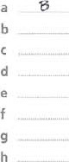— French for three years, but I still can't say a thing!  A I've learned B I've been learning the work I had to do, so now we can go Out. e A I've done B Eve been doing the vegetables, so you can start cooking them.  A I've washed B I've been washing all the ice-cream, and now I feel sick!  A I've been eating B I've eaten three letters so far, but I still have to write two more. h A I've written B I 've been writirw Score: _ / 8

Unit 7 past perfect

Underline the correct form.

|  |
| --- |
| I Gottfried Liebnitz and Isaac Newton developed the mathematics we call calculus at about the same time in the  17th centu ry, although their versions a / had been slightly different. However, Newton was sure that he was first and that Leibnitz b copied I had copied him.  2 TheWright brothers made the first powered flight in 1903, but only four men anda boy c saw / had seen their plane fly, UntilVVilburWright in front Of a large crowd in France in most people refused to believe that their earlier fight d succeeded I had succeeded.  Shakespeare e used I had used familiar stories and events from history in a lot Of his plays, so the audience f heard / had heard the plots befOre. However, that didn't stop him being very successful.  4 Aristotle g had been a philosopher and teacher in ancient Greece. By che time he died in 322 BC, he h had written / wrote some Of the most famous philosophical texts Of all time, and had tutored Alexander the Great. |

Score: 18

Unit 8 tense contrasts

Complete the text with the most suitable form of the verbs in brackets.

Bob Dylan a (become) has one Of the most famous singer I song-writers Of all time-At the age Of 65 in 2006, he b (reach) the top of the US album charts with Modern Times, the oldest living singer to do so. He c (record) many other hit albums since he d (make) his first album at the age of 21 while he e (perform) as a folk singer in New York clubs-Although he first f (find) fame as a folk singer; he g (try) originally to be a rock and roll singer, but without success. In the mid-COs, Dylan h (start) to perform rock songs with a group, instead of the solo folk songs which i (make) him famous.At the time. many Of his fans j (feel) angry because they k (think) that he I (do) this simply for money. Many folk music fans still m (believe) that he Was wrong. In fact, songs n (change) in the time up to this point-As far as he was concerned, he o (do) everything that he could with folk music already; and he p (need) a different musical style w express his changing feelings.

career q (be) a long ane, and there is no sign that he r (think) of retirementHe s (perform) _ since the late 1950s and t (appear) _ in several films too.

Score; / 20

unit 10 future time

Complete the dialogue with will. be going to, shall.

|  |
| --- |
| a 'What _ _ ar&. you _ going +0 do this evening?' b •I'm not sure. My brother go to a basketball match. He bought the tickets yesterday. But I don't like basketball very much.What about you?' don't have any plans. My parents go to the theatre, but I think that' really boring.  we do something together?' d 'That's a good idea. DO you like action films? I borrow a DVD from my brother if you want to watch one.'  •No thanks, I saw a film yesterday. I know! Marie go ice skating. I phone her and ask if we can go?'  'Great. I get my skates.' |

Score;

|  |  |  |  |
| --- | --- | --- | --- |
| Unit 13 tag questions  Complete the questions with a positive or negative past simple tag.  a Before the French Revolution, the king did whatever he wanted to do, b All the people paid high taxes, so they weren't Very happy, c The people didn't have enough to eat, d The government tried to introduce new taxes, e The people formed a National Assembly, f The Assembly took power from the king, g The king tried to leave France, h •me government executed thousands of aristocrats,  It also killed the king and the queen,  Napoleon Bonaparte took over the government and later became Emperor, |  |  |  |
| Unit 15 -ing form  Complete the text with the to-infinitive or -ing form Of the verbs in the box. |  | Score: | 110 |
| eat lose have cook go prepare | eat | eat |  |
| do cook find exercise cook wash up | cook | shop |  |

Scientists have given uS some very good advice about a _ healthily. but how many Of us do What they say? We are used to b fast food and chocolate. and don't have the time to spend and all the time. If you want f weight

there are lots Of diets you can cry, and you should also try as much as possible. Healthy food means h lots Of fresh fruit and vegetables, and if you are interested in i

day of new recipes. However, if you are bored by and dislike I

to the supermarket, itS going to be difficult m healthily. You might be lucky and have

someone who doesn't mind n _ food for you. If this is true, then you should offer o the washing up. or they may stop p for you!

194

Score: / 16

Unit 18 conditionals: true, real and unreal

Use the information to complete a real conditional sentence about the consequences of global warming.

 weather patterns change —+ droughts and floods are more frequent

If aca+hcr _chanqc, drouqR+s and Roods b water becomes warmer the gulfof —S the Strength Of litiiTiCciiies increases

If rain [alls at the wrong time —i lanners are unable to grow their crops If

If

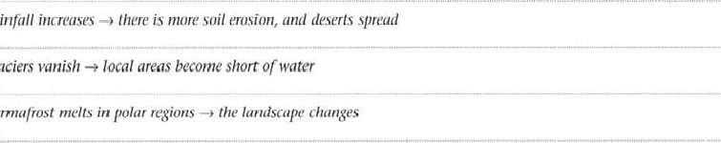

d

rainfall

glaciers

permafrost

e

If f

If g polar ice melts —9 Sea levels rise

If

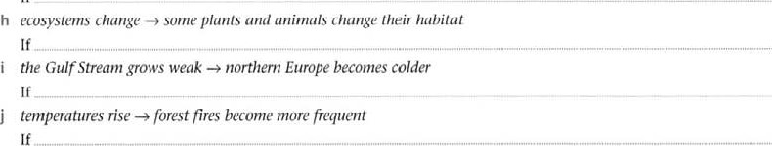

Score; / 10

2 Use the prompts to make an unreal conditional if-sentence.

1. you melt a mediu_m-sized iceberg / you have enough water to supply a big city for several weeks



1. Amazonia is a country / it is the ninth largest in the world

11 c you put all the cells from your brain in a straight line / they reach for 1,000 km



d you are a sloth / you spend 18 hours a day sleeping

If e you have a piece Of the Sun 2.5 cm square / it shines brighter than a thousand 60 Watt light bulbs

If

f you have a piece Of the Sun / it burns you to nothing!

If g you fly a plane to Neptune / it takes nearly 290 years to get there If h all the matter in a baby becomes energy / it runs a power station for a year If

Score:

tJnit 20 the passive and its uses

Complete the text with the passive form of the verbs in brackets.

|  |
| --- |
| Hundreds of movies a (produce) produced all over the world every year.The most successful ones b (make) in America, because they c (direct) by famous people and lots of money d (spend) on advertizing 'hem, Hollywood films e (watch) all over the world, but many countries have their own directors and stars. Bollywood films, which f (make) in India. are becoming very popular in other countries. Beautiful costumes, music, singing and dancing g (love) by moviegoers everywhere, and thatX why so many Bollywood films h (show) all over the world.According to many film critics, the best film ever made is Citizen Kane, which i (direct) by Orson Welles in 1941. The story j (base) on the life Of a very powerful business man. and the Studio that made the film k (threaten) by legal action. Luckily, the film I (release) and m (enjoy) by audiences ever since. |

Score: / 13

unit 23 modals: ability, obligation, criticism (past)

Rewrite each sentence so that it contains the word or words in capitals. Leave out any unnecessary words.

1. It was impossible for ancient sailors to travel far because they usually followed the coastline. COULDN'T Ancie.n•f- SadorS 4-r•avat -car because, usuatlg -Cottoned 4-he- coas4-tine.:.
2. Early ships were very small, but they were forced to carry a lot Of fresh food and water.
3. Small sailing ships found it impossible to survive heavy storms and very bad weather. WERE
4. There was no radio, so it was only possible for them to send messages home if they met other ships.

COULD

1. didn't have accurate maps, so it was necessary for them to guess their exact position.

HAD

1. They didn't have radar, so it was necessary for them to keep a close look-out for dangerous rocks.

NEEDED

1. It was necessary for them to see the Sun or the stars in order to navigate. HAD
2. There were no rescue organizations, so if they got into trouble, it was necessary for them to 100k



after

themselves.

Score:

Unit 24 modals: possibility, uncertainty, certainty (present, future)

Rewrite the sentence so that it contains might.

1. Perhaps a lot of terrible things will happen to the Earth.

A khhtqs happen ko ear*h.

1. •I-here is always the chance that an Object from space will hit it.

C Or it's possible that a huge volcanic eruption will change the climate. d Maybe hurricanes and tornadoes will spread across the world.

1. Or there's a chance that climate change will lead to a sudden Ice Age.
2. Of course it's possible that before that, a nuclear accident will destroy life on Earth.
3. There's also a chance that a new disease could kill nearly everyone.
4. Maybe aliens will invade the Earth and do the same thing.

On the other hand, it's possible that things will continue as they are!

so perhaps it's better not to worry so much.

Score:

Unit 27 countable and uncountable

Read the following text. Decide if the words and phrases underlined are countable (C) or uncountable (UC).

### How to make vegetarian Spaghetti Bolognese

First of all you need an a a few b and some c Qr'ic. Chop them up, then put some d QIiy_gÄLin a saucepan and fry them for about five minutes.Add some chopped e peppers (green is best). a chopped f and a few chopped g Fry for a further five minutes.Then add some h i a cup ef wager and j a tin of chopped Bring to the boil and simmer for 1 5 to 20 k In a separate pan, add some I to boiling m and cook for about 10 minutes. When cooked, pour the water away and put rhe pasta on a plate. Serve the vegetarian Spaghetti Bolognese with n and o Parmesan cheese.

k

f

Score: / 15

197

Unit 30 articles (2)

Complete the following text with a / an, the or leave blank for zero article.

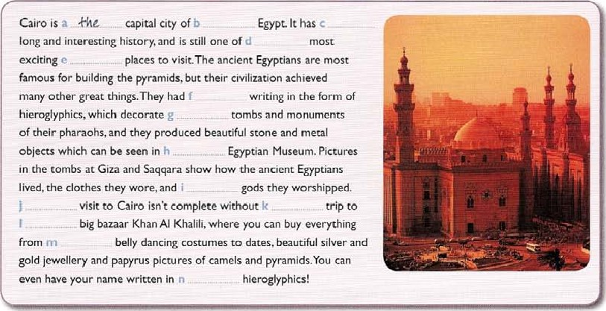

Score:

/

14

Unit 35 adjectives

1 Put the adjectives in brackets in the correct order.

a In the vase is a bunch Of  ,ahi+c.roses.

(white, beautiful, small) b It's a painting.

(medieval, round, large) c This is a / an_ gallery.

(German, interesting, new) d This was painted by aartist.

(renaissance, French, famous) e The painting consists of rows of. stars.

(green, plastic, tiny) f We bought a / anplate.

(glass, Italian, small) g At the end of the room was a / an painting.

(old, Spanish, large) h Hanging from the arms were a number Ofobjects. (metal, shiny, circular)

 The painting is protected by ascreen.

(transparent, large, plastic)

 The sculpture was bought by a / ancollector. (American, young, wealthy)

Score: / 10

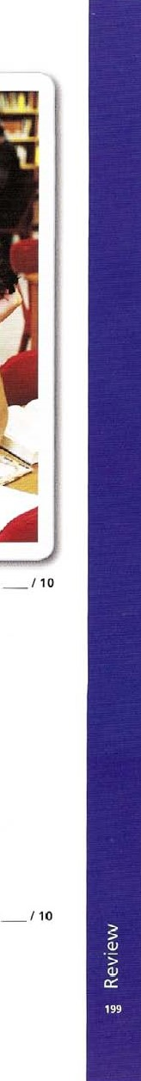2 underline the correct form.

|  |
| --- |
| Many students report that they often feel a / boring by studying.This is not b surprised I surprising when you consider how some students study.A recent report, which many teachers find worried I worrying, suggests that a majority of students listen to music at the same time as studying.  However, what experts say about this issue is rather d confused  / Confusing. Some people study more effectively when they are relaxed / relaxing, and listening to music may help. Students who are f worried / worrying by the pressure Of school may find that they are in a better mood if their music is playing-When they become more g interested / interesting in what they are studying, they do not in fact 'listen' to the music at all. It just becomes background noise. On the other hand, there are certainly students who find the music more h entertained / entertaining than their school work, and never really concentrate on their work at all. So perhaps we shouldn't be i surprised / surprising to discover that listening to music helps some but not all, though this can also depend on the type of music.And it also depends on what students are supposed to be studying. Anyone who listens to music while trying to read and remember details will almost certainly be j distracted / distracting by the music. So in the end, perhaps it's a matter of •what works for you' |

Score:

Unit 36 adverbs

Complete the sentence with too. very or enough.

1. Nobody finds studying AVC-rd easy at the best of times.
2. If you are reallytired to Study, it can be a real effort to force yourself. C Many Students, however, are disorganized to study effectively. d If you are busy, then you have to make good use Of your time.

e It's not good to just sit down at the last minute and study for a long period.  Using this method most people become exhausted to concentrate well. g It'seasy to spend hours with books open on the desk, but to achieve little.

h But if you stay up too late studying, you won't be alert _the following day, which can add to your problems.

 You have to becareful to organize learning over a long period.

 Studying has to be done regularly, and divided into sections so that it is nottiring,

Score:

Unit 43 phrasal verbs

Choose the correct option, A, B, C or D, to complete the sentence.

a It's not a difficult problem. I'm Sure you can b I had flu really badly, and I haven't c If you like, I can _ at the end of this street, d She wassomething, but I couldn't understand what it was.

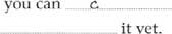

it

yet.

e Kate had to  ballet lessons because she had too many other things to do.  We'llthe case. and we'll let you know what we find out. g Could you come round and the baby on Saturday evening? h Pat kept talking on his mobile phone in class, until the teacher  The next exercise isn't very important, so we'll

 I'll come round andat 7.00, so make sure you're ready!

|  |  |  |  |
| --- | --- | --- | --- |
| a A till it in | B let it down | C work it out | D look it up |
| b A got over | B looked after | C run through | D come across |
| A leave you out | B turn you | C bring you up | D drop you Ott |
| d A standing for | B heading for | C getting at | D joining in |
| e A let down | B work out | C drop om | D give up |
| A join in | B get over | C 100k into | D Come across |
| g A 100k after | B [ill in | C work out | D bring up |
| h A picked him up | B told him om | C let him down | D dropped him om |
| A 100k it up | B sort it out | C miss it out | D put it Off |
| A leave you out | B drop you om | C tell you om | D pick you up |

Score: 10

Unit 45 conjunctions, adverbs and prepositions as connectors

Match the examples 1 to 6 On page 201 to the statements a to f, then connect the two using the words in brackets.

1. (For example) Human activities can upset the balance of nature. upsunood, coal or pe.+rd, sulphur and ni+roqe-n cmpounds are, added air, and *he-sc cause, 40 04 lakes SQ, 4-ha4- GSh die-.
2. (such as) These games help younger children understand basic number concepts. Adding, subtracting, and getting to know numbers are explained in cartoons of everyday activities.



1. (for example) Some energy sources are called 'non-renewable' because in the end they will run out.



1. (For example) A risk factor is anything that increases a person's chance Of getting a disease.



1. (such as) The Wild Information page tells you what you want to know about wild animals. It includes information about dangerous predators.



1. (such as) Science Now is great magazine which explores the science behind the news.

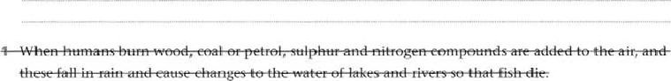

1. Sunbathing too much is a risk factor for skin cancer, and smoking is a risk factor for lung cancer.
2. We Cannot make Oil, which was formed millions of years ago from the remains Of ancient sea plants and animals.
3. . why planes crash, and why athletes shouldn't use drugs. 5 playing football, getting on a bus, or going to the beach. 6 tigers, cheetahs and great white sharks.

Score:

#### Unit 46 relative clauses

Complete the sentence with which or who, or leave the space blank if this is possible.

1. Scientists 'Oho _ study rocks are known as geologists.
2. The genetic information you get from your parents makes you the person you are.  The light leaves the Sun takes eight and a half minutes to reach the Earth.
3. Louis Pasteur was a French scientiststudied microbes.
4. Cold-bl ooded animals are animalsrely on heat from the Sun for their body temperature.
5. Hydrogen is a fuel space rockets use.
6. Breathing is a mechanical process fills the lungs with air.
7. Acid is a substance we find in lemons, for example.

 Somethingposes a risk to people is known as an environmental hazard.

The metal the manufacturers choose depends on their reason for using it.

Score: / 10

#### Unit 47 defining and non-defining relative clauses

Make one sentence from the pair of sentences, using which.

1. In the 14th century, Ibn Battuta, the Moroccan explorer. travelled more than 120,000 km on his journeys. This would be difficult even for a modern traveller, in •Btz 1444t Ibn ga4•ku4-a, on "hic-h would be. di$Gc.u14-



*rave.ter.

1. In the early years of the 1 Sth century, European sailors usually refused to sail further south than the Canary Islands. This was understandable, as they believed that it was too dangerous to go further.
2. In 1487, Bartolemeu Dias and his ships reached the Indian Ocean. •Hlis was a great achievement for the time.



1. In I SO AD. the Greek geographer Ptolemy made a map Of the world showing two lakes in Africa as the sources of the Nile. This was remarkable, considering that modern European explorers did not discover these lakes until the 1860s.



1. Nobody thought that Marco Polo's book about China was true. This was not surprising because some parts of his story were so unbelievable.



1. Archaeologists have found the remains of a Viking settlement in North America. This proves that the Vikings were the first Europeans to reach America.

Score:

#### Unit 48 purpose and result

Read the following information about tennis, then write similar sentences for the other sports.

You need a racket, a ball and a net for playing tennis.

To play tennis, you need a racket a ball and a net.

You need a racket, a ball and net So that you can play tennis.

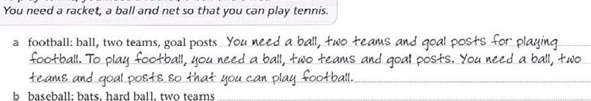

b

baseball:

bats,

hard

ball,

two

teams.



c

ping

1. ice hockey: puck, ice rink, ice skates



1. polo: ball, horses, mallets 



Score: 15

### Wordlist

|  |  |  |  |
| --- | --- | --- | --- |
| most common and | construct (vb) • | Investigate (vb) ••• |  |
| basic words | factory (n) | litter (n) • | Unit 9 |

|  |  |  |  |
| --- | --- | --- | --- |
| very common words | improve (Vb) | Oil (n) | conjunction (n) |
| • fairly common words | invade (vb) • | origin (n) | erupt (vb) |
|  | march (vh)•• | overfishlng (n) | geologist (n) |
| unit 1 | microscope (n) • | polar (adi) | goggles (n) |
| acid (n) " | mine (n) • | reduce (n) | local (adi) |
| antibiotic (n) | poison (n) • | remains (n) | lorry (n) |
| antibody (n) | prove (vb) | reproduce " |  |
| bacteria (n) " | soap (n) | stable (adi) " | solution (n) |
| breathe (vb) | Steam (n) | transplant (vb) | spectator (n) |
| breed (vbj | stress (n) |  | traffic (n) |
| chick (n) | sugar beet (n) | unit 6 | threat (n) |
| common (adj) | textile (n) | coral reef (n) | waste (n) |
| enzyme (n) • | transport (vb) | excavate (vb) | worldwide (adl) • |
| harm (n) | vaccine (n) | identify (vb) |  |
| hatch (vb) |  | image (n) | unit 10 |
| immunize (n) | unit 4 | malor (ad)) ••• | absorb (vb) |
| infection (n) •e | active (volcano) (n) | reef (n) • | artificial (n) |
| inject (vb) • | army (n) | satellite (n) " | atom " |

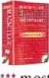Red words vanish (Vb)  lossil (n) " composer (n) " based on volcano (n) • fossil fuel (n) night shift (n) Macmillan English global warming (n) • opera (n)

Dictionary greenhouse (n) operation (n) conquer (vb)  greenhouse gas (n) out Of breath

institution (n)  attack (vb)  service (vh) cancer (n) 

Invader (n) banquet (n) shut down VI)) collide (vb)  buoyancy (n) site (n) " core (n) mask (n) cave (n)cure (n)



"

|  |  |  |  |
| --- | --- | --- | --- |
| mate (n) | climate (n) | species (n) | dense (ad') |
| matter (n) | coast (n) | spot (vb) " | dwarf (n) |
| microorganism (n) | complex (adi) • | telescope (n) • | expand (vb) |
| mucus (n) | continent (n) | tide | expire (vb) • |
| patient (n) | density (n) " |  | fusion (n) • |
| plot (n) " | dig (vb) " | unit 7 | giant (n) |
| propose (vb) | Equator (n) | alliance (n) | nuclear (ad') |
| represent (VI') | fall (vb) | aristocratic (adi) |  |
| saliva (n) | free (adi) | award (n) | poverty (n) " |
| swallow (VB) | gravity (n) • | blank (n) | retire (vb) •• |
| train (vb) | insect (n) | bravery (n) | schedule (n) " |
| Vaccinate (n) | interrupt (vb) | calculate (VB) | solution (n) |
| virus (n) | knot (n) | civil war (n) • |  |
| Vote (Vb) | land mass (n) | craftsman (n) | Unit 11 |
|  | legend (n) | damp (adi) | annual (adj) |
| unit 2 | local (ad.) | dcnsity (n) | block (vb) • " |
| crater (n) | nobleman (n) | deteriorate (vb) • | deciduous (ad') |
| deforestation (n) | observe (vb) | dishonest (adj) • | dormant (ado |
| developing (adi) " | obviously (adv) | download (vb) | drop (n) |
| equipment (n) • | quarrel (n) • | earthquake (n) • | Equator (n) |
| erosion (n) " | rebellion (n) | exhausted • | fertilize (vb) |
| gas (n) | record (n) | expert (n) " | layer (n) |
| giant (adi) | remains (n) • | governor (n) | mate (vb) • |
| ground | settlement (n) | key (n) | itiatter (vb) •s. |
| head | soundproof (ado | mass (n) | poor (ad') |
| mission (n) | trade (vb) | pure (adi) | preda tor (n) |
| patient (ad') | wound (n) " | route (n) | reproduce (vb) |
| population (n) |  | scream (vb) | rich (adi) |
| pressure (n) ••• | Unit 5 | screen (n) •• | shallow (adi) |
| rate (n) | advance (n) | shore (n) | slope (n) |
| rescue (vb) " | atmosphere (n) " | South Pole (n) | soil (n) |
| respond (Vb) | climate change (n) | spill (Vb) | sonar (adi) |
| rise (vb) | coal (n) | survive (Vb) | Steep (ad') |
|  | contribute | tsunami (n) | symbol (n) |
| sharply (adv) | descend (vb) •e | volume (n) | tadpole (n) |
| smoke (n) | emission (n) •• |  | take a risk |
| solar (adi) | expedition (n) | unit 8 | temperate (adi) |
| spaceeraft (n) | experience (n) | authority (n) | tropical (adj) |
| species (n) | force (n) ••• | compose (Vb) |  |

  •

unit 12

Coal (n) •a nbow• (n) • crust (n) • blemish (n) unit 18 central heating (n) epidemic (n)

erupt (Vb)

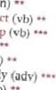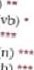lava (n) allCn (n) cosmetic (adi) goal (n) layer (n) ••• contract fit (vh) " medieval (ado melt (vb)develop helmet • prosperous (ad') migrate kit (n)lilt put forward (phr vb) plate (n) pole (n) mobile (phone) (n) ruling (adj) pressure (n) regularly plastic surgery (n) support (VI") remain (vb) spin (vb) re'lwpe (n) trace (n) 

|  |  |  |  |
| --- | --- | --- | --- |
| Richter scale (n) severe (ad') | unit 19 | scat (n) •  Spirits (n) | unit 26 |
| shake (vb) ••• | algae (n) | surgeon (n) | enemy (n) |

stress (n) battle (n) thicken (vb) tectonic (adj) border (n) unit 27

|  |  |  |  |
| --- | --- | --- | --- |
| laboratory (n) notice (n) | rightful (n) | rapid (adj) | upset (adj) |
| obey | Sail (vb) | seaweed (n) |  |
| permit (vb) | sloth (n) | step (n) | unit 28 |
| practical (adjj | twig (n) | swear (VI') | attract (vb) |
| pretend (vb) •• | upside down (adv) • | Victim (n) | clerk (n) • |
| tough (ad!) | Voyage (n) • | vital (ad') | collide (vb) |
| notice (n) | unit 20 | Unit 23 | crop (n) CTystal |
| weaghtless (ad') | arena (n) • | apprentice (n) | (n) display (vb) |
| unit 15 | assembly (n) | ban (v•b) | droplet (n) |
| authority | coastline (n) | Coal mine (n) | freezing (n) |
| consider (vb) | continuous (adj) | compete (VI') | generation (n) |
| effort (n) | counteract (vb) | Cornpound (n) " |  |
| expedition (n) | criticjse (vb) | employ (vb) | investment (n) |
| hammer (n' • | derelict (ad') | employer (n) | lawyer (n) |
| hobby (n' • | dinel (n) • | execute „ | nurse (n) •t. |
| muddle (n) | dock (n) | fine (n) | parliament (n) |
| rate (n) •4. | ecotourism (n) | freezing (adj) • | remarry (vb) |
| sunspot (n) | employ (VB) | Iceberg (n) | report (n) ••• |
| 'urrcnder (vb) • | facillry (n) | limit (vb) | respect (n) •e. |
| unacceptable (ad') | float (Vb) | tnaster | snowflake (n) |
| voluntary (adj) | global (ad') | pyrites | stretch (vb) |
| wage (m   weight (n) | habitat (n) • hectare (n) | radioactive (adl) • rust (vb) | super. (prefix) (cooled) treat (vb) |
| unit 16 | lease  (n) | shelter (n) tonne (n) | unit 29 |
| archaeologist (n) • | licensc plate (n) | trade (n) | alpine (ad') |
| citizen (n) | media (n) ••• | Wage (n) | ensure (vb) •• |
| devote •• | rnurderer (n) • | wreck (n) • |  |
| evidence (n) •i. | obvious (ado |  | glacier (n) |
| excavate | On bch'rd | unit 24 | sheet (n) |
| excavation (n) | pack (vb) ••• | advance (Vb) | Infrared (ad') |
| fascinating (ddi) | post (n) | benefits (n) | layer |
| inaccurate (adj) | prototype (n) • | detect (vb) | mass (n) |
| iewelJery (n) | reality (n) ••• | frequent (ado | matter (n) |
| publicity (n) | redevelop (vb) | growth hormone (n) | melt (vb) •• |
| reject (vb) ••• | resident (n) | immune system |  |
| spectacular (auj) | retailer (n) • | opportunity (n) | polar (adj) |
| thesis (n) | Stole (n) | repair (v•b) " | Seismic (adi) |
| wealth (n) | unit (n) ••• | Sway (vb) • | snowfall (n) |
|  | urban (adj) •e. | tremor | surface (n) |
| unit 17 | Venue | universal indicator (n) | transfer (vb) |
| Val (n) | Wrap (Vb) " | unmanned (adj) | turn (n) |
| motivate (vb) photosynthesis (n) | Unit 21 | Unit 25 | typically (adv) vibrate |
|  | alter (vb) | abandon (vb) drought In) | vibration (n) • |

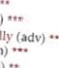Civil War (n) • unit 22 absorb (vb) unit 13 coast (n) calm (ad') coal (n) cable (n) " evolvedivision (n)cortVection (n) portable (adi) • extinct (adj) • economically current (n) • gate (n) economy (n) extract (vb) unit 14 kingdom (n) equation (n) ground (n) conductleader (n) •e. family planning (n) liquid (n) conquer • marchllama (n) outdoors in) force (vb) ••• opponent (n) •• measure (n) soutce (n) javelin (n) powerful (ad)) multiplication (n) spread (vb) predator (n) policy (n)  surrounding

unit 30 appear (vb) • assemble (vb) brochure (n) • depression (n) loco (intoro't in) (vb) meteorology (n) motivation (n) National Curriculum (n) permanent (adi) • psychologist (n) push (vb) severe (adj) shiver (n) spreadsheet (n) • Surface (n) thunderstorm (n) treatment (n) unrivalled (ad))

Unit 31 ape (n) beak (n) • cone (n) • evaporate (vb) extinct (ad') • habitat • member (n) parachute (n) preserve (vb) species (n) spread (Mb) tide (n) "

v.'ebbed (feet) (adi) unit 32 assume (vb) bare (adj) " consist (of) (vb) diet (n) dune (n) extreme (adj) " fatty (adi) fried (adi) generate (vb) indication (n) " lose (weight) (Vb) moisture (n) nutritional (adi) proof (n) reptile (n) • rocky (adj) • sandy (adi) • scorpion (n) shade (n) shortage (n) • soft drink (n) • stole (vb)

unit 33 action (n) calcium carbonate (n) cope (vb) defeat (vb) discourage (vb) episode (n) " forecast (n) individual (adj) narrow (adj) number (of) (n) rewarding (adi) roughly (adv) sign (n) special effect (n)

unit 34

assume (Vb) blind (adi) " cave (n) • design (vb) drunk (ad') " empty (adj) •i. escape (vb) giant (n) " hide (vb) monument (n) orchid (n) pain (n) roll (vb) tomb (n) • tuberculosis (n) wonder (n) 

Unit 35

admit (vb) according tn (prep) amount (n) blame (Vb) commercial (ad') fortress (n) get around (phr vb) graceful (adj) • Vast

Unit 36

album " appeal (vb) chemical (n) crowded (adj) • decrease (n) • diet (n) enthusiasm (n) intectiön (n)



sewer (n) responsible (ad)) statistics suffer (vb) swollen (ad') • sympathetic (ad') track (n) true to life



upset (vb) " victim (n)

Unit 37 a  pressure (n) dense (adi) • planet (n)



unit 28 considering (prep) culture (n) destination (n) digest (vb) • estimate (vb) freeze (vb) " gallery (n) 

hum (vb) palace (n) previously (adv) Vibrate (Vb)

unit 39 applause (n) crater (n) crust (n) • flagship (n) float (vb) " impact (n) lava (n)



part (vb) • pilc (n) possession (n) run aground (adv) space (n) undisturbed (adi) Unit 40 astronomical (adi) comet (n) crash (n) " excavation (n) hibernate (vb) lens (n) • optical (adj) • reference (n) retina (n) sparse (ad') sphere (n) strike (vb) unit 41 conducted (Vb) decipher (vb) de:notic (adj)



hieroglyphics (n) inscription (Il) originally (adv) patient pitch (n) " publish (vb) resistance (n) resistant (ad')



sell-taught (adj)

(Chemical) structure (n) unit 42 roughly (adv) fixed (adl) " gain (vb) land eone in yawn (vb) •

unit 43

forehead (n) Once upon a time wart (n)

Unit 44 attend boost (vb) " colleague (n) generatio n (n) issue (n) photocopier (n) pitfall (n) politely (adv) • previous (ad') resentment (n)

scam

side effect (n) • stress (n) unresolved (adi)

unit 45



barrel (n) " carnivore (n) coastline (n) deadline (n) divide (w) effectively (adv) fattening (adi) food chain (n) generate (vb)



herbivore (n) honest (ad') " maintain (vb) oilfield (n) power station (n) renewable (adj) reward (n) spoil (vb) target (to turbine (n) unconnected (adl) unit 46 DNA (n) • election (n) genetic (adi) membrane (n) • novel (n) novelist (n) • protein (n) " remains (n) •• seal (n) serial (n) • shelter (vb) 



unfeeling (adj)

Unit 47

backward (ad') • compete constant (ad)) dip erosion (n) " flourish (vb) • mysterious (adj) originate (vb) pollinate (vb) protest (n) resource

Unit 48 arrow (n) convenient (adi) grasp (vb) " shield (n) stylus (n)

List of irregular verb forms

Infinitive Past simple Past participle Infinitive Past simple Past participle be was / were been know knew known beat beat beaten lay laid laid become became become lead led led begin began begun learnt learnt / learned learnt / learned bend bent bent leave left left bite bit bitten lend lent lent blow blew blownlet break broke broken lose lost lost bring brought brought make made made build built built meet met met burn bumed / burnt bumed / burntpaid paid burst burst burst put put put buy bought boughtread catch caught caught ride rode ridden choose chose chosenrung come came comerisen cost cost cut cut Cut say said said deal dealt dealt dig dug dug sell sold sold do did done send sent Sent draw drew drawn shake shook shaken drank shine shone shone drive drove driven 00t shot shot eat ate eaten sing sung fan fallen sink sank sunk feed fed fed Sit sat sat feel felt felt sleep slept slept fight fought fought speak spoke spoken find found found spend spent spent fly flew flown stand stood forgive forgave forgiven steal stole stolen freeze froze frozen stick stuck get got gol gave given take took taken go went gone teach taught taught grow grown tear tore torn hang hung hung tell told told hear heard heard think thought thought hide hid hidden throw threw thrown hit hit hit understand understood understood hold held held wake woke woken hurt hurt hurt wear wore kept keptwon write wrote wri[ten

### Grammar index

a/an 114, 118 adjectives 138

adverbs 140

as connectors 176

of place 152

of time 156, 160

advice 102 articles 114, 118

causative have 82 certainty 94, 98 clauses, defining and non-defining 184

clauses, relative 180 commands in reported speech 66 comparisons 144, 148 conditionals 70, 74 conjunctions 176

countable nouns 106 criticism 90 future continuous 40 future perfect 40

going to 36, 40

gone 23 have 10 86, 90 infinitives, after verbs and adjectives 54 -ins form 58

intensifiers 138, 140, 144

intransitive verbs 78 it 44 it's, its 44 just 22 modals ability 86, 90 advice 102

certainty 94, 98 criticism 90 Obligation 86, 90 offers 102 permission 102 requests 102

suggestions 102

uncxrtainty 94, 98

must 86, 94, 98 neither 52 noun + noun 110

obligation 86, 90, 102

offers 102

partitives 122

passive formation and uses 78 reporting verbs 82 verbs with two Objects 82 past continuous 18, 32 past perfect 28, 32 past simple 14, 32 permission 102 phrasal verbs 168, 172

possessive apostrophe ('s) 110

possessive of 110

possibility 94, 98 prepositions after verbs and adjectives 164 as connectors 76 before nouns 164

in phrases 152 of place 152

oftime 156, 160 present continuous 10, 32 present perfect continuous 26, 32

present perfect simple 22, 32

present simple 6, 32

promises 102

pronouns 134

purpose 188

quantity

all 130

any 122

countable and

uncountable 106

each 130

enough 126 every 130

126

little 126 many 126 much 126 none 130

some 122

questions embedded 48 formation 48 reported 66 tags 52 reported speech 62, 66 reporting verbs 66 requests 102 result 188

Say 62 shall 36 suggestions 102

superlatives 148 tell 52 tense contrasts 32 the 114, 118 there 44 transitive verbs 78 uncertainty 94, 98 uncountable nouns 106

unless 70 used to do 18 when 18 while 18

conditionals 70 future 36, 40 obligation 102

wishes 74

zero article 114, 118

### Factual answers

#### unit 1

Ex 6 a yes, tiny hairs called d about 2 e yes f about a minute g pull — they can't push h vitamin A i about 25,000.



b

#### unit 3

##### Ex 2

All true except; d the army went as far as India; f Caligula meant 'Little Boot'; h girls married at

True: b and hUnit 5

days continuously in 1995 c no d no, only in films e Yes, the first heart transplant took place in 1967 f NO — they even agree about where it was g NO — though some have laught animals to Communicate using signs etc. Unit 12 Ex 4 aB bA CA dB eC fC gC hA iB jB



a

no

b

OBWLLLIAVINSILIOGOGOGOH according to one source the longest place name in the world, With 58 letters- It is a town in North Wales meaning 'St Macy's Church in the hollow 01 the White hazel near to the rapid whirlpool ot Llantysilio of the red cave' or •St Mary's (Church) by the White aspen over the Whirlpool, and St Tysilio's (Church) by the red cave' in Welsh. Local people apBirently Invented the name for the railway station in order to encourage tourism. TA AKOAUAUOTAMAT

EAIURIPUKAKAI'IKIMAUNGAHORONUKUPOKAI

WI-IF—NUAKITANATAHU is the name of a hill in Southem Hawke's Bay in New Zealand. Taumata was a Maori chief, and the word apparently means 'The summit of the hill, where Tat Jmata, who is known as the land eater, slid down, climbed up and swallow•ed mountains, and played on his nose flute to his loved one. '

#### unit 18

##### Ex 3

Probable answers!aA b C CA d C e A f B Unit 22

Things you should do: a, b, c, d, f. You shouldn't do e Or g - they are dangerous. You shouldn't do h — they might need medical treatment. unit 31

a very little b no! c yes, the duck-billed platypus d yes, although the atmosphere may not be the same as that on Filrth e yes, the walking catfish, though it really wriggles its way on land f about 40 species, penguins for example g no h no, though some apes can be taught to communicate using sign language i no — this would mean that there had once been sea•creatures living in oceans, and forests j this wouldn't be impossible, but they haven't yet been found. Ex 2

a False — there are cars that use various kinds of gas, or alcohol — hut not water. b False - a group of animals in the pacific region called Monotremata lay eggs, and feed their young like mammals. They are the duck-hilled platypus and the echidna. True — they only live in the Arctic. d Nobody really knows, but they haven't got in touch with us yet. e No active ones, but plenty of extinct ones, f False — it rains occasionally. unit 32

Ex 1 a about ISOO b nearly of the air is made up of oxygen c over 15,000 species, and rising d over SOO million cubic kilometres, by some estimates e ten main types, and up to 28 or more in all f normally 32 g approximately kg h about 80 million barrels by Some estimates. unit 33

a All birds have feathers. b Most animals eat plants. NO mammals have green or blue hair. d All reptiles are cold-blooded. e Most mammals give birth to live young. f No mammals can really fly, except for bats. g Most animals are colour-blind. h All birds lay eggs, i are no reptiles in the Arctic or Antarctic. i Most birds arc able to fly.

1. Alexander conquered most 01 the Middle East and parts of Asia, Napoleon conquered most Of Western and central Europe.
2. Alexander died in Babylon, Napoleon on the island of St Helena, Alexander's generals took over his empire, Napoleon lost power completely, and the French monarchy returned. d Alexander couldn't conquer all of India, and Napoleon was forced to leave Russia. e Alexander in 331 BC, Napoleon in 1798. f Alexander is supposed to have won all his battles. Napoleon lost the Battle of Waterloo. g Alexander to India, Napoleon to Russia. h Alexander three or more times, Napoleon twice, each had several children. i Alexander died aged about 33, Napoleon about 52. j Alexander by his generals, Napoleon by the British, but both are doubtful. Alexander probably died from malaria or an infected wound, and Napoleon from stomach cancer.

##### Unit 38

a more easily b more quickly c more quietly d faster e carefully f move 9 more heavily h more i earlier j more slowly

False: c, e and i. The others, believe it or not, arc all true.

##### Unit 40

a French, British and German forces and their allies signed an agreement (0 stop fighting, b Nazi planes bombed the Spanish town of Guernica in the first terror air raid against civilians. Over 1,600 were killed, and the event inspired Picasso's painting. c The execution by guillotine Of the French king Louis XVI. d president Lincoln of the USA was shot at Theatre- He died the next day. e Mickey Mouse appeared in his first cartoon, Steamboat Willie. f Neil Armstrong became the first human being to step onto the Moon. g Orville Wright flew a powered aeroplane for 12 seconds — usually recognized as the first flight. h The first atomic bomb was exploded in New Mexico, USA. i The Beatles recorded please Please Me, their first Number One hit single. j The earthquake that caused the Asian tsunami took place in the Indian Ocean. About 300,000 people would die as a result.

### Answer key

#### Unit 1 Ex 1

a drive, cycles b rises, sets c travels d costs e meets f reads g understand h starts i give j like

##### Ex 2

a don't do b doesn't play, doesn't like c don't think d don't work e doesn't agree f don't want g doesn't drive h aren't i don't stay j doesn't sing

#### Ex 3

a leaves, isn't b loves, don't interest c don't study, is d don't dance, look e doesn't go, goes f does, doesn't crash g doesn't have, has h needs, doesn't burn i doesn't own, are j live, don't eat

a live b provides cdive d hold e stand f keeps g breeds h lays i return j stands k keep I sleeps m eats n hatches o comes p finds q feed r spends s returns t look after

#### Ex 5

a don't get on b doesn't love c doesn't know d doesn't allow e doesn't agree f doesn't forgive g don't understand h doesn't care i doesn't see j don't realize

EX 6 a DO, stop b does, tain c Do, have d ddes, cover e Does, grow f does, lake g Do, pull h does, produce i do, breathe

a does, do b prevents c doesn't allow d Catch e push f destroy g Do, help h use i don't work j don't give k does, work I starts m doesn't get n come 0 destroy unit 2

a are leaving b is rising, are using c is studying, is studying d are standing e are staying f am going g is chasing h is becoming i are training j is listening

a do not understand b is it getting c don't agree d reaches e lasts f are still searching g Are they looking h doesn't seem i consists j has

Ex 3 a am speaking b is visiting c am standing d looking e are climbing f are wearing g is standing by h is rising i are setting j are trying k is going on I is happening m is shaking n are climbing o are shouting



a isn't going b isn't heading for c isn't sending d isn't working e aren't receiving f aren't pointing g aren't producing h isn't responding i aren't having j aren't giving up



a Is the weather in your country changing? b Is it growing warmer or colder? c Are storms happening more often? d Is less snow falling in winter? e Is summer getting hotter? f Are the changes becoming a problem? g Are people worrying about this? h Are they doing anything to help?

#### Ex 6

a means b doesn't stay c is growing d believe e is falling fis happening g is rising h have i die j 100k after

Ex 7 a knows, are disappearing b cover, contain c remove, produce d are they vanishing e agree f is changing g are cutting down, causing h is happening i are burning, using j understand, are beginning

##### Unit 3

a developed b left c believed, wanted d arrived e built f planted, worked, improved g arrived, thought h saw, decided I killed, defeated, destroyed

a wore btook c drank d went e made f meant g had h got i paid j knew

 Alexander the Great didn't marry Cleopatra. b Nelson Mandela didn't become President of South Africa in 1994. c Leonardo da Vinci didn't invent the Internet. d Confucius the Chinese philosopher died in 1900 BC. e Marco Polo didn't stay in China for five years, f ancient Romans use Steam engines in their battles. g Genghis Khan didn't invade Italy and capture Rome. h Christopher Columbus didn't reach America by accident. i William Shakespeare didn't write Don Quixote.

a When did the Industrial Revolution happen in Britain? b How did work change? c What did the first factories produce? d What did new technology encourage? e What power did factories use? f What did these factories require? g Where did manufacturers construct their factories? h Why did they decide to do this? i What did factories also need? j Where did industry in the UK d evelop?

a Did he come from a rich family? b Did he grow up in London? c Did he go to school? d Did he know lat in? e Did he get married? f Did they have children? g Did he begin writing plays in Stratford? h Did he write 37 plays all by himself? i Did hc make up all the characters and plots Of his plays? j Did he become rich and famous?

a studied b became c received d owned e made f had g did the alcohol turn to acid h happened i couldn't j threw k asked I didn't know m examined n found 0 believed p caused q Did milk, wine and vinegar behave in the same way r disagreed s made t continued u invented v proved w worked x developed

#### unit 4

a was taking, discovered b was working, dropped, invented c arrived, was trying d discovered, was looking e was climbing, discovered f was sitting fell, understood g was trying, made, stuck h was observing, realized

Ex ZA a Where was Edouard Benedictus working when he invented safety glass? b Where was Columbus trying to go when he reached America? c Where was Isaac Newton sitting according to the story about gravity? d What was Dr Harry Coover hoping to invent? e What was Galileo looking at through his telescope?

2B f wasn't trying g wasn't hoping h wasn't looking for i wasn't sitting j wasn't conductillg



Ex

5



a was growing up, became b was attending, murdered c was fighting, started destroyed d led, was staying, undid e was marching, defeated f founded, was visiting g was travelling, gave h killed, were having i was attacking, received, j was attending, fell. died

a used to write b used to act c used to do, used to set d used to help e used to teach, used to tell f used to work g used to hold h used to spend

Ex 5 a used to be b used to form c didn't use to be d used to exist e used to be f didn't use to live g did they use to eat, used to eat h didn't use to stay, used to travel

a were looking for b reached c were living d tried e fought f drove g gave up h were working i discovered j proved k sailed I were arguing m wanted n took o found p were looking for q was travelling r learned s arrived t received

Unit 5

a have sent b have put up c have collected d have planted e have replaced f have recycled g have shown h have painted i have installed j have organized

a has always come b has fallen c have caused d have not / haven't done e have grown f have not / haven't reproduced g has reached h have reduced i have lost j has become, have stopped

Ex 3 a Have you ever seen a humming bird? b Have you ever read War and Peace? c Have you ever visited San Marino? d Have you ever swum in the Pacific Ocean? e Have you ever taken a trip to the Sahara Desert?

a yet b since cyet d already e for, yet f since g already h yet i already, yet

a have gone b have gone c have been d have gone e have not been f have been g has gone h has not been i have been j has gone

a Have scientists discovered a cure for the common cold? b Have people lived for long periods in space (yet)? c Have human beings landed on Mars (yet)? d Have scientists invented time travel (yet)? e Have doctors managed to transplant human hearts (yet)? f Have archaeologists found the lost city Of Atlantis (yet)? g Have scientists ever taught an animal to talk?

a B b B CA d A e A f B gA h B iB jB k B 1 B m A n A o A PB

##### Unit 6

Ex 1 a haven't been waiting b have been looking for c have been studying d has been going e has been having f have you been doing g have been working h have been painting

Ex 2 a have recently identified b have been searching c have found d has been exploring e have found f have been looking g spotted h has been working i has produced j have discovered k have managed

a How long have astronomers been looking for Pluto's moons? b How I ong have archaeologists been hoping to find Atlantis? c How long have scientists been using satellites to discover new reefs? d How long have physicists been investigating the origin of the universe? e HOW long have scientists been Observing Vesuvius? f How long have biologists been trying to find new species Of mammal? g How long have archaeologists been excavating the palace in Guatemala? h How long have doctors been searching for a cure for HIV?

Unit 7 Ex 1 a finally reached b had actually arrived c found d had got e had used f restored



a tried, had run b turned, had not saved c had not paid, stopped d received, had Sent e checked, had done f had received, ran g downloaded, had made h had gone, looked i had pressed, happened j went, had happened

a came b died, served c returned, had won d became e had risen, had formed f fought g had died h ordered, had become i defeated j murdered, had been

#### Ex 4

ac bC CA dc ec fC k B 1 B mB n A o A PA qA r A s A tA

#### Ex 5

a wanted b gave c produced d had not used e mixed f had done g asked h knew i was thinking j was climbing k noticed I had spilled m realized n had solved o had spilled p jumped q ran r admitted s had cheated t had discovered

a had been climbing b had been snowing, had hurt c had been looking d had already phoned e had also left f had prepared g had been heading h had brought

##### Unit 8



a stopped, had robbed b turned on, was climbing c arrived, had missed d tried, died e had made, had gone f had just finished, hadn't had g didn't answer, was painting h wasn't working, was i woke up, had been snowing j landed, had been waiting

a left b completed c hasn't arrived d haven't played e liked f did you go g hasn't taken h Have you seen i did you realise j 've had

Ex 3 a gave up b had learned c were travelling d had composed e was visiting f listened g had kept h had published i managed j had listened k had become I had m wrote n was working 0 fell

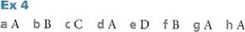i D j B

a are you getting on b I haven't written c I've been training d played ecame f enjoyed g I haven't done h arrived i went j was raining k arrived I was crossing m splashed n changed 0 is expecting p told q hasn't arrived r has discovered s died tbought u was working v rcu»gnized w painted x paid y say

##### Unit 9

a will be, will continue, will claim b will cause, will probably destroy c will never want, will reach d will crash, will cause e will come, will have to

Ex 2 a will hold b will take place c will provide d will carry e will sell f will cost g will use

a 6 b 8 c9 d 10 e 2 f 7 g l h4 i5 j 3

#### Ex 4

Suggested answers: a I'm not going to waste paper. b I'm going to recycle paper and cardboard as much as I can. c I'm going to recycle bottles, cans and organic waste. d I'm not going to take plastic bags from the supermarket. e I'm not going 10 n lake unnecessary car journeys. f I'm going to walk or use a bike. g I'm going to buy local produce. h I'm going to take a shower not a bath. i I'm going to change to low-energy light bulbs. j I'm going to turn off unnecessary lights.

a The volcano is going to erupt. b The water is going to disappear. c The river is going to flood the houses. d The ship is going to hit the iceberg. e It's going to snow (again), f The trees are going to blow down. The wind is going to blow down the trees.

Suggested answers: a I'm going to do biology. b I'll be back at two o'clock. c It isn't going to work. d Shall I turn the lights on? e I'll Sit with Helen. f I'm going to study engineering.

##### Unit 10



a retires 7 b takes off 3 C Continues 8 d starts 9 e takes place 4 f rises 10 g expires 6 h closes 2 i Ieaves 5 j open I



a are holding b is coming c is giving d is showing e are serving f is arriving g Is, meeting h are picking, up, taking i is leaving

a will break b is going to come out c is going to Start d won't drop it. e We're playing f I'll take g I'm going to study h I'll see you

a I'll be lying b I'll be waiting c I'll be working d I'll be starting e I'll be going f I'll be watching g I'll be living h I'll be catching

a will have started b will / won't have invented c will / won't have found d will / won't have discovered e will / won't have moved f will / won't have used g will / won't have become h will / won't have made

a will Continue b enters c will grow d finishes e occurs f will become g collide h will form i begins j will produce k will grow I increases m will be n stops o expands p will absorb q uses r will become s won't make t will be

Ex 7 a A bC cc d B ec g B h c i B iC

##### Unit Il

a There b there c There d there e There f They g there h there i •lhey j They k there I There m They n This o There

a is a match on Tuesday. b are three ways you can do this. c was a lot Of snow yesterday. d isn't any milk. e seems to be a strange man outside. f were a lot of people at the rock concert. g were crowds Of people on the train. h is an interesting television programme on at 8.00.

a their b They're c There d There e Their f They're g Their h  i They're j their

###### alt's bit's c its d its e It's f it's g its h It's

a There b there c It d It e There fit g It h there i It j There

#### Ex 6

a it b There c It d there e There f There g it h There i There j it k there 1 1t m there n There 0 it pit q there r There sit t there

Ex 7 cc dB e B fC g A hB jc

##### Unit 12

a Is the Nile the longest river? b Have earthquakes occurred in this country? c Had the vcolcano eru before? d Was there only one continent 200 million years ago? e Were people expecting a tsunami in 2004? f Will our climate be different in 50 years' time? g Has the capital city continued to grow? h Are the Arabian Desert and the Gobi Desert similar in size? i Has the ice at the Poles started to melt? j Were many people injured in the earthquake?

Ex 2 a they don't b it is c it can't d it does e they have f they don't g weare hit is i they can j they didn't

EX 3 a 5 b 8 c2 d 10 e 4 f6 a Where does the name volcano come from? b How many volcanoes are there on Earth? c Where does the hot lava come from? d Why does the lava come out of the volcano? e What docs dormant mean? f How long do most volcanoes remain active? g How do scientists predict that a volcano will erupt? h What do they measure the movements with? i What is a sign that volcanoes are going to erupt? j What did people once think caused volcanic eruptions?

1. Do you know what the capital of Argentina is? b Do you know how long the River Nile is? c Do you know where Lake Titicaca is? d Do you know what colour the flag Of Mali is? e Do you know how many states there are in Australia? f Do you know how high Mount Everest is? g DO you know what the capital Of the Republic of Gambia is? h Do you know how many official languages Switzerland has got? i DO you know what the Finnish name for Finland is? j Do you know what the population of the Republic Of San Marino is?

Ex 5 a DO you know where Llanfairpwllgwyng.. is?

1. Do you have any idea if / whether it is the name of a real place? c C.an you tell me if / whether it was an invented name? d I wonder why they decided to make up a name. e Could you tell me what the local people say? f DO you have any idea where the name Taumata..... comes from? g Do you know how you pronounce it? h Do you understand what it means? i Can you tell me which language this word is from? j Could you tell me what the longest place name in your country is?

a What moves when an earthquake occurs? b What creates this stress? c How many earthquakes happen ewery day? d What does a large earthquake do? e When did a powerful earthquake hit the city Of Lisbon? f How many people died? g In which d istant country was the shock felt? h What do geologists now

believe?

Unit 13

a is it? b have they? c will it? d did they ?

e Can they? f is it?

a weren't you? b isn't it? c haven't you? d don't they? e isn't she? f didn't it?

Ex 3 a A b B CA dB e B fA g A h B

##### Ex 4

a Most portable radios need batteries for power. so do most CD players. b Airships don't need a runway to land. Neither helicoptem. c Diesel engines produce exhaust fumes. So do petrol engines. d Wind power doesn't cause air pollution. Neither does wave power. e Computers use electronic microchips. So do calculators. f A wireless keyboard doesn't require a connecting cable. Neither does a wireless mouse. g Some cookers Can use solar power. so can some lighting systems.

In India all children are supposed to go to school between the ages of six and 14. In fact in the countryside it is very difficult for young children an education because the government has failed_tgy enough schools, and also because transport is difficult, and children the bus to get to school. •I-here are few buses So most children go on foot. On top of all these problems, many parents never went to school themselves, so they don't expect their children to.go. Many parents are also so poor that they don't their children go to school, but prefe! .tg_senql them to work instead, because they need the money. Children from richer families, On the other hand, often live near good schools, and their parents encourage them to_pa» their exams so that they can get good jobs.

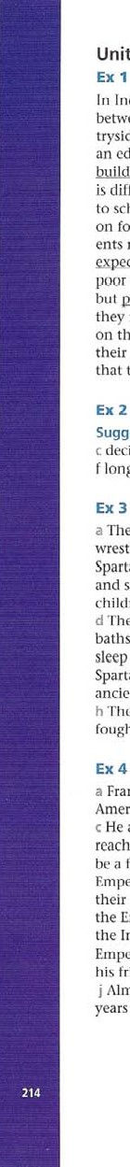

unit

14

Suggested answers: a hope to b manage to c decide to d learn how to e prefer to f long to g need to h aim to i fail tn j try to

The ancient Spartans made girls practise running, wrestling and throwing javelins. b The ancient Spartans did not let a baby live if it was not fit and strong. c The ancient Spartans made young children fight each other to make them tough. d The ancient Spartans didn't let people take a lot Of baths. e The ancient Spartans made the children sleep on rushes, a kind of grass, f The ancient Spartans didn't Ict people cat a lot of food. g The ancient Spartans made all the boys join the army. h The ancient Spartans didn't let boys Cry when they

fought.

a Francisco Pizarro decided to return to South America in 1532. b He hoped to conquer the Incas. c He also expected to become rich. d When he reached the Inca city of Cajamarca, he pretended to be a friend. e He threatened to kill his prisoner, the Emperor Atahualpa, unless the people brought him their gold and silver. f But he did not intend to let the Emperor go free. g Ile aimed to make sure that the Incas had no leader. h He promised to set the Emperor free, but killed him. i Pizarro also killed his friend Almagro, who refused to obey his orders. j Almagro's friends managed to kill Pizarro three years later.

a It's difficult to learn how to live in space. b It isn't easy to eat in weightless conditions. c It's difficult to take enough exercise. d It's very important for astronauts 10 he in good health. e It's difficult to imagine what astronauts have to do. f It's impossible to live a completely normal life in space. g It's never boring going into space, h Most astronauts feel happy to return to Earth.

Suggested answers: a sorry b decided c encouraged d let e allow f managed g supposed h careful i failed j learned k trying I refused m prepared n threatened o forced

#### unit 15 Ex 1

a can't help b avoid c enjoy d involves e keep f suggest g means h feel like i go i consider

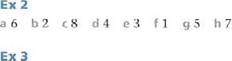

a to do b getting c to lake d shopping e to think f to remember g writing h paying

a in b by con d of e for f at g of h in i of j between

a Are you interested in fossil-collecting? b Does it involve walking long distances? c I keep finding rocks that aren't really fossils. d When you look for fossils on a cliff, you risk falling. e I can't help thinking this is the wrong place to look for fossils. f Going on the club trip means getting up early. g I didn't remember to bring my hammer. h I feel like sitting down and having a rest! i I am good at finding fossils. i It's not worth taking up a h Obby unless you're serious about it.

a Collecting fossils can be very relaxing. b Giving up smoking can be very difficult. c Doing an exam without revising isn't a good idea. d Learning a new sport is fun. e Learning a foreign language takes lots Of hard work. f Seeing my favou rile hand play live was very exciting. g Living on Mars will never be possible. h Writing the report took a long time. i Walking up this mountain is so tiring! j Driving without a licence is illegal.

Ex 7 a to cross b to win c travelling d riding e to lind f discovering g to reach h to complete i to arrive j crossing

##### Unit 16

a She said (that) she got up every day at 6..30.b He said (that) he had forgotten to phone the doctor. c He said (that) everybody liked comedy films, d He said (that) he was thinking about it. e She said (that) she was reading the paper. f She said (that) scientists didn 't understand everything.

1. He said (that) he had decided to 100k for a new job.
2. He said (that) he could swim 5,000 metres. i She said (that) she was going to have a baby. j He said (that) he would phone on Friday.

Ex 2 a her b her c him d his e she f him g they h him i his j there k their I him m the n his o theirs

Ex 3 a said b told c said d said e told f told g told h said i told

a He told journalists (that) he had always been interested in the story of Troy. b He said (that) his father had read the stories to him when he was a child. c He said (that) he had always believed that Troy was a real place. d He said (that) at an early age he had decided to discover the site of the city. e He said (that) for many years he had worked as a merchant in the USA and Russia. f He said (that) he was a wealthy man and he had retired from business. g He said (that) he had first been / gone to the site at Ilissarlik in 1868. h He said (that) since then he had spent a lot of his Own money on t he excavation. i He said (that) he was working with a British archaeologist. j He said (that) they were hoping to prove that Ilissarlik Was the site Of ancient Troy.

a She told the journalists (that) she was the director of the dig. b She said (that) she wanted to explain how they had found the site, and what they had been doing there. c She told them (that) she was sure (that) they had read the publicity handout, and (that) they knew something about it. d She said (that) it was important to give them the latest information. e She told them (that) she was going give a description of some of the interesting discoveries they had made there. f She said (that) she would give them a general account of the project. g She told them (that) she would show some slides Of the site. h She said (that) there would be a chance for all Of them to 100k at some fascinating objects. i She told them (that) they had brought some Of the more spectacular finds. j She said (that) they were waiting for them in the room next door. k She told them (that) they would be able to take photographs. I She said (that) they had been very patient.

##### Unit 17

a The teacher asked me if / whether I had done my homework. b I asked the teacher if / whether we were starting a new lesson. The teacher asked me if / whether I was paying attention. d I asked the teacher if / whether I had to write it down. e The teacher asked me if / whether I was feeling all right.

f 'DO you have / Have you got a spare pen?' g 'Are you going to start?' h 'Is it all right to use a pencil?' i 'Do you know the answer?' j 'Is it the end of the lesson?'

a The teacher asked us how many colours there are in a rai nbow. b The teacher asked LIS what a tadpole turns into. c The teacher asked us how fish take oxygen from the water. d The teacher asked us how many stomachs a cow has. e The teacher asked us what scientists mean by gravity.

f The teacher asked us when the Second World War had begun. g The teacher asked us why Romeo had drunk the poison. h •me teacher asked us what Edison had done in 1877. i The teacher asked us what Gregor Mendel had been famous for. j The teacher asked us what Marie Curie had discovered.



a I asked him if / whether he lived there. b I-le asked me what my name was. c I asked her what time it was. / what the time was. d She asked me if / whether I was sitting there- el asked her if / whether she wanted some coffee.

EX 3B f 'When does the next train leave?' g 'Where is the bus station?' h 'Do you have / Have you got any change?' i 'What are you staring at?' j 'Are you waiting for us?'

a The teacher told John to the fill the jar with water. b -me teacher asked Angela to help him. c The teacher told Michael not to spill the water. d The teacher asked Alison if she would pour / to pour a little water into the test tube. e The teacher told Steve 10 light the gas. f The teacher told Alan nnt to touch i t with his finger. g The teacher told Sarah to heat the water gently until it boiled. h The teacher asked all Of them to watch the water carefully.

Ex 5 a l 68 c 7 d6 e? f4 03 hS

##### Ex 6

Suggested answers: a said his advice was b told, to choose a workout c told /advised [hem / [he audience to avoid activities that were d suggested doing it a bit differently each time e explained that making sure you have f warned that overtraining Can g reminded them / the audience to eat h said they / the audience shouldn't use

Unit 18 Ex 1 a If you heat water to 1000C, it boils. b If you boil water, it turns into steam. c If you cool the steam, it turns back into water d If you heat a piece of metal, it expands. e Il you freeze a piece 01 metal, it contracts. f If you freeze water, it expands.

a If everyone recycles paper, companies won't cut down so many trees. b If everyone recycles metal and glass, we won't waste valuable resources. c If everyone recycles paper, metal and glass, we won't produce so much rubbish. d If everyone turns Off unwanted lights, we will save a lot of electricity. e If everyone walks or cycles, we won't waste so much Oil and petrol. f If everyone insulates their houses, we won't waste so much energy for heating. g If countries use more wind and water power, they won't depend so much on power slat ions. h If countries use power stations less, they will cause less air pollution.

Ex 3

a What would happen if you travellcd through the Farth to the other side? b What would happen if the Earth suddenly stopped going round? c What would happen if we didn't have a Moon? d What would happen if all the ice at the poles melted? e What would happen if there was no more electricity? f Whal would happen if aliens received messages from the Earth and decided 10 visit us?

##### Ex

a You won't succeed in sport unless you train hard. b You can improve your performance as long as you train regularly. c It doesn't really matter whether you succeed or not, as long as you enjoy your sport. d You won't develop as an athlete unless you eat and sleep properly.

Ex 4B e Take a spare pair of running shoes in case you need them. f Take a waterproof coat with you in case it rains. g Take a warm jumper in case you get cold when you slop. h Take a Ii rst-aid kit in case someone gets injured.

a used, would be able b were, would see c turn off, won't be able d didn't, would weigh e don't have, will let f looked, would be, would be g smoke, take place h removed, would be able

##### Unit 19

a had marched, would have conquered b had gone, would have succeeded c had built, would have crossed, (would have) landed d had not hit, would not have arrived e had continued, would have sailed f had not read, would not have tried g had sailed, would have reached h had not thought, would not have conquered i had not found, would not have made j had not taken, would not have written



Suggested answers: a If I hadn't brought a map with me, we would be lost. b If I hadn't explained my new ideas to the Church, I wouldn't be in trouble. c If I hadn't exaggerated some of the descriptions in my book, perhaps more people would believe me. d If we hadn't gone to the theatre last night, he would be alive today, e If I had spent more time on my painting, more cot them would be finished. f If I hadn't invaded Rwssia, I would still be Emperor Of France.

Suggested answers: a If the Trojans hadn't taken the wooden horse into Troy, the Greeks would not have captured the city. b If the Greeks hadn't won the battle Of Marathon, Darius and his army wouldn't have gone home. c If Julius Caesar hadn't made the decision to cross the River Rubicon. he wouldn't have become leader of the Roman state. d If Isabella hadn't married Ferdinand, Spain wouldn't have become one of the most powerful countries in Europe. e If Harold's army hadn't been tired, William wouldn't have become king of England.

Ex 4 a I wish J knew the answer to this problem. b I wish I had a calculator. c I wish I understood the problem. d I Wish my' teacher explained things to me. e I Wish I Was / were in a different class. f I wish I did French instead. g I wish I lived in France. h I wish I didn't have to do my homework.

a I wish I hadn't met him. b wish I'd stayed at home. c I wish I hadn't decided to go to a wizard school. d I wish I had stayed in China. e I wish I hadn't sat under an apple tree. f I wish I hadn't run away with him. g I wish I hadn't made him, h I wish I had put some clothes on.

a I wish you'd hand your work in on time! b I wish you wouldn't make so many mistakes! c 1 wish you wouldn't drop litter on the floor! d I wish you would pay atten tionl e I wish you wouldn't talk during the test! f I wish you would listen to what I'm saying: g I wish you wouldn't interrupt people! h I wish you wouldn't throw things across the room! i I wish you would behave! j I wish you would make less noise / wouldn't make so much noisel

a were b would spend c stays d do not realize ego fswim g remained h would die i had been j would have seen k continue I will become

##### Unit 20

a were lit b was invented c were shown d were used e was designed f was made g were sold h were replaced i was written j Were introduced

a AS a first step, a computer is used to plan the exact shape of the car. b Then this computer programme is fed into a machine and a plastic prototype is produced. c 'lhe actual toy cars are produced in a factory abroad. d The bodies are made from plastic. e Small electric motors are added to the cars, and they are painted. Licence plates are also attached. f At the next stage, the Cars are inspected, then they are wrapped and packed into cardboard boxes. g Finally, the cars are shipped to Britain.

a have been made b has been advertised c will be constructed d will be taken e will be powered f will be carried g will be provided h will be used i has not been built i has been criticized

a The global expansion in tourism has been made possible by cheaper air travel. b A growth in tourism has been experienced by countries all over the world. c The popular Mediterranean resorts have been visited by millions of tourists since the 1970s. d Recently more distant locations in Africa, Asia and South America have been chosen by tourists. e Some countries have been badly affected by mass tourism. f Large hotels have been built on unspoilt coastline by international wmpanies- g Local wildlife has been disturbed by these developments, h Coral reefs a nd other habitats have been damaged by tourists. i Local people have also been displaced by such developments. j The idea Of ecotourism has been developed by some governments to counteract some of these problems.

a have been redeveloped b has / have been transformed c had been built d had been lost e had been closed f has been spent g have been improved h have been built i have been created j have been constructed k have been planted I have been created m have been opened n have been done o has been gi ven

Ex GA a Ships with sails were built more than S,OOC) years ago. b A hot-air balloon was constructed in 1783. c The steam ship was developed the 19th century. d The first successful passenger railway was opened in 1830. e The first passenger airlines were started after the First World War.

###### Ex 6B

f The first books were probably printed by the Chinese more than a thousand years ago. g The first modern typewriters were sold by the Remington Company in the 1870s. h first words were recorded On a gramophone record by Edison in 1877. i 'Ihe first modern cinema was created by the Lumiére brothers in France in 1895. j The tape recorder was invented by Valdemar Poulsen in 1899.

##### Unit 21

a I am having my photograph taken. bis having her hair cut. cis having a tooth taken out.

d are having Our kitchen painted. e am having it (my car) serviced. f are having their new central heating fitted.

a Tim had his nose broken while he was playing football. b Maria had her bike stolen last week.

1. Mr Grover had his car damaged last week.
2. Anna had her mobile taken. e Our garden wall had paint sprayed on it. f We had our house broken into. g One policeman had his helmet knocked off. h We had our windows smashed with a brick.

a People have scars and blemishes removed. b People also have their faces lifted in order to look younger. c In a recent poll, many people admitted that they had had / admitted having their noses altered. d Several people had also had their eyes reshaped. e One woman had also had her lips thickened. f Psychologists are worried that so many young people want to have their appearance changed. g So if you're thinking of having an operation performed, think again _ h People can also have their lives ruined by plastic surgery.

##### Ex 4

a Did you get your project finished in the end? b Did David get sent to the head teacher's office? c Did you get all your homework done? d Did Susan get chosen as class representative? e When are you getting the school sports programme sorted out? f Did you get your revision organized? / Have you got your revision organized? g Did *IOny get iniured playing basketball? h Did you get invited to Maria's party?

a was offered a job in Dubai b was promised a good position c was sent a letter explaining all d would be given e was lent some money f was given some CDS

##### Ex 6

a is believed to be seriously ill. b is thought to be in hospital. c is supposed to be flying to Washington tomorrow. d is understood to be remaining in London. e is not said to be dangerously ill. f is expected to leave hospital in a few days. g are believed to be at her bedside day and night. h is known to be a kind of flu. i is understood to be taking antibiotics. j is reported to be in good spirits.

##### Unit 22

a can't reach b can hear c can't open d haven't been able to take e can't come f to be able to use g can 'f swim h haven 'i been able to sleep

a mustn't b must c mustn't d mustn't e must f mustn't g mustn't h must

Ex 3 a mustn't b don't have to c don't have to d mustn't e don't have to f mustn't

a can cause b has to provide c have to produce d have to have e can't grow f have to control g have to take h have to ask i have to be j have to ask

Ex 5 a should b should c should d should e shouldn't f should g shouldn't h shouldn't

a We'd better take an umbrella. b You'd better call a taxi. c You'd better not play in the match.

d We'd better take some sandwiches. e You'd better wear a hat. f We'd better leave now. g We'd better not wake him up. h You'd better check it in the dictionary.

a You need to think about all the information given. b You needn't worry about spelling, but you should try to be as accurate as you can. c You need to identify all the necessary Steps to solve a problem. d You need to understand technical words eg equation. é You need to be able to use methods of multiplication and division. f You need to know when to use an example.

al) bD cB dB e D fC gA h C

##### Unit 23

a couldn't b could c couldn't d could e could, couldn't f couldn't g could h couldn't i could i could

a I needn't have worked so hard! b I didn't need to work at [he weekend. c I didn't need to borrow any books. d But I needn't have given up so much Of my spare time. e I needn't have spent a lot of time reading and writing every evening, f But I managed to do it on my own, and I didn't need to ask for any help. g And I didn't need to give up playing tennis. h I needn't have used the Internet so much. i But it was quite easy in the end, and I didn't need to think too hard! j In the end, I needn't have worried about it so much!

a didn't have to go b couldn't pay chad to find d had to work e had to sign f had to climb g had to be h had to use i had to pay j cou Idn't employ k could work I could put m had to limit

Suggested answers; a He Should have conducted an experiment. b He should have worn warm clothes. c He shouldn't have tested it on his students. / He should have tested it on himself. d He shouldn't have carried radioactive substances in his trouser pockets. e He should have told people about his sister. f The French revolutionary authorities shouldn't have executed him.

a should have been b couldn't find chad to look for d had to avoid P could kill f shouldn't have told g needn't have worried h had to work i couldn't Stop j should have shown k couldn't tell I had 10 admit

#### unit 24

##### Ex 1

|  |  |
| --- | --- |
| a may b may not c may d may g may not h may i may j may  a might b can, may not c may be f will g will, might h could | e may not f may  d can e might |

a You must know the difference between a solid and a gas! b If a substance does not contain hydrogen, then it can't be an acid. c If we put some litmus paper in a solution and it turns red, then the solution must be an acid. d If we add a substance to a red cabbage solution and it stays red, then the substance can't be an alkali. e If we add a substance to a red cabbage solution and it turns green, then the substance must be an alkali. f If we put some litmus paper in a solution and it turns red, then the solution can't be an alkali. g [f it's not an acid, or an alkali, then it must be neu tral. h If We use a universal indicator to check a substance, and it turns purple, then the substance can't be an acid.



a If the world becomes warmer as some scientists predict, Europe could change dramatically over the next century. b •I-here might be no snow-covered mountains in Europe by then. c And areas in the south of Europe could become deserts. d Heavy rain might become normal in northern Europe. e While southern Europe could be always short of water. f There might be some benefits for some people. g Summers coul d become longer, hotter, and winters could become Warmer. h On the Other hand, some species Of plants and animals might become extinct.

a A, B bA, B cB, c dC fB g A, c h A, m A nA oc

##### Unit 25

a You Could have damaged the computer! b You might have been more careful! c You might have asked for help! d You could have broken the printer. e The computer could have got a virus. f You might have checked the name of the sender! g You could have lost all your work. h That could have been a very serious problem. i You might have told me you hadn't used a computer before: j You might have turned the computer off when you finished!

a [f you go near the edge, you could fall. b If you hadn't rescued me, I might have drowned. c If Somebody had seen •10m come in late, he could have got into trouble. d If you run a bit faster, you might win the race. elf Maria's explanation had been detailed, we might have believed her. f If you lift such heavy weights, you could hurt yourself, g If you don't put your wallet in your pocket, somebody could steal it. h If you had dropped the plates, you could have broken them. i If you phone him, he might still be at home. j If United had scored an early goal, they might have won.

a The Ancient Egyptians might have crossed the Atlantic. b "Ille Egyptians could have had traded with America more than 3,000 years ago. c Traces Of tobacco have been found in Egyptian mummies and this may have come from Central America. d The discovery Of silk in mummies also suggests that the Egyptians could have traded with China. e And because there are pyramids in Central America, the Mayas might have got the idea for building pyram ids from Egypt. f On the other hand, as Egyptian pyramids and Mayan pyramids are so different, the two civilizations may have had similar ideas. g •I-here has even been a claim that it was aliens from another planet who might have built the Mayan pyramids. h According to this theory, the aliens could have used the pyramids as landing places for their flying saucers.

a The local people must have been shocked when they saw the Spanish armies. b They can't have known where the Spanish came from. c They must have soon realized that they were enemies. d They can't have been aware Of the invaders' intentions. e They must have wondered whether they were gods. f The Spanish can't have expected to beat the local people so easily.

g They must have thought they would be killed. h They can't have realized what the Incas were like i The local people must have given up when faced by horses and guns. j The Spanish can't have expected to find so much gold.

a If the Trojans hadn't taken the wooden horse into Troy, they might / could have won the war. b If Alexander the Great hadn't died at an early age, he might / could have conquered the whole world. c If the Romans hadn't spent a lot of time fighting among themselves, their empire might / could have lasted longer. d If the medieval Europeans had known that America existed, they might / could have gone there sooner. e If the Aztecs hadn't thought the Spanish used magic powers, they might / could have beaten them. f If the Spanish had succeeded in invading Britain in 1588, they might /could have then conquered all 01 Europe.

Suggested answers: a The Mayan ruling class might have died out because rulers did not work. b Farmers might have been unable to grow enough food to support large populations in cities. c A natural disaster, such as an earthquake, might have occurred. d Another Mexican people might have conquered the Mayas. e There might have been a revolution. f An epidemic of some kind might have caused the disappearance of the Mayas. g The Mayan cities might have suffered from an environmental disaster. h The people might have abandoned their cities because their priests told them to do it.

unit 26 Ex 1 a May I b Could you Would you mind taking d Shall I el wouldn't leave f I don't think you should spend g Do you think you could explain h Why don't you ask i Would you like j Can you

a B bC cc d A eB fC g A h A iB jc

##### Ex 3

a Shall b could c were d mind e about f Can

/ Could / May g if h wouldn't i let's j should



bS c 7 d 10 e 1 f4 g8 11 6 i 3 j 2

Ex 5 a Is it all right if I keep my coat on? b Shall I give out the books? c I think you should buy a dictionary. d Do / Would you mind sharing with Mary? e How about playing volley ball for a change? f I won't forget my homework. g Do you think you could explain / Do you mind explaining what this means? h If I were you, I'd read it again. i May I leave the room? j I don't think you should touch that.

Ex 6 a Would you like to go to lunch now? b Do you think you could collect in the homework, please? c Why don 't we have another look at the table on page 218? d If I were you, I'd revise all of Unit 6. e Shall I explain it again? f Can you stay behind for a moment? g Is it all right if I sit near the front? h How about looking for the information on the Internet?

##### Ex 7

Suggested answers: a Could you tell me? b Why don't you make / How about making notes so you don't forget? c Can / Could you speak more slowly? d Shall I speak more slowly? e Can you tell me what happens next? f Shall I tell you who wins? g Can you stop / Do you mind stopping, please? h You should read the play, / If I were you, I'd read the play. i Shall we go to the library? j Let's go now. / We could go now.

##### Unit 27

a Sheep b thanks person d knives e stairs f clothes g belongings h mouse i aircraft j goods

a salt b travel c wood d hair e advice f iron g salts h wines i knowledge j information

##### Ex 3

a The students' accommodation was of a very high standard. b 'l'he weather has been very bad this year. c The furniture is arriving löfiiörröw. d There is a lot of / lots of rubbish at the edge of the sports field. e The new equipment cost a lot of money, so look after it. f The work in the factory was very difficult. g The scenery in this country is very beautiful. h Most Of the clothing was destroyed in the fire.

Ex 4 a B bA CA d A e A f B 

###### a is bare cis d are e areg are h is

a B b A C A C d The temperature / temperatures, electricity e Air, gases f lights

Extension Activity

2 her hail, some accommodation, some advice

##### Unit 28 Ex IA

a It opens bottles. b It sharpens pencils. c It makes coffee. d It mows lawns. e It washes dishes.

##### Ex 1B

f a watch strap g a keyhole h a tennis racket i a street light j a library book

##### Ex 2

a mountain range b desert areas c sea levels d export income e wool exporter f beef farming g irrigation systems h mineral resources i export earninbs j business district

a temperature of the air b the formation of rain and snow c the temperature of the clouds d droplets of water e size of the droplets f currents of air g drops Of rain h crystals Of ice i flakes of snow

a room temperature b exhaust fumes c mineral salts d food chemicals e future geneJations f heart disease g salt solution h air pollution i climate change j electricity bill

##### Ex S

a Shop window b bus ticket c front door key d bicycle chain e telephone directory f glasses Case g computer engineer h bookshelf i alarm bell J school bus

David Copperfield, the novel by Charles Dickens, is a story of one boy_ls struggle after losing his parents. father dies when he is young, and his mother remarries. His stepfather, Mr Murdstone, treats David unkindly, and he can only find happiness with the Peggoty family, his nurse's relatives. At school, at first he is unhappy but then wins his friends' respect. However, When his mother dies, his stepfather sends him to work in a factory in IOndOn, where the Other boys make fun of him. David runs away and walks 10 his house in Dover. Here he grows up happily, goes to school and becomes a clerk in a lawyers office in London. He fans in love with Dora, his em-pLoyer:s daughter, and when his aunL's money is lost in a bad investinent, he works writing reports of parliament for the newspapers. Many parts of the story follow the events of 12ic.kensLL Dickens's own life.

###### Extension Activity

1 a desk lamp, a door handle, a water jug, an exercise book, the front door, a computer room

29

Note: As article use depends a lot on context, there may be alternative answers ror some items in this section. The answers given are the most likely ones.

Ex 1 a The bthe ca d A ea fan g the h the i A , a jThe

#### a B bC CA dc e A fC g c h B iC jB

a The b a c a d a e the f the g an / the h the i the j the k the the m the n the o The p a q The r the s the t The u the v the w the x the y the z the 1 the 2 The

3 the 4 the

c a d thef The g the i the j - k the I a m a

##### Ex 5

h the i r the

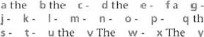

the

v

The

w

The

y

-

|  |  |
| --- | --- |
| a a b the c the d a e the f the  Unit 30 | g the h the |
| a The, the, - b the, the, the, the c e The, f-, - g the h the, the, - | the |

b The, - c-, a  f-, a,j the, -

c the d i the ja k- I the m

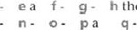

the

r the s the t the

Ex 4

##### Ex 5

h the i the j the ka I the p the q the

r the s the ta

a the b the C the d the ethe f - g- ha i a j a k . l . m a n the o the p The q - r- s - t the u the

##### Unit 31 Ex 1

a Is there any oxygen on Mars? b Is there any cheese on the Moon? c Are there any mammals with beaks and webbed feet? d Is there any weather on Other planets? e Are there any fish that can walk on land? f Are there any birds that can't fly? g Is there any water on the Moon? h Are there any apes that can be taught to speak? i Is there any oil or coal on the Moon? j Are there any living dinosaurs left on Earth?

a There aren't any cars that use water as fuel. b 'Illere aren't any mammals that lay eggs. c There

aren't any polar bears (that live) in the Antarctic. d There aren't any alien beings in Our galaxy. e There aren't any volcanoes in Britain. f There isn't any rain in the Sahara desert.

##### Ex 3

a an b some, some cany d some, any e some

f a g a h some i a j some

|  |  |
| --- | --- |
| a a b any c Some d any e an h an i some, any j some  Ex 5 | f any g any |
| a crowd bean c packet d tube g slice h piece i sheet j carton | e cloud f bar |

a b a (warm) c y/ d / e the (less) f the (real) g the (tropical depressions) h a (maximum) i j the (meteorologists) k/ I the (low) m n a (heavy) o / p/ q the (June 1st)

a Some mountain ranges are only 15 million years old, while others are 400 million years old. b Some pine trees depend on birds to spread their seeds while others depend on forest fires to release the seeds from the cone. c Some frogs 'fly' from tree to tree using webbed feet as parachutes, while others jump using their powerful back legs, d Some rivers in desert areas evaporate in the desert and disappear, while others flow into rivers, lakes or into the sea. e In some places the difference in sea level between high tide and low tide can be almost nothing, while in others it can be as great as 10 to 15 metres.

###### 32

a How many b How much c How many d How much e I-low many f How many g I low much h How much

a isn't much b aren't many c isn't much d aren't many e aren't many f isn't much g isn't much h aren't muny

a Only a few b few ways t NO divers e only a few hours. f There are a lot of g there is none. h There are few

##### Ex 4

a Few b little c few d little e few g few h little

a Both Alexander and Napoleon b Neither A nor N c Neither A nor N d Neither A nor N e Both A and N f Both A and N g Both A and N h Both A and N i Neither A nor N j Both A and N

EX 6 aB b A dc e A fC g B i A jc

#### unit 34

##### Ex 1

d A few people

f little

a He, his b him c He, his g he h their i they j his

a mine b his chers d us h me i theirs j you

1. his, him e he f their
2. yours f ours g them

a Many b many clots d much e few f many g lots h little i Many j lots k little I much m many n few 0 many p few q lots r lots s lots t none

a much b little c Much d plenty / lots e lot f much g enough h lots i much j few

a little b lot c Many d not enough e lots f many g little h few i lots j Many k many I little m lots of n many 0 little p few

#### unit 33

##### Ex 1

a All b Most c No d All e Most f No g Most h All i no j Most/ All

a the whole family b the whole country c the whole series d a whole generation e the whole area f her whole life

a all Of b Most Of c none of d all of e most of f most of g all of h none of

a all beach c every d each / every e each f all g every h all i every i AII

a Hilrry is a friend of mine. b That was their idea. c This one is ours. d This is my pencil, but where's yours? e Sue is talking to a friend of hers. f This bike belongs to him. g Is that house theirs? h That is your cup.

a yourself b yourself c ourselves d themselves e myself f yourself g himself h themselves i ourselves

a Everyone J everybody has b No-one / Nobody knows c everyone everybody d someone / somebody e there is nothing f anyone / anybody g Everyone / Everybody supposes h No-one / Nobody visits i No-one / Nobody knows j is something interesting.

a something else b somebody / someone else c Something else d Everyone / Everybody else e nothing else f anyone / anybody else g anyone / anybody else h anything else i someone l' somebody else j Someone / Somebody else.

a nowhere b anywhere c somewhere d everywhere e anywhere f somewhere g somewhere h anywhere i everywhere j Nowhere

Ex 8 a his b anyone everyone / everybody d No-one / Nobody e something f No-one l' Nobody g him h himself i themselves j them / anything

###### 35

a The boy in the painting seems to be asleep. b The girls in this painting look alike. c I think the person in this painting is dead. d He is awake, but looks as if he is in a dream. e Are you afraid of this painting? f It's a painting of a battle and very few soldiers are alive.

a big, red London b wonderful, old Venice c vast, stone Cairo d graceful, iron Paris e well-known, medieval Moscow f busy, commercial Tokyo g tall, modern Istanbul

a really, absolutely b - cvery d absolutely e very f extremely, very g very, really

###### Ex 4

a depressed b confusing c exhausting d embarrassed e worried f interestin; g surprised h annoying i excited j satisfied unit 36

a adjective b adjective c adjective d adjective e adverb f adverb g adverb h adjective i adverb j adjective

##### Ex 2

a slowly b happily c beautifully d badly e really f truly g incredibly h unbelievably

a I often finish sentences for other people. b Other people usually seem to be comfortable when they talk to me. c When people talk to me, I sometimes look at the floor. d If I don't like a person's voice, I never pay attention to them. e I usually try to be sympathetic when people talk about their problems. f I always try to give people my complete attention when they speak to me. g I rarely interrupt people before they have finished what they are saying, h I sometimes laugh at what people say to me, and upset them. poor listener: a, c, d, h

##### Ex 4

a properly b Unfortunately c easily d wrongly e usually f thoroughly g dreadfully h definitely i carefully j entirely

###### EX 5

a no you usually take the lead in discussions? b Do you sometimes feel unable to say anything interesting? c DO you often change your opinion after you hear what others say? d Do you always listen carefully to what all the others are saying? e Do you sometimes feel that nobody is interested in what you say? f Do you usually find ways of keeping other people'S attention ? g DO you often avoid saying what you really think? h Do you always encourage Other members of the group to speak?

a very b very c too d very every f very g too h very

##### Ex 7

a adjective b adverb c adverb d adjective e adverb f adjective g adverb h adverb

a ill b hardly c hard d badly e well f hard g bad h hardly

##### Unit 37

a The River Mackenzie is longer than the River Niger. b Lake Victoria is larger than Lake Michigan. c Marianas Trench is deeper than the Japan Trench- d Mount Elbrus is higher than Mont Blanc. e Arica„ Chile is drier than the Libyan Sahara Desert. f The oldest rocks in Canada are Older than the oldest rocks in Scotland. g The lowest recorded temperature in Finland is lower than the lowest recorded temperature in Sweden. h Monaco is smaller than Nauru.



a more difficult than the first one b are tastier than yours c is more expensive than staying at home d is more modern than the Royal Hotel e is more comfortable than this chair f more refreshing than milk (is) g romantic films more interesting than war fi Ims h wasn't as heavy as Jack's suitcase

a worse b cleverer c larger / bigger d younger e funnier f further / farther g longer h warmer / hotter i happier j better

a This book is less interesting than that one. b A scooter is more expensive than a bike. c I'm not as tall as you (are). d The first explanation is just as unlikely as the second. The accident Was more serious than Carol thought (it was), f My arm is lass painful than it was.

|  |  |
| --- | --- |
| f difficult g cleverer and cleverer h important  Ex 6  CB d A e B f A g c h B i A j c  unit 38  Ex 1 a heaviest b longest c oldest d fastest e deepest f speediest g most ferocious h most poisonous i largest i Smallest  Ex 2 a This is the most comfortable classroom I've ever sat in.  b This is the tastiest school lunch I've ever eaten. c This is the worst book I've ever read.  d This is the most useful English lesson we've ever had. This is the easiest problem I've ever solved.  f This is the longest test I've ever taken. g This is the most difficult test I ever written. h This is the most entertaining school play I've ever seen, i This is the most interesting textbook we've ever used. j You are | a in b in con don eat f On g at h in j in k At I in m on n in  EX 4  to bat c to d to, on e to f on h to i in j in  a at b in at d in e At f Ori g at by h at  Ex 6 c A |

Ex S a essential b easier and easier e cheaper and cheaper d important e more up-to-date, the faster

|  |
| --- |
| a B bD  IJnit 40 |

a Can you tell me whether Jim is in? b Mary has gone to live abroad. Shall we go indoors now? d This snake is red on the top but green underneath, e Wait / Stay Outside, please. f David has gone away / is away (on a trip). g Alan lives opposite. h Sorry, but Sue is out at the moment.

a in, on, at bin, on, in c in, at, on e in, on f in, on, at gin, on, at, in i in, on, in j in, at, on

###### d in, at, in, on h on, in, in

the best friend I've ever had.

|  |  |
| --- | --- |
| a harder b faster more often e more easily f longer g bet ter | d more slowly h more heavily |

a more easily b quickly more quietly d faster e more carefully f more loudly g more heavily h more clearly i earlier j more slowly

##### aA bC dC fA hC

|  |  |
| --- | --- |
| a the largest b lower c the most popular famous e wider f the dirtiest g cleaner i the most exciting i the least expensive | d most h the best |

Unit 39

a to b under c over d to e outside h above i in j in

a next bin clast don e at f last h next i at j In

a last b ago e Since d for e next f last g next h ago i Since j for

Ex 4 a from, to / until b until c during d By e During f until g Until h During i during j from, to

a Paula didn't arrive at school until 12.30. b My library card runs out on the last day of July. c By the time we arrived at the cinema, the film had finished. d What were you doing at the time of the accident? e I've been waiting for an hour f During the night there was an earthquake. g I waited until 4.30 and then I left.

h I'll have finished within a week. i It's ages since I saw George. j I'll see you in a week. I in a week's time.

Ex 6 a tor b ago c After d from e to / until f later g during / in h until i Since j during / in k at

##### Unit 41 Ex 1

CD d D

a by now b in time c after d now on e until f then g once h At i then j As soon as

bA cB dC eA f B g A h A iC jB

a They'll be back in the afternoon. b Can you do it at once, please? C At the end of the lesson, Helen asked the teacher a question. d My head is still aching. e Jan was in time for his music lesson. f I've been waiting since six o'clock. g The film began, and soon after all the lights came on. h Lunch isn't ready yet, So until then we'll sit in the garden. i I haven •t finished my homework yet. j Vll finish watching TV and start my work afterwards.

a Until b ago c Until / Before d from e until f already g by h in i at At k during I in m later n In o afterwards pin q Since r still

##### Unit 42

a from b to about d on e with f from g On hat i with j on

a Sometimes I'm really annoyed with you. b We were all shocked by the things we saw on the news. c I'm sorry for losing your magazine. d Who was responsible for the accident? e I'm not keen on horror films. f Football is different from rugby. g Is Madonna married to Guy Ritchie? h Are you interested in playing computer games? i I'm bored by doing the same things every day. j Some people are afraid / frightened of going to the top of high buildings.

a theory b purpose c impression d practice e all f trouble g control h fact i average j end

a In the end I succeeded in finding the answer. b Martin's teacher accused him of cheating. c Our school provides us with a free lunch. d I insist on having my money back! e They blamed the fire On Anna. / Anna was blamed for the fire. f You remind me of my sister. g I'm not used to getting up early in the morning. h Don't worry, you can depend on Chris. i What were you two talking about? prefer jazz to rap.

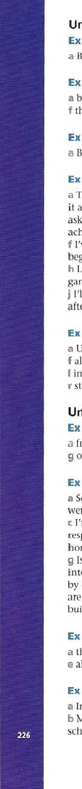

Ex

4

Ex

5

4

a On bon c under dfor e with fon gin h in i ln j from k of l in min n after

##### Ex 6

a Is your bike for sale? b I'm out of practice. c In the end we stopped and turned back. d Are you On holiday here? e I thought it was Andy, but in fact it was David, f I think you broke the window on purpose. g They told him that he was in danger of losing his life. h The train was out Of control. i I was under the impressi0'1 it was a holiday today. j We turned left instead of right by mistake.

#### unit 43

Ex 1 a looked into b took after c heading for d looked after e joined in f came across g running through h getting over i getting at j running into

a look b get crun d take e stand f run g look h come i join j head

Ex 3 a Don't forget to give-cn your homework at the end Of the lesson. b The maths teacher has put the Friday, c I'll come round and pick tomorrow. d Make sure you every new word. e Remember to lutn-lheXY-off when you go to bed. f Don't worry, we'll sorr_QMt the travel arrangements next week. g Please form in as carefully as you can. h The bus drops mssengers off right outside the hotel, i You have let the wholg class dc•wo, and I'm very disappointed. j An elderly couple the Children after their parents died.

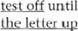

until

a carry out b sort out c getting over d put off e came across f work out g look into h join in i ran into j let down

a 'I-he trip to the National Gallery has been put Off until next Friday. b Make sure you look up these words / look these words up in a dictionary. c You Can miss out Exercise 9 / miss Exercise 9 Out. d A special team is looking into the cause of the accident. e I will not stand for such bad language in the classroom! f Turn Off the computer / turn the computer off on when you leave. g A taxi will pick you up at 7.30. h I wish I could give up chocolates / give chocolates up. i Please fill in the applica tion form / fill the application form in. j Tina hasn't got over her illness yet.

a Have you ever come across this word before? b looking after the children until their mother comes home. c Dina takes after her mother's side Of the family. d The basketball match has been put off to next Wednesday. e Make sure you turn the lights 0fl. f •I-he police are looking into a fight outside the cinema. g Let me run through the details of the plan just once more. h Jane found it hard to get over the death Of her pet dog. i Mr Sims had to give up driving when he reached the age of 85. j Peter promised to come and sing in the concert, but he let us down.

Unit 44

##### a A b D cB dD e c fA hA

a I'm finding it difficult to get-round-to my geography project. b I'm afraid we've come agai nst a rather serious problem. c Tim thought he got a way with cheating in the exam. d Have you come up with any good ideas yet? e The school end-ofyear tests. f Unfortunately Helen went down with flu on the first Clay Of her holiday, g I kept up with the rest Of the class. h I'm sorry, but I really can't put_up-YY.iVh this terrible noise. i Tom ran-QLt_Of money three days before the end of his holiday. j Kate seems to get_omL her new teacher.

##### Ex 3

|  |  |  |
| --- | --- | --- |
| a up b Off | c on d up eoff f down | g up |
| h out i up | j down |  |

a leave out b get Over c are looking into d fill in e come up with f work out g dropped him off h has been put off i give up j got away with

a Most students searching for information look up the details on the Internet. b Doctors say that the unpleasant effects of the new malaria pill soon wear Off. c The battery runs out / runs out of power completely after about three months. d The three astronauts said they were looking forward to coming back down to Fmth. e Keep up with the latest science news with Science Magazine. f There is a great deal of confusion and the authorities are still trying to sort out the situation. g The launch of the next Mars mission has been put off until next April.



a come up against b speak out c getting along / on with d come up with e going on f turns up g get round to h build up i breaks down j catch up with unit 45

a According to experts, school science textbooks are not good at teaching science. b According to their reports, most books cover too many topics. c According to these experts, the classroom activities in the books don't help students learn basic scientific ideas. d According to one scientist, the books are 'full of unconnected facts'. e According to some educational experts, students learn science more effectively when they try to answer an everyday question. f According to these experts, a question such as 'Why is the sky blue?' is the kind of science question students like answering. g According to this theory, students learn better if they carry out project work based on this kind of question. h However, according to many science teachers, the school syllabus does not allow enough time for this kind of exploration.

a You don't have to use butter, you can use Olive Oil instead. b Cooking spoils the flavour of carrots, so eat them raw instead, c This is usually made with apples, but you could try pears instead. d Fresll fish is best for this recipe, but you can use froren fish instead. e Try leaving Out salt, and use other spices instead. f Sweets are fattening, so eat fresh fruit instead. g You don't have to use cream, you cun use yoghurt instead. h In some versions Of this dish, and lamb is used instead of beef.

a You need a schedule , so work out how long you've got to prepare and then divide the time into short mana*eable sections. b Don't set unrealistic goals, as you risk losing motivati011 il you fail to reach them c Make sure your goals follow Lhe SMART system, since these are the best types Of goals. d Try to be very precise about what you want to achieve, because this will give you a definite target, eg I will read three pages of history before 6.00. e Ask someone to test you on what you have studied, so you can measure what you have achieved. f You have to be honest with yourself about what you can achieve, because if you set yourself too much, you won't be able to do it. g Give yourself a reward when you achieve your target, as this will make you feel good! h Give yourself a deadline, since you need to feel some pressure if you want to work well.

##### Ex 4

a However b while c while / even though d While / Even though e although f However g While h Even though

Ex 5 a Every living organism needs energy to maintain its body and also grow. b Omnivores are animals that eat plants and other animals too. c Decomposers are organisms [hat eat dead animals and dead plants, and enable other plants to feed off the dead material as well. d Producers are plants that use photosynthesis to convert the energy of the sun into food. and they ure also the lowest layer of the food web. e Primary consumers are the animals that eat the producer layer, and are also called herbivores. f Secondary consumers eat the primary consumers and are carnivores, though some of them eat plants as well,

a Although b because / as c for example d However e so f although g also h such as

|  |  |
| --- | --- |
| i As / Since | j instead k Al though While I While |
| / Although  Unit 46 | m also n for example o Although |
| a No b / | c No  f No h NO |

a 4 Linnaeus was a bota_nist who worked out a method of naming plants and animals. b 2 Marie Curie was a physicist and the first woman who received a Nobel Prize, c 7 Aristotle was a philosopher who taught Alexander the Great. d 3 Mary Shelley was a writer who wrote the novel Frankenstein, e 1 André-Marie Ampere was a physicist who made an instrument for measuring current and [age. f 5 Sonia Henie was an iceskater who took part in the Olympic Games at the age Of 11. g 8 Maria Montessori was a doctor who invented a new method of teaching young children.

h 6 Marco Polo was a merchant who visited China in the 13th century.

##### Ex 3

a J S Bach had two sons whose music was betterknown than his for many years. b John F Kennedy had a brother, Robert, whose death was also a political assassination. c Lord Byron the poet had a daughter, Ada Lovelace, whose work in mathematics led Lo the development of the first computer. d Pablo Picasso had a daughter, Paloma, whose fashion designs have become famous worldwide. e John Lennon had a son, Julian, whose music career has not been as successful as his father's. f The astronomer William Herschel had a sister, Caroline, Whose research contributed to his discoveries. g Paul McCartney has a daughter, Stella, whose career in fashion design has been very successful.

##### Ex 4

a The word cell comes from the Latin cella which means a small b All cells have a membrane or skin which covers the cell. c Inside the cell is a substance called the cytoplasm which contains a number Of chemicals. d All cells contain DNA which holds genetic information. e They also contain RNA which includes the information the cells need to build proteins. f All cells contain a nucleus which controls the actions of the cell.

g Bacteria consist of only one cell which can divide and make other new bacteria. h One Of the most complex structures is the human body which contains over 100,000 billion cells.

a Einstein is a Scientist who I admire. b Shakespeare is a writer I don't understand.

c Marie Curie is a scientist whom we are studying. d Newton is a physicist we often discuss.

e Homer is an ancient Greek writer who we study in translation. f Leonardo is an artist that everybody knows. g Jane Austen is an author most people enjoy. h Beethoven is a composer that I l_ike.

a This is the lamp I made in a craft lesson. b is the ball we lost in the park last week. c This is the poem I wrote in my first year. d This is the portrait she painted as part of her project. e 'Ihis is the computer we used to get the results. f This is the dog we found in the playground. g This is the book J borrowed from the library, h This is the photo MT Smith took Of the basket-ball team.

a which/ that b which / that cwhich/ thal d which / that e who / that f which / that g h which / that i of which j which / that k which / that I who / that m whose n which / that o •

##### Unit 47

a The polar bear, which is also known as the white bear, is a large bear that lives in the Arctic. b The polar bear, which has a population OL about 20,000, is found all across the Arctic. c About 60 % of the bears, which hunt well on land and in water, are found in Canada. d The Polar Bear, which is threatened by global warming, may become extinct by the end of the century e The sea ice in the Arctic, which bears use as a platform when they hunt seals, is beginning to melt. f The polar bear, which is twice the weight of a lion or tiger, is the largest land predator. g The males, which are twice the size of the females, weigh between and 600kg. h The bear cubs, which are born helpless and blind, remain with their mothers for ten months. i Adult bears, which do not hibernate, live for as long as 30 years. j Polar bears, which are excellent swimmers, can often be Seen in open water kilometres from land,

a Alan Graham is the teacher I've learnt most from. b He is Someone I have the greatest respect for. c We all admire people we owe a lot to. d Especially if it is a person we enjoy working with. e There are some people you can easily form a relationship with. f But you don't always work with people you feel admiration for. g And now here is the person we have all been waiting for. h He is the man I am pleased to present the Teacher of the Year Award to.

1. There are a number of trees and plants from which rubber is taken.
2. The pura rubber tree is the major commercial source from which rubber is extracted.
3. Brazil is the country from which rubber originates.
4. Ancient Central American cultures collected rubber, from which they made balls.
5. The Mayas made temporary shoes by using a rubber mixture, into which they dipped their feet.
6. The people in Brazil used a mixture Of rubber, from which they made waterproof clothes.
7. In England people noticed it was a substance with which you could rub out marks, h This was the origin of the name by which English people called it.

a which is b which c which d which e- f which g - h which i which j which k which I which m which was n which 0 with which

a why b when c where d when e when f why g when h why i when j when



a who b where which d which e- f which g who h which i which j whom k where I which m which n when o who

##### Unit 48

Ex 1 a Roman slaves worked hard so that rich Romans could have a comfortable life. b When enemies shot arrows at Roman soldiers, they put their shields over their heads to protect themselves. c The Romans built a road system all over Europe so that their armies could move quickly from one place to another. d When the Romans wanted to catch mice, they used other animals to catch them. e The Romans used a pointed metal stylus to write on pieces of wood covered in wax. f The Romans buried their dead beside the road outside their town so that the ghosts couldn't return to their old homes.

a A barometer is used for measuring air pressure. b A microscope is used for looking at things that are too small to see. c A microphone is used for making someone's voice louder. d A calculator is used for doing maths problems. e A thermometer is used for measuring temperature. f A hygrometer is used for measuring humidity. g A Bunsen burner is used for heating things in a lab. h A pipette is used for measuring and moving liquid.

Ex 3 a Some parts of the universe are too distant to visit. b The atmosphere of Mars is too thin to breathe. c Venus is too hot to land on. d For most people, a journey into space is too expensive to take. e Trips to most other planets are too dangerous to consider. f The universe is too large to explore completely. g Perhaps its meaning is too difficult to grasp.

a If all the blood vessels in the body formed one line, it long enough to reach more than twice round the Earth. b Some metals, eg sodium, are light enough to float. c A week after it is born, a baby gazelle is strong enough to run with adults. d The planet Pluto is not large enough to have a proper atmosphere. e The dinosaurs Were not adaptable enough survive climate change. f If a spider's web had threads as thick as a pencil, it would be strong enough to catch a Boeing

707 jet!

a Tropical rain is sometimes so heavy that it can damage the leaves of trees, b The bee hummingbird js So small (6.2 cm long) that people Often think it is an insect.

cJupiter's moon Europa is so cold that the ice on the surface is probably as hard as rock.

1. A camel spider is such a greedy eater that it will eat until it cannot move.
2. The Sun is so hot that the chemical elements found on Earth exist on the Sun as gases. f The African Elephant is so heavy that it's only able to move at the speed of a fast walk.

Suggested answers:

a Because Of its caves, more than half a million people visit Han-sur-l,eses every year, h As a result of falling rocks, most of the caves are too dangerous for visitors to enter. c Because of the river's disappearance beneath a hill, ancient people threw objects into the water. d Because of the beauty 01 its unexplored cave system, it was a challenge 10 cavers for many years. e As a result of its disappearance under the rocks, the course of the river through the cave Was unknown. f AS a result of the ice-cold water, many explorers of the cave system lost their lives. g However, because of the importance Of the caves, they are open to scientific researchers. h And as a result of recent explorations, the course Of the river has now been traced.

a so b that c for d Because eso f such g so h so i that jso k to I such

### Review Answer Key

Unit 2 a am sitting b don't know care travelling d is dripping e apologize f are running out g rains h call i suppose j isn't raining k am having I a m finding out m grow n makes o travel p are taking q want r smells s seem t is crawling

Unit 3 a was I' were b went chad d ate e waited f bought g studied h paid i brought j cooked k made I won m wrote n drank o swam p told q read r picked s sang t ran

Unit 5 a been b gone c had d eaten e waited f bought g studied h paid i brought j cooked k made I won m written n drunk o swum p told q read r picked 5 sung t run

#### Unit 6 a B b B c A d B e A fA g B h A

Unit 7 a were b had copied csaw d had succeeded e used f had heard g was h had

Unit 8 a has become b reached Chas recorded d made e was performing f found g tried / had tried h started i made / had made j fclt k thought I was doing / had done m believe n had been changing 0 had done p needed q has been r is thi nking s has been performing t has appeared

Unit 10 a are, going to bis going to care going to, Shall d will e is going to, Shall f will

Unit 13 a didn't he b were they c did they d didn't it e didn't they f didn't it g didn't he h didn't it i didn't it j didn't he

#### Unit 15

Suggested answers: a eating b having c Shopping d cooking e washing up f to lose g to exercise h eating i cooking j finding k cooking I going m to eat n preparing o to do p cooking

Unit 18 a If weather patterns change, droughts and floods will be more frequent. b If water becomes warmer in the gulf of Mexico, the strength of hurricanes will increase, If rain falls at the wrong time, farmers will be unable to grow their crops. d If rainfall increases, there will be more soil erosion, and deserts will spread. e If glaciers vanish, local areas will become short Of water. f If permafrost melts in polar regions, the landscape will change, g If polar ice melts. sea levels will rise. h If ecosystems change, some plants and animals will change their habitat- i If the Gulf Stream grows weak, northern Europe will become colder j If temperatures rise, forest fires will become more frequent.

2 a If you melted a medium-sized iceberg, you would have enough water to supply a big city for several weeks. b If Amazonia was / were a country, it would be the ninth largest in the world. c Ifyou put all the cells from your brain in a straight line, they would reach for 1,000 km. d If you were a sloth, you would spend 18 hours a day sleeping. e If you had a piece Of sun 2.5 cm square, it would shine brighter than 1000 60 watt light bulbs. f If you had a piece of sun, it would burn you to nothing! g If you flew a plane to Neptune, it would take nearly 290 years to get there. h If all the matter in a baby became energy, it would run a power station for a year.

unit 20 a are produced b are made c are directed d is spent e are watched f are made g are loved h are shown i was directed j was based k was threatened I was released m has been enjoyed

unit 23 a Ancient sailors couldn't travel far because they usually followed the coastline, b Early ships were very small, but they had to carry a lot of fresh food and Water. c Small sailing ships were unable to survive heavy storms and very bad weather. d There was no radio, so they could only send messages home if they met other ships. e They didn't have accurate maps, so they had to guess their exact position. f They didn't have radar, so it they needed to keep a close look-out for dangerous rocks. g They had to be able to see the Sun or the stars in order to navigate h There were no rescue organizations, so if they got into trouble, they had to 100k after themselves.

Unit 24 a A lot of terrible things might happen to the Earth. b An object from space might hit it. c Or a huge volcanic eruption might change the climate, d Hurricanes and tornadoes might spread across the world. e Or climate change might lead to a sudden Ice Age. f Before that, a nuclear accident might destroy life on Earth. 9 A new disease might kill nearly everyone.

h Aliens might invade the Earth and might do the same thing. i On the other hand, things might continue as they are! j So it might be better not to worry so much.

Unit 27 ac bC CUC d UC ec fC gc h UC iC j c kc I UC mUC ntjC OUC

unit 30 athe b- c a d the e- f- g the h the i the jA k a Ithe m - n—

#### Unit 35

1 a beautiful small white b large round medieval c interesting new German d famous French renaissance e tiny green plastic f small Italian glass q large old Spanish h shiny circular metal i large transparent plastic j wealthy young American 2 a bored b surprising c worrying d confusing e relaxed f worried g interested h entertaining i surprised j distracted

#### Unit 36

1 a very b too ctoo d very e enough f too g very h enough i very j too

Unit 43 ac b A CD dc QD fC g A h B i c j D

unit 45 a Human activities can upset the balance Of nature. (1) For example, when humans burn wood. coal or petrol, and nitrogen compounds are added to the air, and these fall in rain and cause changes to the water of lakes and rivers so that fish die.

b These games help younger children understand basic number concepts. Adding, subtracting, and getting to know numbers are explained in cartoons of everyday activities, (S) such as playing football, getting on a bus, or going to the beach  Some energy sources are called 'non-renewable' because in the end they will run out. (3) For example, we cannot make oil, which was formed millions of years ago from the remains of ancient sea plants and animals.

1. A risk factor is anything that increases a person'S chance of getting a disease. (2) For example, sunbathing too much is a risk factor for skin cancer and and smoking is a risk factor for lung cancer.
2. 'l'he Wild Information page tells you what you want to know about wild animals. It includes information about dangerous predators, (6) such as tigers, cheetahs and great white sharks.
3. Science Now is great magazine which explores the science behind the such as why planes crash, and why athletes shouldn't use drugs.

unit 46 a who b- c Which d who e which fg which h- i which j -

unit 47 a In the 14th century, Ibn Battuta, the Moroccan explorer, travelled more than 120,000 km on his journeys, whiCh would be difficult even for a modern traveller. b In the early years of the 15th u•ntury. European sailors usually refused to sail turther south than the Canary Islands, which was understandable, as they believed that it was too dangerous to go further. c In 1487, Battölemeu Dias and his ships reached the Indian Ocean, which was a great achievement for the time. d [n 1 SO AD, the Greek geographer Ptolemy made a map Of the world showing two lakes in Africa as the sources of the Nile. which was remarkable, considering that modern European explorers did not discover these lakes until the 1860s. e Nobody thought that Marco Polo's book about China was true, which was not surprising because some parts of his story were so unbelievable. f Archaeologists have found the remains of a Viking settlement in North America, which proves that the Vikings were the first Europeans to reach America.

unit 48 a You need a ball, two teams and goal posts for playing football. To play football. you need a ball, two teams and goal posts. You need a ball, two teams and goal posts so that you can play football.

b You need bats, a hard ball and two teams for playing baseball. TO play baseball, you need a hard ball, two teams and bats. You need a hard ball, two teams and bats so that you Can play baseball.

 You need a ball, a table and small bats for playing ping pong. To play ping pong, you need a ball, a table and small bats. You need a ball, a table and small bats So that you Can play ping pong.

1. You need a puck, an ice rink and ice skates for playing ice hockey, To piay ice hockey, you need a puck, an ice rink and ice skates. You need a puck an ice rink and ice skates so that you can play ice hockey.
2. You need a ball, horses and mallets for playing polo. To play polo, you need a ball, horses and mallets, You need a ball, horses and mallets so that you can play polo,